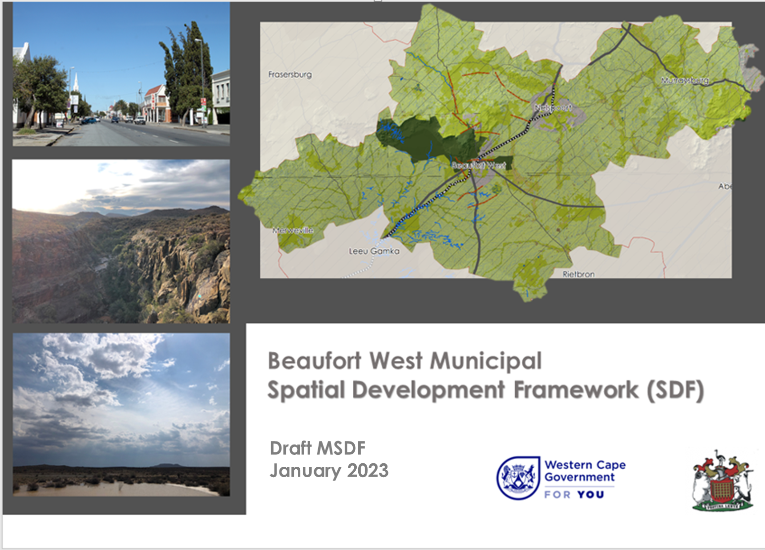
March 2023

March2023

Contents

CHAPTER 4: SPATIAL PROPOSALS FOR BEAUFORT WEST MUNICIPALITY 2
4.1 INTRODUCTION 2
4.2 THE SPATIAL VISION STATEMENT 2
4.3 THE SPATIAL CONCEPT 4
4.4 SPATIAL STRATEGIES 6
4.6 THE MUNICIPAL WIDE SPATIAL POLICIES 15
4.7 BEAUFORT WEST TOWN: SPATIAL DEVELOPMENT FRAMEWORK 39
4.8 MERWEVILLE: SPATIAL DEVELOPMENT FRAMEWORK 48
4.9 MURRAYSBURG: SPATIAL DEVELOPMENT FRAMEWORK 54
4.10 NELSPOORT: SPATIAL DEVELOPMENT FRAMEWORK 60

CHAPTER 4: SPATIAL PROPOSALS FOR BEAUFORT WEST MUNICIPALITY

4.1 INTRODUCTION
The purpose of this section is to provide the overarching spatial vision, direction, spatial development policy and associated strategies for the development and protection of the Beaufort West Municipality.
This chapter will set out:
- the spatial vision for Beaufort West Municipality,
- the future growth needs of the municipality,
- the spatial concept for the future growth and development of the municipality,
- the spatial strategies required to attain this concept; and
- how this concept manifests within the entire municipality.

4.2 THE SPATIAL VISION STATEMENT
The following policy documents have vision statements that are informants to the Beaufort West MSDF’s vision:
The Central Karoo District Municipal Spatial Development Framework (2020): “Working together in Sustainable Spatial Development and Growth towards a Resilient Central Karoo.”
The 2014 Beaufort West MSDF states that it seeks to be the “Wilderness tourism and transport gateway to the people, mountains and plains of the Central Karoo.”
The Beaufort West Municipality’s IDP: Beaufort West in the Central Karoo, the economic gateway to the Western Cape where people are developed and living together in harmony.
Additionally, the core values of the Municipality, as set out in the IDP, are:
- Integrity which includes honesty, fairness, and respect
- Trust

- Responsibility and accountability
- Harnessing diversity
- Participative decision-making
- Transparency
- Professionalism including friendliness, and
- Efficient service delivery.
All of these inform the spatial vision of Beaufort West Municipality, which is now:

To work together to develop Beaufort West into a thriving Regional Development Anchor that is the economic, tourism and transport gateway to the people, mountains, and plains of a resilient Central Karoo.

From a spatial planning, development planning and land use management perspective, and as represented in the spatial concept in Figure 99, the implications of this vision are as follows:

- Beaufort West town has a responsibility to present itself as a welcoming and convenient centre for catering to the needs of through travellers as well as to attract visitors to spend time in the sub-region;

- An important aspect of improving the presentation of the town is constructing the proposed bypass to remove heavy truck traffic from the main street. It is important to note the following:
- The proposal should be implemented in a manner so that it is does not detract from the economic activity that supports the town – namely fuel and refreshment purchases which are a result of private cars, buses, taxis, and freight trucks stopping to refuel;
  - Only truck traffic should be able to use the bypass. It is not desirable for cars, taxis, and buses to bypass the town; and,
  - It is envisaged that facilities for taxis and buses are not allowed along the proposed bypass.

- Promoting urban tourism opportunities in the municipality’s settlements will require upgrading their main streets, the creation and management of heritage precincts where appropriate and considerable effort into creating a town and township tourism culture based on B&Bs, restaurants and cultural activities such as the music for which the region has become well known (Karoo Kitaar Blues);

- Beaufort West should position itself as a tourist destination due to its expansiveness and desolation, particularly the areas north of the town in the Karoo National Park and the surrounding mountain regions;

- The main rural economic resource outside of eco-tourism is extensive agriculture. The growth of this resource depends on improving the carrying capacity of the land through good veld management practices. It would appear that the National Department responsible for agriculture intends to declare significant portions of the Karoo as Protected Agricultural Areas for grazing;

- Wildlife preservation continues to be an issue in the Karoo. The preservation of biodiversity will require ‘Fair Game’ practices to be employed in sheep farming. ‘Karoo Lamb’ must become a trademark geographic indicator to increase its value and contribution to the economy;

- Accessibility and mobility issues, which are dire, can only be addressed if a Rural Integrated Public Transport Network is implemented, which supplies periodic, affordable, reliable, and safe services. Current costs of transport are affecting the poor;

- Intensive engagement should continue with the shale gas exploration open cast uranium mining proponents to successfully resolve the following issues to protect the long-term interests of the municipality and its residents, which could be:

- Maximizing job opportunities for locals and identify what skills training will be required to enable this;
- Ensuring that the nature and location of any infrastructure maximizes long term benefits – e.g., staff housing should be located in existing settlements;
  - Rehabilitation plans, including proper topsoil stock piling, are prepared, and implemented on a phased basis as extraction proceeds and not left until all extraction is completed. Mines should be prevented from starting further production phases until rehabilitation milestones of open cast pits or well head pads have been achieved;
  - Key areas such as Critical Biodiversity Areas, conservancies and stewardship areas and visually sensitive landscapes contributing to long term heritage and tourism opportunities should be off limits to mining and shale gas exploration; The visual impact of Shale Gas Extraction on the Karoo landscapes could be severe, considerably diminishing its long-term tourism appeal unless properly rehabilitated; and,
  - One of the potential impacts of shale gas exploration is the anthropogenic contamination of underground water aquifers.

- It should be noted that both Beaufort West and Nelspoort are in a state of potential and, from time to time, actual crisis regarding their water supplies. These are increasingly dependent on groundwater as surface water sources have been inadequate for a number of years in spite of wide-ranging water demand management efforts although there is not much evidence of rainwater harvesting, especially in new low income housing areas;

- However, in recent years water demand has increased while recharge has decreased due in part to below average rainfall (<250mm p.a.) Beaufort West’s boreholes have experienced a one metre per annum drop in the water table;

- Nelspoort is reliant on the Sout River aquifer whose recharge is considerably weakened by the highly degraded soil and vegetation conditions in the basin above. This is an important motivating factor for the biodiversity restoration of this bioregion;

- Beaufort West is exploring aquifers such as Rytkuil to the south of the town. However, this also underlies a potential open cast uranium mine;
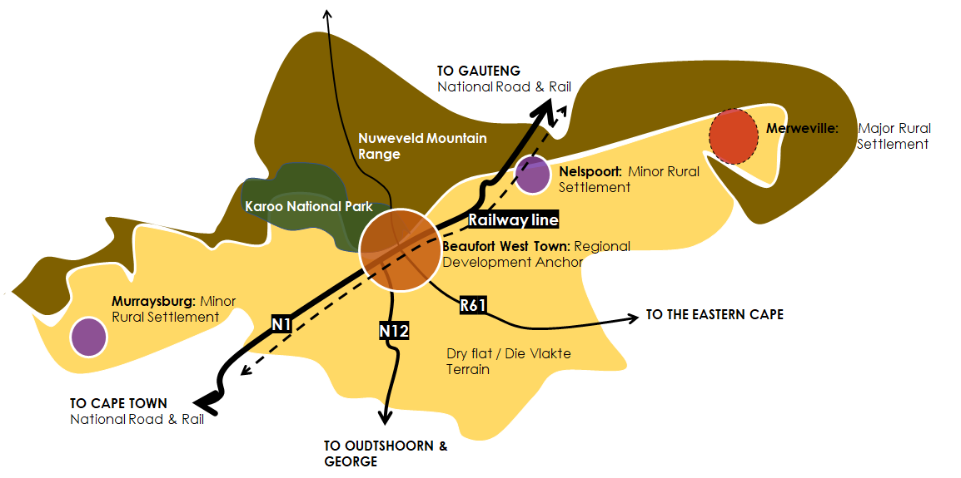
- Clearly if the water supplies of these settlements is undermined or compromised their future will be in question; and,

- Short term impacts of shale gas extraction will include transport and traffic and issues around accommodating mining crews, physically (housing) and socially (employment, recreation, entertainment. schooling, health– HIV, alcohol, drugs; crime and prostitution).

4.3 THE SPATIAL CONCEPT
Beaufort West Municipality comprises of five main structuring elements:
- The N1 road and adjacent rail route are the main transport and socioeconomic artery through the municipality, significantly increasing its opportunities compared to other similar sized municipalities not enjoying such access.

- The Nuweveld Mountains to the north form an impressive scenic backdrop to the municipality. They contain large areas of significant CBAs and most of the formal and informal conservation areas – these constitute 14% of the total area.

- The Gamka river basin contains the settlements of Beaufort West town and Merweville and is mostly used for extensive farming – small stock grazing.

- South of Beaufort West is a large area of significantly degraded land in the Sout River basin with extremely low stock carrying capacity and low concentrations of people. This area requires extensive rehabilitation if it is not to become a dustbowl.

- To the west Murraysburg forms an almost separate eco and social system. It is not linked to Beaufort West but is accessed off the R63 between Graaff Reinet and Victoria West. It is the highest, wettest, and most fertile part of the municipality where most of the small areas of intensive farming are found, particularly in the west. In the south the landscape rises up to the Sneeuberg. It is 91kms from Graaff Reinet in the Eastern Cape and 158kms from Beaufort West. This remote location creates a significant challenge as it depends on services delivered from Beaufort West.
Figure 99: Spatial Concept for the Beaufort West MSDF (2023)
As articulated in the spatial vision, the spatial concept for the municipality focusses on sustainable development, resilience, and partnerships. As will be illustrated, the four strategies of the municipal wide spatial concept are:

      - A region that protects the environment, enhances resilience, and capitalises on and honours the Karoo charm in support of a vibrant people and economy.

      - Improve regional and rural accessibility and mobility for people and goods in support of a resilient economy;

      - Allocate government resources, infrastructure and facilities in a manner that uplifts and skills people and focusses on maximising impact on the most possible people, while providing a basic level of service for all; and

      - Partnership-driven governance and administration towards improved financial and non-financial sustainability and resilience.

How the above translates spatially in the region is described as follows:

- Protect and enhance the natural systems of the municipality, ensuring continuity in the natural systems Karoo (such as the Karoo National Park, the Onder-Sneeuberg and Nuweberg mountain ranges) and ensure the river corridors in the region (Gamka river – and its tributaries) are provided with the necessary buffers and setbacks (of at least 32m from the side of each riverbank) to preserve continuity and integrity of biodiversity systems. Prioritise the protection of Critical Biodiversity Areas and Environmental Support Areas from development.

- Protect and enhance water catchment areas and water resources by demarcating Critical Biodiversity Areas and Environmental Support Areas and preventing inappropriate development within these areas.

- Capitalise on the tourism appeal of the various assets that exist in the Karoo, such as the heritage appeal of existing town centres, as well as the Karoo National Park. Ensure that all development in the Karoo is compatible with the sense of place, Karoo character and charm. This intrinsic value create lifestyle, tourism, and hospitality opportunities, as is seen in Merweville, and hence creates employment opportunities and assists in poverty alleviation.

- Ensure the development and maintenance of a road network that provides good access and mobility for the region, as well as ensure the regional rail network is equipped to provide for the movement needs. The N1, N12 and R62 corridors are key economic and social assets in the Municipality area as well as the District which requires regular maintenance and upgrading. Attention should be placed on appropriate measures to ensure road safety in the municipality.
- Specific focus is also needed on non-motorised transport within the region. Non-motorised transport, particularly pedestrian movement, is the primary transport mode among residents. Key interventions for implementation in this area are pedestrian walkways, bridges and underpasses, and cycle paths. An important consideration in the planning of such interventions is safety, security particularly for the most vulnerable members of society, which provides good lighting, visual surveillance as well as shelter from the heat.

- Ensure that the town of Beaufort West, as the Regional Development Anchor, provides the primary regional services and facilities in the region. Business opportunities within the town are to be maximised to encourage the multiplier effect of investment and expenditure. From a governance, capital investment and maintenance perspective, Beaufort West town is a crucial driver of growth and development opportunities.

- Strongly encourage value-add, industrial and agri-processing industries locating in the Regional Development Anchor of Beaufort West town to create jobs and add value to the region’s agricultural goods and services. Specifically, Beaufort West and Murraysburg present opportunities for value-add and agri-processing activities.

- Focus government investment, facilities, services and housing opportunities in Beaufort West and to a much lesser extent Murraysburg. Prevent the creation of new low-income settlements in low growth, job deficient towns that have little prospect of creating employment opportunities.

- Seek partnerships to enhance various interventions, with a focus on the top 3 most impactful and critical interventions for the municipality. These will have to be determined based on the priorities of the municipality and the transversal nature of the issues. Currently water, gas and energy, and rural mobility are three areas of potential partnership between all spheres of government and civil society.

4.4 SPATIAL STRATEGIES
The spatial development strategies for Beaufort West Municipality are informed by the Central Karoo District MSDF (2020). These are summarized in Figure 100. These strategies inform a series of municipal-wide spatial policies, that subsequently direct the settlement specific spatial development frameworks proposals for each town and settlement.
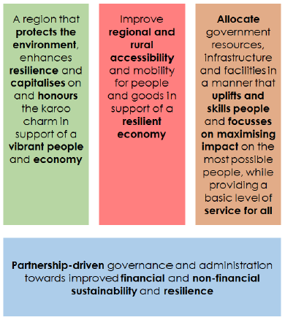
Figure 100: Spatial Development Strategies for the Beaufort West MSDF
STRATEGY A: A REGION THAT PROTECTS THE ENVIRONMENT, ENHANCES RESILIENCE AND CAPITALISES ON AND HONOURS THE KAROO CHARM IN SUPPORT OF A VIBRANT PEOPLE AND GROWING THE ECONOMY

Beaufort West municipality is a dry, arid landscape, which is sparsely populated. The Growth Potential of Town’s Study (2018) views its overall growth potential as low to very low, however, the municipality does possess a few inherent competitive advantages which must be capitalised upon to grow the economy, provide more people with access to work opportunities and perhaps even more importantly, the ability to see and create latent entrepreneurial opportunities in the economy.

This competitive advantage centres on its scenic appeal, sense of place and related tourism potential; its limited yet important agricultural activities and related agri-processing potential; green energy (solar and wind) potential; as well as on the potential shale gas reserves that exist in the region. Furthermore, the region has a significant rail system and national highway infrastructure assets running through it, providing the potential for improved connectivity to the broader South African economy.

The competitive advantage of the economy of Beaufort West Municipality is, however, dependent on its natural resource base. This underpins the history, character, scenic and heritage appeal of the region, as well as the vitality of the tourism industry and limited yet important agricultural, agri-processing, manufacturing and downstream trade and construction economy. The functioning of this economy is linked to the availability of water and the health of the ecological systems. Hence the protection and enhancement of the environment is one of the main strategies of this MSDF. Through municipal policy and programmes, the municipality must therefore protect its natural assets, build its resilience, and honour and enhance its tourism economy. The primary resources to protect, maintain and enhance are listed below and shown in Figure 101.

- Natural and agricultural resource base: Karoo National Park, the Gamka Dam, Critical Biodiversity Areas, and Environmental Support Areas, and the Sout River, the Dorps River and their tributaries, as well as irrigated agricultural production areas associated with these rivers, such as the areas around the town of Murraysburg;
- Settlements with different economic roles and heritage potential: The towns of Beaufort West, Murraysburg, Merweville and Nelspoort. All of these settlements hold significant built heritage assets such as churches, and other significant buildings and facades;
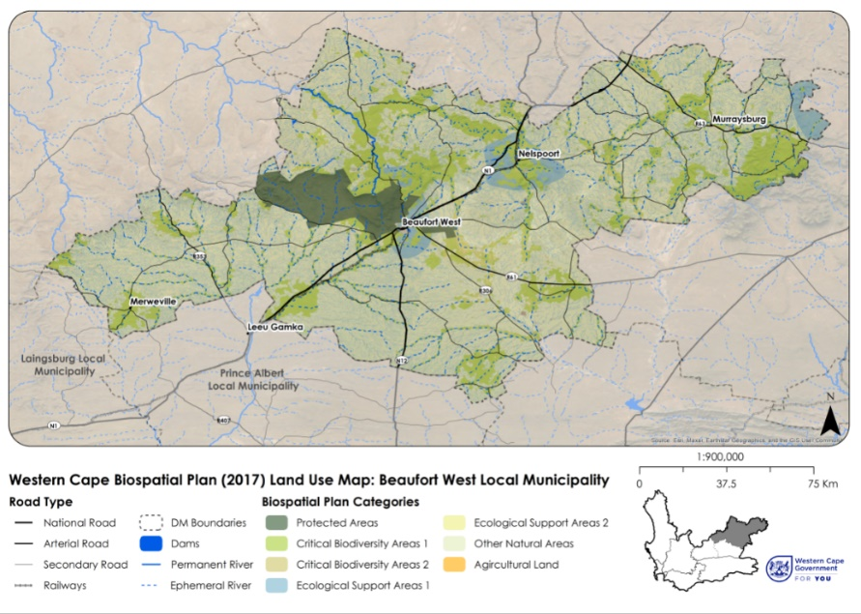
- Unique landscapes, lifestyle, and tourism offerings: Beaufort West Town, Donkin Street, monuments and heritage zones, and scenic routes – namely the Gamkaskloof Pass, as well as Molteno Pass in the Nuweveld range.

Figure 101: Beaufort West Biodiversity Spatial Plan 2017

STRATEGY B: IMPROVE REGIONAL AND RURAL ACCESSIBILITY AND MOBILITY FOR PEOPLE AND GOODS IN SUPPORT OF A RESILIENT ECONOMY
How easily citizens of and visitors to Beaufort West can access the opportunities, services, and amenities it offers is a critical precondition for growth of the economy and development of its communities. However, small towns and remote settlements are difficult and expensive to service with public transport, and the absence of public transport systems serving rural communities and outlying settlements fundamentally constrains socio-economic development. Similarly, the state of the road network is generally deteriorating, specifically municipal roads – undermining the ability of the people and businesses of the region to thrive.
The MSDF promotes an effective and efficient accessibility network that supports a productive interaction between settlements as well as within them.
What this means for Beaufort West is that, at the municipal scale, the regional road and rail network must support the effective and efficient movement of freight and people into and through the Beaufort West Municipality. This requires ensuring that a clear primary and secondary regional route hierarchy is set out, which means defining the role of the route and how the land uses alongside it are managed to ensure efficient mobility. This network must support the ability of rural dwellers and workers, and those living in smaller rural settlements to be able to access services and amenities both within and outside Beaufort West Municipality within a reasonable time.
As part of both encouraging business, as well as encouraging tourism activities and money spent within towns of the region, Beaufort West Municipality needs to continue to ensure that its towns are conducive to use by both local and tourist passengers (on foot and in car) as well as attractive for businesses to invest in the area. This means paying attention to urban management, infrastructure repair and upgrade, ensuring towns and ordered, clean and attractive. Given the sparsely populated nature of the municipality, school learner transport and mobile services need to be provided.

STRATEGY C: ALLOCATE GOVERNMENT RESOURCES, INFRASTRUCTURE AND FACILITIES IN A MANNER THAT UPLIFTS AND SKILLS PEOPLE AND FOCUSSES ON MAXIMISING IMPACT ON THE MOST POSSIBLE PEOPLE, WHILE PROVIDING A BASIC LEVEL OF SERVICE FOR ALL

Given the limited nature of government resources, there needs to be a strong focus on ensuring that a full suite of facilities and services are provided in the higher order urban settlement (being Beaufort West) with more rudimentary services and lower order services in the smaller settlements – and even mobile service solutions in the sparsest, smallest settlements or hamlets where there is insufficient demand and insufficient funds for a permanent service.
For these reasons, the National Spatial Development Framework (NSDF) (2022), as well as the CSIR, provide the national spatial social service provisioning model. This assists in the effective, affordable, and equitable development of social service delivery. The NSDF defines Beaufort West Town as a Regional Development Anchor which is situated along a strategic national route (N1) and a National Freight Corridor. Murraysburg is a major rural settlement which offers some services mentioned above to the surrounding farming communities. The rural settlements like Merweville and Nelspoort offer limited services that are structured around farming, railway, and transport activities. This is shown in the Spatial Concept in Figure 101.
The overarching aim is to achieve balance within settlements so that they function optimally within finite resource constraints. It is also to prevent situations where low growth settlements such as Nelspoort and Murraysburg expand to accommodate low-income persons without the requisite employment growth.
Through establishing a clear settlement hierarchy (see Figure 102), strategy C aims to ensure that:
- Opportunities are created for residents to prosper in inclusive and just settlements by preventing outward sprawl, disconnected and low-density development;
- Municipal financial sustainability becomes a central concern in municipal and government infrastructure investment, growth management and expansion; and
- Limited resources are used efficiently to protect long term financial sustainability of households, businesses, and government.

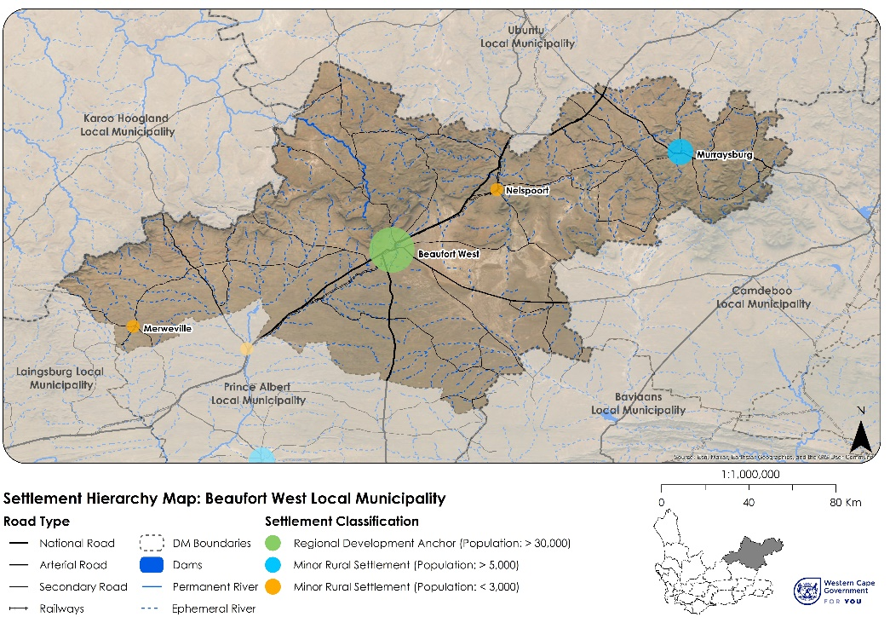
The development approach of the municipality should be that infrastructure development and investment is directed where growth is matched to capacity, resources, and opportunity. Specifically, this means:
- Focus government investment, facilities, services, and housing opportunities in Beaufort West Town and to significantly lesser extent Murraysburg and Merweville, therefore preventing the creation of new low-income housing developments in low growth, job deficient settlements that have little prospect of creating employment.

- Recognise population dynamics in infrastructure investment (more diverse housing products and opportunities in the centralised locations like Beaufort West Town).

Figure 102: Settlement Hierarchy for Beaufort West Town, Merweville, Murraysburg and Nelspoort.

STRATEGY D: PARTNERSHIP-DRIVEN GOVERNANCE AND ADMINISTRATION TOWARDS IMPROVED FINANCIAL AND NON-FINANCIAL SUSTAINABILITY AND RESILIENCE

Strategy D underpins all of the other strategies, because an integrated partnership and governance-based approach is required for better coordination, alignment, and impactful planning, budgeting, and delivery. The application of an integrated governance approach directly ties in with this SPLUMA principle, which also requires municipalities to pursue good administration practices to enhance and strengthen the spatial planning and land use management systems of the municipality.
Beaufort West, as part of the Central Karoo, must seek partnership-driven solutions, realizing that the challenges are multi-faceted and cannot be addressed only by the local sphere of government. It is therefore required that a range of partnerships be explored to find a shared service solution within the Central Karoo that ensures shared financial viability along with the administrative and logistical burdens associated with servicing a sparse region.
Focus areas of potential partnership between all spheres of government and civil society pertaining to Beaufort West Municipality include:
- Shared service centers between local and district municipalities.
- Water.
- Energy (both renewable energy and shale gas).
- Rural mobility; and
- Tourism.

4.4 SETTLEMENT SPECIFIC URBAN DESIGN PRINCIPLES
The following sets out the urban planning and urban design principles that are adopted in support of the implementation of the MSDF, that should guide the implementation of the MSDF, as well as land use management in the municipality.
Spatial efficiency and resilience

Land must be used efficiently to ensure municipal financial sustainability. Low density development typologies are costly for the municipality to service and create inequitable settlements that are costly to live in and negatively impact the poor most. Water resilience is an important consideration in all urban and rural development within the municipality.

Inclusivity & Connectivity
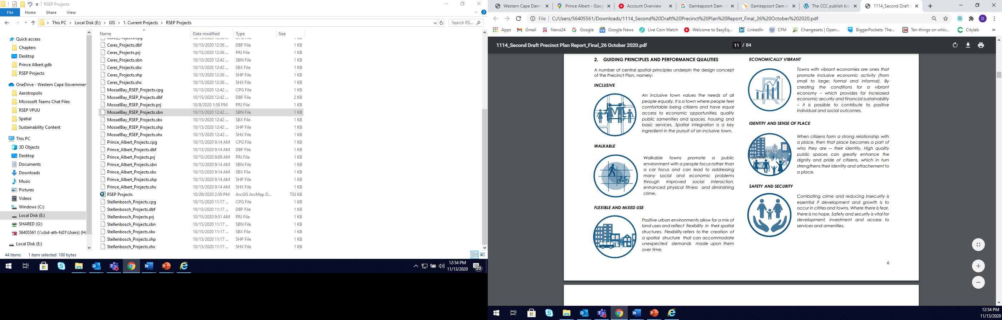
An inclusive town values the needs of all people equally. It is a town where people feel comfortable being citizens and have equal access to economic opportunities, quality public amenities and spaces, housing, and basic services. Connectivity is a key ingredient in the pursuit of an inclusive town, which seeks to ensure that all people have access to all the benefits of living in an urban environment, but also ensuring that the urban environment is well managed, clean, dignified, and attractive to live and do business in.

Walkability & Compact Settlement
Walkable towns promote a public environment with a people focus rather than a car focus and can lead to addressing many social and economic problems through improved social interaction, enhanced physical fitness, creating an urban environment conducive to walking or cycling and more eyes on the street – reducing opportunities for criminality. This requires investing in non-motorised transport, as well as promoting urban development that is compact, that uses land efficiently and reduces dependence on cars.

Flexible and Mixed-Use development
Positive urban environments allow for a mix of land uses and reflect flexibility in their spatial structures. Flexibility refers to the creation of a spatial structure that can accommodate unexpected demands made upon it over time. To this end, grid-style layouts must continue to connect with the original layout of the town, and the necessary connections and

Economically Vibrant
Towns with vibrant economies are ones that promote inclusive economic activity (from small to large; formal and informal) by providing basic services and basic urban management reliably and consistently, thereby creating an urban environm4nt that is desirable to invest in. By creating the conditions for a vibrant economy – which provides for increased economic security and financial sustainability – it is possible to contribute to positive individual and social outcomes.

Identity and Sense of Place
When citizens form a strong relationship with a place, that place becomes a part of who they are ― their identity. High quality public spaces, as well as preservation of built heritage can greatly enhance the dignity and pride of citizens, which in turn strengthens their identity and attachment to a place, and care for the place.

Safety and security
Combatting crime and reducing insecurity is essential if positive development and growth is to occur. Where there is fear, there is no hope. Safety and security are vital for development, investment and access to services and amenities. Urban design principles should ensure that the urban environment is one that is supportive of passive surveillance and enables “eyes on the street”.

Spatial Transformation
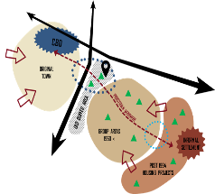
Spatial transformation refers to addressing the apartheid legacy through settlement restructuring. The reconstruction framework developed by the WCG Regional Socio-Economic Programme (RSEP) is a practical toolkit for addressing apartheid spatial inefficiencies and spatial divides (where lower income residents live and where jobs and services are usually located). The toolkit provides guidelines to connect fragmented towns by finding and upgrading integration zones, primary pedestrian movement routes and township satellite nodes.
4.5 FUTURE DEMAND APPROACH STATEMENT: POPULATION, HOUSING AND LAND DEMAND
The population of the Beaufort West municipality was estimated to be 51 158 people in 2021 (Department of Social Development, 2020) – which is essentially unchanged from the 2020 projection of 51 298, when the population is estimated to have peaked. The population has increased from the 2002 estimate of 48 790 by a total of 4.85%, over the 19-year period, which translates into an average annual growth rate of 0.14%. While there are expected to be some fluctuations in the population over the coming years (see Figure 103), the medium-growth population projection for 2035 of 51 146 represents a change of 0.00% between 2021 and 2035. From 2021 to 2035, the total number of households is however projected to increase by 9.6%, from 13 087 in 2021 to 14 343 in 2035 (an increase of 1256 households). This is because household sizes are steadily decreasing: from 4.1 people per household in 2021 to 3.7 in 2035. This is a trend that can be observed throughout South Africa: that household formation growth is greater than population growth.
Population projections are inherently uncertain, and it is important to contextualise that these estimates have been generated at the time of highest uncertainty: at the end of a census cycle and prior to the subsequent census data being released. It will be necessary to check these projections and recalibrate infrastructure and housing plans accordingly against the 2021 Census once its data becomes available.
Future population estimates are shown in Figure 103; whilst the housing demand database figures are shown in Table 14. The future facility demand as a result of projected household growth is shown in Table 15. In summary, by 2031, the following facilities may be required in Beaufort West:
- 1 new ECD centre; and
- 1 new Primary School (assuming there is no existing capacity in existing Primary Schools).

Figure 103: Past Population Growth and Future Projections for Beaufort West Municipality
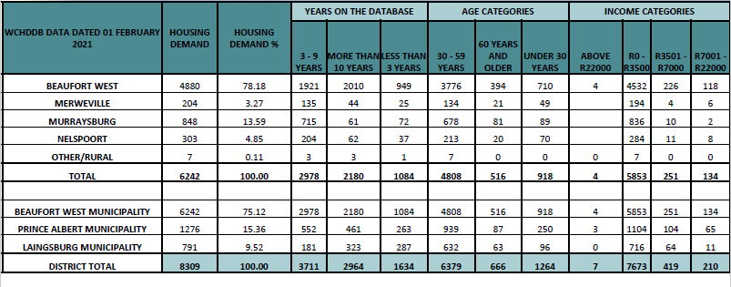
Table 14: Housing Demand figures for Beaufort West Municipality (Western Cape Government Department of Human Settlements, 2021)

Table 15: Future facility demand in Beaufort West Municipality

4.6 THE MUNICIPAL WIDE SPATIAL POLICIES
The purpose of this section is to give expression to the spatial strategies by framing a set of spatial policies that must be used to inform land use planning, infrastructure development and rural and urban development decision making within Beaufort West Municipality. The policies listed below link to Beaufort West Municipality’s IDP Strategic Objectives. The following sections will then provide further detail on each of the policies.
STRATEGY A: A REGION THAT PROTECTS THE ENVIRONMENT, ENHANCES RESILIENCE AND CAPITALISES ON AND HONOURS THE KAROO CHARM IN SUPPORT OF A VIBRANT PEOPLE AND GROWING THE ECONOMY

POLICY A1: PROTECT CRITICAL BIODIVERSITY AREAS, ENVIRONMENTAL SUPPORT AREAS & NATURAL ENVIRONMENT TOWARDS A RESILIENT MUNICIPALITY

POLICY A2: ENVIRONMENTAL OFFSETTING & BIODIVERSITY STEWARDSHIP

POLICY A3: PROMOTE AND DEVELOP A WATER RESILIENT MUNICIPALITY

POLICY A4: CLIMATE CHANGE ADAPTATION AND DISASTER MITIGATION

POLICY A5: TOURISM ENHANCEMENT & PROTECTION OF SCENIC ASSETS

POLICY A6: RESILIENT, SUSTAINABLE AGRICULTURE & AGRI-PROCESSING
POLICY A7: SHALE GAS DEVELOPMENT (SGD)

POLICY A8: LAND REFORM SUPPORT

STRATEGY B: IMPROVE REGIONAL AND RURAL ACCESSIBILITY AND MOBILITY FOR PEOPLE AND GOODS IN SUPPORT OF A RESILIENT ECONOMY
POLICY B1: IMPROVE INTER SETTLEMENT CONNECTIVITY
POLICY B2: RURAL MOBILITY & SCHOOL LEARNER TRANSPORT
POLICY B3: TOWN IMPROVEMENT PLANS FOCUSSED ON NON-MOTORISED TRANSPORT, SAFETY AND GREEN NETWORKS

STRATEGY C: ALLOCATE GOVERNMENT RESOURCES, INFRASTRUCTURE AND FACILITIES IN A MANNER THAT UPLIFTS AND SKILLS PEOPLE AND FOCUSSES ON MAXIMISING IMPACT ON THE MOST POSSIBLE PEOPLE, WHILE PROVIDING A BASIC LEVEL OF SERVICE FOR ALL

POLICY C1: ESTABLISHING A CLEAR SETTLEMENT HIERARCHY
POLICY C2: URBAN EDGE POLICY
POLICY C3: FACILITY CLUSTERING & DESIGN PROTOCOL LINKED TO A CLEAR NODAL HIERARCHY

STRATEGY D: PARTNERSHIP-DRIVEN GOVERNANCE AND ADMINISTRATION TOWARDS IMPROVED FINANCIAL AND NON-FINANCIAL SUSTAINABILITY AND RESILIENCE

POLICY D1: SHARED SERVICE CENTRE FOR THE CENTRAL KAROO
POLICY D2: INTEGRATED PLANNING, BUDGETING, AND IMPLEMENTATION

STRATEGY A: A REGION THAT PROTECTS THE ENVIRONMENT, ENHANCES RESILIENCE AND CAPITALISES ON AND HONOURS THE KAROO CHARM IN SUPPORT OF A VIBRANT PEOPLE AND GROWING THE ECONOMY

The Beaufort West municipality seeks to become a resilient municipality that can adapt to and mitigate against the negative effects of climate change, increasing temperatures, reduced rainfall, and the host of downstream impacts on the economy and society at large. The future vibrancy of the economy and social advances will invariably be rooted in the resilience of the natural environment, society, and the economy to a host of negative impacts. This section seeks to set out policies in support of this strategy.
POLICY A1: PROTECT CRITICAL BIODIVERSITY AREAS, ENVIRONMENTAL SUPPORT AREAS & NATURAL ENVIRONMENT TOWARDS A RESILIENT MUNICIPALITY

Designated Spatial Planning categories (SPCs) must be considered in terms of land use management. This, in part, should ensure that Critical Biodiversity Areas (CBAs) and protected areas are conserved and, where applicable, restored. Land use change should always favour rehabilitation of indigenous species in degraded areas that have the potential to connect protected areas, CBAs, and Ecological Support Areas (ESAs).
Policy A1 Guidelines:
- Manage land use management in the rural areas of Beaufort West Municipality through the application of Spatial Planning Categories (SPCs) as set out in the Western Cape Rural Land Use Planning Guidelines and the Western Cape Biodiversity Spatial Plan (2017) and ensure that all investment in Beaufort West Municipality seeks to underpin the principles of spatial sustainability and spatial resilience. Greater detail on each SPC layer can be found in the Western Cape Rural Land Use Guidelines.

- Protect and conserve important terrestrial, and aquatic habitats (rivers and wetlands) as identified in Figure 5 as well as the Biodiversity Spatial Plan maps in the Status Quo section of this MSDF.

- Regarding interpreting the Guideline, the table in the maps shows how to convert the Protected Areas, Critical Biodiversity Areas, Ecological Support Areas and Other Natural Areas to the various Spatial Planning Categories set out in the Western Cape Biodiversity Spatial Planning Map.

- The following mechanisms may be implemented when considering ways of formally protecting endangered and irreplaceable biodiversity. These mechanisms include:
  - Private Land: involving Stewardship Contract Nature Reserves, Biodiversity Agreements, or Protected Environments;
  - Municipal Land: Nature Reserve or Municipal Biodiversity Agreement (e.g., City of Cape Town);
  - Forest Nature Reserves through the Natural Forest Act and Wilderness Areas into Wilderness Act;
  - Title deed restrictions where land has been designated under the Stewardship Programme or declared a Nature Reserve or Protected Environment;
  - Contractual National Parks: the zoning of private properties to Open Space III could be used as a mechanism for conservation in terms of the Beaufort West Zoning Scheme By-Law. Financial and non-financial incentives have the potential to be linked to the conservation on private land with title deed restrictions.

- In line with the Western Cape DEA&DP guidelines for rural land use development, new investment in rural areas should not:
- Have significant impact on biodiversity;
- alienate unique or high value agricultural land;
- compromise existing farming activities;
- compromise the current and future use of mineral resources;
- be inconsistent with cultural and scenic landscapes within which it is situated;
- involve extensions to the municipality’s reticulation networks;
- impose real costs or risks to the municipality delivering on their mandate; and
- infringe on the authenticity of the rural landscape and heritage assets.
The following land uses are permitted in the municipality, as per the following Spatial Planning Categories (SPCs).
- Core 1 Areas: Critical Biodiversity Areas (CBA) and Protected Areas. These include habitats classified as highly irreplaceable, critically endangered, or endangered terrestrial (land), aquatic (rivers, wetlands, and estuaries) and marine habitats. In Beaufort West, the Karoo National Park is the key Protected Area for the municipality, but CBAs also run along river corridors and other sensitive areas. This category also includes essential biological corridors, as it is vital to sustain their process and pattern functionality. These areas must be regarded as “no-go” for development and must be kept in a natural state, with a management plan focused on maintaining or improving the state of biodiversity. There should be no further loss of natural habitat and degraded areas should be rehabilitated. In Beaufort West Municipality, CBAs are also typically found in conjunction with where the towns and settlements are located.

- Core 2 Areas: These consist of two areas, namely Critical Biodiversity Area 2 (Degraded) and Ecological Support Area 1. These areas are in a degraded or secondary condition and are required to meet biodiversity targets for species, ecosystems, or ecological processes and infrastructure. These areas should be maintained or rehabilitated into a natural or near-natural state with no further loss of natural habitat.

- Buffer 1 Areas: These areas may be degraded but still play an important role in supporting the functioning of Core Areas (either Protected Areas or CBAs) and are essential for delivering ecosystem services. These areas should be restored and/or managed to minimise impact on ecological infrastructure functioning, especially soil and water-related services. Two components of the rural landscape make up Buffer 1 areas:
- Ecological Support Area 2: Here the goal is to restore and/or manage to minimize impact on ecological infrastructure functioning, especially soil and water-related services.
- Other Natural Areas: in these areas the goal is to minimise habitat and species loss and to ensure ecosystem functionality through strategic landscape planning. This designation offers flexibility in permissible land-uses, but some authorisation may still be required for high impact land-uses.

- Buffer 2 Areas: This category includes areas designated as Other Natural Areas, located in an extensive and/or intensive agriculture matrix (i.e., grazing and livestock production) as the dominant land use. The Buffer 2 SPC requires that habitat and species loss is minimized, and that ecosystem functionality is preserved through strategic landscape planning. Buffer 2 areas offer flexibility in permissible land-uses, but some authorisation may still be required for high-impact land-uses.

- Agriculture Areas: These consist of areas with an existing or potential intensive agriculture footprint (namely homogeneous farming areas made up of cultivated land and production support areas). This designation includes areas in which significant or complete loss of natural habitat and ecological functioning has taken place due to farming activities. Existing and potential agricultural landscapes should be consolidated and protected; sustainable agricultural development, land and agrarian reform, and food security should be facilitated, and ecosystems must be stabilised and managed to restore their ecological functionality.

- Settlement Areas: This category includes all existing settlements, large and smaller towns, villages and hamlets: generally all urban areas with land uses compatible with urban development. Settlements are delineated by municipalities in terms of an urban edge or by DEA&DP in terms of the 2014 NEMA Listing Notices as urban areas. The purpose is to develop and manage settlements in a sustainable manner. Wherever possible, existing settlements should be used to accommodate non-agricultural activities and facilities.
The Western Cape Biodiversity Spatial Plan maps is shown in Figure 104 and the Spatial Planning Categories for Beaufort West Municipality are mapped in Figure 110.

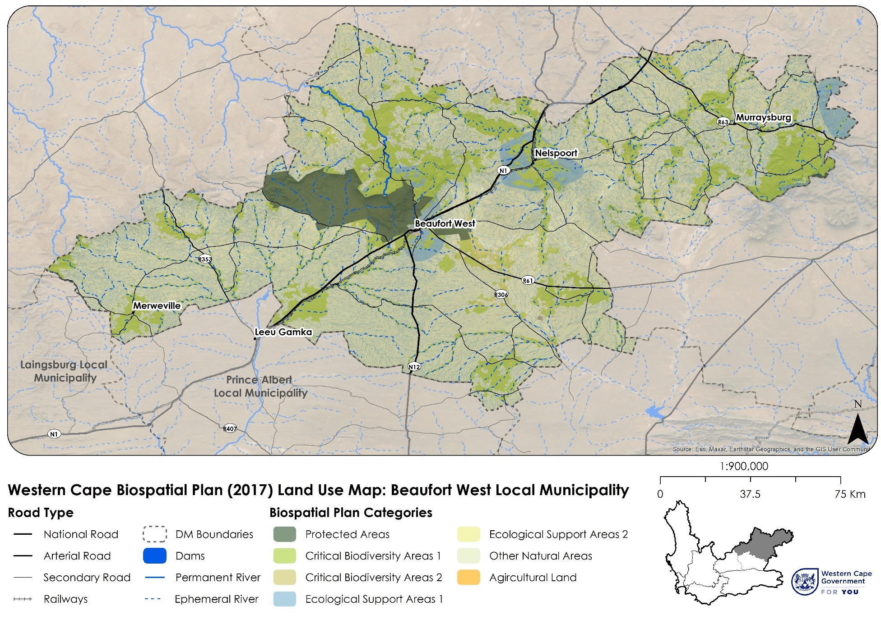
Figure104: Biodiversity Spatial Plan for the Beaufort West Municipality

POLICY A2: ENVIRONMENTAL OFFSETTING & BIODIVERSITY STEWARDSHIP

Environmental offsetting aims to slow and progressively reverse ecological deficit by counterbalancing human-induced negative effects on the environment that remain after every effort has been made to avoid, minimise, and then rehabilitate these impacts by making positive intervention elsewhere. This approach recognises the interdependence between biodiversity, ecosystems, and the benefits they provide for people through use and cultural values. It takes a landscape scale, rather than a site-specific view, to enable consideration of cumulative impacts.

Policy A2 Guidelines:
- The 2017: Draft National Biodiversity Offset Policy aims to ensure that significant residual impacts of developments are remedied. The Western Cape Conservation Stewardship sites can be downloaded from http://bgis.sanbi.org/. The Offset Policy should be taken into consideration with every development application that still has significant residual impact after the Mitigation Sequence has been followed in the Environmental Impact Assessment process. Table 2 provides a set of basic offset ratios to be considered when designing an offset intervention.

- The chosen offset intervention must go through public participation during the EIA process.
Table 2: 2017: Draft National Biodiversity Offset Policy Offset Ratios
- It is worth noting that the offsets could be ringfenced and linked to town-scale tree planting and water and waste management initiatives that demonstrate equal offset reduction measures.

- Draft an Offset Register to monitor compliance with the environmental offset and to monitor the progress and impact of the offset interventions.

MSDFs often identify land in terms of the Biodiversity Spatial Plan data set that needs to be protected but is also privately owned land, making landowners uncertain over its future use. Therefore, information on incentives or concessions around property rates or tax benefits is useful.
Section 37D of the Tax Income Act allows for a 4% straight line deduction on the value of the land declared. This means that a landowner who declares their land under Stewardship as a Nature Reserve or National Park may deduct 4% of the value of that declared land value from their taxable income each year for 25 years.
The tax incentive governed by section 37D can only accrue to the title deed holder of the land. The land must be declared as a Nature Reserve or National Park in terms of section 20 or 23 of NEMPAA with the endorsement reflected on the title deed of the land for a minimum period of 99 years.
If the landowner maintains a right of use of the land, then the deduction is apportioned accordingly. The deduction becomes effective in the year the land is declared and in each subsequent year of assessment. It is important to remember that these straight-line deductions only apply to land declared on or after 1 March 2015.
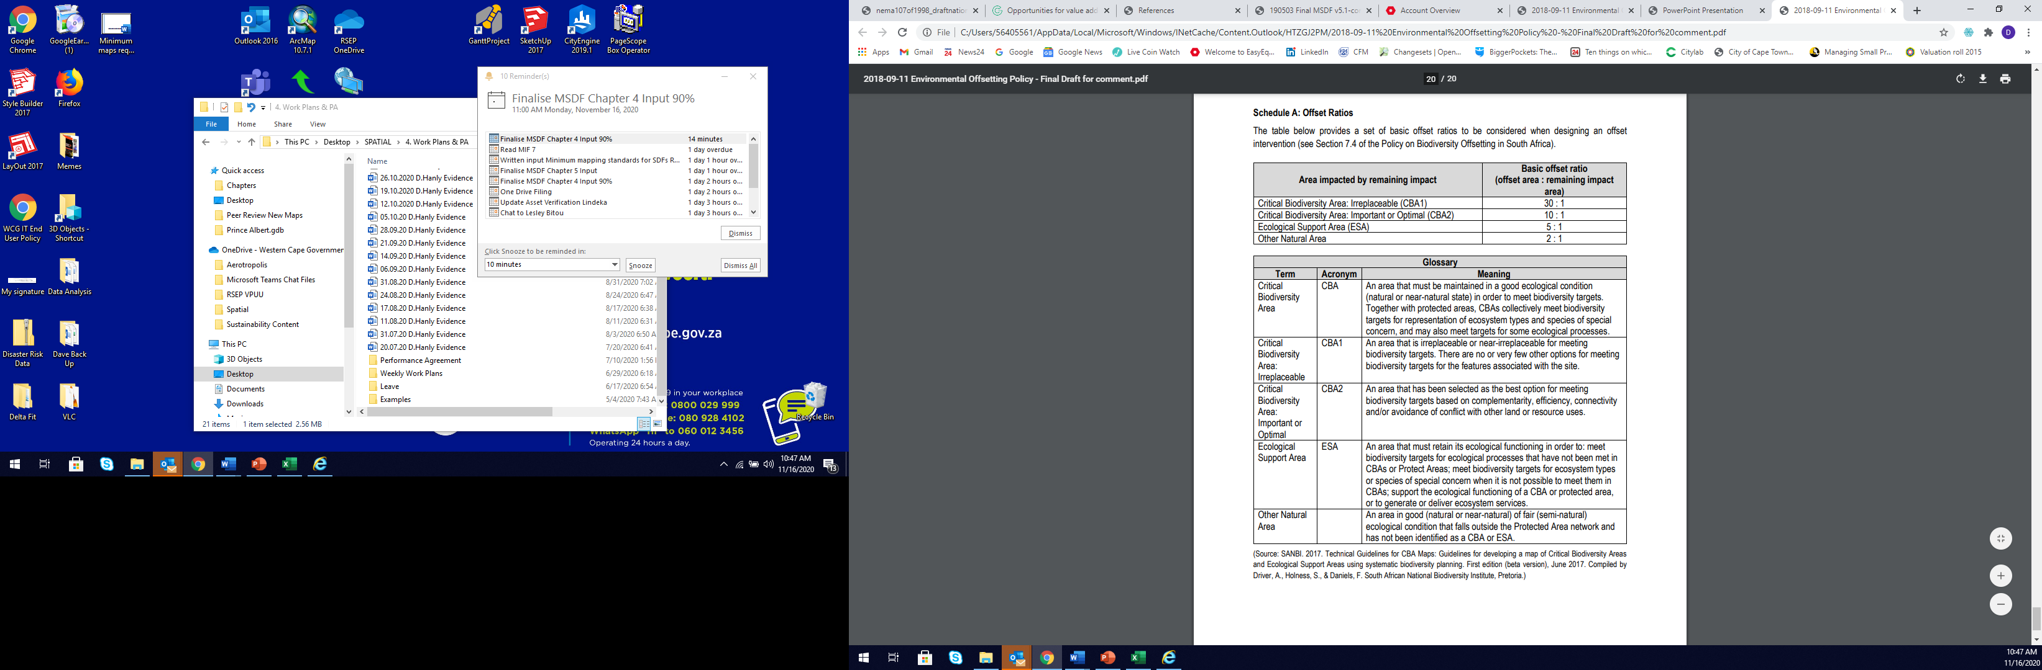
Should the Stewardship agreement be terminated, the landowner will be liable for certain tax penalties. The landowners’ responsibilities in terms of the Stewardship agreement are defined by NEMPAA. The section applies to taxpayers in profit making or loss positions and has benefits for both scenarios.

POLICY A3: PROMOTE AND DEVELOP A WATER RESILIENT MUNICIPALITY

The drought in Beaufort West has damaged the municipality’s people and its economy. If the status quo remains, the region will continue to experience economic shocks related to water unavailability. Water sensitive design, water availability or water constraints must be considered as part of all land use management changes, infrastructure expansion or any other process that impacts on water use or availability in the municipality. The aim should be to make the towns progressively less dependent on rainfall, so that reserves can last through dry periods.
Policy A3 Guidelines:
At the municipal scale, the following adaptation policy measures apply:
- Monitor ground water resources and implement effective water reduction techniques when sources are low. See the Groundwater Monitoring Network Strategy for the Karoo: https://cbosss.com/igscbss-to-design-gw-monitoring-network-for-karoo/.

- Protect and rehabilitate the Sout River system, which is of particular importance to the municipality, by evaluating the carrying capacity of the Sout river and reconciling this with future growth needs.

- Protect and rehabilitate high-yield groundwater recharge areas around Murraysburg and the Sneeuberg mountain range.

- Adhering to the National Department of Water and Sanitation’s water resource quality objectives. In September 2020, in terms of section 13(1) of the National Water Act, 1998 (Act No. 36 of 1998), the National DWS determined water resource classes, prioritisation units, river nodes and corresponding resource quality objectives for the catchment. The sub catchment of Breede-Gouritz Water Management Area in which Beaufort West municipality is located is classified as a Class II: moderate protection. The ecological category and the Resource Quality Objectives (RQOs) (water quantity and quality, habitat, and biota) for each groundwater resource unit and river node can be found in the relevant gazette.

- Reduce the loss of water through evaporation reduction as a primary objective. This includes covering reservoirs and dams, conversion of canals to water pipelines, recycling of grey water for reuse, etc

- Ensure that the integrity of valuable rainwater catchment areas, groundwater recharge areas and riverine systems are kept clear of invasive plant species or any use that will degrade either the quality or quantity of water available for use.

- Develop agricultural water demand management programmes, focusing on ground water appropriate agricultural areas, particularly in Murraysburg and its surrounds and the areas around the Sout River.
At the settlement scale, the following following climate change adaptation policy measures apply:
- Regulate borehole use to ensure sustainable use of groundwater systems.
- Develop water and sanitation infrastructure that utilises water re-cycling and reuse.
- Promote household and farm-scale rainwater capturing for non-potable uses.
- Ensure rainwater tanks are included in new developments of households on erven larger than 120m².
- Promote compact urban development to minimise infrastructure expansion that increases the risks of water loss from expansive water reticulation systems.
- Invest in a maintenance programme that seeks to minimise leaks from municipal water infrastructure.
- Implement water demand management programmes in Government facilities (such as municipal offices, education, health, and public works).

POLICY A4: CLIMATE CHANGE ADAPTATION AND DISASTER MITIGATION

This section, in addition to policies A1, A2 and A3, provides adaptation and mitigation guidance on combatting the effects of climate change. According to the Central Karoo District Municipality Disaster Risk Assessment Report, the following climate hazards are key risks for the Central Karoo (and Beaufort West by extension):
- Fire;
- Drought;
- Floods;
- Snow;
- Shift in seasons;
- Storm events (including lightning and wind);
- Increased number and extent of heat days;
The municipality’s flood hazard, heat stress, dam level status and ground water depletion risks are indicated in the CSIR green book tool.
Policy A4 Guidelines for Adaptation and Mitigation:
- In terms of disaster risk, where feasible and through broader partnership, respond to the infrastructure and risk guidelines put forth by the 2021 Central Karoo District Municipality Disaster Risk Assessment Report.

- Link to the WCG Ecological Infrastructure Investment Framework and CSIR investment framework to assist with informing decisions on where and how to invest in the Western Cape’s ecological infrastructure (See video link: https://youtu.be/ivR7zKs1Jqk). The study analyses risks & vulnerabilities per catchment such as water supply (surface & ground water), fire, flooding, and erosion and rangeland degradation. It then links these to opportunities for restoration through investment strategies that focus on collaboratively funded interventions such as alien invasive species strategy, fuel load reduction via Management Unit Control Plans (MUCPs), general ecosystem rehabilitation, conservation agriculture, integrated fire management and improved awareness, monitoring and evaluation.

- Alien vegetation clearing has the highest and most immediate positive spin off for reducing fire and groundwater depletion risk. It can also be linked to a biomass economy. There are also opportunities for carbon sequestration using spekboom see the link provided below:

https://www.greencape.co.za/assets/Uploads/BioValSA-Lignocellulosic-Biomass-Opp.pdf

- Guidelines for the monitoring, control, and eradication of alien invasive species can also be found in Section 76 of the National Environmental Management: Biodiversity Act, 2004 (Act 10 of 2004) (‘NEMBA’) and Ecosystem Guidelines for Environments in the Western Cape (2016) see the link below:

http://biodiversityadvisor.sanbi.org/wpcontent/uploads/2012/04/Ecosystem_Guidelines_Ed2.pdf.

- Eradication programmes should focus on the urban periphery, in river catchment areas and Fire Management Areas. These programmes should also prioritise high veld fire risk areas and asset protection zones (interfaces between settlements and agricultural/natural environment – must ensure adequate fire breaks are considered and implemented).

- Public landowners must allocate enough resources to ensure the management of their land to remove and prevent alien vegetation infestation.

- The CKDM’s Disaster Risk Management Department must be given an opportunity to provide input into land use applications in interface areas where there is fire and flooding risk. A protocol between the CKDM and Beaufort West Municipality must be developed to facilitate this.

- Prevent future flood risks by ensuring development is set back from the 1:100-year flood zones adjacent to all river systems. Stormwater systems need to be maintained and where necessary upgraded to accommodate intense flood events.

- Preserve river riparian zones and wetlands with at least a 32m buffer from agriculture and any other development.

- Ensure that storm water systems in urban areas can accommodate flooding conditions effectively, particularly in Beaufort West Town, both through design and regular maintenance. Where development is permitted, it must be associated with sustainable urban drainage design.

- Promote renewable energy generation and use. All new buildings must be designed such that they can be migrated off fossil fuels without cost to the owner/occupier - e.g., electrical connection (can be switched to renewables), solar geyser, no reliance on coal/paraffin or other pollutants. An often-overlooked aspect is the possible future penalties that will apply to fossil fuels (e.g., carbon tax). This will reduce the appeal of shale gas in favour of renewables such as solar and wind.

POLICY A5: TOURISM ENHANCEMENT & PROTECTION OF SCENIC ASSETS

Beaufort West Municipality’s tourism industry has been significantly constrained by several factors over recent years. Key issues have been:
- Drought.
- The COVID-19 lockdown.
- Deteriorating municipal infrastructure, particularly waste management.
COVID-19 in particular had a damaging effect on tourism. It was estimated that the wholesale and retail trade, catering and accommodation sector contracted by -11.3% per cent in 2020 (MERO, 2021). In 2019, this sector was the largest contributor to employment in the municipality, accounting for 25% of employment opportunities.
In spite of these challenges, Beaufort West has significant scenic and heritage resources that should be restored and preserved as appropriate. The main cultural heritage and scenic resources, as identified in the PSDF and endorsed in this MSDF, include:
- The Karoo National Park and scenic routes.
- Historic settlements, main streets and heritage assets which include the CBD in Beaufort West Town, the Eastern section of Merweville, parts of Nelspoort and Murraysburg, proclaimed monuments and heritage zones.

The landscape character of the passes and settlements must be safeguarded and compromising development on ridge lines or in important view corridors must not be allowed. These are shown in Figure xx, below.

Policy A5 Guidelines:

- The PSDF Heritage and Scenic Resources Specialist Study (2013) provides guidance in terms of the spatial form and character of settlements. These guidelines are adopted in this MSDF and should be referred to in land use management decision making.

- Rejuvenate and invest in the historic settlement cores of Beaufort West, Merweville and Murraysburg towns to make these appealing to tourists, businesses and attract investment into the town centres. Leverage these assets to create employment opportunities by attracting tourists.

- Develop a heritage overlay zone to guide land use decision making. The Beaufort West desktop heritage survey conducted for the 2014 MSDF denotes the key heritage resources that must continue to be protected. This included Grade I, II and III sites in Beaufort West town, and a number of sites in its smaller towns – including national monuments in Merweville and Murraysburg.

- The development of a settlement (consolidation or growth) should take the existing (and sometimes historic) structure and spatial form into consideration and strengthen its character. This spatial form must be compact and respond to the topography of the landscape.

- Promote vernacular Karoo-style building typologies in all development – low-income housing development could be adapted to have Karoo-style features. Beaufort West, together with the Karoo region, has unique vernacular building and housing typologies that must be honoured and enhanced in future growth and development in order to make these places more appealing and desirable for tourism and to enhance their sense of place. These typologies should be replicated in government subsidy housing initiatives, as well as in gap and normal market housing development. Figure 3.32 shows some of the different housing typologies.

- When delivering any agri-processing, renewable energy, or any infrastructure in rural areas, ensure that key view sheds and vistas are not undermined and that, where appropriate, set-backs and screenings (in the form of tree planting) are provided from roads.

- Continue to develop and implement a destination and tourism branding and marketing strategy to promote the tourism sector.

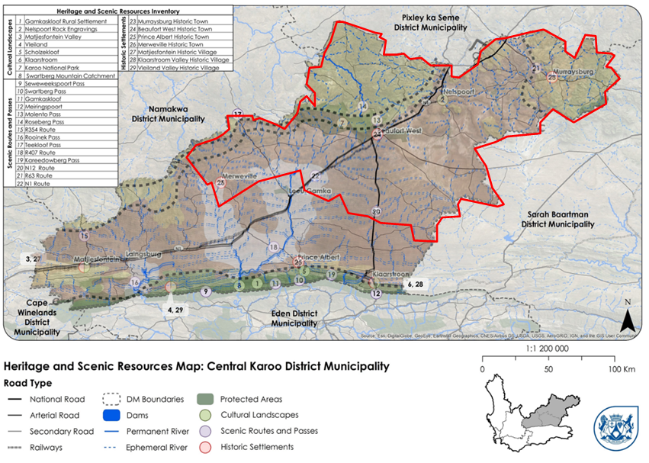
Figure 105: Mapping the Cultural, Scenic landscapes and historic settlements (Central Karoo MSDF (2020)
POLICY A6: RESILIENT, SUSTAINABLE AGRICULTURE & AGRI-PROCESSING
Agriculture contributes 10% to Beaufort West’s GDPR, and 19% to employment opportunities (Western Cape Government, 2020)). Although agricultural activity has been declining due to the protracted drought conditions, it still provides opportunities to maintain and enhance both job and food security.

The use of agricultural land and the integrity of agricultural operations must be protected and enhanced, as mapped in Figure 106. The conversion of irrigated, arable land is not supported in terms of this MSDF and the Subdivision of Agricultural Land, Act (Act 70 of 1970), section 3 (f), which states that “no area of jurisdiction, local area, development area, peri-urban area, or other area … of the definition of ‘agricultural land’ in section 1, shall be established on or enlarged so as to include, any land which is agricultural”. This underscores the need to protect agricultural land as stipulated in the Draft Preservation and Development of Agricultural Land Bill (2016).

It is in the national interest to preserve and promote sustainable use and development of agricultural land to produce food, fuel, and fibre for the primary purpose to sustain life further recognising that high value agricultural land is a scarce and non-renewable resources; and recognising that it is in the interest of everyone to have agricultural land protected, for the benefit of present and future generations. The sustainable development of agricultural land requires the integration of social, economic and environmental considerations in both forward planning and ongoing agricultural land management to ensure that development of agricultural land.

Policy A6 Guidelines:
- Encourage water-resilient farming practices that enable more efficient and productive use of water.

- Encourage the use of drought-resistant crops and crop hybrids that tolerate drought conditions and use less water.

- Actively and aggressively promote value-add to all locally produced agricultural products in the region.

- Ensure that farmers in the region are granted the necessary rights and building plans on their farms to promote agri-processing and job creation, but in a way that doesn’t undermine Karoo charm and character (i.e., new developments must be designed well and must fit in with the landscape).

- Provide the necessary farmer support for drought relief, water use efficiencies and agricultural expansion in the region, with a specific focus on emerging farmers.

- Implement catalytic economic development projects such as SMART gardening, Agri Parks and Dry Fruit Facilities and plantation.

- Producers of long-term crops, such as orchards and vineyards, as well as game and ostrich producers, are excluded from government drought assistance, while they are in dire need of it. Thanks to financial contributions and feed donations to the Agri Western Cape Drought Relief Fund, Agri Western Cape can offer support to livestock farmers, but there is no assistance for producers who have had to de-root hundreds of hectares of vineyards and orchards.

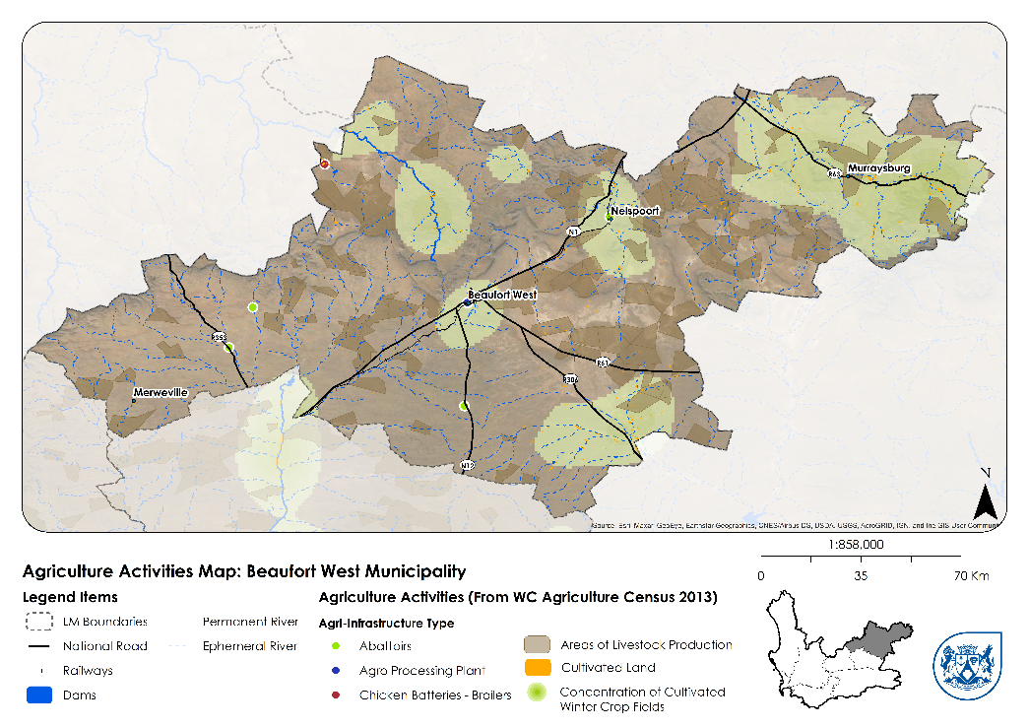
Figure 106: Agricultural Assets in Beaufort West
POLICY A7: SHALE GAS DEVELOPMENT (SGD)

Figure 110 shows the Biodiversity Spatial planning Categories for the Central Karoo. This includes Exclusion Areas for Phase 1: Exploration of SGD. Figure 109 shows the area designated for shale gas exploration. To date, SGD is still only a theoretical proposal within the Karoo Basin that is subject to exploration, feasibility and confirming recoverable reserves. The extent and viability of the gas reserves in the Karoo Basin, as well as the characteristics of the subsurface environment, is largely unknown. Satisfactory levels of certainty can only be ascertained by means of exploration or drilling into the target shale deposits. If hydrocarbons are encountered, a limited amount of hydraulic fracturing can then be undertaken.

Policy A7 Guidelines:
- Natural gas represents an opportunity for economic development in the Western Cape (and South Africa as a whole).

- With South Africa focusing on its climate change commitments, natural gas should only be regarded as a transition fuel on the way to reliance on renewable energy. The use of natural gas must occur in support of renewable energy, not at the cost thereof, or as an alternative thereto.

- All impacts of this activity, on ground water resources specifically, must be adequately mitigated if it is to proceed in the Karoo basin.

- Critical Biodiversity Areas, Environmental Support Areas, Protected Areas, and areas with valuable aquifers must be protected from shale gas extraction or any other kind of environmentally compromising activity.

- Local communities potentially exposed to negative air quality because of shale gas extraction and related activities must be protected by an adequate buffer.

- Agricultural, tourism, visual and heritage areas that are deemed sensitive to shale gas extraction must be avoided as per the CSIR’s Shale Gas Strategic Environmental Assessment (2017).

- Information gathering and evidence-based policy development remain key priorities for providing relevant information upon which decisions can be taken.

- When considering Karoo shale gas as a possible source of natural gas, the following factors must be considered: the anticipated shale gas drilling costs in South Africa may be significantly higher than those of the United States due to the lack of infrastructure; the gas reserves are remote (i.e. far away from the markets); there is a lack of drilling technology and expertise; the institutional context (i.e. regulatory framework, human resources and knowledge capacity) is inadequate; markets are undeveloped; and there are significant socio-ecological implications, inclusive of latent environmental impacts.

- There is inadequate information to support or oppose full or large-scale production of shale gas. The WCG does, however, acknowledge that the need for information necessitates the commencement of exploration.

- The WCG supports shale gas exploration conducted in a phased manner to support evidence-based decision making. A prerequisite, however, is an improved state of readiness of both government and non-governmental stakeholders prior to the commencement of exploration activities. This includes the improvement of the regulatory and broader institutional framework based on the findings of the SEA process. Significant progress has been made in this regard through, for example, establishing a regulatory framework for hydraulic fracturing, although it is acknowledged that a lot must still be done to review and enhance this institutional framework.

- Support for the commencement of exploration activities does not constitute support for the production phase of shale gas development. The need for information is still a primary aim of the exploration phase in understanding the extent of the shale gas resource as well as the receiving environment. Once this information has been considered, an informed (and evidence-based) decision to move into the production phase for SGD can be taken. This is inclusive of the open and transparent consideration of information generated through the exploration phase.

- Should shale gas prove to be a viable environmentally sustainable source of natural gas, the WCG will consider both the potential risks and opportunities related to shale gas development, including how these may affect the Karoo environment. The WCG is in the process of evaluating its readiness to respond to SGD demands if exploration goes ahead within the Karoo Basin of South Africa.

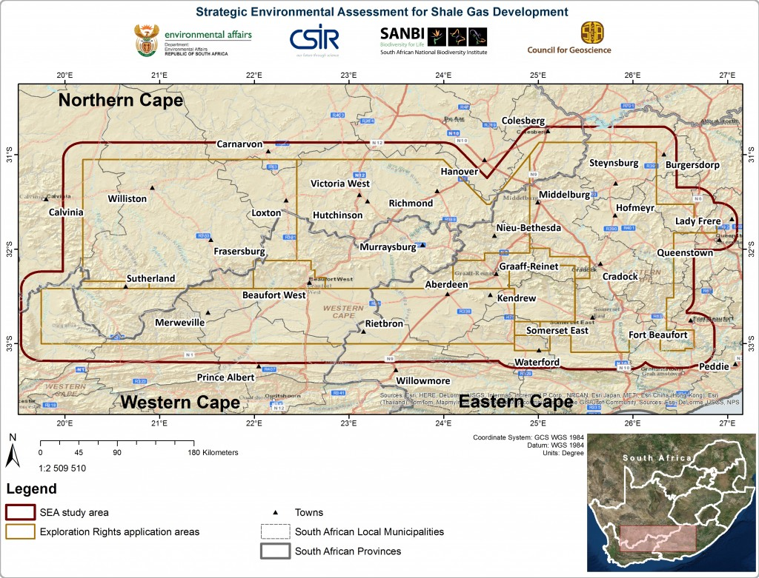
From an air quality perspective, an emission inventory of all point and mobile sources (including vehicles) should be compiled. This emission inventory would establish a baseline to inform future developments in the Beaufort West Region, especially when dealing with airshed planning. A spatial expression of the airshed within the Beaufort West area will determine the impact of existing and planned emissions. With the establishment of more industries/ developments, the cumulative impact of those may significantly affect air quality as well as other environmental and health impacts.
Figure 109: Strategic Environmental Assessment for Shale Gas Development

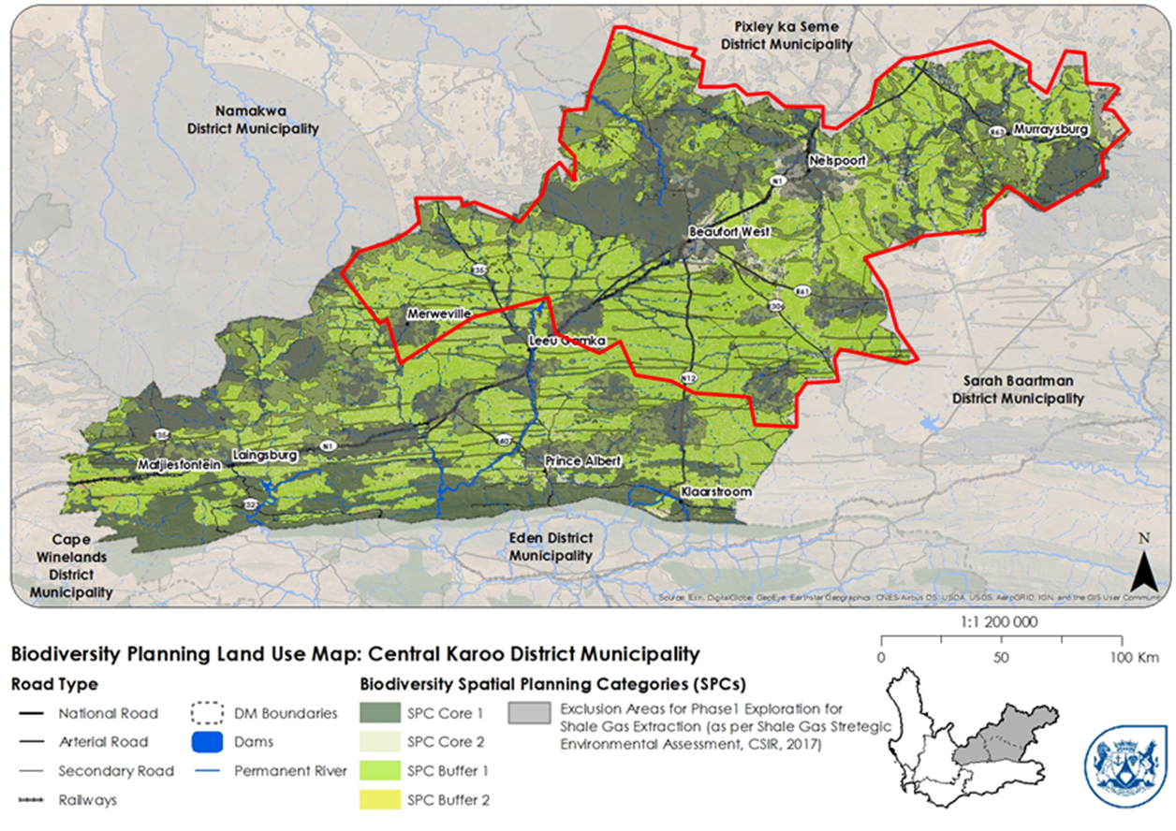
Figure 110: Indicating the Spatial Planning categories and Exclusion Areas form Phase 1 Shale Gas Exploration
POLICY A8: LAND REFORM SUPPORT

The following list sets out five criteria that must be used to identify Strategically Located Land (SLL) for land reform in Beaufort West Municipality. These criteria should be used to inform the acquisition of farms in rural areas for land reform purposes.

Policy A8: Guidelines

- The farm should fall within the Farmer Production Support Unit (FPSU) catchment area, which indicates its proximity to the nearest town, potential markets and accessibility to the district road network. The FPSU catchment area is defined as being within 60 km of an FPSU.

- The priority FPSU catchment area covers the majority of Beaufort West Municipality.

- The farm must not fall within a Spatial Planning Category (SPC) or Biodiversity Spatial Plan area that indicates it as sensitive or having significant constraints (i.e., in a core or buffer SPC). Ideally, an Agricultural SPC is the most suitable land for acquisition purposes. This may not be a consideration if the farm is intended to be used for tourism (non-farming) purposes due to its natural beauty or if the intent is to sustainably harvest biodiversity (such as fynbos).

- The farm should not contain significant land with steep slopes (i.e., slopes above 12%).

- Land ownership: state owned land should be first considered for land reform purposes before privately-owned land is acquired for land reform purposes.

- The farm must have access or have the potential to access enough water to sustain its operations.

- A toolkit for integrating land reform and rural development into Spatial and Land Use Planning can be found at https://www.westerncape.gov.za/eadp/files/atoms/files/Toolkit_Integrating%20LRRD%20into%20Spatial%20%26%20LUP_0.pdf.

STRATEGY B: IMPROVE REGIONAL AND RURAL ACCESSIBILITY AND MOBILITY FOR PEOPLE AND GOODS IN SUPPORT OF A RESILIENT ECONOMY

POLICY B1: IMPROVE INTER SETTLEMENT CONNECTIVITY
The municipality’s transport system must be appropriate and affordable for both the inhabitants of the region and the people passing through. The tarring of the road leading to Merweville – and the consequent benefits to the town – is instructive about the importance of connecting infrastructure to the health of the towns in the municipality.

Given limited budget, it is important to prioritise maintenance and upgrading of roads where necessary. Figure 111 shows the routes of National and Regional importance from the Central Karoo MSDF.

The national and arterial movement routes through the municipality (roads of key economic importance) are:
- N1 national road – running diagonally through the municipality and the town of Beaufort West. This route is the main movement route between Cape Town and Johannesburg and is the economic lifeline of the municipality.
- N12 arterial – running in a southerly direction from Beaufort West to Oudtshoorn, and George.

A number of main roads link with the N1 national road and facilitate movement to rural areas in the Beaufort West Municipality and nearby towns in adjacent municipalities. These main roads are as follows:
- R353 – cuts across the western corner of the municipality and the link between Leeu-Gamka and Fraserburg.
- R381 – between Beaufort West and Loxton in the north.
- R61 – between Beaufort West and Aberdeen in the east.
- R306 – between Beaufort West and Rietbron in the southeast.
- R63 – link between the N1 and Murraysburg which further extends to Graaff-Reinet in the east.

Policy B1: Guidelines
- Prioritise road maintenance over the building of new roads.
- Focus on ensuring the paved roads within urban settlements are maintained, potholes addressed, and pedestrian mobility optimised.
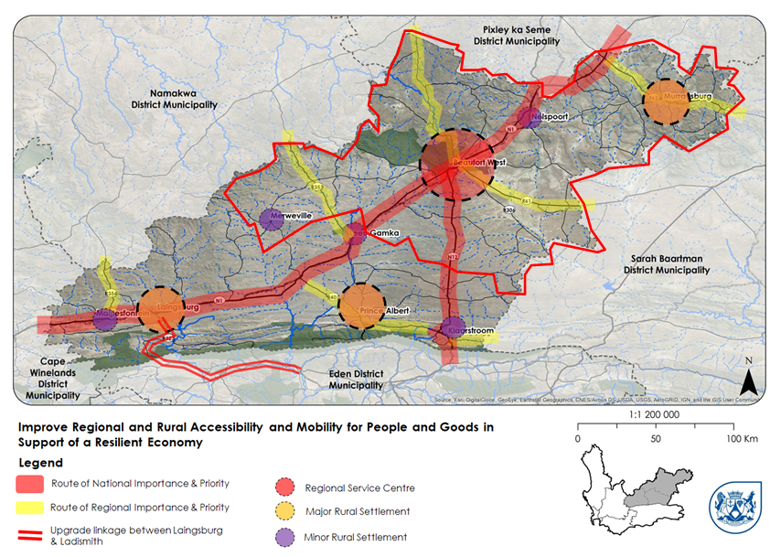
Figure 111: Indicating the routes of national, and regional importance (Central Karoo MSDF)

POLICY B2: RURAL MOBILITY & SCHOOL LEARNER TRANSPORT

Public learner transportation is performed by the Western Cape Education Department. There are three routes running in the municipality. Two routes come from outside Beaufort West town bringing learners from two opposite sides to the schools in town. One route starts in town and transports learners to schools on the opposite side of the town due to learners having to cross the busy N1 as there is no bridge or sub-way for them to cross. While these routes are operational, the LITP indicates that they are insufficient, as many learners still walk or hitch hike to school or hostels.

Policy B2 Guidelines:
- Invest in rural pedestrian safety and scholar transport safety through partnership with the Western Cape Department of Education and the CKDM. This may include implementing safe crossings over or under the N1 highway and other busy regional roads.

- Implement the strategy aimed at offering cost-effective transportation services for rural communities – the Central Karoo Mobility Strategy

- Lobby the Western Cape Department of Education to add additional school learner routes for school children from Merweville and other areas of need, or join investigate co-funding the Central Karoo Mobility Strategy.

- The roll-out of the rural mobility and accessibility strategies must be mindful that vulnerable groups (women, children and disabled) are disproportionately more dependent on the availability of public transport.

- Prioritise interventions that allow learners to safely cross the N1 within Beaufort West Town.

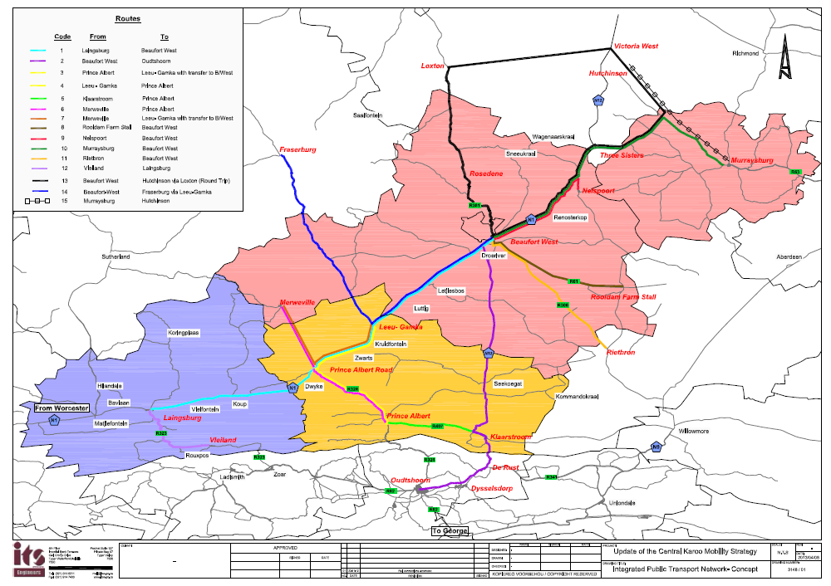
Figure 112: The Central Karoo Mobility Strategy Route Proposals (2013)

POLICY B3: TOWN IMPROVEMENT PLANS FOCUSSED ON NON-MOTORISED TRANSPORT, SAFETY AND GREEN NETWORKS

Beaufort West Municipality needs to ensure that its towns are conducive to both local and tourist passengers (on foot and in car) as well as attractive for businesses to invest in. This should be specifically pursued in Beaufort West Town and Merweville because of their heritage appeal and accommodation offerings. Walkable towns promote a public environment with a human focus rather than a car focus. They can lead to many social and economic problems being addressed through improved social interaction, increased spending, and diminished crime. With climate appropriate tree-planting, walkable towns can also provide shade and keep temperatures lower. This strategy can be achieved, in part through the beautification measures described below:
Policy B3 Guidelines:
- All towns should continue to carry out basic beautification measures at their entrances and main streets, including cleaning and sanitation services and tree-planting (of drought-tolerant species). These measures aim to create proud, distinct, clean and attractive spaces through litter, grime, graffiti and weed removal; landscaping and planting; colour differentiated bicycle lanes; paving and sidewalk regeneration; street furniture installations; lighting improvements; improved safety, security and law enforcement; budgeting for and undertaking infrastructure maintenance; as well as putting systems and teams in place for people to report damaged infrastructure and the municipality to respond to this. This is the basic minimum that the municipality can set in place to create a conducive investment environment.

- Adjacent landowners in Donkin, Bird and Nuwe Streets, Beaufort West Town should continue to be encouraged to beautify their frontage zones, supplemented by investment in the public realm by the municipality as described above. This should be accompanied by a pedestrian zone, furnishing zone, bicycle lanes and a tree greening network.

- Beaufort West Town should continue to focus on and lobby for funding for implementation of priorities 11 to 14 of the 2021 Beaufort West Integrated Transport Plan, which deals with Non-Motorised Transport upgrades. The priority would be improvements in the network, pavement condition, walkway widths, and lighting, particularly in Murraysburg and to an extent in Beaufort West. The proposed NMT routes for the Beaufort West Town are illustrated in Figure 1011.

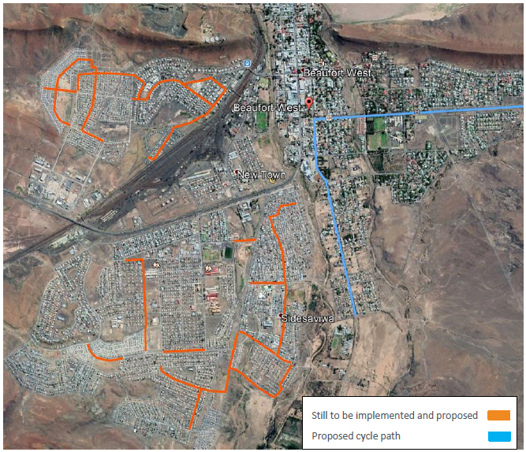
Figure 113: Proposed NMT routes for the Beaufort West Town
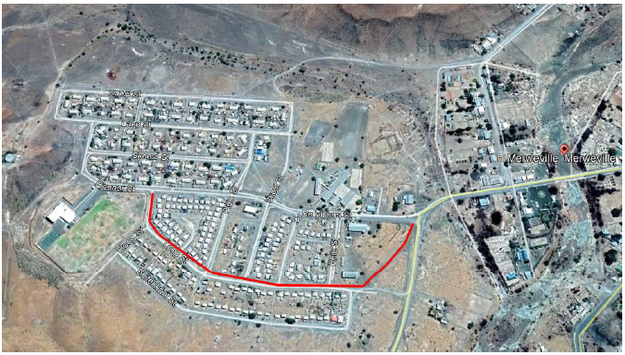
Figure 114: Proposed Walkway for Merweville

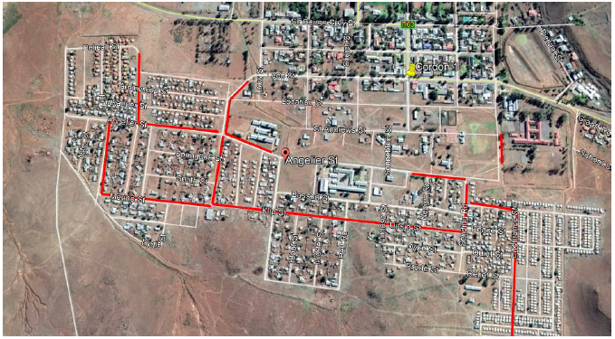
Figure 115: Proposed Walkways for Murraysburg

STRATEGY C: ALLOCATE GOVERNMENT RESOURCES, INFRASTRUCTURE AND FACILITIES IN A MANNER THAT UPLIFTS AND SKILLS PEOPLE AND FOCUSSES ON MAXIMISING IMPACT ON THE MOST POSSIBLE PEOPLE, WHILE PROVIDING A BASIC LEVEL OF SERVICE FOR ALL

POLICY C1: ESTABLISHING A CLEAR SETTLEMENT HIERARCHY
Beaufort West Municipality consists of 4 distinctive settlements, each fulfilling their own role in the district and municipal economy.
The primary administrative centre, which is a regional development anchor and regional service centre – for the municipality as well as for the Central Karoo District Municipality – remains the town of Beaufort West. Given the limited nature of government resources, there needs to be a strong focus on locating a range of services in Beaufort West Town, with more rudimentary and lower order services in Merweville and Murraysburg. Mobile service solutions can be considered for Nelspoort if demand and funds are insufficient for a permanent service.
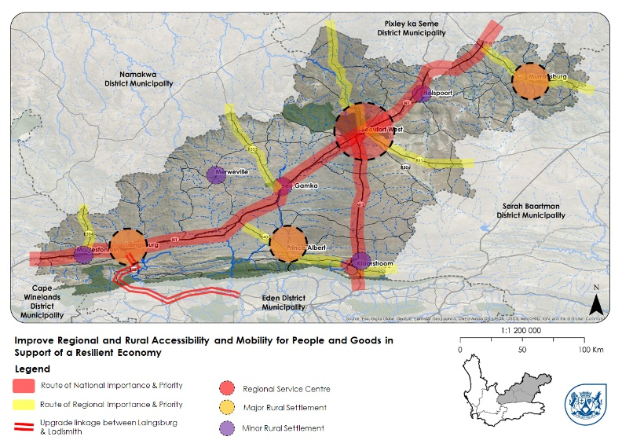
While Merweville is comparatively small in terms of population, it has been revitalised in recent years following the tarring of the road connecting it to the N1. As a result, this MSDF proposes raising it in the hierarchy to be on equal footing with Murraysburg. It certainly is playing a more prominent role from a tourism economy perspective, and this should be supported and strengthened though municipal investment.

SETTLEMENT CLASSIFICATION | SETTLEMENT | FUNCTION/ROLE
Regional Development Anchor  OR  Regional Service Centre | Beaufort West Town | This is a priority investment area for the municipality. Beaufort West Town functions as a specialised inland service centre with tourism, medical, educational, commercial, and administrative services as well as servicing surrounding rural areas and smaller settlements. The spatial strategy is that, out of all the settlements in the municipality, most of the infrastructure investments should be focused in support of this town and will have the greatest multiplier effect and impact the greatest number of people.
Major rural service centre | Murraysburg & Merweville | This is an upgrading settlement for the municipality. This is currently a largely non-rates generating settlement where basic infrastructure renewal and maintenance are the priorities, along with appropriate infill, and densification as well as investing in developments that promote economic development and job creation. The spatial strategy is to meet the local convenience needs with basic social facilities and basic levels of service for surrounding rural communities.
Minor rural service centre | Nelspoort | These are consolidation settlements for the municipality. In these areas the focus is to ensure the provision and maintenance of services so that the area may perform well within their current functions with no further expansion or growth of these areas, as far as possible.
Table 16: Beaufort West Settlement Hierarchy
POLICY C2: URBAN EDGE POLICY
The purpose of setting an urban edge is to ensure that development is contained, and that urban areas do not encroach into agricultural and biodiversity land, and that a more functional urban development form is achieved within a settlement. Urban edges also ensure that low density development does not occur, which is costly for the municipality to service and maintain. Low density (sprawl-like) development creates inequitable settlements that are costly to live in and travel around in. Land for housing must therefore be used efficiently and by doing this, municipal financial sustainability can be secured.

Policy C3 Guidelines:
- Urban edge boundaries for Beaufort West town, Murraysburg, Merweville and Nelspoort have been delineated in this MSDF. It should be ensured that these boundaries adhere to national and provincial government targets of increasing the density of urban areas to an average gross dwelling unit density of 25 dwelling units / hectare.

- To counter apartheid spatial patterns, the aim is to follow a vacant infill strategy within the urban edges and to enhance densification within existing developed areas. This should take place specifically along the N1 at the entrance to Beaufort West Town. Specifically, strategically located vacant sites of land need to be prioritised.
POLICY C3: FACILITY CLUSTERING & DESIGN PROTOCOL LINKED TO A CLEAR NODAL HIERARCHY

Table 16 also summarises the ‘nodal hierarchy’ at the town scale. The focus within these nodes is to cluster social facilities, diversify the mix of land uses and increase densities. [Figures XX and XX] show the proposed ‘nodal hierarchy’ for Beaufort West Town, Murraysburg and Merweville. There is no node proposed for Nelspoort.
Policy C2 Guidelines:
- The municipality must promote and encourage mixed land uses and higher densities within each of the proposed nodes.

- Co-locating facilities and services in accessible nodal locations has the added benefit of reduced commuting distance and exposure to accidents and crime.

- The primary nodal location in which investment should follow is the series of nodes along the N1 running through Beaufort West Town’s CBD. This is where the bulk of economic activity in the municipality is concentrated.

POLICY C4: HUMAN SETTLEMENT FOCUS AREAS

Over the last 25 years, the settlement growth of Beaufort West Municipality has been driven by the housing pipeline in Beaufort West Town, with Hillside in particular having grown significantly in the last 10 years. Based on the population projections and housing numbers presented, Beaufort west Town must be the priority investment area for human settlements, infrastructure, and services.

The Western Cape Inclusionary Housing Policy Framework has been developed by the Western Cape Government and can be used to facilitate the inclusion of more affordable housing units in areas that experience a strong and vibrant property market.

Section 21(i) of SPLUMA indicates that MSDFs must identify areas where a national or provincial inclusionary housing policy may be applicable. While property markets in Beaufort West are not currently strong enough to support inclusionary housing, this may change in the future, particularly if shale gas extraction becomes a realistic possibility. Should this be the case, inclusionary housing opportunities should be focused in Beaufort West Town, specifically in the areas designated for “Incentivising Business and Commercial” in the MSDF proposals maps.

It is noted that there were a substantia; number of BNG units delivered in Murraysburg, outside of the 2014 MSDF urban edge. In future, it is crucial that Beaufort West Municipality actively desist from providing any more government subsidy housing in settlements other than the town of Beaufort West, unless economic opportunities warrant otherwise, because this entrenches a cycle of poverty and creates poverty pockets and poverty traps in the municipality. Murraysburg in particular is distressed, with extremely limited opportunities for the people already living there.

STRATEGY D: PARTNERSHIP-DRIVEN GOVERNANCE AND ADMINISTRATION TOWARDS IMPROVED FINANCIAL AND NON-FINANCIAL SUSTAINABILITY AND RESILIENCE

Beaufort West Municipality cannot, by itself, address many of the social, economic and environmental issues and opportunities it faces. It requires cooperation and partnership not only with other spheres of government, but also with civic organisations, private sector businesses and the public at large to comprehensively address many of its challenges.

POLICY D1: SHARED SERVICE CENTRE FOR THE CENTRAL KAROO

Beaufort West Municipality, together with the rest of the Central Karoo, is a sparsely populated region that can greatly benefit from ‘bringing together’ the experience, capabilities and finances of the three local municipalities (Beaufort West, Laingsburg and Prince Albert) under a single umbrella that provides a shared service centre. This can perform a range of functions, not least of which is the planning function as defined in SPLUMA, LUPA and the local municipal planning bylaws. Such shared service centres could also include provincial regional offices and expertise as well, if this is required.
A Shared Service Centre Model for the Central Karoo was developed in 2012, revised again in 2019, but not implemented due to a range of factors such as of lack of capacity and adequate resources to implement the shared service centre. This must be implemented as a matter of priority, particularly for the town planning function and planning tribunals as well as finance, engineering, and technical services. A shared service centre is required to split time between the municipalities, as per the proposed model.

POLICY D2: INTEGRATED PLANNING, BUDGETING, AND IMPLEMENTATION

The WCG, together with the municipalities of the Western Cape, has implemented an Integrated Work Plan with the intention that all of government seeks to plan, budget and implement in a more coordinated, integrated and sequenced manner. This is in line with the “One Plan” or Joint District Approach being used nationally.
Various platforms and engagements take place throughout the year in which integrated planning, integrated budgeting and integrated implementation are reported on and should take place. The Central Karoo DM should use these forums to ensure the implementation of its Integrated Development Plan and Spatial Development Framework.
Various annual engagements are set out in the Integrated Work Plan (2018). In short these are:

- Provincial Strategic Planning in July – ensuring provincial alignment at the strategic level;
- Provincial Top Management & Municipal Managers engagement in September – ensuring provincial and municipal planning engagement over strategic planning alignment;
- Integrated Municipal Engagements (IDP Indaba 1) in October / November – ensuring strategic and technical alignment between provincial government and municipal government;
- Provincial Government Medium Term Expenditure Committee (PGMTEC) 1 & 2 in November and January for provincial budget alignment; and
- Local Government Medium Term Expenditure Committee (LGMTEC) engagements in April / May to ensure municipal budget alignment.
The new district-based model will attempt to address the need for a capable and developmental state. The aim of a district-based approach is to focus on regional collaboration in the 44 districts and eight metros nationwide, which will attempt to ensure that municipalities are properly supported and adequately resourced. The delivery model will aim to break down the silos between the different spheres of government in a bid to improve service delivery in the 257 municipalities across the country.

4.7 BEAUFORT WEST TOWN: SPATIAL DEVELOPMENT FRAMEWORK
In the normal run of events, Beaufort West town is unlikely to see significant population growth. The most pressing need in the town is for improved urban management and waste management in particular, and to generally create conditions for tourism, private sector investment and confidence. Formal urban development could occur from housing the 6 200 households currently on the housing waiting list, but it is unlikely to occur at any significant scale given the diminishing housing subsidy being allocated outside of PHSHDA areas. However, should uranium mining and shale gas extraction occur, there may be many urban growth pressures and opportunities that the town will experience, the population could increase considerably as miners and drill riggers will require accommodation in the nearest large centre that offers a wide range of social and economic facilities.
The following sets out a description of the main proposals for the town of Beaufort West.
4.7.1 Core landscape and agricultural areas
- A continuous boulevarded network of activity streets planted with water wise shade trees should integrate the town, see Figure 120 below.

- Trees are the cheapest way to make the biggest visual improvements on an urban settlement and lend themselves to EPWP programs. These can include in-situ brick paving where necessary a material also suitable for labour-based construction.

- River corridors should be protected by setback lines at a standard 32 m from the banks or as determined by a freshwater ecologist must be defined in which there should be no ploughing or urban development and the riparian vegetation restored.

- There is little intensive agriculture around the town and production on existing lands to the south must be encouraged and where possible fallow land brought back into production.

- The existing golf course should be retained as an important amenity to existing and future residents but water wise fairway and green management techniques should be employed.

- In view of the prevailing water supply issues, no further green areas are proposed and existing ones should be managed according to water wise management principles.

- High flood hazard areas, as mapped in Figure 117, are to be avoided from an urban development perspective, and are better suited to open space uses in future.

- Protect the Gamka Dam / Springfonteindam Dam from urban development or any other rural development that has the potential to pollute the dam or tributaries following into the dam.

4.7.2 Urban Development
- Table 17 below provides the proposed new development areas for Beaufort West, also shown in Figure 118, 119 and 120.

- A 100 m noise buffer is strongly recommended along the eastern boundary of the proposed bypass in which only industrial activity, warehousing or tree planting and open space activities should occur. There should be no residential activities within this zone. Design of the bypass should ensure minimal noise generation, and sufficient noise reduction measures are implemented.

- As far as possible new development areas should not extend beyond the current urban development periphery and or beyond a 2km radius from the centre of town. Specifically, the western urban edge should not extend past the bypass, and the bypass remains as the hard permanent urban edge for the town for the foreseeable future.

- North facing land around the golf course could be suitable for upmarket development, although there are already a number of undeveloped plots here which should be incentivised.

- Large areas of infill are proposed in Hillside and Rustdene.

- Rather than extending westwards of the proposed N1 bypass, a new development area in the eastern quadrant should be investigated bounded approximately by a 2km radius from the town centre. This includes sites U, W, X and Z as shown in Figure 118.

- New development areas should continue the ‘grid style’ of the historical lay-out. Retrofitting the settlement in the long term to continue this style is recommended.

- It is recommended that the municipality puts its efforts on registering and incorporating waste pickers within the municipal area who will assist in waste collection and separation.

- Additionally, it is also recommended that the municipality focuses on separation at source programmes at household level and with assistance from local waste pickers or/and ‘wastepreneurs’, especially since informal picking takes place at the landfill, which is non-compliant.

4.7.3 Heritage Areas
- The historic CBD should be declared a heritage area and land uses and building appearance on old and new buildings managed accordingly. An overlay zone in the zoning scheme in the municipality should be declared, as shown in Figure 11, covering Donkin Street, Nuwe Street, Bird Street, and surrounds.

- As far as possible, the Karoo architectural styles should be encouraged in all developments, to cement the character, heritage, and appeal of the Karoo, and solidify Beaufort West as the heart of the Karoo.

4.7.4 Urban Restructuring
- Rerouting the N1 around the town for road freight traffic only is seen as the most important action to enable development of other sustainable sectors in the town including retail, tourism, and accommodation.

- The rerouted freight route is intended to act as the Urban Edge for the town limiting development to the west of it.

- It is important that only freight traffic use this realigned route. Careful signposting of the two intersections as well as significantly upgrading the landscape and urban quality of Donkin Street between the two proposed access points in contrast to the freight bypass route, which should remain “unlandscaped”, will help facilitate this priority. Similarly, no future development opportunities should be allowed adjacent to the bypass that would allow traffic to stop or engage in any economic activity. Economic activity should be kept to within the existing town centre. The only exception would be service or facilities that are offered to the freight traffic, although these are already catered for to a large extent.

- If the freight route goes ahead, the current N1 route in the town itself should be significantly redesigned to accommodate similar retail development that is occurring within the historical core of Beautiful West, abutting it on each side, between each end of the N1 which crosses the railway line. A slightly higher density, mixed use (including residential) component could be accommodated ensuring that heritage streetscapes are preserved and enhanced.

- All gateways into town should be enhanced to improve its sense of arrival.

- The currently separate sectors of the town should be integrated through a continuous network of activity streets that reinforce the NMT network and link suburbs across buffer strips and vacant ground as well as the large new development area proposed in the south-eastern quadrant of the town.

- This network should comprise the following routes:
- Hillside: service road next to proposed N1 bypass along Faktor Street; Ondermeyer Ext across rail yard to intersect with Oppeld Street (Rustdene) on Donkin Street (former N1 now bypassed), design continuity of Stolzhoek/7th Ave/Plein/Kerk/ link to Donkin Street;
- Rustdene: Alfonso; Bantom; Skool; linking to N1 opposite proposed Ondermeyer Ext N1 intersection; Buitenkant linking to Mandlenkosi Street;
- Mandlenkosi: Plaza Street to link across Gamka river to van Wyk Street (currently informal link to Du Toit Street); Falatsa Street to link across river to Blyth Street (existing);
- Southwest quadrant: van Wyk Street Ext to intersect with Brummer Street; and,
- Town north: extend golf course access road to Kerk Street.

4.7.5 Urban Edge Amendments (changes from the 2014 MSDF)

Economic development opportunities in Beaufort West are very rare and the municipality is of the view that it could grow its rates base and improve its municipal financial sustainability through the inclusion of various properties within the Urban Edge.

The intention is to:
- expand industrial sites in the south-western portion of the town, as shown in Figure 120 (see excerpt below) to allow for industrial land suitable for noxious activities;

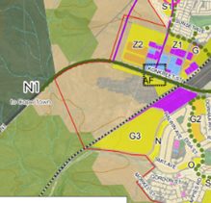

- allow for sensitive medium to high income development and a possible gold course on a site to the South side of the Springfonteindam / Gamka Dam as shown in Figure 120 (see excerpt below).

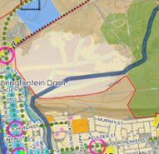

- Enable the development of a 20MW (or greater) electricity generation facility on the Farm Bulskop (RE/1/163) or surrounds (see excerpt below), which is the municipal land that is proximal to the electricity transmission and distribution infrastructure, as shown by the red circle on the excerpt below, also shown in Figure 120. This land is not included in the urban edge, as the envisaged land use is compatible with agricultural land uses.

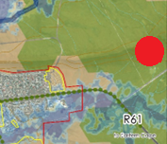

Regarding the proposed medium to high income golf estate development that has been proposed to the south of the Springfonteindam / Gamka Dam, the municipality needs to consider the following before going ahead with allowing the private sector to develop the site:

- Confirmation of housing market demand for such a development.
- A Geotechnical assessment for the site, determining that the site is appropriate for urban development and will in no way undermine the future expansion of the dam, or the existing dam and its services.
- An environmental, water availability and biodiversity assessment, with specific focus on ensuring that future expansions of the dam are not undermined / existing dam use and service is not undermined or polluted, and that sufficient water is available to accommodate the golf course component.
- A slope and engineering services assessment, with specific focus on ensuring that any engineering services leaks, such as sewerage spills, does not place the dam at future risk.
- Financial Feasibility Assessment of the development (specifically viability assessment and evidence required).

Settlement | Site_ID | Size_HA | Size_SQM | Comments | Vacant
Beaufort West | S5 | 3 | 28985 | GAP/BNG | Yes
Beaufort West | G2 | 9 | 88550 | GAP | Yes
Beaufort West | S1 | 3 | 29752 | Mixed Use with Possible School | Yes
Beaufort West | G3 | 30 | 304045 | GAP | Yes
Beaufort West | S | 5 | 46040 | GAP | Yes
Beaufort West | T | 2 | 21505 | GAP | No
Beaufort West | G | 4 | 41665 | Mixed Use/GAP/BNG | Yes
Beaufort West | S2 | 14 | 136117 | Mixed Use/GAP/BNG | Yes
Beaufort West | V | 6 | 57862 | GAP | Yes
Beaufort West | U | 2 | 18750 | GAP | Yes
Beaufort West | G1 | 2 | 23717 | Mixed Use/GAP/BNG | Yes
Beaufort West | S7 | 22 | 217789 | GAP | Yes
Beaufort West | R | 4 | 41452 | GAP/BNG | Yes
Beaufort West | X | 17 | 167156 | GAP/BNG. Not included in Central Karoo LITP 2020/21. These sites speak to spatial transformation through supply of affordable housing. | Yes
Beaufort West | B | 2 | 19709 |  | Yes
Beaufort West | A | 2 | 19430 |  | Yes
Beaufort West | AP | 6 | 56982 | Approved Plot | Yes
Beaufort West | AP | 5 | 47052 | Approved Plot | Yes
Beaufort West | AP | 19 | 192445 | Not included in Central Karoo LITP 2020/21. These sites speak to spatial transformation through supply of affordable housing. | Yes
Beaufort West | AP | 2 | 18381 | Approved Plot | Partially
Beaufort West | AP | 0 | 3982 | Approved Plot | Yes
Beaufort West | AP | 6 | 59744 | Approved Plot | Yes
Beaufort West | N | 5 | 45049 | GAP | Yes
Beaufort West | O | 2 | 23860 | GAP | No
Beaufort West | H | 5 | 51296 | Mixed Use/GAP/BNG | Yes
Beaufort West | I | 1 | 11433 | GAP | Yes
Beaufort West | Q | 2 | 20345 | GAP | Yes
Beaufort West | L | 1 | 9882 | Mixed Use/GAP/BNG | Yes
Beaufort West | J | 3 | 28426 | Mixed Use/GAP/BNG | Yes
Beaufort West | D | 4 | 44396 | Upmarket | Yes
Beaufort West | C | 9 | 88429 | Upmarket | Yes
Beaufort West | F | 7 | 69108 | Mixed Use/GAP/BNG | Yes
Beaufort West | K | 2 | 23060 | Mixed Use/GAP/BNG | Yes
Beaufort West | P | 3 | 28193 | GAP | Yes
Beaufort West | M | 3 | 25149 | GAP | Yes
Table 17: New Development Areas for Beaufort West Town

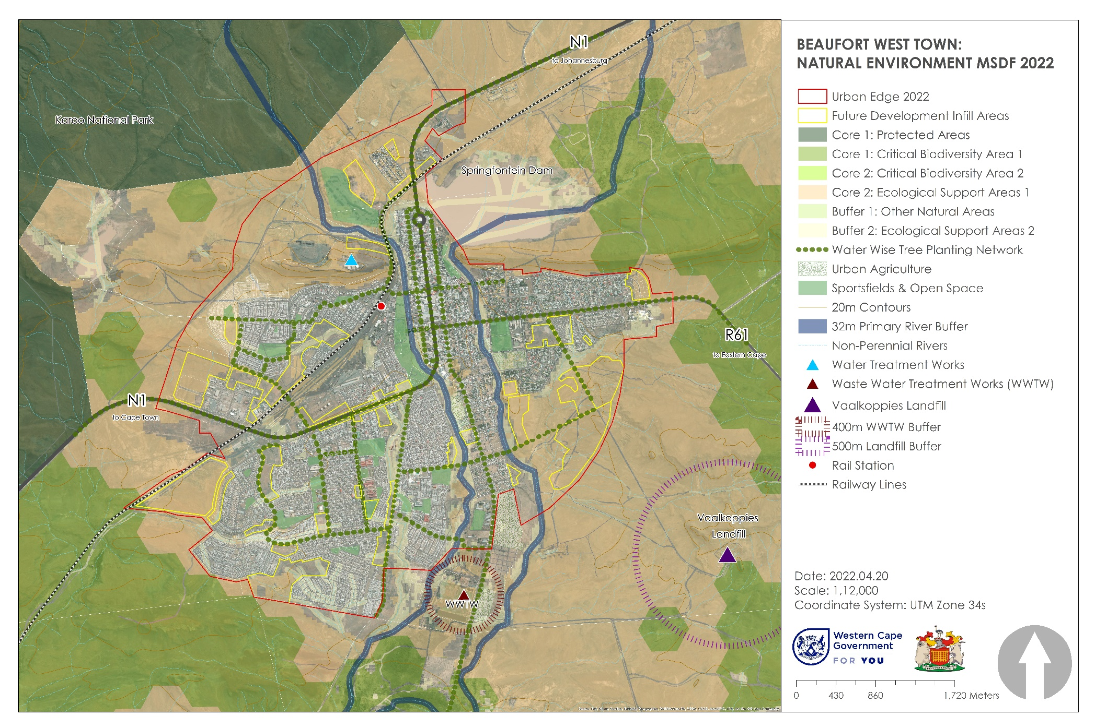
Figure 116: Beaufort West Town Natural Environment MSDF 2022

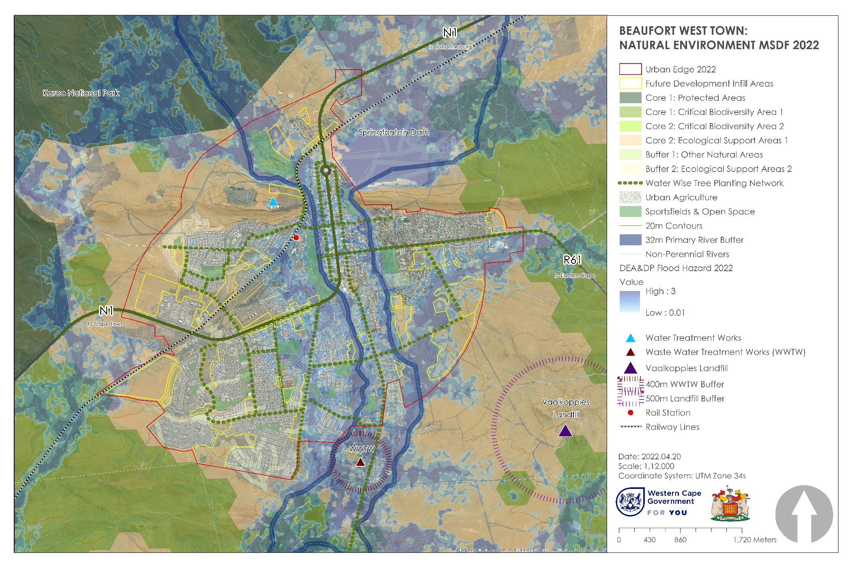
Figure 117: Beaufort West Town Natural Environment MSDF (with flood hazard index)

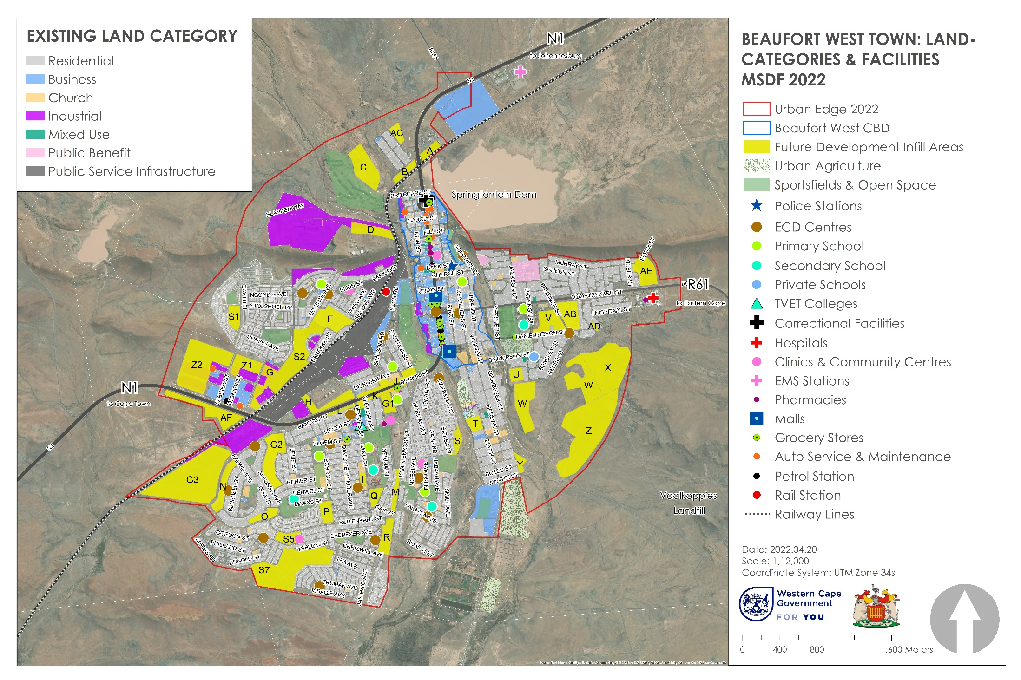
Figure 118: Beaufort West Town: Land Categories and Facilities MSDF
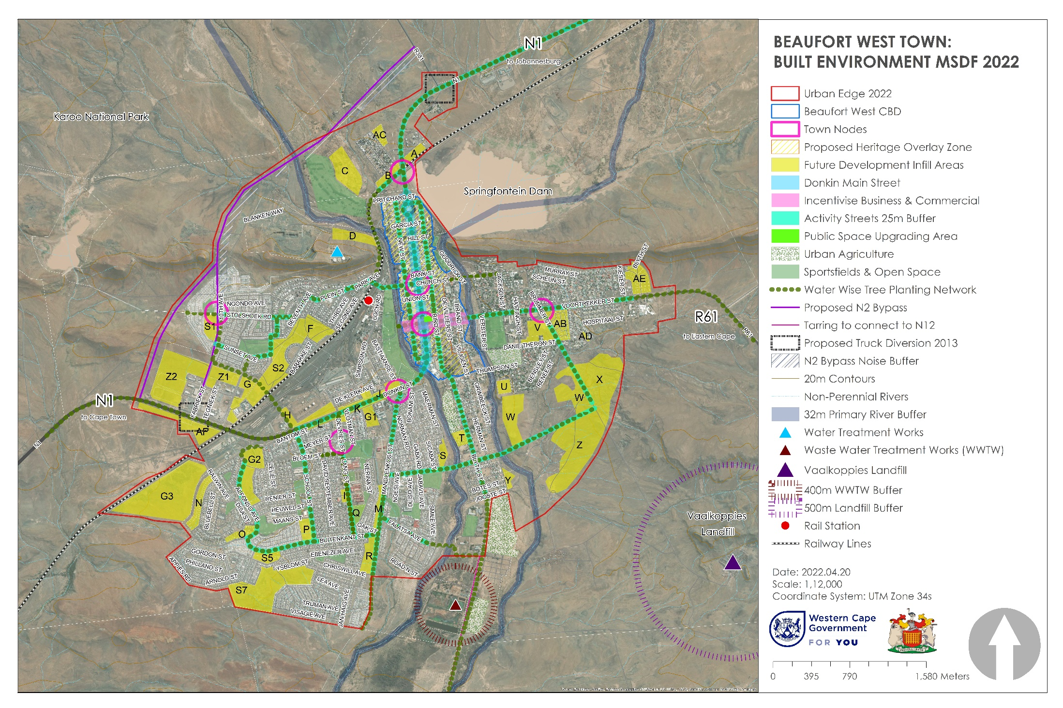
Figure 119: Beaufort West Town: Built Environment MSDF

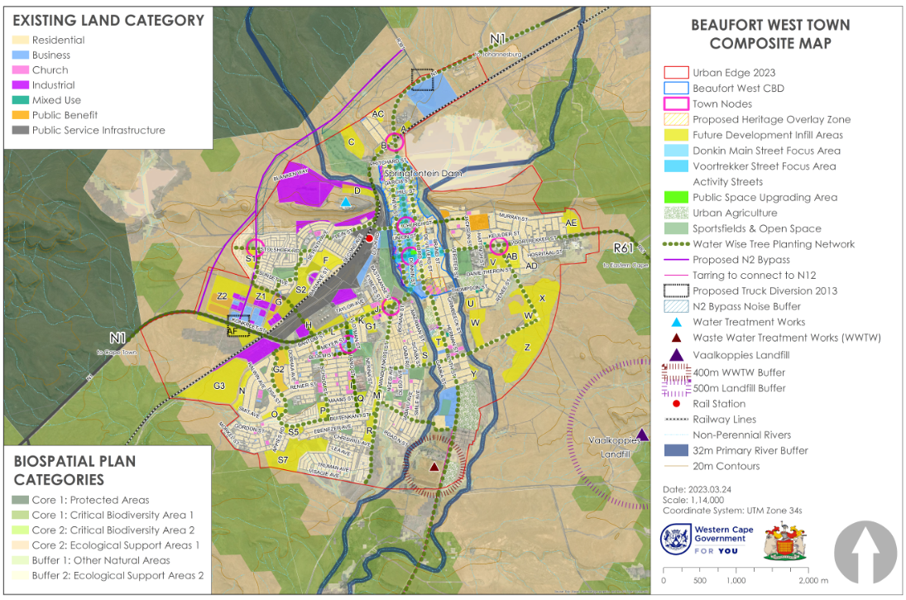
Figure 120: Beaufort West Town: Composite MSDF

4.8 MERWEVILLE: SPATIAL DEVELOPMENT FRAMEWORK
Merweville epitomizes the challenge faced by an isolated small settlement with a declining natural resource base as to what its development future should be. Its low economic growth potential and social needs relative to places like Beaufort West means that it is likely to have far more chance of success if it can develop on its local attributes; e.g., it is likely to be difficult motivating completing tarring the road to Prince Albert Road given other higher priority road tarring project elsewhere in the province. Therefore, attributes to be built on include some land for grazing and food gardening, isolation and wilderness environments and historic very small-town atmosphere.

4.8.1 Core landscape areas
The following set out the spatial planning directives as encapsulated in Figure 125.
- Proclaim river corridors, where possible at least 32 m from banks in which no intensive agriculture nor urban development is permitted;

- Support and encourage continued use of current market gardening plots;

- Investigate use of open land or undeveloped areas closest to river corridors for market gardening and livestock farming, (e.g., pigs); and,

- Plant trees along Pienaar and DS de Villers Streets to create an integrating main street network between all parts of the town, including paving the eastern extremity of these networks.

4.8.2 Urban Development
- Incentivise development of existing undeveloped plots furthest from the rivers. Those close to the rivers should be considered for market gardening or stock farming. Development typology to reflect the unique Karoo style architecture that is articulated in the Central Karoo MSDF; and,

- Land for further BNG housing should consolidate existing settlement (portions (A), (B) and (C)), however the provision of such should accompany extensive efforts to generate sustainable job opportunities.

4.8.3 Heritage Conservation and Frontage Urban Design Control Areas
- One of Merweville’ s strongest and few selling points is the historic and original state of many of the buildings;

- The eastern side of the settlement should be declared a heritage precinct with guidelines for how renovations to existing and extensions and new buildings should comply so as to strengthen and not erode this important heritage and tourism asset; and,

- Note: there is a comprehensive history of Merweville produced by the Cape Town Heritage Trust which provides a useful resource for the development of such guidelines.

4.8.4 Urban Restructuring
- All gateways into town should be enhanced;

- Symbolically integrate the settlement by ensuring a uniform tree planting and road pavement treatment on the main route network linking all the urban areas comprising Pienaar, DS de Villiers west and DS de Villiers east streets; and,

- Land for any new urban development, for instance, BNG housing should be located on the land parcels identified that will consolidate rather than disperse the settlement.

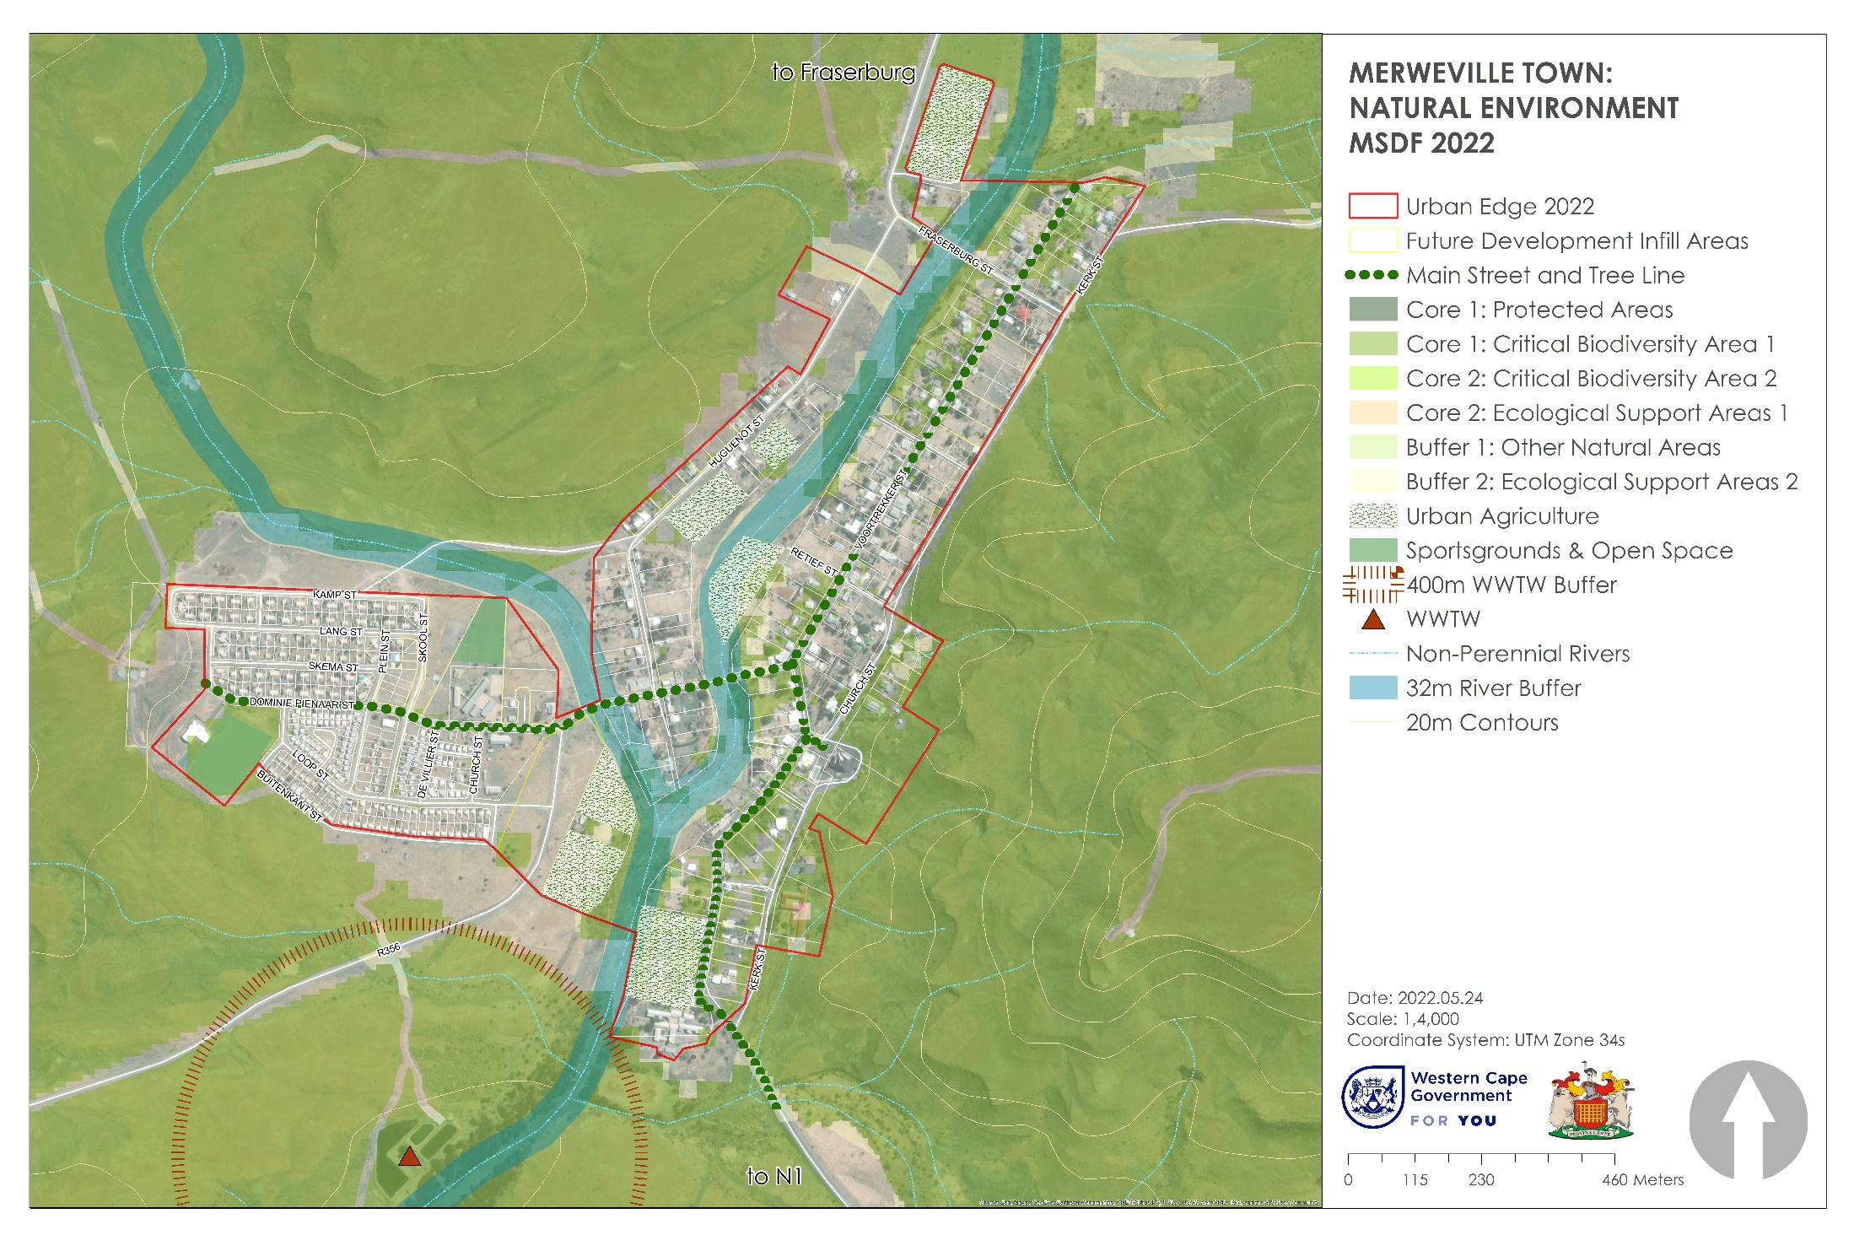
Figure 121: Merweville: Natural Environment MSDF
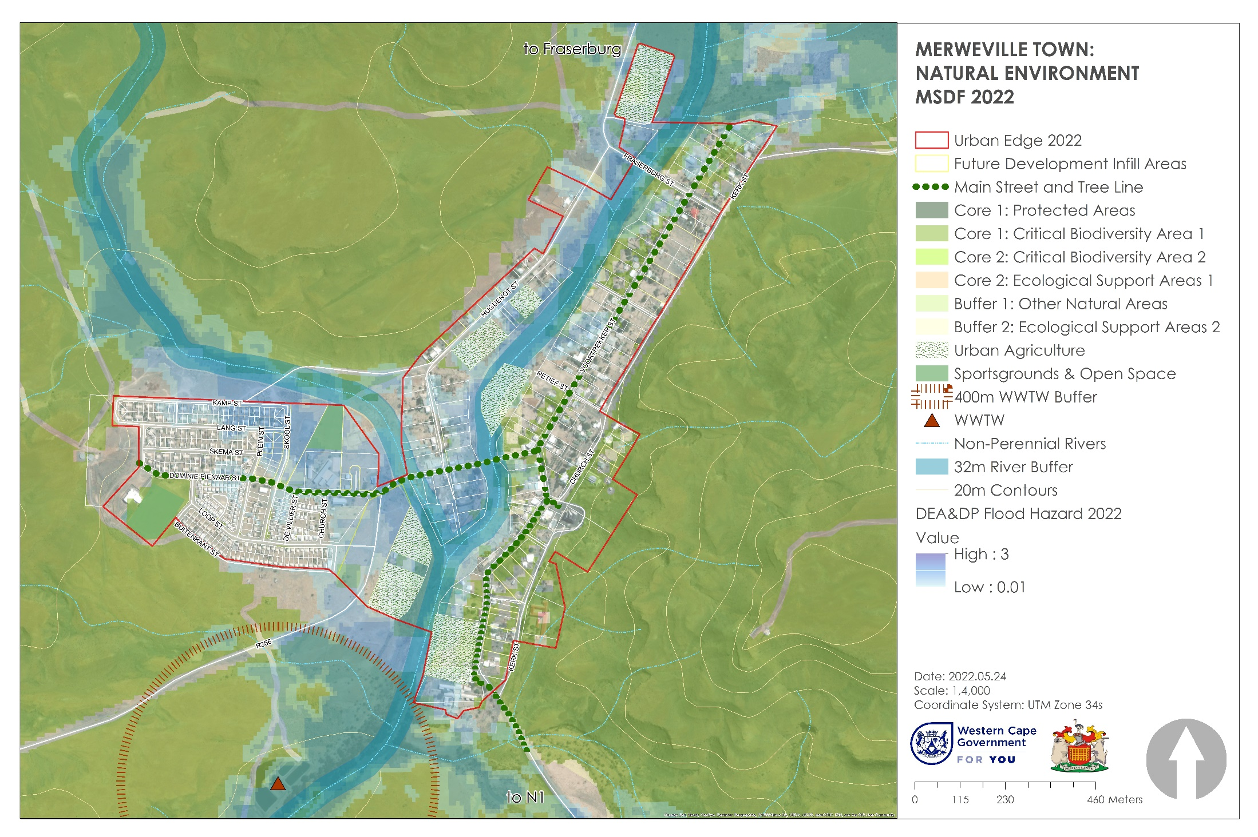
Figure 122: Merweville: Natural Environment MSDF (with flood hazard index)
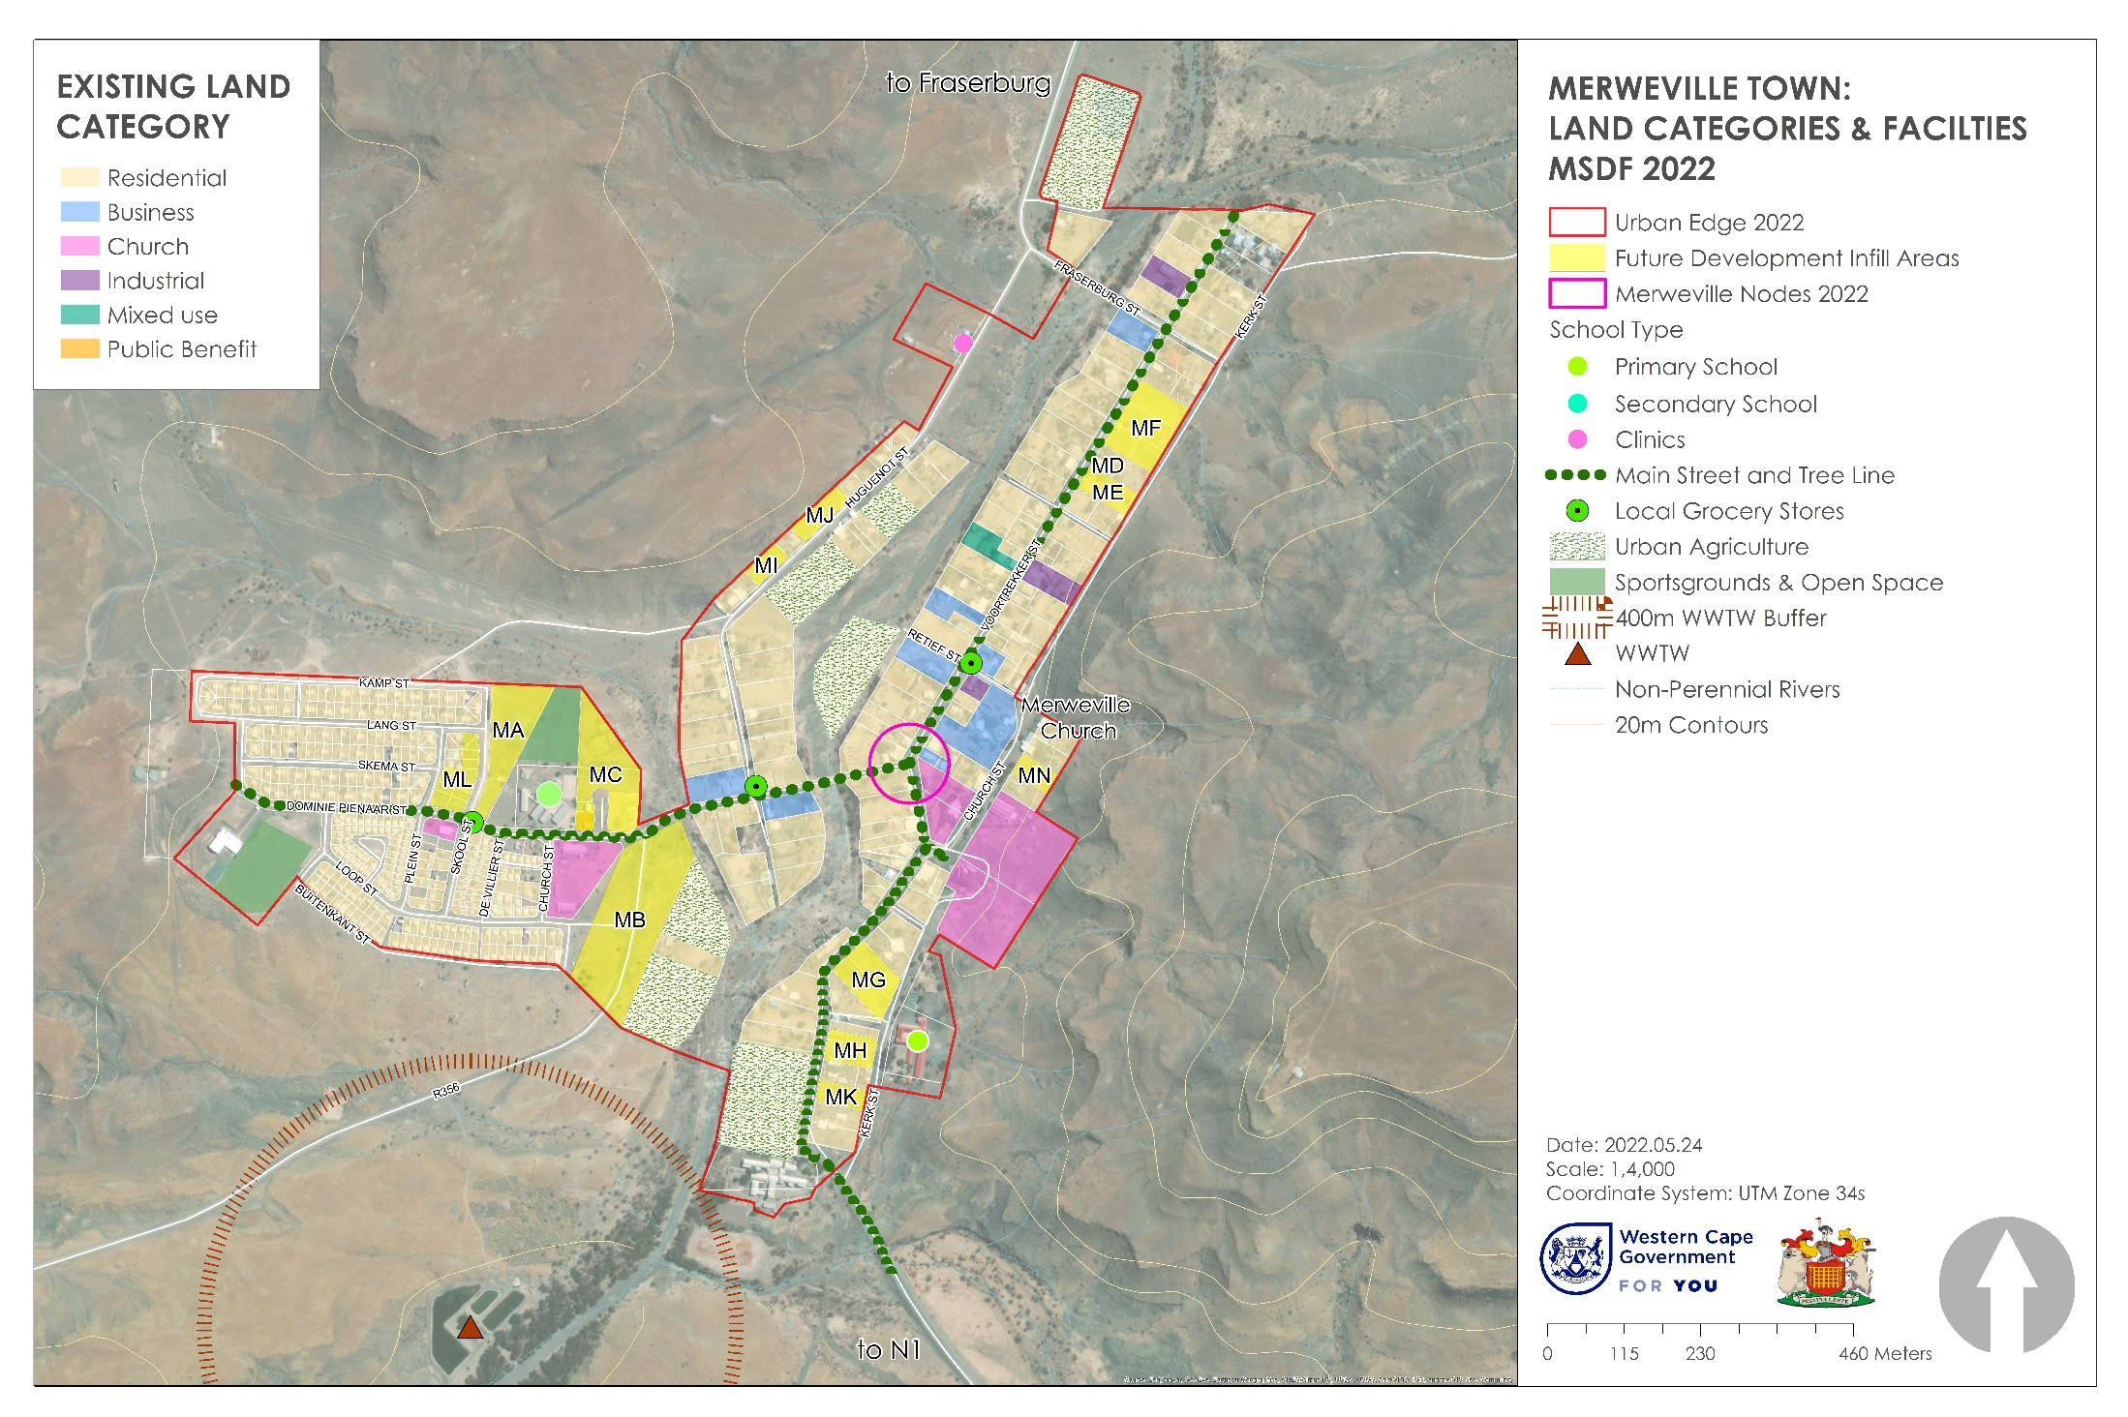
Figure 123: Merweville: Land Categories and Facilities MSDF
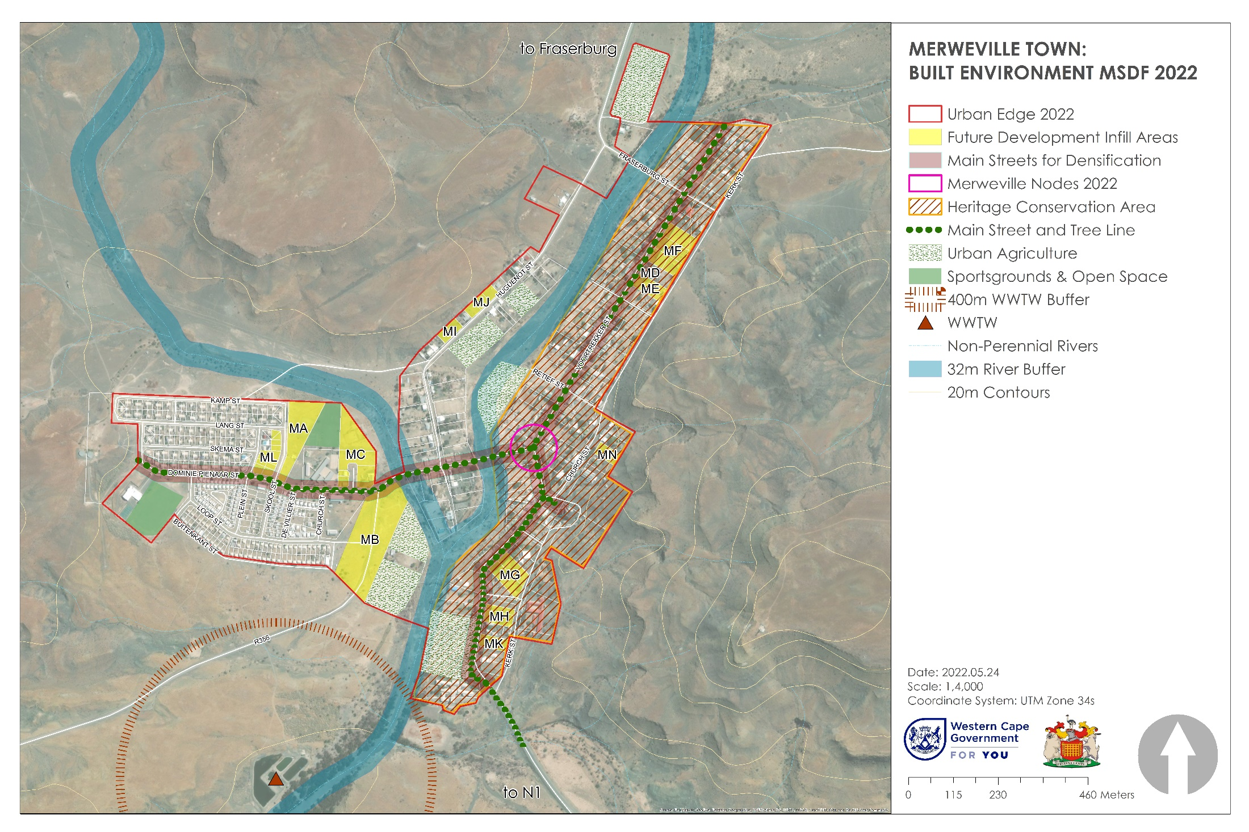
Figure 124: Merweville: Built Environment MSDF
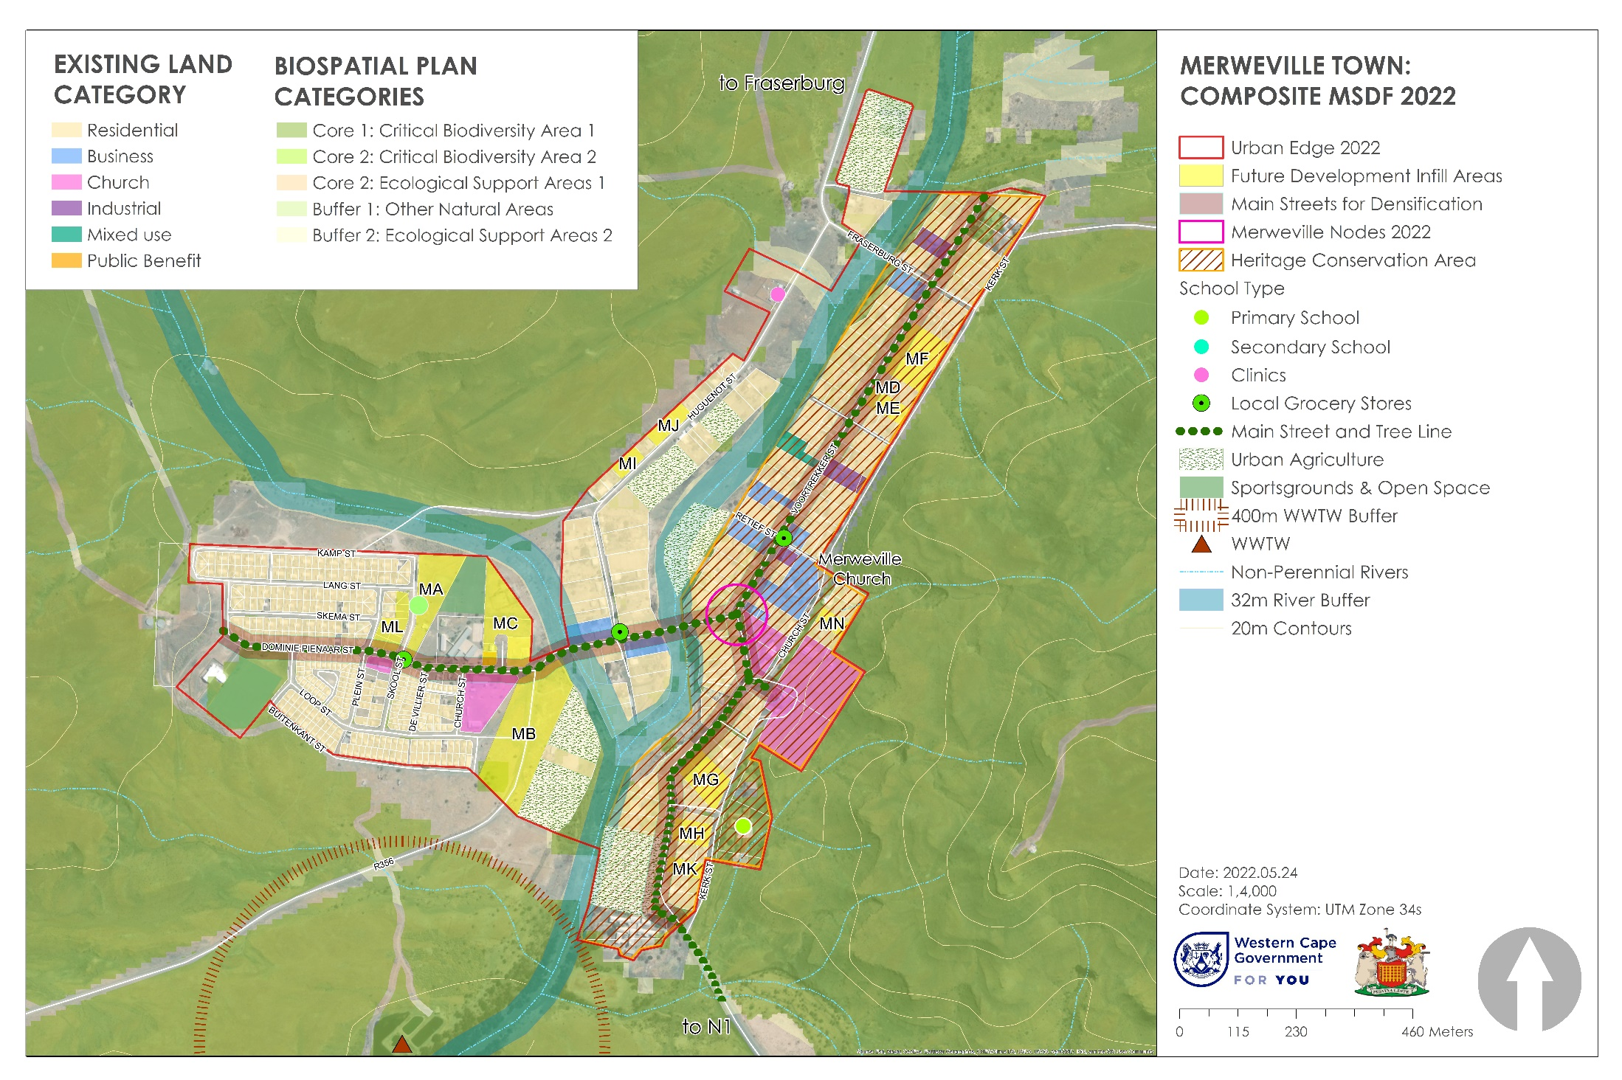
Figure 125: Merweville: Composite MSDF

MURRAYSBURG: SPATIAL DEVELOPMENT FRAMEWORK
Murraysburg enjoys good tar road access on the R63 between Victoria West (90kms) and Graaff Reinet (92kms), Cape Town (650kms) and Johannesburg (860kms), are the nearest large towns and the N1 is 43kms away. Similar to Merweville, although much older, (± 1850), Murraysburg, was established because it was too far to either Richmond (+ 90kms) or Graaff Reinet to attend church services and register births and deaths. It is located in the wettest and most fertile part of the municipality and has performed relatively well compared especially to Laingsburg and Prince Albert municipalities with regards to agricultural GVA and employment.

In general, the town is fairly compact with most people living with in a 1km radius from the town centre. From its layout, Murraysburg appears much larger than it actually is because the northern part of the town, comprising agricultural allotments on the same grid as the three rows of urban blocks between Sir George Grey and Location Street, remain hardly developed to this day. Thus, in actual fact, its original built-up area is not much larger than Merweville. However, the low-income section of the town is substantially bigger than that of Merweville. There are large amounts of vacant land between Angelier and Location Streets. The new township extension comprises ever decreasing smaller blocks with the smallest in the extreme west. Units in this extension have all been built on the back boundaries leaving very little private space. As happens with many Karoo towns, the various sports codes’ facilities, instead of being concentrated in a single complex where some level of viable threshold facility can be achieved, especially for social activities, are scattered across the northern part of the town.

4.9.1 Core landscape areas
- Encourage market and food gardening on the large blocks to the north of the town generally north of Hoffmeyer Street. Depending on their ownership they should be made available to those who wish to use them productively for food or market gardening.
- Determine river corridor set back lines from which intensive agriculture (plowing) and urban development are prohibited. In the interim they should be set back 32 m from the banks; and,
- Plant or infill a tree lined street network linking Sir George Grey and Leeb Street including Parsonage and Church streets to create a pinwheel around the Church that also integrates the southern part of the town along a new road, Church Street extension linking to the school on Angelier Street.
4.9.2 Urban Development
- Incentivize development of approved vacant plots for GAP housing, particularly those closest to Church Street Extension.
- Encourage all new BNG (to be appropriately designed) and GAP housing to be located on vacant land with the center of the town first so as to promote integration before using peripherally located land.
4.9.3 Heritage Areas
- Investigate declaring the center of the town from midblock between Location and Leeb Streets to the south to midblock above Hoffmeyer Street in the north as a heritage conservation area with guidelines to assist the renovation and restoration of existing buildings and the design of new buildings within this precinct.
4.9.4 Urban Restructuring
- All gateways into town should be enhanced to improve its sense of arrival.
- Upgrade the road pavement and plant trees along the street network as shown in Figure 130, focusing around the Church as a focal point to integrate and link the northern and southern parts of the town;
- Extending Church Street southwards to the school on Angelier Street is critical to successfully achieving this link. This will entail paving the unmade section of Church Street south between Leeb and St Andrew’s Streets and then creating a new road, Church Street Extension, through the undeveloped plots between St Andrews and Angelier Streets; and,
- Concentrating all new housing developments on the vacant or undeveloped land in this vicinity rather than constructing large new townships on the periphery will also assist urban restructuring. However, this implies projects of a much smaller number of units in each phase. Although this may not be as financially viable for housing developers in the short term, it will contribute to a more sustainable and better integrated urban fabric in the long term.

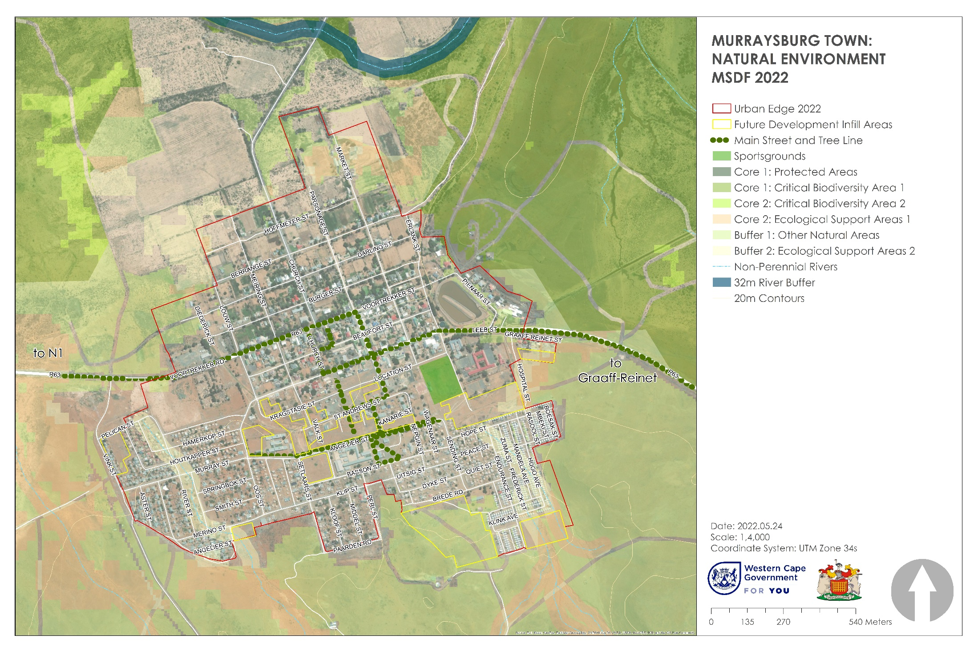
Figure 126: Murraysburg: Natural Environment MSDF
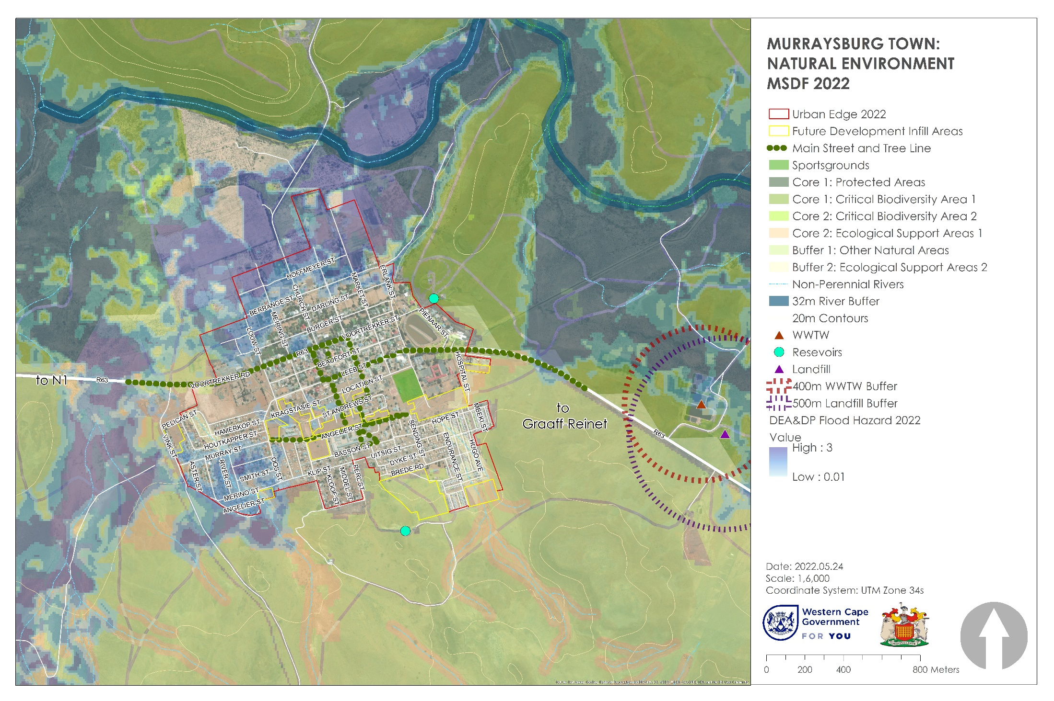
Figure 127: Murraysburg: Natural Environment MSDF (with flood hazard index)
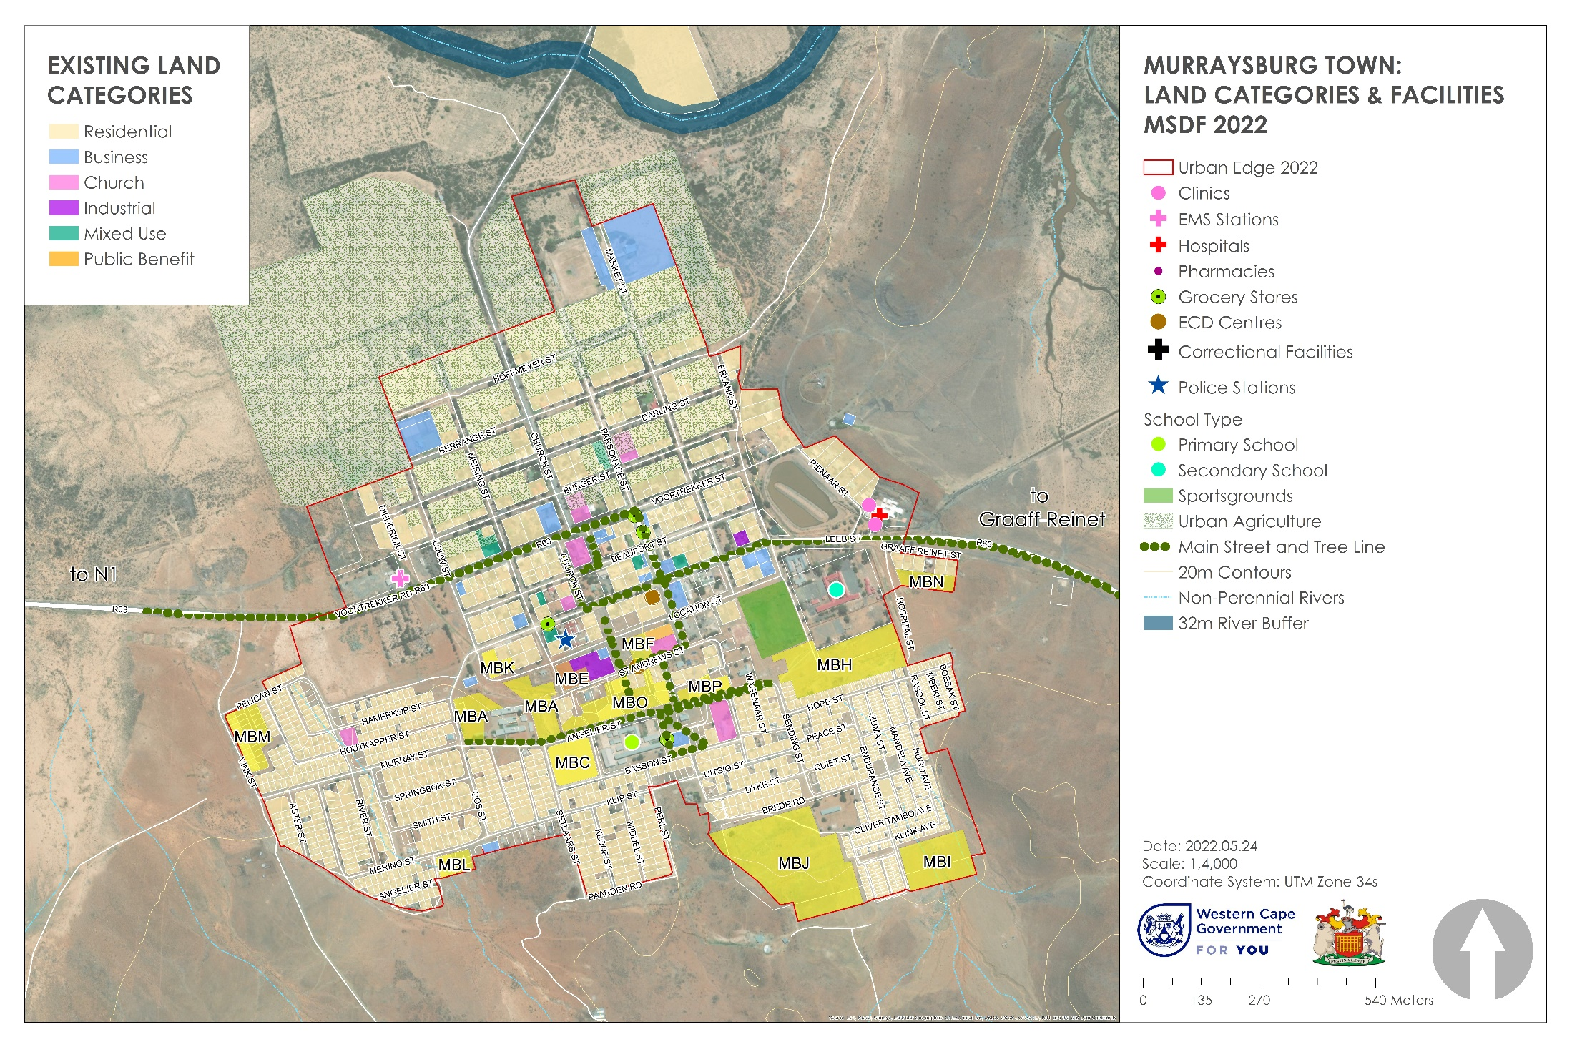
Figure 128: Murraysburg: Land Categories and Facilities MSDF
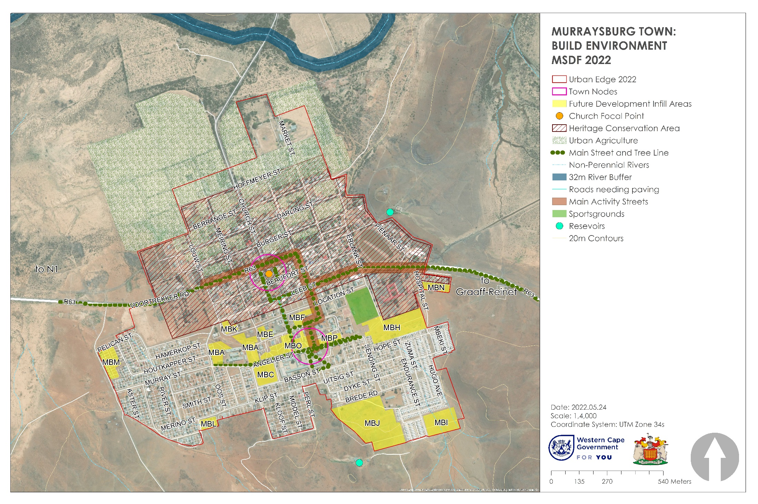
Figure 129: Murraysburg: Built Environment MSDF
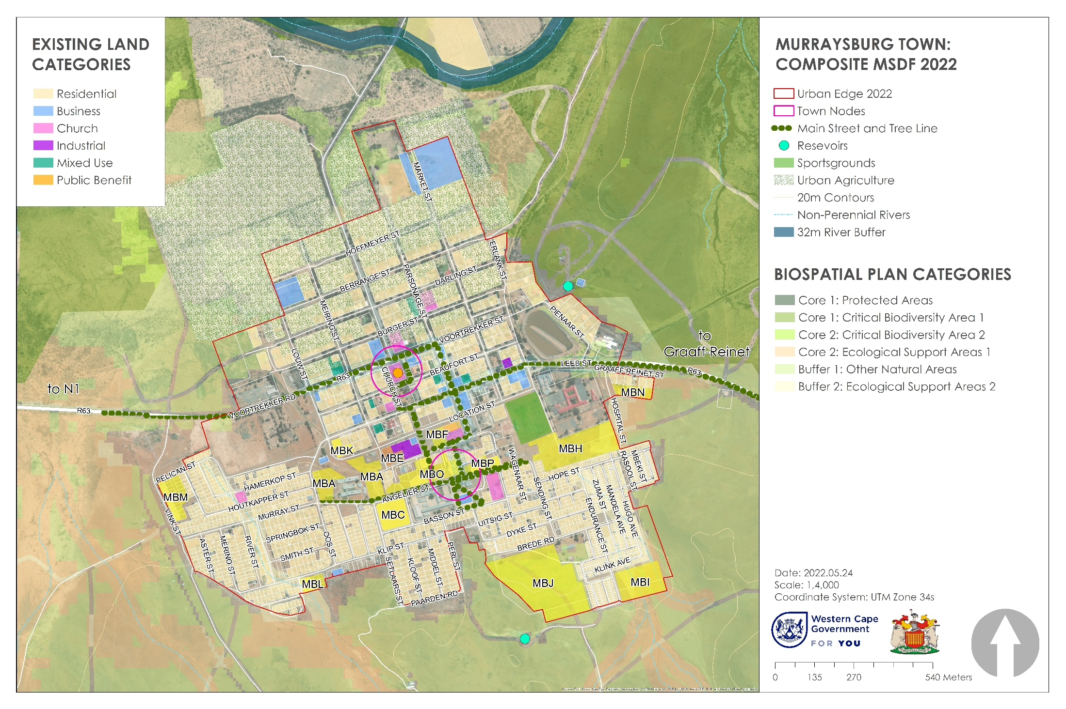
Figure 130: Murraysburg: Composite MSDF

4.10 NELSPOORT: SPATIAL DEVELOPMENT FRAMEWORK
Although the hospital was once a national facility currently it only serves the Central Karoo District for TB patients and psychiatry patients and is a 92-bed facility that is managed managed by a Matron. It nevertheless is a significant anchor to the settlement.
Nelspoort has four assets to build on:
- The health facilities and institutional buildings, although many are in a poor state of repair and under used, have potential as a large heritage precinct.
- Excellent climate.
- Relatively good agricultural land which is also currently underutilized; and,
- Remote location which nevertheless is served by good road and rail infrastructure not too far from the N1.
This suggests that it would be a good location for a large leadership academy / rehabilitation center that could address the various social problems increasingly affecting communities in the large cities as well as the platteland. The sub-regional location makes the settlement suitable for offering tourist opportunities that could include the Khoi history of the area (rock bells, paintings, and engravings), the Anglo Boer War as well as the sanatorium’s history. The farming operations should be restored, and this could also form the basis of a local value chain via an on-site farmers market and supplying Beaufort West.

4.10.1 Core landscape areas
- Nelspoort should retain its heavily treed character which forms a strong part of its sense of place but begin to replace the current Blue Gum trees with suitable indigenous water wise species; and,
- Restore farming to the large area of prepared lands currently lying fallow.

4.10.2 Urban Development
- The settlement is exceptionally well endowed with various education and community facilities and all that is generally required is their restoration rather than the construction of new facilities; and,
- In general, no new housing should be provided for as a large number of units have been recently built, there is suitable land if needed along the main entrance road and the short to medium term focus should be on promoting economic activity and job creation rather than more residential opportunities.

4.10.3 Heritage Areas
- The northern part of the settlement should be restored as a heritage precinct. This could be coupled with history tours through the hospital grounds and farming area and a coffee shop and B&B facilities operating somewhere out of the large stock of currently underused buildings.

4.10.4 Urban Restructuring
- Create continuous link avenue between the two main entrances to the settlement including the hospital, facilities, and residential areas; and,
- All gateways into town should be enhanced to improve its sense of arrival.

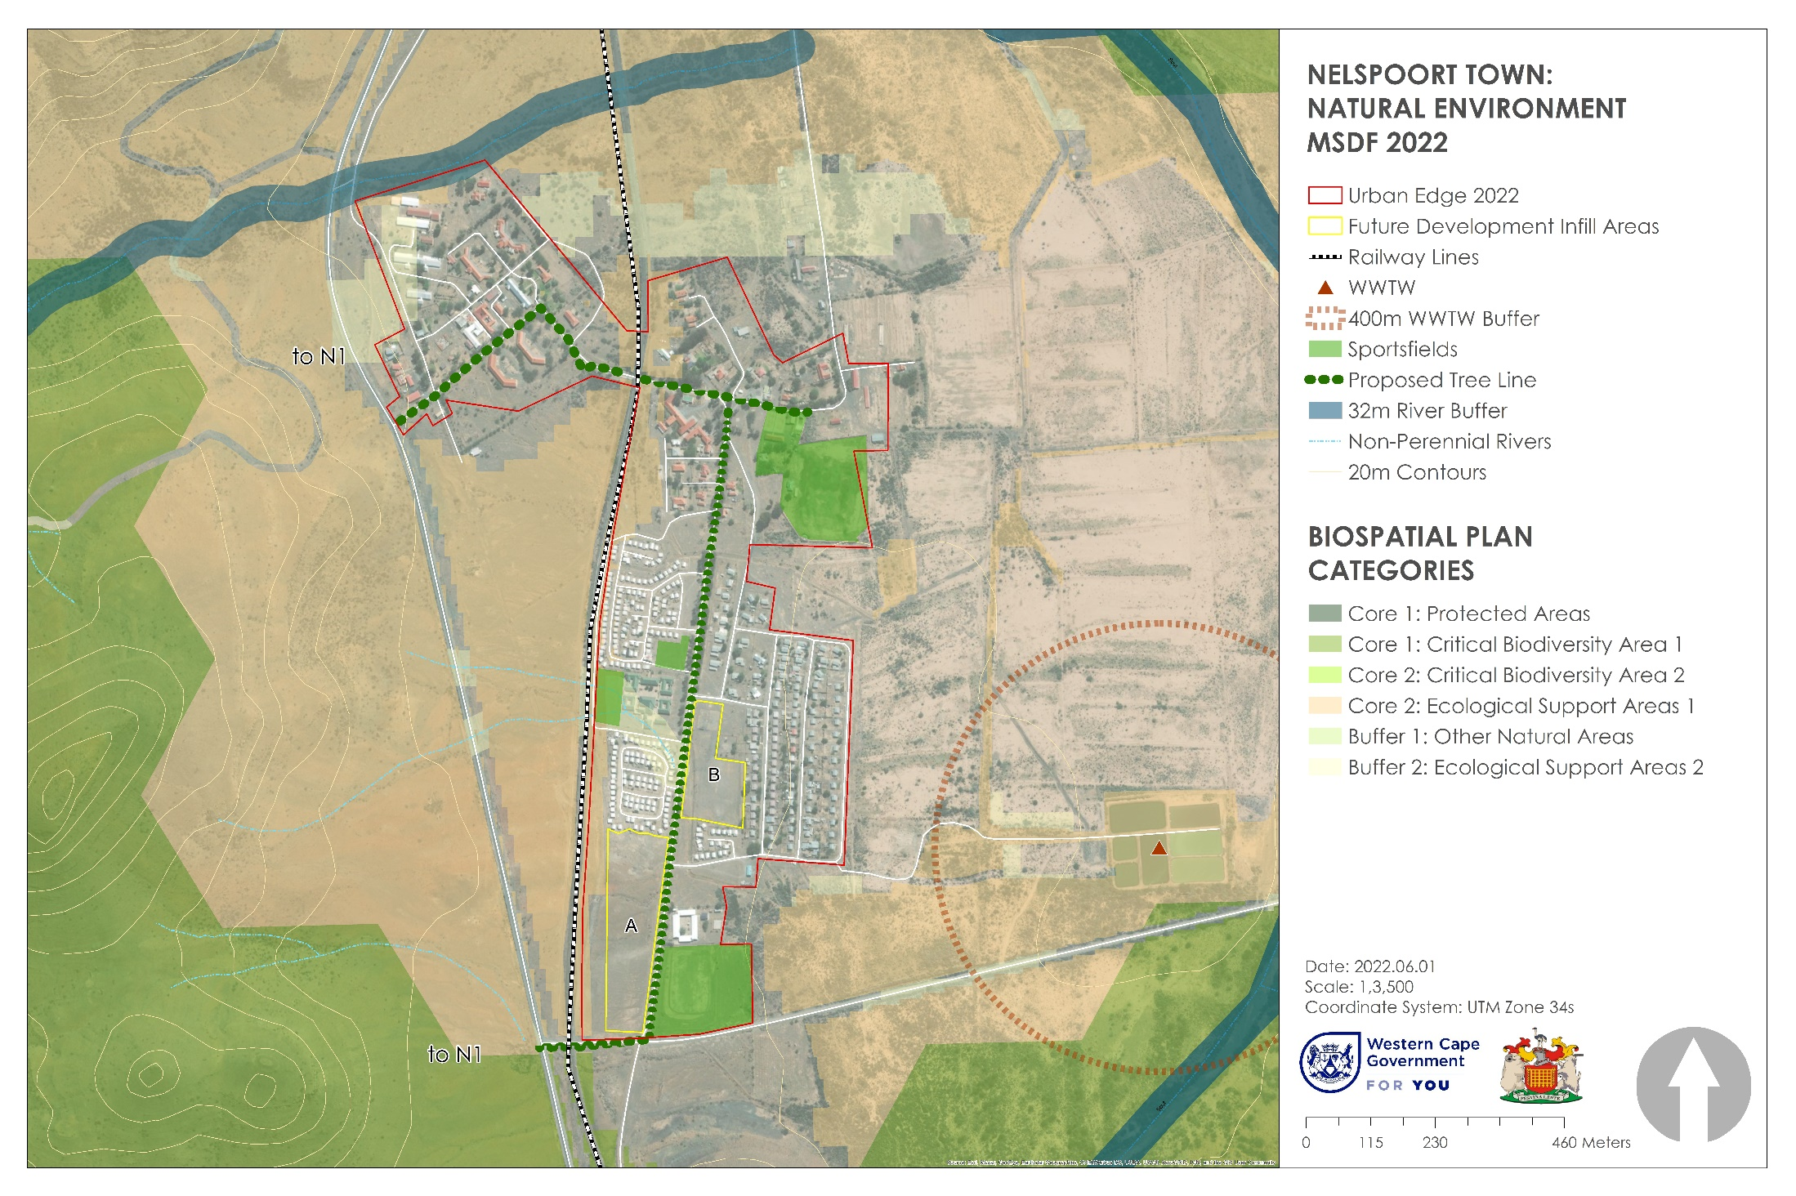
Figure 131: Nelspoort: Natural Environment MSDF
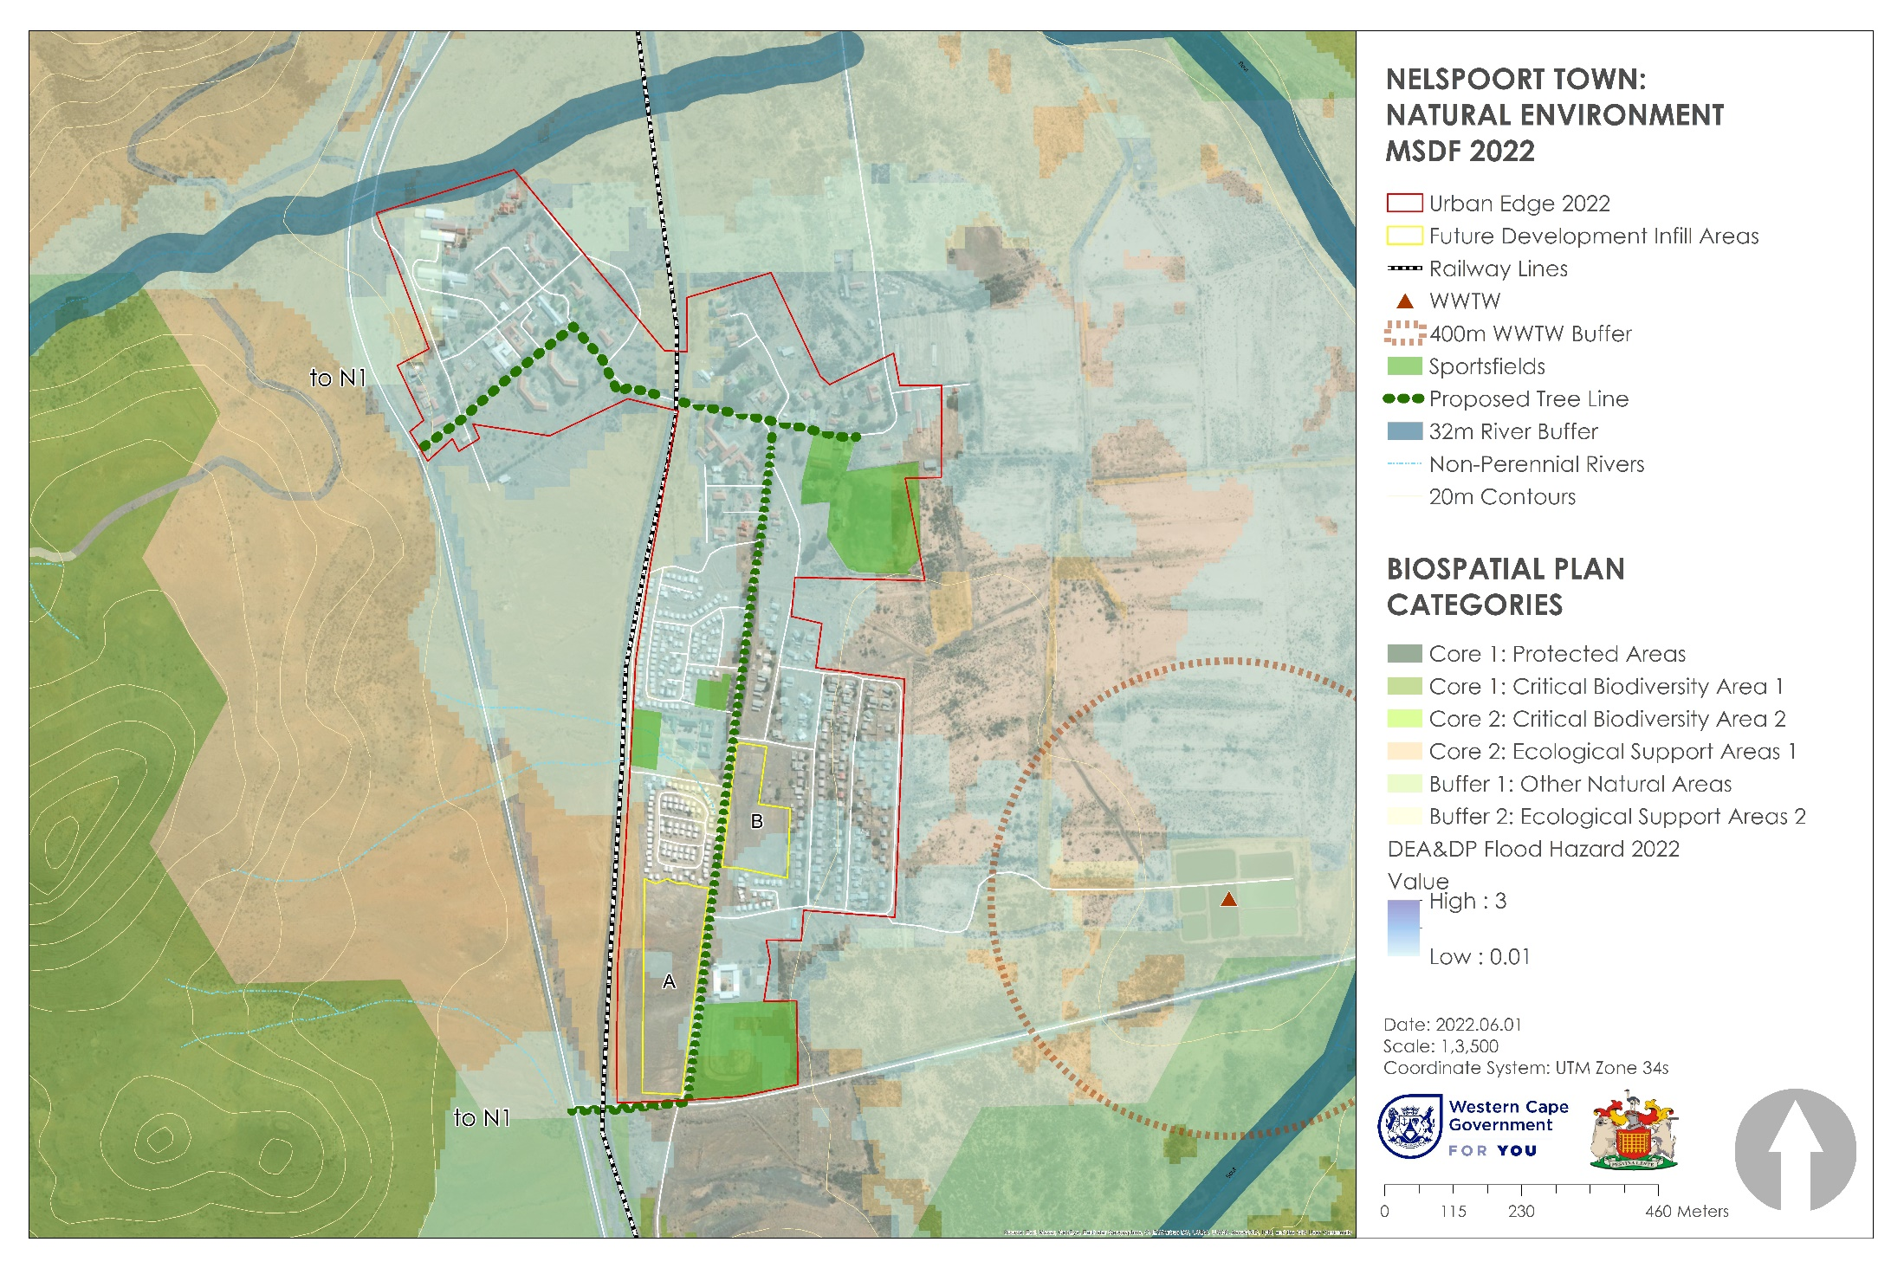
Figure 132: Nelspoort: Natural Environment MSDF (Including Flood Hazard Index)
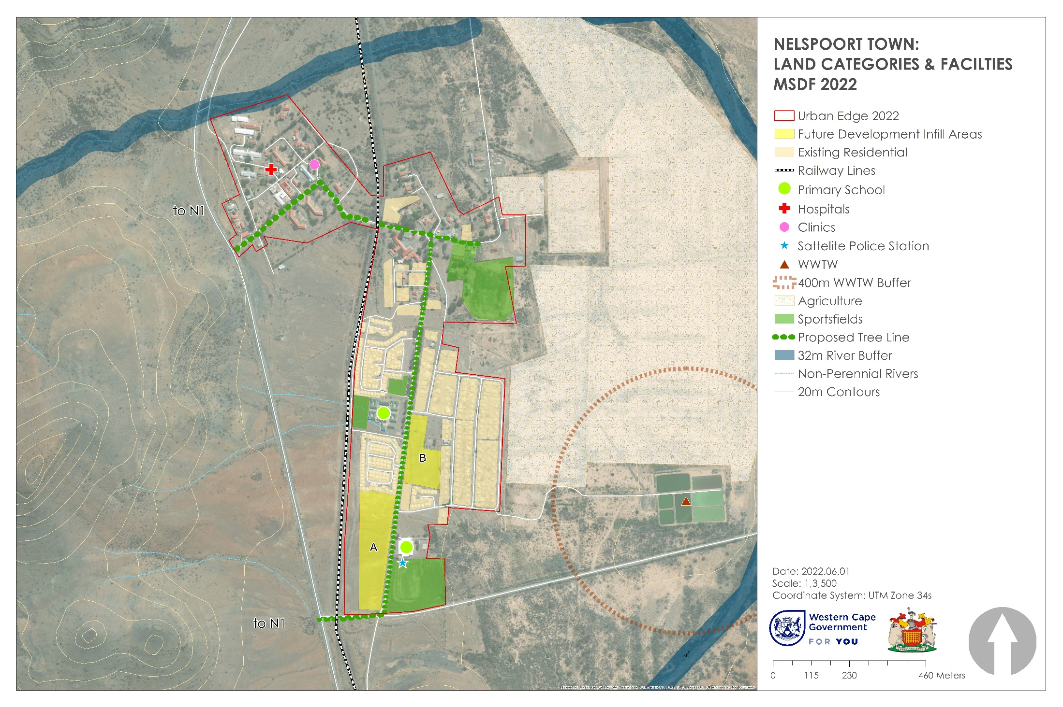
Figure 133: Nelspoort: Land Categories and Facilities MSDF
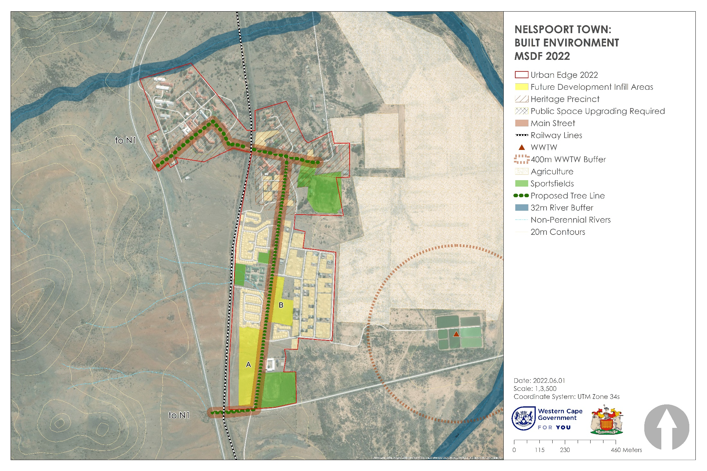
Figure 134: Nelspoort: Built Environment MSDF
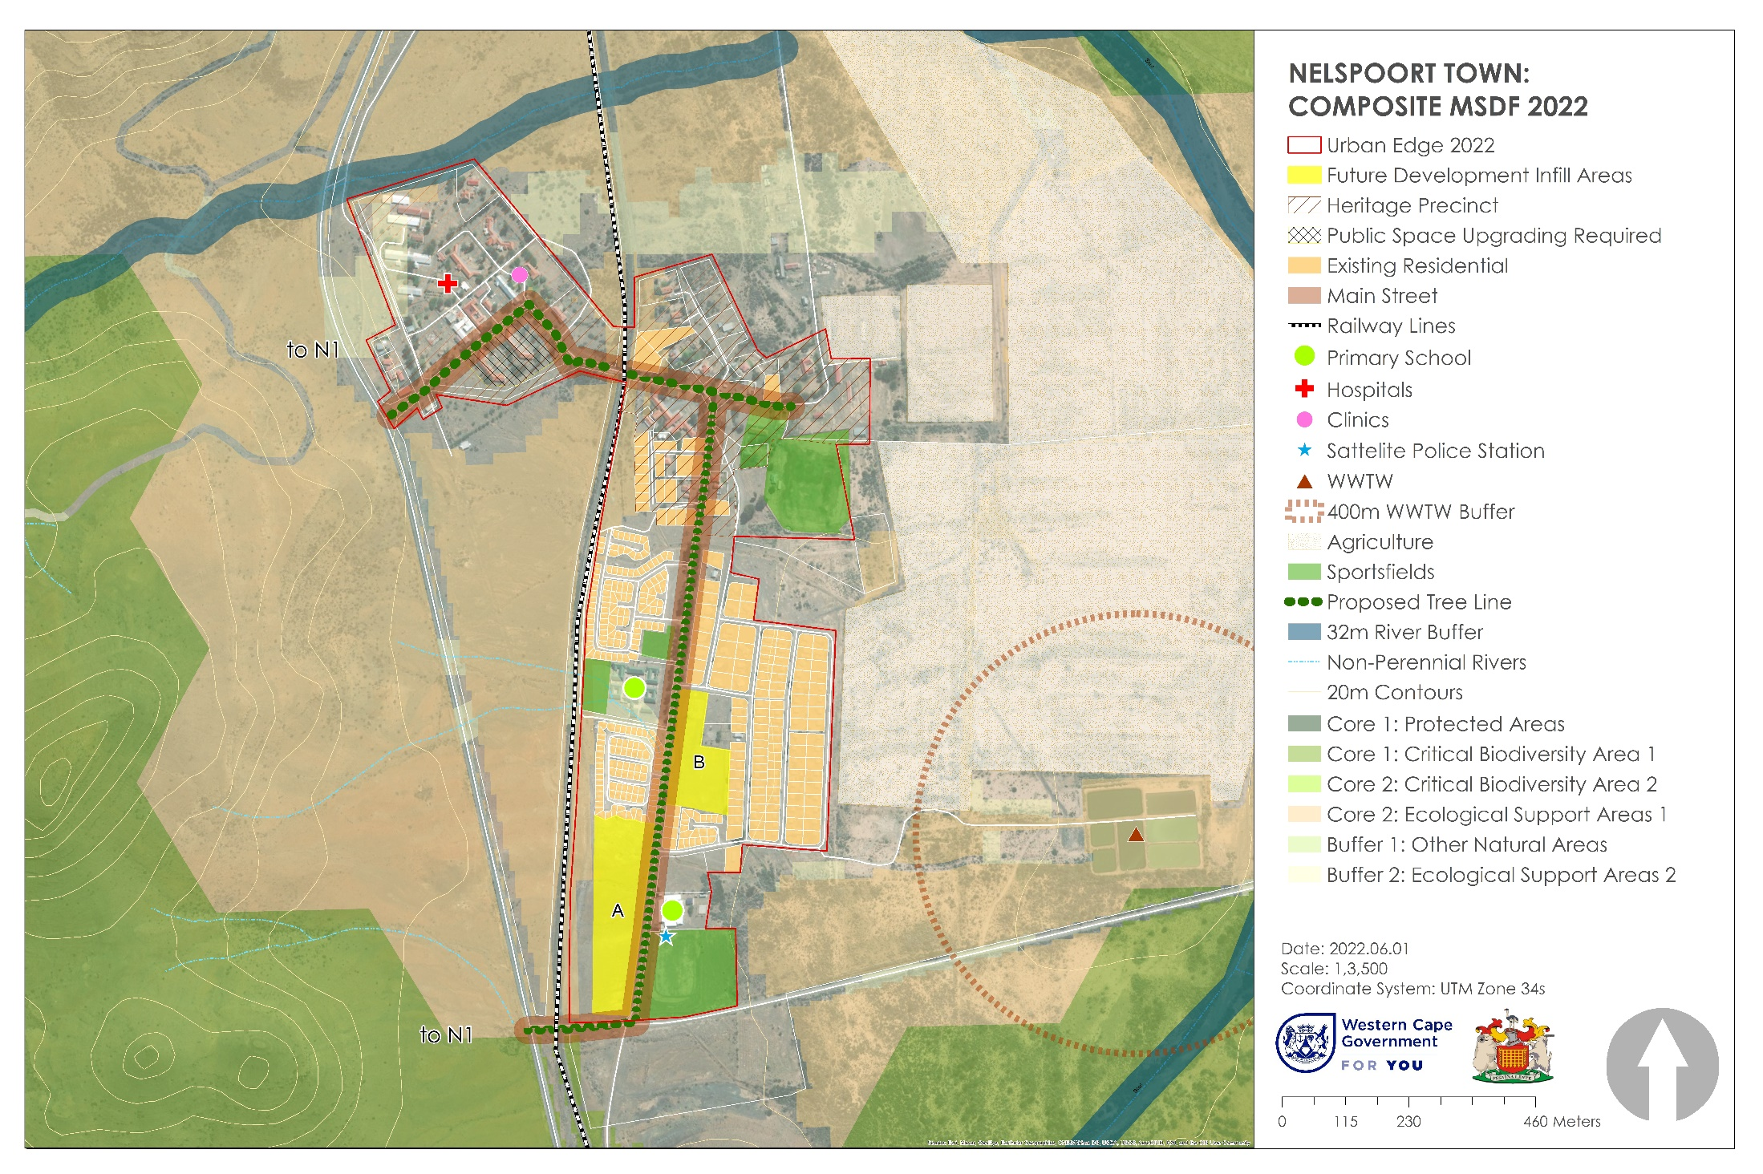
Figure 135: Nelspoort: Composite MSDF

