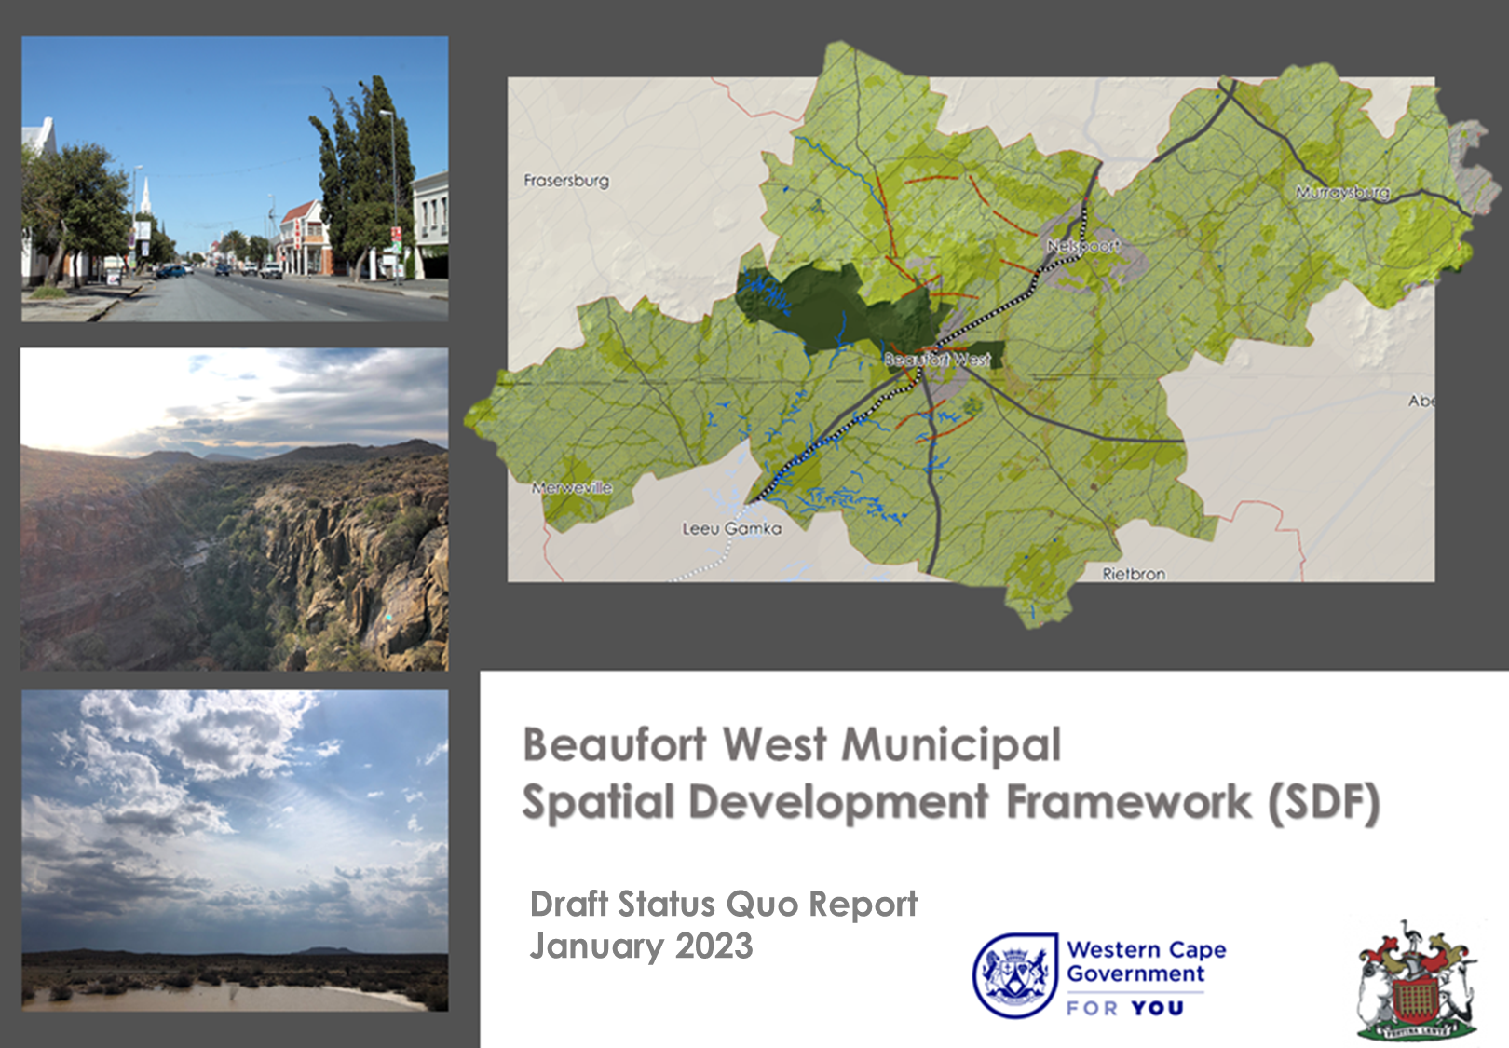
Draft Status Quo Report
March 2023
Contents
CHAPTER 1: INTRODUCTION & BACKGROUND 1
1.1 PURPOSE OF THE REPORT 1
1.2 PROBLEM STATEMENT 1
1.3 PROCESS AND DOCUMENT STRUCTURE 2
1.3.1 MSDF Process 2
1.3.2 Document Structure 4
1.4 LOCATION AND CONTEXT 4
CHAPTER 2: LEGISLATIVE AND POLICY CONTEXT 5
2.2 RELEVANT NATIONAL POLICY AND LEGISLATION 5
2.2.1 National Development Plan 2030 (NDP) 5
2.2.2 Integrated Urban Development Framework (IUDF) 5
2.2.3 The National Spatial Development Framework 2050 (NSDF) 5
2.2.4 The draft Karoo Regional Spatial Development Framework (KRSDF) 8
2.2.5 The Spatial Planning and Land Use Management Act, 2013 (Act 16 of 2013) 10
2.2.6 Municipal Systems Act, 2000 (ACT 32 OF 2000) 11
2.2.7 The Local Government: Municipal Planning and Performance Management Regulations, 2001 (LG: MP&PM REGULATIONS) 11
2.2.8 The National Biodiversity Strategy and Action Plan 2015-2025 11
2.2.9 The National Environmental Management Act 11
2.2.10 The National Environmental Management Act: Protected Areas Act 11
2.2.11 The National Environmental Management: Waste Management Act 12
2.2.12 National Climate Change Adaptation Strategy 12
2.2.13 The National Transport Master Plan 2005-2050 12
2.2.14 Implications for Beaufort West Municipality 12
2.3 PROVINCIAL AND DISTRICT POLICY AND LEGISLATION 12
2.3.1 The Western Cape Provincial Spatial Development Framework (PSDF) (2014) 12
2.3.2 The Western Cape Inclusionary Housing Policy Framework 13
2.1.1 Central Karoo District Spatial Development Framework (CKDMSDF) 2020 13
2.1.2 Living Cape: A Human Settlements Framework 13
2.1.3 The Western Cape Land Use Planning ACT, 2014 (ACT NO. 3 OF 2014) (LUPA) 14
2.2 MUNICIPAL POLICY AND LEGISLATION 14
2.2.1 2014 Beaufort West MSDF 14
2.2.2 Beaufort West Municipality IDP 14
2.2.3 By-law on Municipal Land Use Planning for Beaufort West, 2019 14
2.2.4 Implications for the Beaufort West Municipality 14
2.3 ADJACENT MUNICIPAL INFORMANTS 14
2.3.1 Adjacent MSDF informants 14
2.4 DRAFT VISION STATEMENT AND IMPLICATIONS 15
2.4.1 Vision Statement 15
CHAPTER 3: STATUS QUO REPORT 17
3.1 INTRODUCTION 17
3.2 BIO-PHYSICAL AND NATURAL ENVIRONMENT ASSESSMENT 18
3.2.1 Natural Landscape 18
3.2.2 Climate and Climate Change 21
3.2.3 Water Resources (Hydrology) 24
3.2.4 Biodiversity and Biodiversity Conservation 28
3.2.5 Agricultural Resources 31
3.2.6 Mineral Resources 33
3.3 REGIONAL AND LOCAL SOCIO-ECONOMIC CONTEXT LINK 34
3.3.1 Population and Household Trends 34
3.3.2 Economy and Employment Trends and Forecasts 35
3.3.3 Socio-Economic Conditions 37
3.3.4 Property Market 46
3.3.5 Municipal Finances 46
3.3.6 Tourism 47
3.3.7 Trade 48
3.3.8 Agriculture, Land Reform and Rural Development 49
3.4 BUILT ENVIRONMENT ASSESSMENT 55
3.4.1 Urban Settlements and Settlement Hierarchy 55
3.4.2 Housing 56
3.4.3 Road, Rail and Public Transport 60
3.4.4 Road Network 60
3.4.5 Rail Network 62
3.4.6 Road based Public Transport 62
3.4.7 Learner Transportation 63
3.4.8 Air transport 64
3.4.9 Non-Motorised Transport 64
3.4.10 Water Infrastructure 66
3.4.11 Energy and Electricity 67
3.4.12 Waste Infrastructure 69
3.4.13 Built Heritage 70
3.5 SYNTHESIS 72
3.5.1 Municipal Scale Synthesis 72
3.5.2 Town Scale Synthesis 77
3.6 PERFORMANCE ASSESSMENT: OPPORTUNITIES AND KEY ISSUES OR CHALLENGES 92
3.6.1 Beaufort West Town 92
3.6.2 Murraysburg 93
3.6.3 Merweville 95
3.6.4 Nelspoort 98

CHAPTER 1: INTRODUCTION & BACKGROUND

PURPOSE OF THE REPORT
The purpose of this report is to present a newly compiled Municipal Spatial Development Framework (MSDF) for Beaufort West Municipality, which will in part build upon the 2014 Beaufort West MSDF spatial proposals. The compilation of a new MSDF seeks to:
- Establish the existing level of development of the Beaufort West Municipality;
- Review and update the key issues and opportunities in the Municipality as they relate to its future spatial development;
- Review and update the spatial vision of the Municipality, to bring it in line with the National Development Plan; Vision 2030, the National Spatial Development Framework (NSDF) vision 2050, the Integrated Urban Development Framework (IUDF), 2014 Western Cape Provincial Spatial Development Framework (PSDF), the draft Karoo Regional Spatial Development Framework (KRSDF), the Central Karoo District Municipal Spatial Development Framework (2020) and the Beaufort West Municipality Integrated Development Plan (IDP);
- Bring the MSDF into alignment with the Spatial Planning and Land Use Management Act, 2013 (Act 16 of 2013) (SPLUMA), the Western Cape Land Use Planning Act, 2014 (Act 3 of 2015) (LUPA) and the Municipal Planning By-laws for Beaufort West;
- Review and update the Spatial Development Framework proposals and Implementation Framework in the existing 2014 MSDF for the Municipality; and
- Undertake preliminary work towards the development of a Capital Expenditure Framework (CEF) and Implementation Framework as required in terms of SPLUMA.

The Beaufort West MSDF will focus on:
- Clearly defining the relationship, hierarchy, linkages, and corridors between and within the settlements;
- Identifying growth nodes, priority investment areas, consolidation areas, and upgrade areas within the Municipality;

- Identifying protected areas, threatened ecosystems, critical biodiversity areas, valuable agricultural land, water catchment areas and natural.

resources of the Municipality, based on the latest available information and articulate how these assets will be managed from a land use perspective;

- Setting out general urban planning and design principles to be applied in developing and managing the settlements located within the municipality; and
- Identifying spatial transformation opportunities and, where appropriate, urban expansion opportunities for growth.

The MSDF is guided by various National, Provincial, and Local planning legislation and policies, as well as municipal sector plans. The MSDF will guide local-level land development and planning decisions by outlining future development opportunities and constraints. It should be noted that whilst the MSDF does guide land development and land use management decision making, it does not in and of itself give or take away land use rights.

PROBLEM STATEMENT
The Beaufort West Municipality seeks to compile a new MSDF that will coincide with the 5-year term of the new Integrated Development Plan (IDP). Some of the key areas of focus or change that this MSDF is responding to are:
- Updated Critical Biodiversity Area information and associated Western Cape Biodiversity Spatial Plans;
- New population growth figures, economic data, and service level data for the municipal area;
- An evolved policy position on shale gas extraction in the Karoo;
- The content requirements of SPLUMA and LUPA, which came into effect after the compilation of the last MSDF;
- Amalgamating spatial data sets and policy positions from the 2020 Central Karoo District MSDF;
- Ensuring alignment with the National Spatial Development Framework (NSDF) vision 2050, the 2014 Western Cape Provincial Spatial Development Framework (PSDF), the draft Karoo Regional Spatial Development Framework (KRSDF), the Central Karoo District MSDF, and;
- Undertaking preliminary work towards the development of a Capital Expenditure Framework (CEF) and Implementation Framework as required in terms of SPLUMA.
In addition, the Beaufort West Municipality is facing a number of pressing challenges relating to water scarcity, flood risk, ageing infrastructure, slowing population growth, economic stagnation, and increasing urban management issues, particularly around waste management which is both an environmental health risk and economic risk. The trajectory of the municipality is also highly uncertain, with the potential for shale gas development in the area holding significant implications for medium-term economic and population projections. Conversely, the ongoing drought conditions have the potential to have significant and long term economic, social, and environmental consequences. This set of challenges and potential changes to the municipality necessitates the development of an MSDF that both supports the people of Beaufort West in the current state of ecological and economic distress and plans for the possibility of population and economic growth in the future.

PROCESS AND DOCUMENT STRUCTURE

MSDF Process
The process to compile a Spatial Development Framework is set out in the Municipal Systems Act, 2000 (Act 32 of 2000) (MSA), the Spatial Planning and Land Use Management Act, 2013 (Act 16 of 2016) (SPLUMA) and the Western Cape Land Use, 2014 (Act 3 of 2014) (LUPA) . This process is shown in Figure 1. In short, the process entails the following:
- The municipality decides whether to establish an Intergovernmental Steering Committee (ISC);
- Municipal Council to give reasonable notice of the intention to compile the MSDF;
- The proposal to compile the MSDF must be published in the media in at least 2 official languages;
- The municipality must inform the provincial minster in writing of its intent to compile the MSDF;
- Register relevant stakeholders who may be invited to comment on the draft SDF;
- The Municipality must establish a project committee;
- If an ISC is established, then provincial and other departments must be invited to sit on it and provide input on the MSDF;
- The project committee should compile a draft status quo report setting out an assessment of the existing levels of development and development challenges and submit it to the ISC for comment (if an ISC was established);
- The project committee must consider the comments of the ISC (if established), finalise the status quo report and submit it the Council for adoption;
- The project committee must compile a first draft of the municipal spatial development framework and submit it to the ISC (if established) for comment;
- After considering the comments of the ISC (if established), the project committee must finalise the first draft of the municipal SDF and submit it to Council to approve the publication thereof;
- Once available, the draft MSDF must be made available for public comment for a period of 60 days;
- The Project Committee must consider all comments received and compile a final MSDF for council adoption;
- MSDF is presented to Council for approval;
- Once adopted, a notice of adoption must be placed in Provincial Gazette within 14 days;
- The MSDF must be submitted to the provincial minister within 10 days of Council approval.

Due to human resource capacity and budget constraints within the Beaufort West Municipality, the municipality sought assistance from the Western Cape Department of Environmental Affairs and Development Planning (DEA&DP) regarding the compilation of the new MSDF. DEA&DP has agreed to provide this assistance in fulfilment of sub-programme 1 of the Western Cape Government’s MSDF Support Programme: 2020 - 2024 Plan. Beaufort West Municipality and DEA&DP held an inception meeting on 1 June 2021, and the Municipal Council decided to establish an ISC to oversee the drafting of the MSDF. The drafting of the MSDF followed the relevant legislative provisions under the guidance of the ISC. This process is summarised in Figure 1.

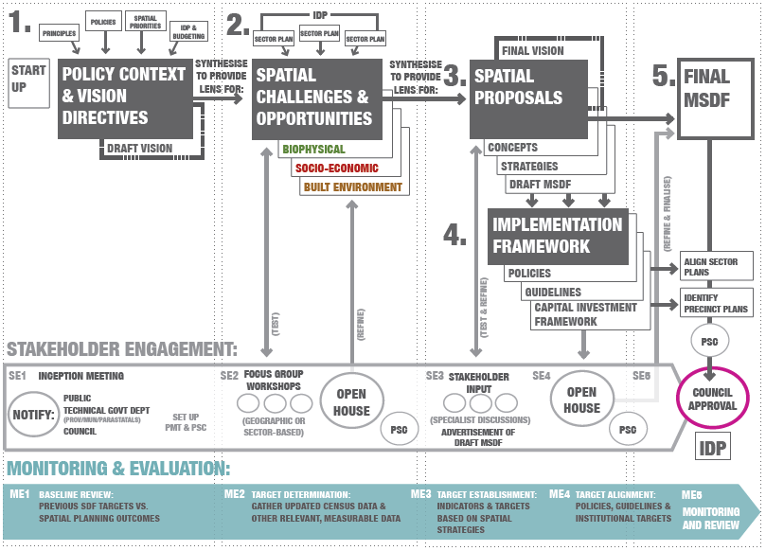
Figure 1: MSDF Process Diagram (Former Department of Rural Development and Land Reform, 2017)

Document Structure

The structure of this MSDF is broadly in alignment with the then-DRDLR Guidelines for SDFs (Former Department of Rural Development and Land Reform, 2017) and follows the document structure shown in Figure 1. This report contains the following Chapters:
- Chapter 1 provides an introduction and some background information on the purpose of this report and what it seeks to achieve. It further articulates the process to be followed in compiling the MSDF and sets out the structure of the document.
- Chapter 2 provides an overview of the key legislative, policy, strategy and planning context, and the implications for spatial planning and land use management in the municipality.

- Chapter 3 is a Status Quo Analysis that sets out a comprehensive assessment of key environmental, social, economic, infrastructure and built environment assets in the municipality, concluding with a synthesis, identifying key development issues and opportunities and their spatial implication.

- Chapter 4 sets out a spatial vision and spatial concept for Beaufort West Municipality, which will be the overarching framework that guides all subsequent policy interventions. It then goes on to set out the spatial development strategies, and spatial policies to guide land use planning, management, regulation, and investment decisions throughout the municipal area, organised around four spatial strategies that support the spatial development vision. Within each of the strategies there is a stated objective, and an indication of how the municipality intends to measure the successful implementation of it, including identifying the impacts of the MSDF on sector planning.

- Chapter 5 sets out preliminary work towards the development of a Capital Expenditure Framework (CEF), which aligns the spatial proposals of the MSDF with the infrastructure plans and municipal budget and in so doing provides as an implementation framework for the municipality between 2022 and 2033.

LOCATION AND CONTEXT
The Beaufort West Municipality (WC053) is one of three Category B municipalities in the Central Karoo District Municipality of the Western Cape Province. It lies on the southern edge of the Great Karoo, a semi-desert region. The municipalities within the Central Karoo District are Beaufort West Municipality, Laingsburg Municipality and Prince Albert Municipality (See Figure 1.2).
The size of the Beaufort West municipal area is approximately 21 916 square kilometres, which comprises 56.4 per cent of the total Central Karoo District geographic area. The Beaufort West spatial area is the largest in the district. The N1 (National Road) cuts through the Municipality. The town of Beaufort West is the economic hub of the CKD and thus often serves as a popular rest and service area for travellers on the N1. Other small towns in the municipal area include Merweville, Murraysburg and Nelspoort. The N12 runs on a north-south axis through Klaarstroom (Prince Albert Municipality) and connects Oudtshoorn and George in the south to Beaufort West in the north, essentially linking the N1 and the N2. Figure 2 illustrates the location of the Beaufort West Municipal Area within a Western Cape Provincial spatial context.
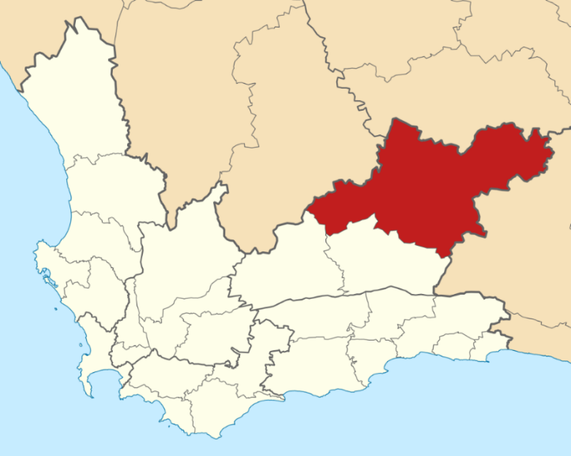
Figure 2: Location of Beaufort West Municipal Area

CHAPTER 2: LEGISLATIVE AND POLICY CONTEXT

The purpose of this chapter is to briefly provide a summary of the policy and legislative landscape informing the Beaufort West MSDF. The MSDF should progressively seek to comply with the prescribed process and content requirements of the legislation and policy described below.

RELEVANT NATIONAL POLICY AND LEGISLATION
This section summarises national policy and legislation informing the Beaufort West MSDF.

National Development Plan 2030 (NDP)
The National Development Plan 2030 (NDP), which was developed by the National Planning Commission and adopted in 2012, serves as the strategic framework guiding and structuring the country’s development imperatives and is supported by the New Growth Path (NGP) and other national strategies. In principle, the NDP is underpinned by, and seeks to advance, a paradigm of Space Economy, including the upgrading of all informal settlements on suitable, well-located land; increasing urban densities to support public transport and reduce sprawl; promoting mixed housing strategies and compact urban development in close proximity to services and livelihood opportunities; and investing in public transport infrastructure and systems (with a special focus on commuter rail) to ensure more affordable, safe, reliable and coordinated public transport.

Integrated Urban Development Framework (IUDF)
The Integrated Urban Development Framework (IUDF), approved by National Cabinet in 2016, aims to steer urban growth nationally towards a sustainable model of compact, connected and coordinated towns and cities. The IUDF provides a roadmap to implement the NDP’s vision for spatial transformation, creating liveable, inclusive, and resilient towns and cities while reversing apartheid spatial legacy. To achieve this transformative vision, four overall strategic goals are introduced:
- Spatial integration; to forge new spatial forms in settlement, transport, social and economic areas;
- Inclusion and access; to ensure people have access to social and economic services, opportunities, and choices;
- Growth: to harness urban dynamism for inclusive, sustainable economic growth and development; and
- Governance; to enhance the capacity of the state and its citizens to work together to achieve spatial and social integration.
These strategic goals inform the priority objectives of nine policy levers, premised on the understanding that integrated urban planning forms the basis for achieving integrated urban development, which follows a special sequence of urban policy actions. Integrated transport needs to inform targeted investments into integrated human settlements, underpinned by integrated infrastructure network systems and efficient land governance. The IUDF states that, taken all together, these levers can trigger economic diversification, inclusion, and empowered communities, if supported by effective governance and financial reform.

The National Spatial Development Framework 2050 (NSDF)
The National Spatial Development Framework (NSDF), which is the first of its kind in South Africa was approved by National Cabinet in 2022 and seeks to make a bold and decisive contribution to bringing about the peaceful, prosperous, and truly transformed South Africa, as articulated in the Freedom Charter, the Reconstruction and Development Programme and the NDP.
In summary, and as illustrated in Figure 3 (below), the NSDF must, within the broader ‘family’ of strategic and sector plans of government:
- Target and direct all infrastructure investment and development spending decisions by all national sector departments and SOEs;
- Guide and align plan-preparation, budgeting, and implementation in and across the three spheres, and between the sectors of government;
- Frame, guide and coordinate provincial, regional, and municipal spatial development frameworks; and
- Together with other stakeholders, notably those in the Department of Forestry, Fisheries, and the Environment (DFFE) and representatives of coastal provinces and municipalities, (1) clarify the interface of spatial planning with marine planning, and (2) ensure that the NSDF is both informed by and informs marine spatial planning processes and products.

Figure 3: The role of the NSDF within the ‘Family’ of Strategic and Sector Plans of Government
The foundation for the NSDF is premised on the main frame for the Ideal Post-Apartheid National Spatial Development Plan as spatially illustrated in Figure 4 and five sub-frames. These emanate from the National Development Plan 2030 priorities, the National Spatial Development Vision and Logic, as well as development issues identified through the analysis process.
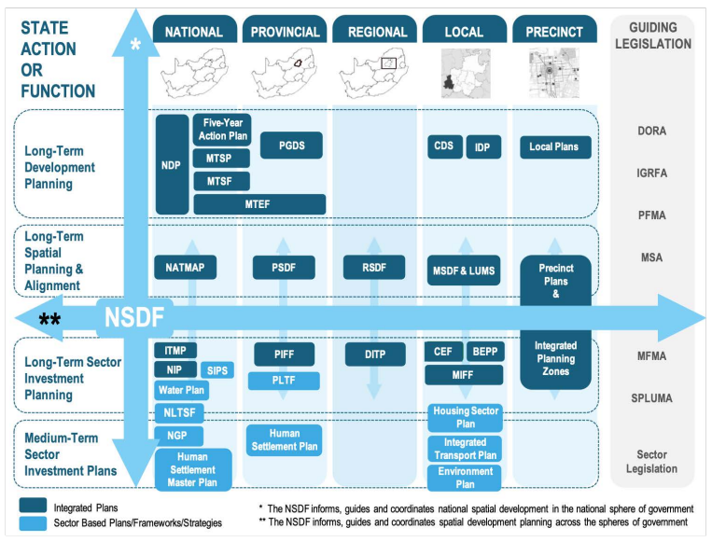
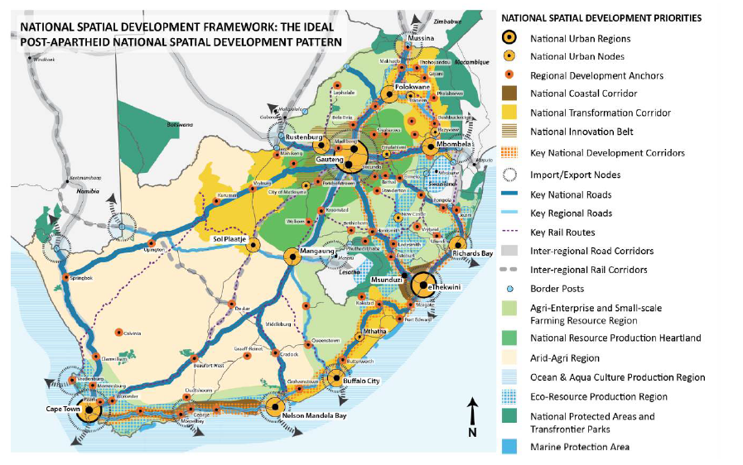
Figure 4: The NSDF Main-Frame: The Ideal Post-Apartheid National Spatial Development Plan
The five Sub-Frames forming the foundation for the NSDF are listed below, along with an analysis of the key spatial implications for Beaufort West Municipality:
- NSDF Sub-Frame One: Inter-Regional Connectivity. This sub-frame is focused on connections to other SADC countries, but the national rail link between Cape Town and Johannesburg is highlighted as an inter-regional Rail Corridor. This corridor passes through Beaufort West Municipality and is an important spatial informant to the municipality. The town of Beaufort West, and other settlements along this rail route, have inherent latent future potential to benefit passing passenger and freight rail. These opportunities should be identified, and space made provision for them to materialise;

- NSDF Sub-Frame Two: The National System of Nodes and Corridors. The key spatial implication of this sub-frame is that Beaufort West Town is listed as a Regional Development Anchor. It is identified as an example of one of the anchors under stress and in need of support through targeted settlement planning and development, higher-order social infrastructure provision, and focused support for small and medium-sized enterprise development, industrialisation, and economic diversification. Regional connections to neighbouring anchors De Aar (in the Northern Cape) and Oudtshoorn are also important at the national scale. As a Regional Development Anchor, the town of Beaufort West is the primary investment node for certain government and private sector services and facilities. Future potential facility and service opportunities should be identified and enabled by the municipality, to promote employment creation and maintain the multiplier effect of ensuring funds generated within the municipal area are reinvested within the businesses of the towns of the municipality;

- NSDF Sub-Frame Three: The National Resource Economy Regions. Beaufort West falls into the National Arid-Agri Innovation Region as illustrated in Figure 5. The NSDF notes that, for the region that Beaufort West falls into, changing climatic conditions will significantly impact on national food production and require regional agricultural adaptation and effective land use management. Additionally, it states that within remote and arid regions in the western and north-western parts of the country, the cumulative impact of a growing number of wind farms, solar plants and mining and energy-related projects should be carefully evaluated in regional context. The growth of existing towns close to these areas is supported, but new and on-site settlement far away from existing towns is not. In the context of Beaufort West, shale gas extraction and renewable energy development zones have been identified as future potential industries. The spatial planning categories of the MSDF must make provision for the location and management of these activities, being clear where it is appropriate to accommodate them, and where such activities should not be accommodated (and provide reasons for this – whether it is due to landscape character considerations, important scenic viewsheds routes, or from a biodiversity or riverine constraints perspective).

- NSDF Sub-Frame Four: The National Movement and Connectivity Infrastructure System. Beaufort West sits on an Inter-regional National Road and under-utilised Rail Corridor, with both the N1 and railway highlighted as being of national importance. Similarly, the access roads to rural hinterlands are important for the NSDF’s regional-rural development mode as illustrated in Figure 6. Future rail opportunities exist in significantly increasing passenger and freight rail. The potential also exists for high-speed rail opportunities between Cape Town and Gauteng (and potential connections through Beaufort West) which brings economic opportunities;

- NSDF Sub-Frame Five: The National Ecological Infrastructure and Natural Resource System. The Karoo National Park is identified as a key ecological resource at the national scale. Various critical biodiversity areas, environmental support areas, and other natural areas have been identified in the Western Cape’s biodiversity spatial plan, which builds on SANBI’s extensive biodiversity information and knowledge management systems.

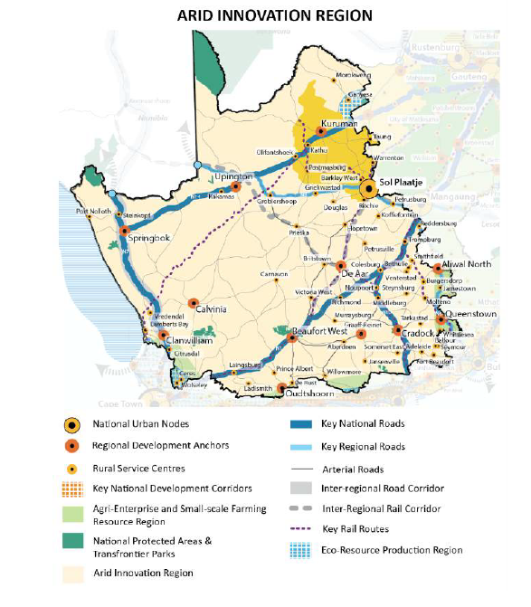
Figure 5: Arid Innovation Region (Republic of South Africa, 2019)

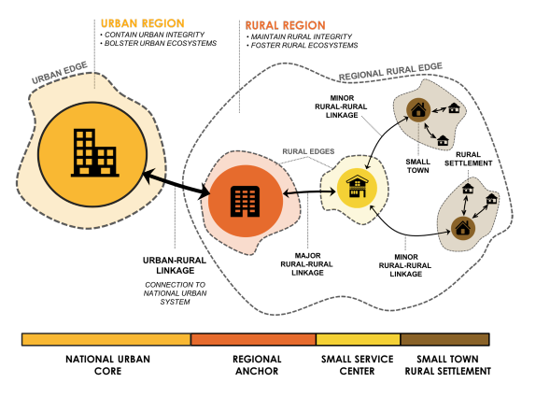
Figure 6: NSDF Regional-Rural Development Model (Republic of South Africa, 2019)

The draft Karoo Regional Spatial Development Framework (KRSDF)
The Karoo RSDF is the first RSDF to be drafted under SPLUMA. It covers a region that encompasses 40% of South Africa’s surface area, including the Central Karoo District Municipality and Beaufort West Municipality as illustrated in Figure 7, and it also gives expression to the Arid-Agri Innovation region identified in the NSDF.
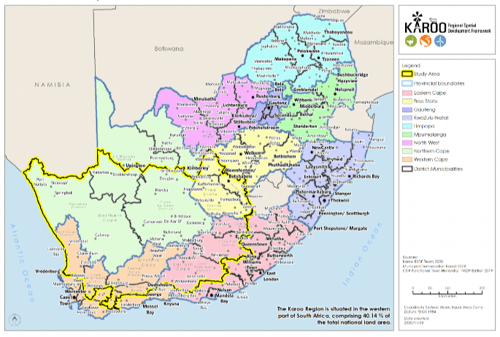
Figure 7: Draft Karoo Regional Spatial Development Framework
The dart KRSDF in its current form aligns with the NSDF in identifying Beaufort West Town as a Regional Development Anchor and highlighting the importance of the N1 and rail route as being connectors of high national importance. A major additional layer to the KRSDF is the demarcation of a Renewable Energy Development Zone (REDZ) that covers much of Beaufort West Municipality. This REDZ forms part of an Economic Functional Region centred around Beaufort West as illustrated in Figure 8.
As a result of these factors, the KRSDF proposes the following roles for the Beaufort West settlement:
- Economic Focus and Opportunity: Extensive agriculture, regional transit node: connecting point for regional and national routes, tourism gateway and eco-tourism.
- Economic Infrastructure and Expansion in Functional Region: REDZ, power corridors, on the national road network, on the national rail network, Agri-Hub, and Farmer Production Support Units.
It notes the following supportive actions for the anchor and region:
- Investigate the feasibility of commercial airport to strengthen the gateway function.
- Improve ICT connectivity.
- Support services for sustainable energy generation.
- Risk management:
  - Potential shale gas extraction;
  - Climate change impact: decreased rainfall;
  - Stressed water catchment area; and
  - The strategic gas pipeline network.
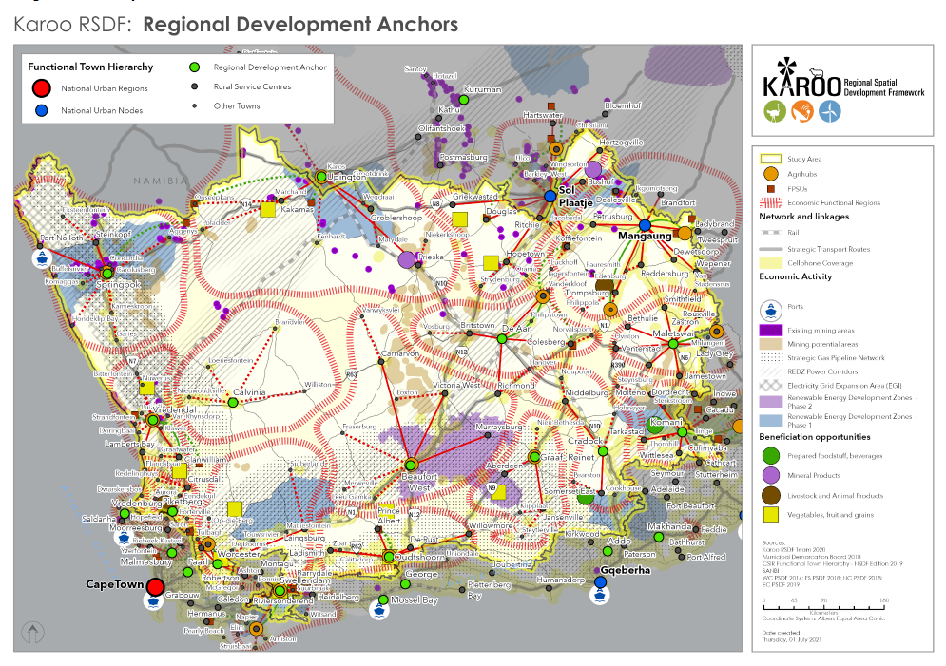
Figure 8: Economic Functional Regions in the draft KRSDF (Karoo Regional Spatial Development Framework, 2020)
In addition, the draft KRSDF highlights the following issues that are relevant to Beaufort West Municipality:
- Critical biodiversity areas and protected areas adjacent to the Northern Cape have special significance for smaller towns in this region to serve as assets considering conservation tourism (attracting tourists);
- Water is a shared and scarce resource and a determining factor for growth and expansion of towns located in the more arid parts of the Karoo;
- Extraction of mineral resources is a concern given water constraints and the potential impact mineral resource extraction could have on the water resource – this is particularly an issue in the Shale Gas exploration areas in the Karoo Basin;
- Landscape and scenic are mostly road-based attractors that also benefit the more isolated municipalities and towns, bringing in visitors. This places a requirement to align road infrastructure maintenance at the scale of the RSDF;
- Energy systems: Rural development nodes near Beaufort West and Laingsburg are remote and need to be connected with ICT and have appropriate road connections/conditions;
- Accessibility challenges are significant in the central and southern Karoo regions, which creates a need for coordinated social service delivery;
- Housing: Isolated housing projects (sites) carry a risk of creating pockets of poverty, far from employment opportunities, and requisite facilities and services to support vulnerable and indigent populations. This creates additional burdens on the education, health, social services, and other government functions in serving these areas. All new subsidy housing should be delivered as integrated settlement housing opportunities, within existing settlements (consider growth/decline trends); and
- Growth potential of towns: Most towns in the southern part of the Karoo RSDF (in the Western Cape Province) do not have significant growth prospects; some might even decline further in future, both in economic and population terms.

The Spatial Planning and Land Use Management Act, 2013 (Act 16 of 2013)
SPLUMA sets out the process to develop an MSDF, as well as the minimum content requirements of an MSDF. Some of the notable outcomes that an MSDF must achieve are:

- Set out and be informed of a longer-term spatial vision;
- Guide all planning of all spheres of government;
- Identify risks associated with developments;
- Identify and quantify engineering infrastructure needed for future growth;
- Provide the spatial expression of the coordination, alignment, and integration of all sector plans.

SPLUMA also includes a set of 5 development principles which must guide the preparation, adoption and implementation of any SDF, policy and/or by-law concerning spatial planning and the development or use of land. These principles are set out below:

Spatial Justice refers to the need to redress the past apartheid spatial development imbalances and aim for equity in the provision of access to opportunities, facilities, services, and land. In the broadest sense, it seeks to promote the integration of communities and the creation of settlements that allow the poorest of the poor to access opportunities.

Spatial Sustainability refers to a sustainable form of development. A part of this means promoting less resource consumptive development typologies that promote compaction, pedestrianisation and mixed-use urban environments which allow for the development of a functional public transport system and space economy. A spatially sustainable settlement will be one which has an equitable land market, while ensuring the protection of valuable agricultural land, environmentally sensitive and biodiversity rich areas, as well as scenic and cultural landscapes and ultimately limited urban sprawl.

Efficiency the principle of spatial resilience refers to ‘flexibility in spatial plans, policies and land use management systems are accommodated to ensure sustainable livelihoods in communities most likely to suffer the impacts of economic and environmental shocks.

Spatial Resilience in the context of land use planning refers to the need to promote the development of sustainable livelihoods for the poor (i.e., communities that are most likely to suffer the impacts of economic and environmental shocks). The spatial plans, policies and land use management systems should enable the communities to be able to resist, absorb and accommodate shocks and to recover from these shocks in a timely and efficient manner. This includes the preservation and restoration of essential basic infrastructure and functions, and also long-term adaptation in order to ensure increased resilience in terms of future shocks (United Nations Office for Disaster Risk Reduction, 2009).

Good administration in the context of land use planning refers to the promotion of integrated, consultative planning practices in which all spheres of government and other role-players ensure a joint planning approach is pursued. Furthermore, it is critical that decisions made in terms of land use planning seek to minimise the negative financial, social, economic, and environmental impacts of a development. Additionally, ‘good administration’ in the context of land use planning refers to a system which is efficient, well run and where the timeframe requirements are adhered to.

Key message: spatial planning is a normative (value driven) process that must be underpinned by five principles that seek to jointly guide all actors in delivery of infrastructure and services in space.

Municipal Systems Act, 2000 (ACT 32 OF 2000)
Section 24 of the MSA notes that planning undertaken by a municipality must be aligned with, and complement, the development plans and strategies of other affected municipalities and organs of state. This is to give effect to the principles of co-operative governance contained in Section 41 of the Constitution. Its further notes that municipalities must participate in national and provincial development programmes as required in section 153(b) of the Constitution, and it requires municipal planning to reflect this as well.

Key message: Planning must be joint, integrated and aligned and give expression to the development plans and programmes of all spheres of government within the municipal space.

The Local Government: Municipal Planning and Performance Management Regulations, 2001 (LG: MP&PM REGULATIONS)
Chapter 2 of the LG:MP&PM regulations, published in terms of the Municipal Systems Act, 2000 (Act 32 of 2000), provides some detail as to what MSDFs should seek to achieve. In brief, it is articulated that an MSDF must set out the desired spatial form of the municipality, contain strategies and policies of how these will be met, and set out basic guidelines for the land use management system, amongst other things. It should be noted that SPLUMA provides greater detail to these requirements.

The National Biodiversity Strategy and Action Plan 2015-2025
The National Biodiversity Strategy and Action Plan (NBSAP) has endeavoured to integrate the country’s obligations under the Convention of Biological Diversity and Global Development Agenda into South Africa’s national development and sectoral planning frameworks. It provides a framework to integrate biodiversity needs into sectoral plans and strategies. The National Biodiversity Strategy and Action Plan outlines a path to ensure the management of biodiversity assets and ecological infrastructure continue to support South Africa’s development path and play an important role in underpinning the economy. The vision of the National Biodiversity Strategy and Action Plan articulates the long-term goal for the state of biodiversity in the country. Six strategic objectives1 reflect the most pressing issues that the National Biodiversity Strategy and Action Plan seeks to address in support of the vision.

The National Environmental Management Act
Similar to SPLUMA, the National Environmental Management Act, act 107 of 1998 (NEMA), is identified as “framework legislation”, intended to define overarching and generally applicable principles to guide related legislation as well as all activities integral to environmental management. Its broad purpose is to provide for co-operative environmental governance by establishing principles for decision-making on matters effecting the environment, institutions that will promote co-operative governance and procedures for coordinating environmental functions exercised by organs of the state, provide for certain aspects of the administration and enforcement of other environmental management laws, and related matters.
NEMA is critical in so far as the issues of environmental sustainability, resilience to climate change, and wise use of the natural resource base, are key to the current and future socio-economic wellbeing of residents in the municipal area. This is especially as a result of the fact that sectors such as agriculture and tourism, which all rely to a great extent on the natural assets of the area, remain of great importance to the local economy and are likely to do so in future. In this regard, the National Environmental Management Principles are important and are to be applied in tandem with the development principles set out in SPLUMA. It is also notable that both SPLUMA and NEMA provide for an integrated and coordinated approach towards managing land use and land development processes. This approach is based on co-operative governance and envisages the utilization of spatial planning and environmental management “instruments” such as SDFs and environmental management frameworks to align the imperatives of enabling development whilst ensuring that biodiversity and other critical elements of the natural environment are adequately protected to ensure sustainability.

The National Environmental Management Act: Protected Areas Act
The Protected Areas Act provides for the formal protection of a network of ecologically viable areas that are representative of South Africa’s biodiversity and natural landscapes. It deals with stewardship programmes, such as conservancies. The Act intends to:
- provide for the protection and conservation of ecologically viable areas representative of South Africa's biological diversity and its natural landscapes and seascapes;
- establish a national register of all national, provincial, and local protected areas;
- ensure the management of those areas in accordance with national norms and standards;
- enable intergovernmental co-operation and public consultation in matters concerning protected areas; and
- deal with other matters in connection therewith.

The National Environmental Management: Waste Management Act
The NEMWA is indirectly linked to development, but in this municipality, it is of extreme importance considering that the landfill is not up to standard and considering that opportunities exist in the waste minimisation field that can go beyond infrastructure, but into job creation.

National Climate Change Adaptation Strategy
The South Africa National Climate Change Adaptation Strategy (NCCAS) supports the country’s ability to meet its obligations to the Paris Agreement on Climate Change. This Strategy defines the country’s vulnerabilities, plans to reduce those vulnerabilities and leverage opportunities, outlines the required resources for such action, whilst demonstrating progress on climate change adaptation.

The NCCAS outlines a set of objectives, interventions, and outcomes to enable the country to give expression to its commitment to the Paris Agreement. Developed in consultation with all relevant stakeholders and approved by Cabinet, it aims to reduce the vulnerability of society, the economy, and the environment to the effects of climate change. It gives effect to the National Development Plan’s vision of creating a low-carbon, climate resilient economy and a just society.

The National Transport Master Plan 2005-2050
The main purpose of the National Transport Master Plan 2005-2050 is to motivate a prioritised programme for interventions to upgrade the transportation system in South Africa. Its goal is to develop a dynamic, long-term, and sustainable land use/ multi-modal transportation system for the development of transport networks, infrastructure facilities, interchange and termini facilities, and service delivery strategies for South Africa.

Implications for Beaufort West Municipality
National legislation and policy make it very clear that MSDFs should seek to redress past imbalances and be transformational, whilst facilitating private sector development and confidence. It is indeed a balancing act, however at the heart of the matter is the imperative to create more resilient, integrated, vibrant and dense urban settlements that provide higher quality urban environments than are currently present and to provide healthy, happy, and inspiring environments in which people, the economy and the natural environment can flourish.

PROVINCIAL AND DISTRICT POLICY AND LEGISLATION

The Western Cape Provincial Spatial Development Framework (PSDF) (2014)
Figure 9: The Consolidated PSDF (Western Cape Government, 2014)
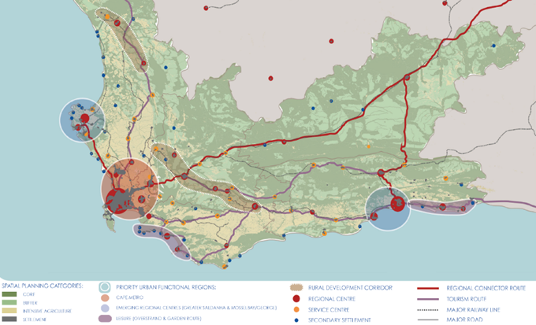
The Western Cape PSDF identifies Beaufort West Town as a Regional Centre, while the N1 and N12 highways are prioritised as Regional Connector Routes as illustrated in Figure 9 above. This is in broad alignment with both the NSDF and the draft KRSDF. The PSDF includes four spatial themes, namely: Resources, Space Economy, Settlement and Spatial Governance. The PSDF composite map graphically portrays the Western Cape’s spatial agenda. In line with the provincial spatial policies, the map shows what land use activities are suitable in different landscapes and highlights where efforts should be focused to grow the provincial economy.

The logic underpinning the PSDF’s spatial strategy is to:

- Capitalise and build on the Western Cape’s comparative strengths (e.g., gateway status, knowledge economy, lifestyle offering) and leverage the sustainable use of its unique spatial assets;
- Consolidate existing and emerging regional economic nodes as they offer the best prospects to generate jobs and stimulate innovation;
- Connect urban and rural markets and consumers, fragmented settlements, and critical biodiversity areas (for example, freight logistics, public transport, broadband and priority climate change ecological corridors); and
- Cluster economic infrastructure and facilities along public transport routes (to maximise the coverage of these public investments and respond to unique regional identities within the Western Cape.

It is noted that the 2014 PSDF is due for a review during the next 24 Months and as such the vision, spatial strategies, policies proposals etc. that the province adopts for the next 10 years could to some extent change.

The Western Cape Inclusionary Housing Policy Framework
The WCG Inclusionary Housing Policy Framework was approved by the Western Cape Government’s Cabinet in 2022 and it seeks to promote spatial transformation, facilitating the provision of affordable housing opportunities in high value, well-resourced urban locations, through private development that is incentivized with additional development rights and other provisions to offset the costs of providing additional, affordable units in their developments. It further seeks to offer an alternative to the poor spatial choices facing our middle to lower income households.
The intention of the Framework is to
- further the Spatial Planning and Land Use Management Act, 2013 (Act No. 16 of 2013) (SPLUMA) principles of spatial justice, sustainability, efficiency, and good governance.
- further the Spatial Planning and Land Use Management Act, 2013 (Act No. 16 of 2013) (SPLUMA) principles of spatial justice, sustainability, efficiency and good governance;
- further the Spatial Planning and Land Use Management Act, 2013 (Act No. 16 of 2013) (SPLUMA) principles of spatial justice, sustainability, efficiency and good governance;

Central Karoo District Spatial Development Framework (CKDMSDF) 2020
The CKDMSDF identifies the Karoo National Park as a Core Area (SPC Category 1). Consequently, the area is delineated as a statutory conservation area. Alignment requirements include:
• Ensure the conservation of the biodiversity of the area;
• Provide for eco-tourism opportunities;
• Provide planned and controlled outdoor recreation opportunities.
Additionally, Beaufort West town is identified as the Regional Service Centre for the CKDM, with the N1 and N12 defined as routes of National Importance and Priority. Murraysburg is a Major Rural Settlement as illustrated in Figure 10.
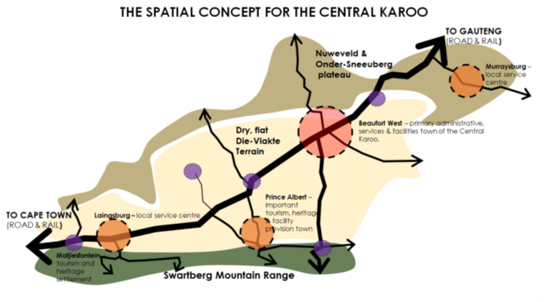
Figure10: Spatial Concept for the CKDMSDF

Living Cape: A Human Settlements Framework

The Living Cape Framework outlines how human settlement planning, delivery and administration can be improved in the province and can add value to this MSDF. The Framework proposes three important shifts namely moving from Housing to Sustainable Human Settlements; Low value production to reaping the urban dividend and most importantly for the State to change its role from provider to enabler.

The Western Cape Land Use Planning ACT, 2014 (ACT NO. 3 OF 2014) (LUPA)
LUPA echoes much of what SPLUMA seeks to achieve from a spatial planning perspective, adding some detail in terms of the process that may be used to develop an MSDF, the content requirements of MSDFs, and setting out the functions of municipalities and provincial government. In brief, LUPA allows municipalities to follow two different processes in developing MSDFs – one with an Intergovernmental Steering Committee and one without. The Beaufort West Municipality has decided to establish an intergovernmental Steering Committee to oversee the drafting process.

Several policies and guidelines were adopted as part of the CKDM, which the Beaufort West MSDF will align itself to. These include the exploration of Shale Gas Extraction as per the 2017 CSIR Strategic Environmental Assessment, and the exclusion areas outlined by the CKDMSDF. Until shale-gas exploration has taken place, there is inadequate information to support or oppose full or large-scale production of shale gas. DEA&DP does, however, acknowledge that the need for information necessitates the commencement of exploration.

Additional provincial policies that inform spatial planning and land use decisions include:
- Provincial Biodiversity Strategy and Action Plan;
- Western Cape Protected Area Expansion Strategy;
- Western Cape Biodiversity Spatial Plan; Western Cape Land Use Planning Guidelines (Rural Areas);
- Karoo Readiness Action Plan.

MUNICIPAL POLICY AND LEGISLATION

2014 Beaufort West MSDF
The Beaufort West MSDF was last revised during 2014 and adopted as a core component of the then IDP. It was adopted again in 2017 as part of the 2017-2022 IDP. As previously indicated, this MSDF is a new compilation. The new MSDF will be adopted as part of the five-year IDP cycle commencing in 2023, therefore presenting an opportune time for the MSDF’s spatial strategy to align with the current IDP.

Beaufort West Municipality IDP
The Beaufort West Integrated Development Plan 2017 – 2022 (IDP) is aimed at coordinating the efforts of various municipal departments in achieving the vision for the municipality as an “economic gateway in the Central Karoo, where people are developed and live in harmony together”. Efforts to achieve this vision are channelled into eight specific values:
- Integrity which includes honesty, fairness, and respect
- Trust
- Responsibility and accountability
- Harnessing diversity
- Participative decision-making
- Transparency
- Professionalism including friendliness, and
- Efficient service delivery.
The intention is for this MSDF to be adopted as a core component of the 5th Generation IDP once it has been approved by Council as required in terms of the Municipal Systems Act, 2000 (Act 32 of 2000).

By-law on Municipal Land Use Planning for Beaufort West, 2019
The By-law on Municipal Land Use Planning for Beaufort West sets out the process for the compilation, adoption, amendment, or review of the MSDF, amongst other things. The process the municipality has followed in compiling this MSDF (Section 1.3.1) is compliant with the process requirements of the municipal by-law.

Implications for the Beaufort West Municipality
The revised, updated and amended MSDF for Beaufort West will be aligned with the policies and spatial proposals for the region as well as the municipal area advanced in the existing National, Provincial, Regional and Local Spatial Plans. In addition, it will adhere to the legislative process and content requirements in terms of all the relevant planning legislation stated above.
As required in terms of the Municipal Systems Act, 2000 (Act 32 of 2000), the MSDF will be adopted as a core component of the Municipal 5th generation IDP. This document will seek to progressively comply, as far as possible, with the prescribed requirements as contained in the applicable planning legislation.

ADJACENT MUNICIPAL INFORMANTS

Adjacent MSDF informants
Figure 11 shows a composite of the adjacent MSDF maps. There are no significant spatial conflicts or misalignments, and the surrounding MSDFs confirm the importance of the N1 (in particular) and N12 as regional connectors. The KRSDF, once adopted, will also be important in guiding development throughout the Karoo region.
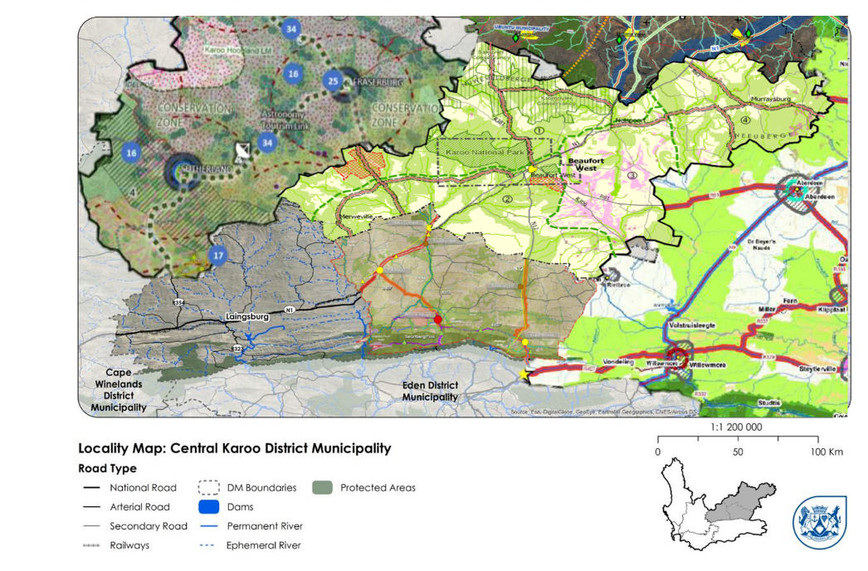
Figure11: Adjacent Municipal Spatial Development Frameworks to Beaufort West

DRAFT VISION STATEMENT AND IMPLICATIONS

Vision Statement
The 2013 MSDF outlines the following vision for the Municipality:

“Wilderness tourism and transport gateway to the people, mountains and plains of the Central Karoo”

The implications of this vision are as follows:

- Beaufort West town has a responsibility to present itself as a welcoming and convenient center for catering for the needs of through travelers as well as to attract visitors to spend time in the sub-region.
- Promoting urban tourism opportunities in the municipality’s settlements will require upgrading their main streets, the creation and management of heritage precincts where appropriate and considerable effort into creating a town and township tourism culture based on B&Bs, restaurants and cultural activities such as the music for which the region has become well known (Karoo Kitaar Blues);
- Beaufort West should position itself as a tourist destination due to its expansiveness and desolation, particularly the areas north of the town in the Karoo National Park and the surrounding mountain regions.
- The main rural economic resource outside of eco-tourism is extensive agriculture. The growth of this resource depends on improving the adaptive carrying capacity of the land through good veld management practices, as well as taking climatic variables into consideration for the types of animals farmed and their carrying capacity.
- Wildlife preservation continues to be an issue in the Karoo. The protection of biodiversity will require ‘Fair Game’ practices to be employed in sheep farming. ‘Karoo Lamb’ must become a trademark geographic indicator to increase its value and contribution to the economy.
- Accessibility and mobility issues, which are dire, can only be addressed if a Rural Integrated Public Transport Network is implemented, which provides periodic, affordable, reliable, and safe services. Current costs of transport are affecting the poor.
- Intensive engagement should continue with the shale gas exploration open cast uranium mining proponents to successfully resolve the following issues to protect the long-term interests of the municipality and its residents:

- Maximizing job opportunities for locals and identify what skills training will be required so that they, and not outsiders, receive job benefits.
- Ensuring that the nature and location of any infrastructure maximizes long term benefits – e.g., staff housing should be located in existing settlements;
- Rehabilitation plans, including proper topsoil stock piling, mine water management, and groundwater contamination, are prepared and implemented on a phased basis as extraction proceeds and not left until all extraction is completed. Mines should be prevented from starting further production phases until rehabilitation milestones of open cast pits or well-pads have been achieved;
- Key areas such as CBAs, conservancies and stewardship areas and visually sensitive landscapes contributing to long term heritage and tourism opportunities should be off limits to mining and shale gas extraction;
- The visual impact on the Karoo landscapes could be severe considerably diminishing their long term tourism appeal unless they are properly rehabilitated;
- One of the potential impacts of shale gas exploration is the contamination of underground water resources and aquifers in particular;
- It should be noted that both Beaufort West and Nelspoort are in a state of potential and, from time to time, actual crisis regarding their water supplies. These are increasingly dependent on groundwater as surface water sources have been inadequate for a number of years in spite of wide-ranging water demand management efforts although there is not much evidence of rainwater harvesting, especially in new low income housing areas;
- Nelspoort is reliant on the Sout River aquifer whose recharge is considerably weakened by the highly degraded soil and vegetation conditions in the basin above. This is an important motivating factor for the biodiversity restoration of this bio-region;
- Beaufort West is exploring aquifers such as Rytkuil to the south of the town. However, this also underlies a potential open cast uranium mine.
- Clearly if the water supplies of these settlements are undermined or compromised their future will be in question; and,
- Short term impacts of shale gas extraction will include transport and traffic and issues around accommodating mining crews (roughnecks), physically (housing) and socially (employment, recreation, entertainment. schooling, health– HIV, alcohol, drugs; crime and prostitution).

CHAPTER 3: STATUS QUO REPORT

INTRODUCTION
The purpose of this chapter is to provide an overview of the current state of development of the Beaufort West municipality, using the latest data and intelligence available, in order to derive the most pressing key spatial issues and opportunities that exist within the municipality.
There are clear issues of scale in considering the context of the Beaufort West Municipality: the municipality’s surface area of 21 916 square kilometres is the largest in the Western Cape province, accounting for 14% of the provincial surface area. Its population of 51 074, however, makes up just 0.7% of the provincial population (Department of Social Development, 2020), and its Regional GDP (GDPR) of R2.2 Billion accounts for just 0.4% of provincial GDPR (Western Cape Government, 2020). These disparities are shown in Figure 12: Chart comparing Beaufort West's Surface Area to Population and GDPR (Figure 11).
This means that Beaufort West’s settlements are dispersed over a large, sparsely populated area, which creates significant challenges for the provision of services to all and connecting infrastructure. These broad regional challenges, which play out over vast expanses, contrast with issues at the settlement scale, where activity is concentrated into much smaller areas. The result is spatial challenges that are polarised in scale.
This Status Quo Analysis covers assessments of Beaufort West’s bio-physical and natural environment, its socio-economic context, and its built environment. It begins with the natural landscape features of the municipality.

Figure 12: Chart comparing Beaufort West's Surface Area to Population and GDPR

BIO-PHYSICAL AND NATURAL ENVIRONMENT ASSESSMENT
Natural systems are the foundational layer on which all of the social, economic, and built environment systems rest. Accordingly, natural systems provide the natural capital, systems, and services from which the socio-economic and built systems derive their value. Whilst currently and historically this relationship is often extractive, it is imperative that these systems are developed, managed, and maintained in a sustainable, resilient way into the future. Thus, geology, soils and climate form the basic geomorphological relationship which gives rise to hydrological, topographical and biodiversity patterns that inform where people live, the activities underpinning the economy, and the built environment and infrastructure response to these.

Natural Landscape
The topography in the South of the municipal area mainly consists of gently undulating plains (Figure 14). In contrast, the northern extent is characterised by the Nuweveld Mountain range, with peaks ranging between 825 to 1,911 m. Toorberg to the south of Murraysburg forms part of the Sneeuberg range which is the divide between the Central Karoo District and the Eastern Cape. The peak is 2,400 metres above sea level and is known for its many watercourses.
The municipal area’s topography is a consequence of the geological formations in the region. There are two significant geological formations in the region, with the southern reaches of the municipality dominated by the mudstone Adelaide Group and a northern portion where Karoo Dolomite outcrops create the Sneeuberg and Nuweveld mountain ranges, leading to the escarpment that defines central South Africa. These features are shown in Figure 13. Using the landscape regions defined by the Heritage and Scenic Resources Inventory and Policy Framework for the Western Cape (2013), the Central Karoo has four broad landscape character types as illustrated in Figure 14, three of which occur in Beaufort West municipality. They are:
(1) the higher altitude ‘Nuweveld Plateau’;
(2) the Nuweveld Mountain escarpment; and
(3) the lower altitude ‘Die Vlakte’ made up predominantly of Beaufort shales / Adelaide Group rock type.
Figure 16 shows that most of the soil clay content and depths within Beaufort West are less than 450mm in depth and the rest of the municipal area has soil depths ranging from 450mm to 750mm. Soil depths greater than 750mm generally occur along river tributaries, which is where the most fertile soils are found within the municipal area. There are no areas with a clay content higher than 35% and thus geotechnical studies in this regard will likely not be required for new developments.
The spatial implications are that the areas with greater soil depths are more arable. These areas should be used for agriculture and protected from inappropriate development (non-agricultural use). The identified dolerite areas (mainly north of Beaufort West) should be treated with special care. Detailed geotechnical investigation of urban development will be required in these areas as these formations hamper development. As a result of the arid, sparse and peaceful nature of the Karoo landscape, there are specific view-sheds worthy of protection and management from inappropriate development – such as the landscape surrounding the Karoo National Park, as well as the interface between the Nuweveld mountain escarpment and the flatter “Die Valkte”.
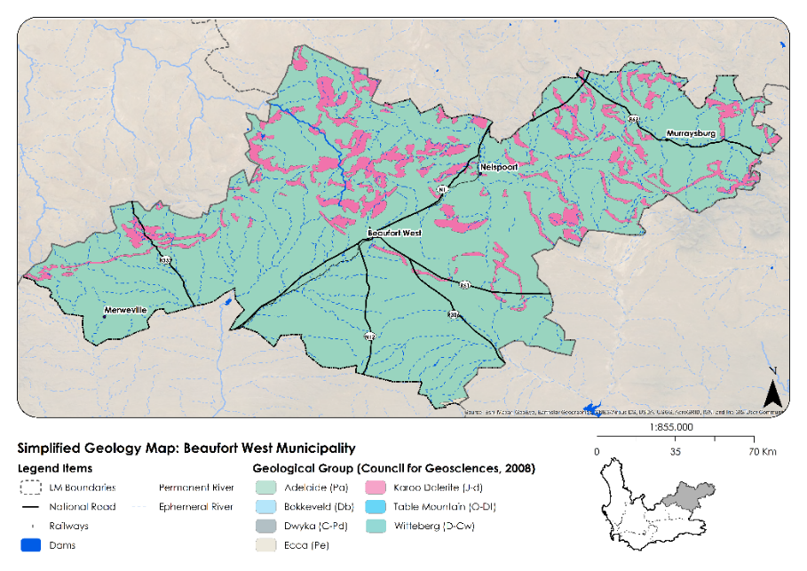
Figure 13: Geology Map for Beaufort West Municipality
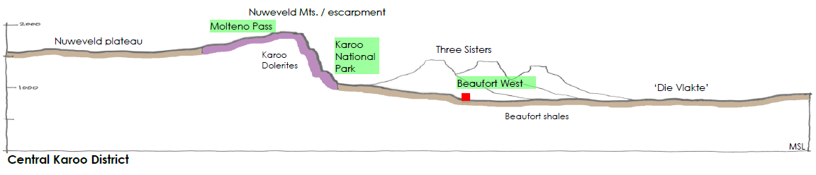
Figure 14: Typical Cross-Section through the Central Karoo District

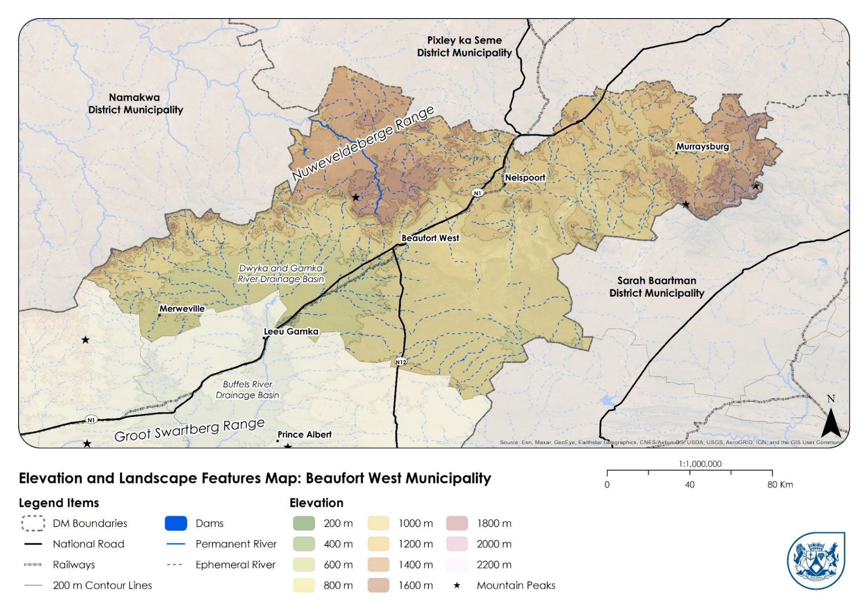
Figure 14: Elevation and Landscape Features Map for Beaufort West Municipality

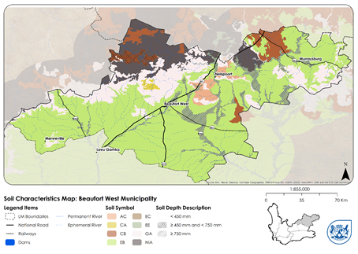
Figure 16: Soil Characteristics Map for Beaufort West Municipality

Climate and Climate Change
Local, district and provincial governments are tasked with implementation of mitigation and adaptation responses to the impacts of climate change on a social, economic, and environment level. Global climate change is impacting us personally, with increasing natural disasters undermining our social and economic systems – the very fabric of our communities. Action at a local level requires pro-active planning and directing, if responses are to match the scale of impact to what is now termed a ‘climate emergency’.
The risks emanating from changing natural conditions such as rainfall and temperature threaten the well-being of the people of the region, many of whom are dependent on incomes derived from industries that are directly or indirectly dependent on the natural/ecological infrastructure of the area. Most of the Western Cape is considered a sensitive natural environment, with climatic extremes being common. And much of it has been lost or compromised. On the positive side, however, many of the ecosystem services supplying the region with water, or ameliorating the temperatures, can be restored, or enhanced through rehabilitation and restoration activities. Investments in the ecological infrastructure that provides these services through ecosystem-based adaptation offer better return on investment, if they are viewed as long-term strategies rather than occasional once-off projects (such as the eradication of water hungry alien invasive plants as opposed to the construction of costly dams).
Decision-making that considers full cost accounting/life cycle costs associated with sustainability under changing conditions, such as increasing ambient temperatures or drought, should become the default approach. For example, upgrading/ replacement of sewage and road infrastructure, upgrading of parks , and funding sustained invasive alien plant clearing can improve water security, water quality and agricultural productivity, as compared to funding that focusses on one-dimensional solutions such as additional boreholes.
Municipal planning cannot be fully informed on climate change unless it has ascertained the following:
- Water availability
- Climate envelope constraints to human and economic activities (temperature extremes, rainfall, frost)
- Climate hazards such as flooding, coastal erosion, and heat islands
- Economic susceptibility to
  - Carbon taxes (border taxes, transport costs, energy costs)
  - Climatic drivers compromising agricultural productivity.
- Energy availability
- How spatial patterns disadvantage women and other vulnerable groups.
- Availability of capital and investment finance
- Where development is planned, and who will own the development? (i.e., who will benefit?)
Prioritisation of development must include climate change response requirements as important weighting factors. The provincial climate change response strategy will provide guidance in terms of a response trajectory, with strategic targets that need to be achieved along the way to a climate resilient end state by 2050. Informed by this trajectory, climate change related focus areas for developmental planning include:
- Embedded and local electricity generation
- Transport system transformation
- Low-carbon compatible economic land uses
- Active retreat from at-risk locations
- Restoration of natural resources
- Natural capital accounting integrated into financial capital accounting.
- Rethink open space planning.
- Allocate development first to priority / optimal development zones.
- Social services accessible to women and disadvantaged groups
- Provision for waste recovery and recirculation
- Matching ambition with the financial balance sheet
- Increasing awareness on climate risk profile and empowering citizens on what needs to be done to improve resilience.
Beaufort West, along with the rest of the Central Karoo region, is a low-rainfall area. According to the Köppen-Geiger climate types, the majority of the southern stretch of the municipal area – the gentle undulating plains featuring Adelaide Group geological formations – is classified as belonging to the BWk, or cold desert, climate type. The area to the East of Merweville is classified as BWh, or hot desert. The Nuweberg and Sneeuberg mountain ranges are classified as BSh, or hot semi-arid. These areas receive the highest rainfall in the municipal area (discussed in more detail in Section 3.2.3). The highest annual temperatures occur in the municipality between December and February. In these months, maximum temperatures exceed 30° Celsius on average. The lowest temperatures are experienced between June and August, when minimum temperatures average around 10° Celsius as illustrated in Figure 22, and morning frosts are common.
While the prevailing climate type means that Beaufort West is ordinarily a water scarce area, this has been dramatically exacerbated by a deep and severe almost decade-long drought that continues to afflict the municipality and the region. The CSIR Green Book (CSIR, 2019) highlights that much of the Northern section of Beaufort West – the hot semi-arid area according to the Köppen-Geiger climate types – is currently at a medium risk of drought events. In the Green Book 2050 projections, this risk is forecast to increase to high and extreme, and to spread throughout the municipal area as illustrate in Figure 20.
Although forecasts and projections are inherently uncertain – and are particularly difficult in the Western Cape’s inland region – it is reasonable to expect that climate change will mean that current trends are amplified in future. In the case of Beaufort West Municipality, this is likely to mean a continued reduction in rainfall, an increase in warm-weather days and associated surface-water evaporation rate increases, and an increase in extreme weather events leading to flash flooding. As such, any relief from the current drought conditions due to increased rainfall in the future must be treated as temporary, and serious adaptation measures for drought must be implemented at the municipal-wide, town-level, neighbourhood, and individual household scales in order to mitigate against current and future drought vulnerabilities.
The spatial implications of drought and climate change risk are discussed in the Karoo RSDF, which notes the following regarding access to water for the broader Karoo region:
- The region is possibly the area that has the highest dependency on ground water in South Africa, and the extent, availability and quality of this resource is poorly understood;
- The low rainfall, and days without precipitation, as well as the possibility of occasional flash flooding in the area, may necessitate a large effort to divert/channel floodwaters towards groundwater recharge and storage areas (e.g., areas with porous soils);
- Increased temperature extremes and more frequent or longer heatwave episodes will impact human and animal activities;
- Alternative service provision modalities, e.g., dry sewerage solutions may have to be considered; and
- With the exception of irrigation areas, livestock and game farming require large spaces for low density farming, bringing with it a set of financial and practical challenges (Karoo Regional Spatial Development Framework, 2020). The viability of stock farming in the future is uncertain, given the current drought and future climate change predictions.
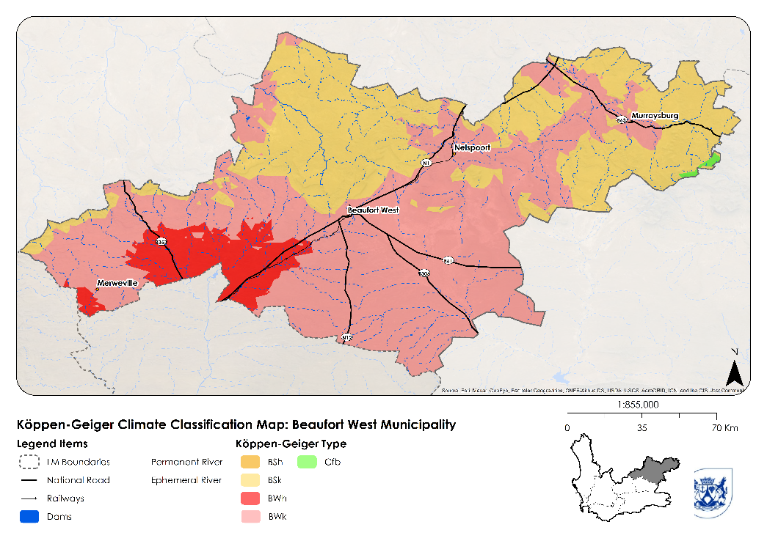
Figure 17: Climate Classification Map
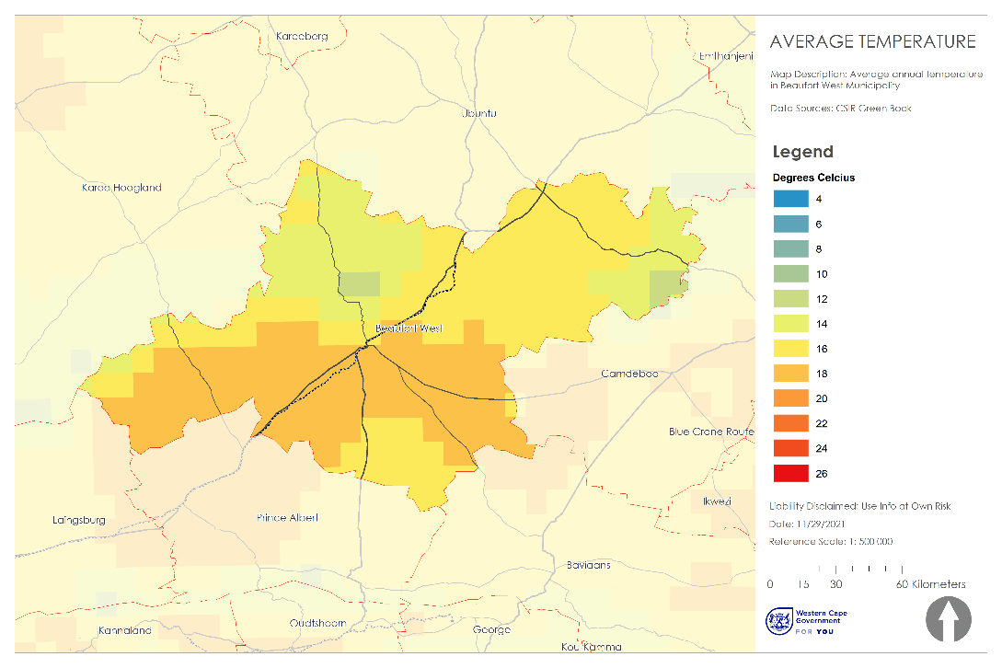
Figure18: Average Temperature in Beaufort West Municipality (CSIR Greenbook, 2021)
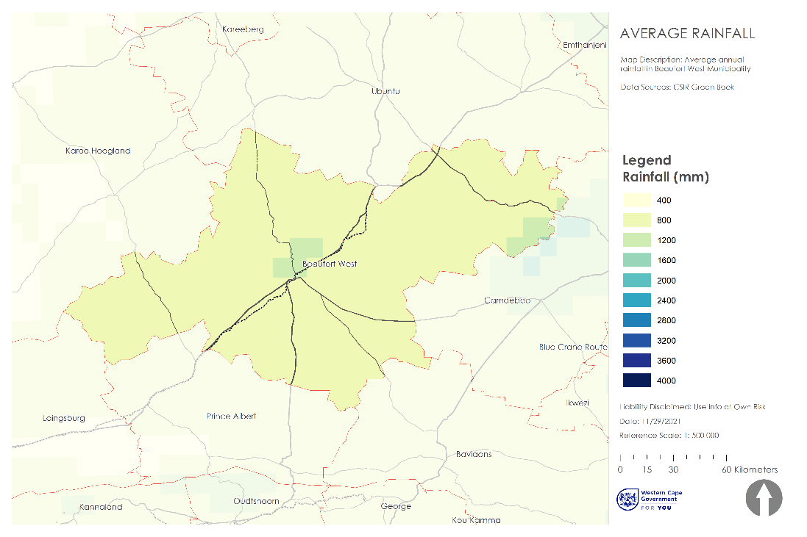
Figure 19: Average Annual Rainfall in Beaufort West Municipality (CSIR Greenbook, 2021)
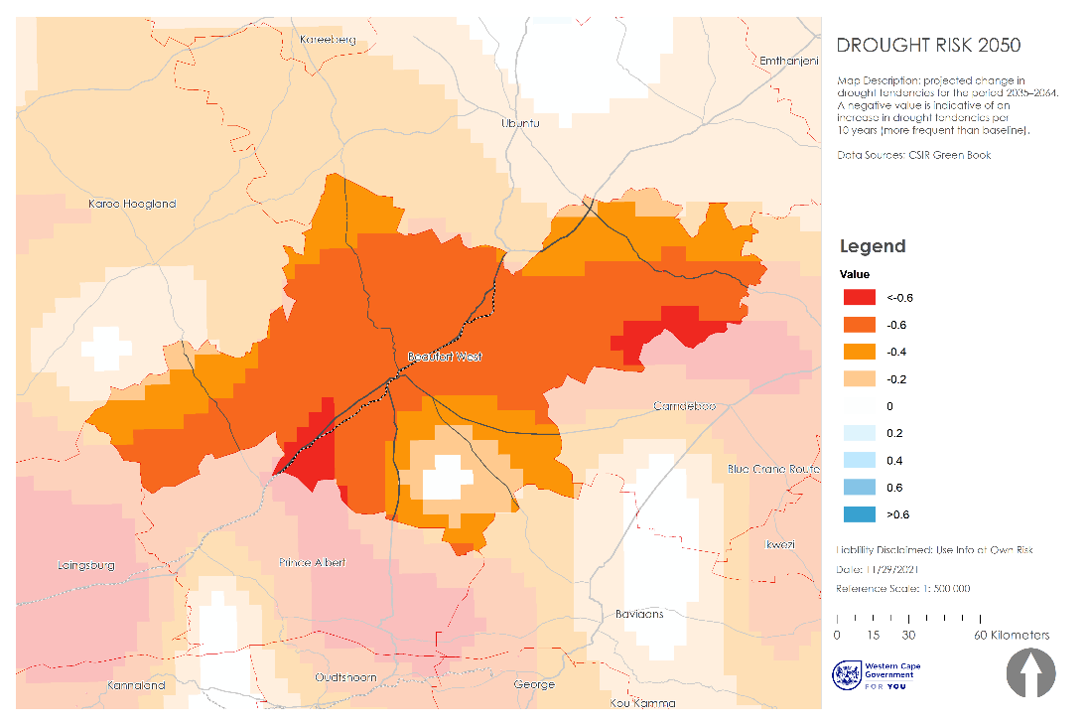
Figure 20: Future (2050) drought risk in Beaufort West Municipality

Water Resources (Hydrology)
As shown in Figure 21, the Beaufort West municipality falls mostly within the upper, drier reaches of the Breede-Gouritz Water Catchment Area (into which the Gamka river drains), although the eastern portion of the municipality (Nelspoort, Murraysburg and surrounds) falls into the Mzimvubu-Tsitsikamma Water Catchment Area (into which the Buffels and Sout Rivers drain), and a small northern portion falls into the Orange Water Catchment Area (into which the Slangfontein and Rietfontein Rivers drain). The Breede-Gouritz Water Management Area (WMA) is the largest WMA in the Western Cape with a total surface area of 53 139 km². The Gouritz River is the main river of the WMA, which flows from the confluence of the Gamka and Olifants River, but is also joined by the Groot River, and contributes 41% of the surface flow in the WMA. The other main rivers, which drain the inland area, are the Buffels, Touws, and Kammanassie Rivers.
The Gouritz Water Catchment Area is managed by the Breede-Gouritz Catchment Management Agency.
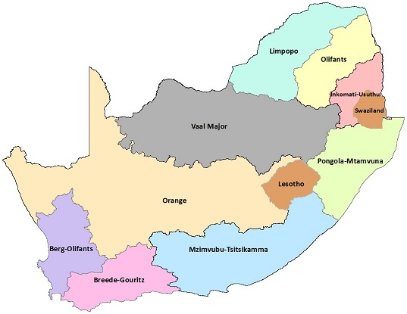
Figure20: South African Water Management Areas (Breede Gouritz Catchment Management Area, 2021)

As discussed in Section 3.2.2, Beaufort West – and the rest of the Central Karoo – is a water-scarce region. The Sout River is the major river in the municipality, flowing from north to south through the northern boundary of the municipality. The Gamka river is the primary river in the central and southern portions of the municipality, along which the Gamka Dam (also called Beaufort West Dam) is located. Whilst the Gamka Dam is the primary source of potable surface water in the municipal area, it has remained largely empty for most of the last decade. Figure 24 shows surface water resources for the municipality. Notable rivers such as the Gamka, Sout, and Dwyka rivers are shown.
Figure 22: shows the historical rainfall and temperature patterns for Beaufort West. As discussed in Section 3.2.2, the hottest months are December to February, with the coldest temperatures occurring from June to August. The highest rainfall occurs in October and November, with monthly rainfall of around 30mm, mostly from seasonal thunderstorms. There is also relatively high rainfall (around 20mm per month) from December to April, during which late-season thunderstorms occur. The driest months are May to September, with rainfall at or below 10mm per month on average as shown in Figure 22.
Figure 25 shows the distribution of mean annual rainfall across the municipality. The highest rainfall is occurring north of the town of Beaufort West and in the east of the municipality in vicinity of Murraysburg. In these areas, annual average rainfall of between 300mm and 600mm per annum has been recorded. The lower rainfall areas are situated in the south of the municipality, where the annual average precipitation sits at between 0mm and 200mm.
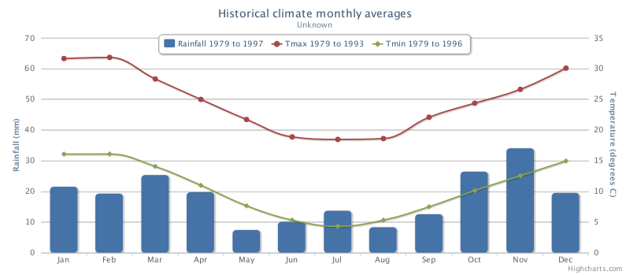
Figure22: Historical Rainfall and Temperature in Beaufort West (Climate System Analysis Group, University of Cape Town, https://cip.csag.uct.ac.za/webclient2/datasets/africa-merged/)
The dry climate and often erratic rainfall leads to surface run-off in the form of flash floods which fill up the usually empty dams. Due to the scarcity of precipitation and subsequent low levels of surface run-off aside from these extreme events, ground water sources are the primary source for the supply of potable water. Figure 26 shows the distribution of groundwater resources in the municipality. The highest potential areas for groundwater track the areas with high rainfall, with the areas in the North and East of the municipality presenting the most favourable conditions for groundwater. This reliance on groundwater has implications for potential action around shale gas development. Figure 23 shows the river condition in Beaufort West Municipality. The majority of the rivers are in an acceptable condition, although there is intensive agricultural production along the banks of the Sout River, resulting in the river being in a seriously modified state.
The spatial implications for Beaufort West Municipality are that groundwater resources should be protected given the unpredictability of surface water supply. Furthermore, the extent and quality of the groundwater resource requires further investigation, to ensure that groundwater is not extracted unsustainably (both by the municipality and through private boreholes), and to ensure that groundwater recharge is prioritised. This is especially important given the potential for shale gas development in the municipality. Current river status should be maintained where the river condition is acceptable, and the condition of the Sout River should be improved given its importance to the municipality. The MSDF must seek out strategic ways to protect water resources and reduce water loss through evaporation reduction as a primary objective, such as covering of any dams and reservoirs. The Municipality should also promote the upgrading of canals to pipeline systems to preserve their scarce water resources.

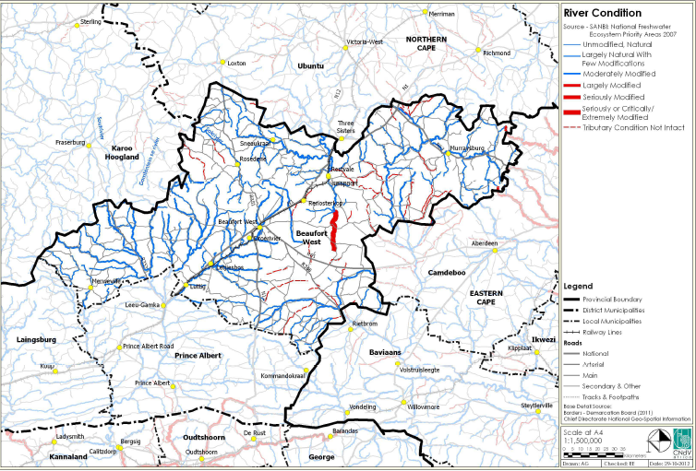
Figure 23: River Condition in Beaufort West Municipality (Beaufort West Municipality; Western Cape Government; CNdV Africa, 2014)

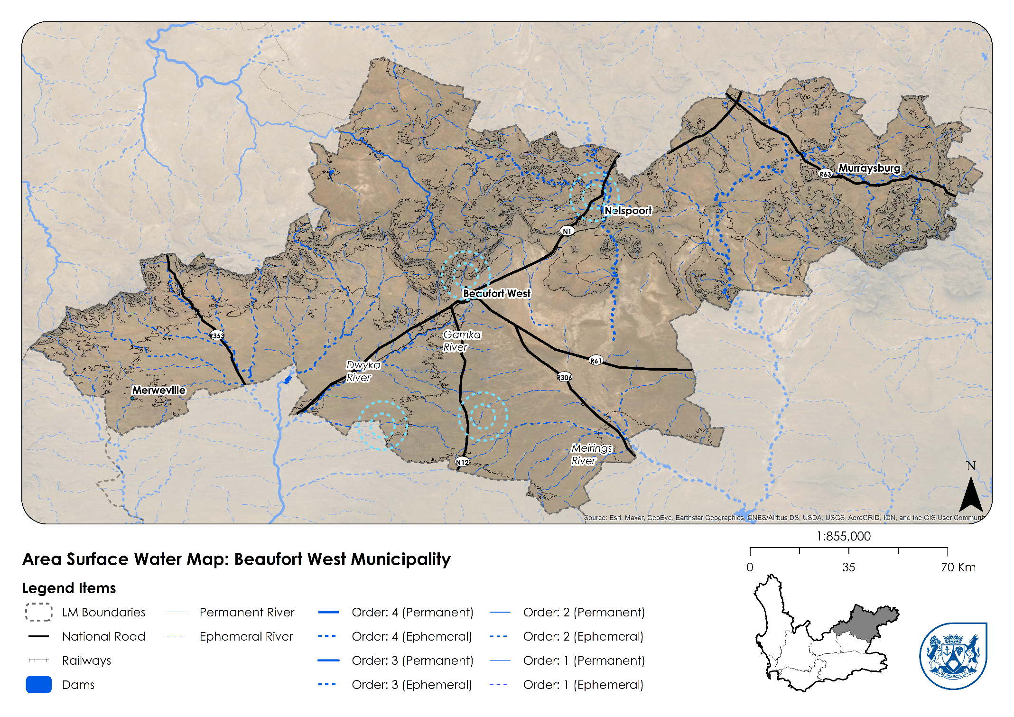
Figure 24: Surface Water Resources for Beaufort West Municipality

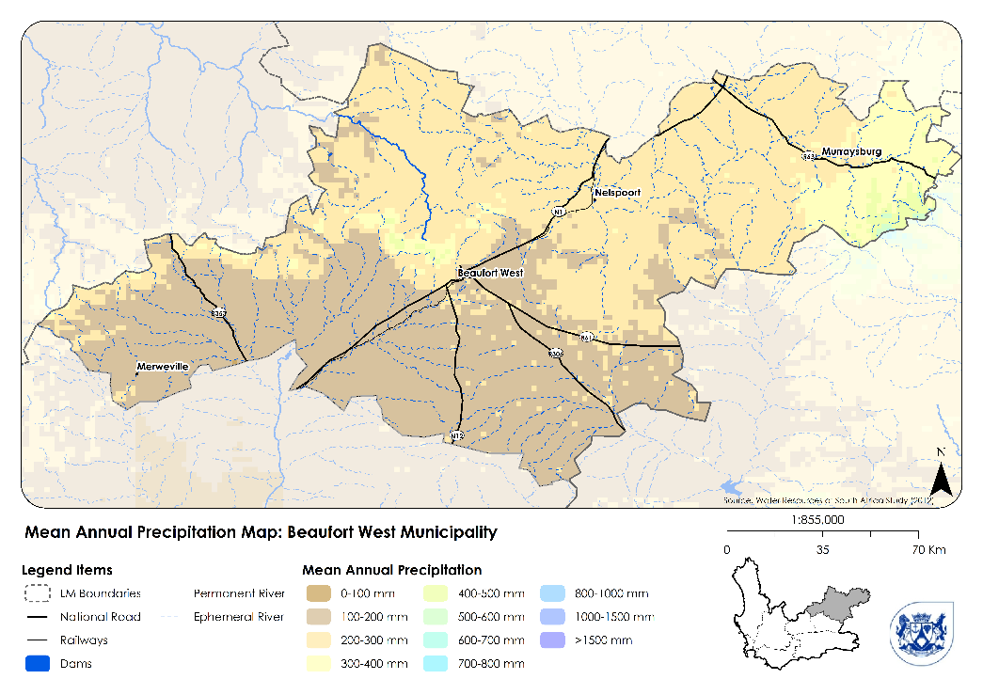
Figure 25: Mean Annual Precipitation for Beaufort West Municipality
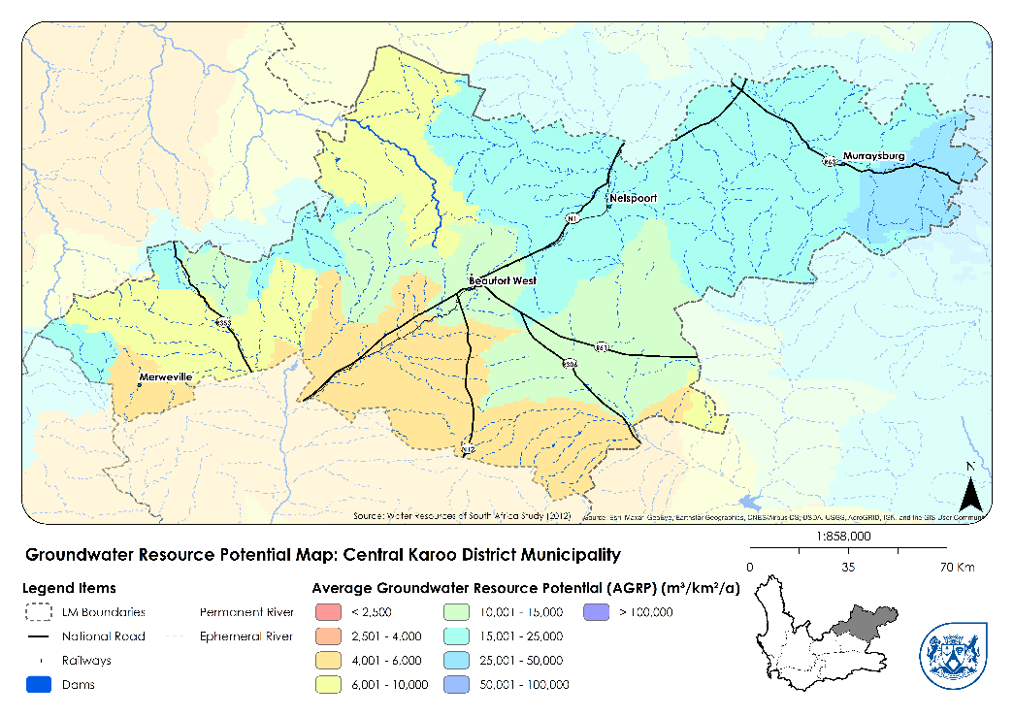
Figure 26: Groundwater Resource Potential Map for Beaufort West Municipality

Biodiversity and Biodiversity Conservation
The key biodiversity management policies and instruments in the Western Cape are:
The Western Cape Biodiversity Spatial Plan
The Western Cape Biodiversity Spatial Plan (WCBSP) was released in 2019 and provides updated biodiversity spatial data for Beaufort West Municipality. This is a critical informant for the future development of the region, as it illustrates Critical Biodiversity Areas (CBA) which are terrestrial features (e.g., threatened vegetation type remnants) and aquatic features (e.g., vleis, rivers and estuaries), and the buffer areas along aquatic CBA features, whose safeguarding is required in order to meet biodiversity pattern and process thresholds. They are identified through a systematic biodiversity planning approach and represent the most land-efficient option to meeting all thresholds. The spatial tool consists of the Biodiversity Spatial Plan Map and contextual information and land use guidelines. The WCBSP recognises that the Central Karoo region (and Beaufort West Municipality) could potentially contain important minerals (e.g., uranium) and fossil fuel (e.g. shale gas) resources which are currently under investigation and could result in high levels of transformation in an area that have to date had relatively low levels of transformation.
The vast majority of the municipal area consists of the Nama Karoo biome. There are small pockets of the Succulent Karoo biome to the North of Beaufort West town. Areas with deep soils and agricultural potential have been heavily utilised for agriculture, leading to them being classified as Azonal Vegetation. As stated in the Western Cape Biodiversity Spatial Planning handbook, the Nama Karoo is important for several threatened faunal species, such as the riverine rabbit (Bunolagus monticularis) which is restricted to riparian habitats in the Karoo. The Nama Karoo is too arid for cultivation but has been impacted through overgrazing practices (Western Cape Government, CapeNature, 2017). Under the worst-case scenario, climate change will alter the vegetation patterns of some biomes. This includes the Fynbos, the Subtropical Thicket, and the Nama Karoo biomes. Important actions include prioritising the protection of ecosystems, habitats, populations, and species with high levels of genetic diversity. Protected areas should include a range of environments and biodiversity. Within these areas, it is important to ensure ecosystem processes are protected (Western Cape Government Department of Environmental Affairs and Development Planning, 2016). The Biodiversity Spatial Planning Categories for Beaufort West Municipality are shown in Figure 29. In the Western Cape Provincial Spatial Development Framework, the entire landscape is divided into spatial planning categories (SPCs) "to reflect how the area should be developed spatially in order to ensure sustainability". MSDFs must convert the Biodiversity Spatial Planning Category into Spatial Planning Categories. The relationship between Spatial Planning Categories and Biodiversity Spatial Planning Categories is shown in Figure 27. This will be applied in the composite map under the MSDF proposals.
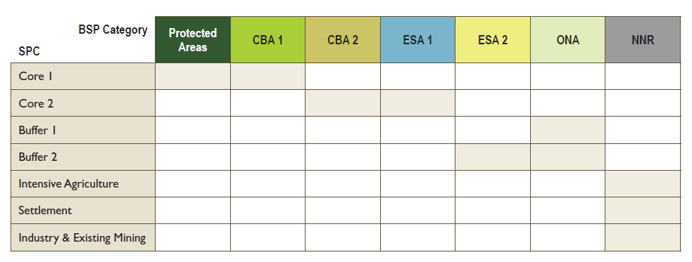
Figure 27: Conversion from Biodiversity Spatial Planning Categories to Spatial Planning Categories (Western Cape Government, CapeNature, 2017)
The Ecological Infrastructure Investment Framework (EIIF)
The Western Cape Government’s Ecological Infrastructure Investment Framework (EIIF) (Western Cape Government, 2020) also provides guidance to prioritise investment in green infrastructure in the province. Ecological infrastructure consists of the ecological and social components of systems that are responsible for the realising of ecosystem goods or services. Understanding these components and their linkages allows investment in them to improve particular ecosystem goods and services. It also facilitates the “engineering” of natural spaces for desired ecosystem goods and services. The EIIF identifies catchment clusters within the Western Cape and defines investment objectives based on prioritised threats specific to these catchment clusters. Beaufort West Municipality falls within the Gouritz, Gamtoos, Sundays and Orange catchment areas. The four Investment Objectives (IO) identified in the EIIF are:
- IO1: Improved water quality and quantity
- IO2: Reduced threat of wildfires
- IO3: Improved rangeland management
- IO4: Reduced exposure to increased flooding
The Beaufort West Municipality is also home to the Karoo National Park, an important environmental conservation asset and tourist attraction for the area. It is critical that the site of the park and its buffer zones as shown in Figure 30, are protected from the effects of harmful development to protect the ecological integrity, scenic landscape, and tourism value of the park. The municipality should seek to assign a budget to improve conservation activities.
Alien invasion is a major threat to biodiversity and an Invasive Alien Clearing and Monitoring Plan must be prioritized. Public landowners should also prevent the spread of alien vegetation. The municipality must continue to promote the eradication of alien vegetation.
The spatial implications are that the areas designated as Critical Biodiversity Areas and Ecological Support Areas in the Western Cape Biodiversity Spatial Plan must be appropriately managed, and safeguarded against future inappropriate development, in line with the WCBSP. The WCBSP will thus be a key informant of the Spatial Planning Categories that will underpin the proposals of this MSDF, specifically to manage land use in the rural areas of the municipality (outside of the urban edges of the settlements). Ecological Infrastructure focus areas are mountain catchments, rivers, wetlands, and rangelands. These areas should be prioritised accordingly, and the Karoo National Park must be protected. Development within the buffer zones must be prevented or mitigated to prevent activity-related disturbances to the park.

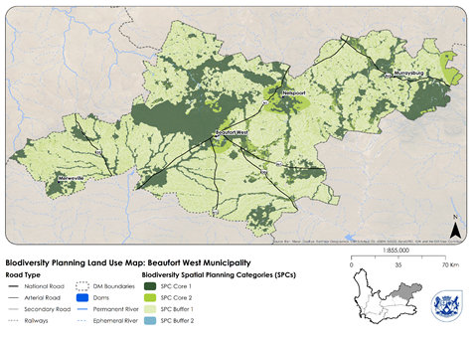
[TO BE REPLACED WITH HIGH RESOLUTION MAPS]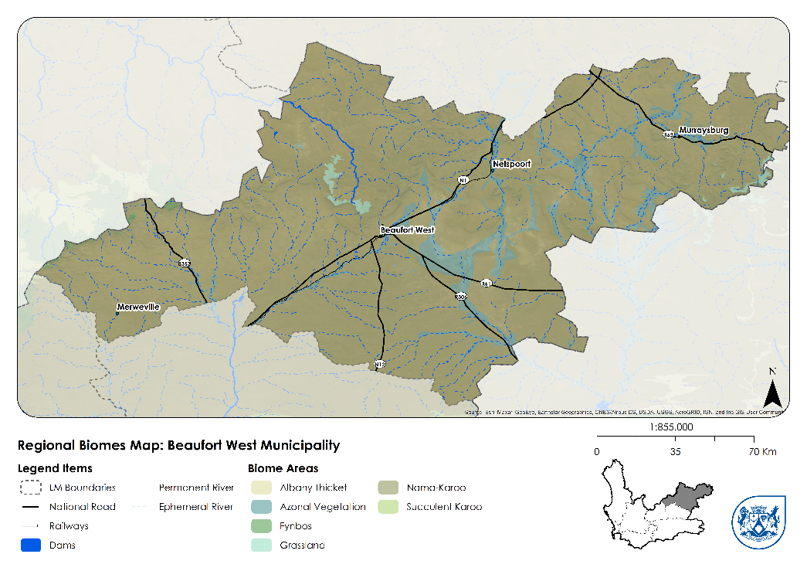
Figure 28: Regional Biomes in Beaufort West Municipality

[TO BE REPLACED WITH HIGH RESOLUTION MAP]
Figure 29: Biodiversity Spatial Planning Categories for Beaufort West Municipality]

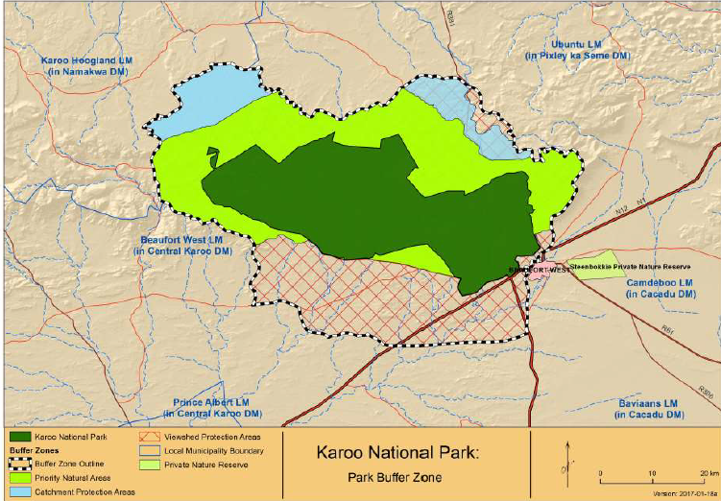
Figure 30: The Karoo National Park and Buffer Zones (SANParks, 2021)
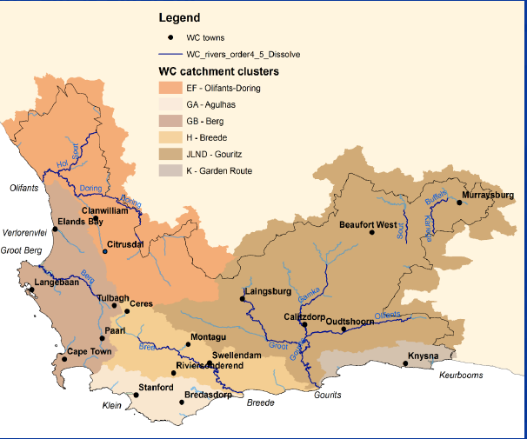
Figure 31: EEIF Catchment Clusters in the Western Cape (Western Cape Government, 2020)

Agricultural Resources
While agriculture is an important sector for the Karoo region and other municipalities in the Central Karoo District Municipality, Beaufort West Municipality has limited agricultural resources largely because of the region being water scarce – a situation that has been compounded by the near decade-long drought. Agriculture is a relatively minor contributor to the regional economy, with agriculture, forestry, and fishing accounting for 11.7% of regional GDPR for 2018. In addition, the agricultural sector is expected to have contracted by 8.7% in 2019 (Western Cape Government, 2020). There are very few areas of cultivated land in the municipal area, with the majority of this land located close to Murraysburg. The nature of the agricultural activities in the Beaufort West municipal district is directly derived from the type of soils in the area, precipitation, and associated water availability. Two main types of agricultural activities take place, namely lucerne and feed-grain production and livestock production (mainly sheep), with livestock farming being the biggest (Beaufort West Municipality; Western Cape Government; CNdV Africa, 2014). Beaufort West Town has been identified as an Agri Hub by the National Department of Agriculture, Land Reform and Rural Development due to its position on key transport routes in the N1 and N12 highways, along with the railway line as shown in Figure 33. This means that the town and the municipality have a significant role to play for agriculture in the region and district beyond agricultural production within the municipality.
The relatively low levels of agricultural production in the municipality have been compounded by the current drought conditions and other factors impacting land availability. These include large land acquisitions in the last several years within the Karoo region by the state for the Square Kilometre Array, national parks, and defence force testing sites. These have removed land from production and have contributed to a decline in agricultural activity (Karoo Regional Spatial Development Framework, 2020).
The key issues for agriculture in Beaufort West Municipality are:
- Water availability (or lack thereof)
- Climate change, with predicted increased average temperatures and drought occurrences
- Rangeland degradation (as a result of alien invasive plants and poor agricultural management)
The key opportunities for agriculture in Beaufort West Municipality are:
- Agri-Tourism
- Investing in the Green Economy (wind/solar energy)
- Agricultural sector embracing new 4IR applications (use of drones)
- Investing in ecological infrastructure for improved resilience and job creation
The spatial implications are that existing agricultural activities should be maintained where possible, and interventions targeted at improving water availability and re-use should be prioritised.
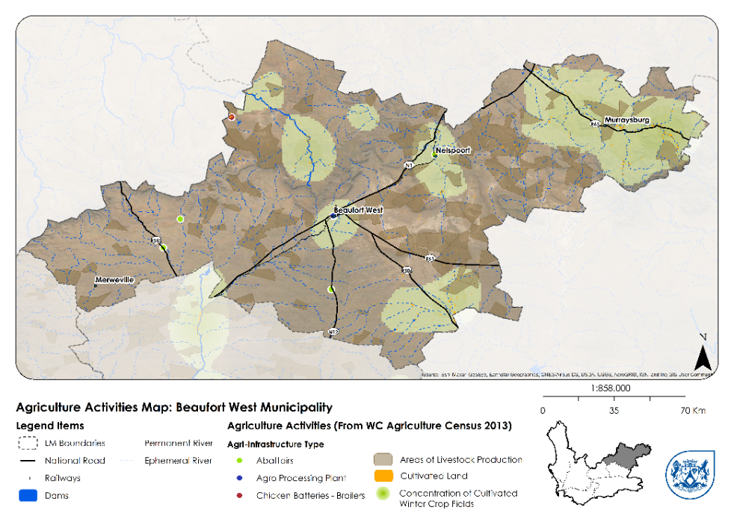
Figure 32: Agricultural Activities Map for Beaufort West Municipality
[TO BE REPLCED WITH HIGH RESOLUTION MAP]
Figure 33: FPSU Catchments and settlement status in Beaufort West Municipality

Mineral Resources
The municipality is on the verge of major change in the mineral resources sector. Firstly, the Central Karoo District in general has extensive uranium deposits. which begin north of Prince Albert and Laingsburg and reach their highest density north of the N1 in the vicinity of Merweville. These deposits have attracted the attention of energy and mining conglomerates but remain untouched. Currently, the area-southeast of Beaufort West town is undergoing a process for receiving prospecting rights for Uranium mining.
Based on the status of the regulatory (mining right) applications in terms of the MPRDA submitted by Tasman Pacific Minerals Limited and Lukisa JV Company (Pty) Ltd (Tasman), their mining operation is likely to commence within the next 10-year period and will initially be located within the Beaufort West Local Municipality within a 50 km radius of the proposed central processing plant (CPP), the location of which is not known at present, but anticipated to be near to the town of Beaufort West (Western Cape Government, 2021).
Secondly, shale gas exploration within the Central Karoo basin has become an increasingly important consideration for Government. Several companies intend to explore shale gas within the Karoo region, and this has become a contentious issue among environmentalists, farmers, local residents and various government and non-government institutions.
The entire Beaufort West Municipality is located in the area designated for shale gas exploration as shown in Figure 34. Should the proposed shale gas extraction through shale gas exploration acquire approval from the relevant competent authorities, an important consideration for the municipality will be to protect the ground water resource and ensure that areas of critical biodiversity value are protected from such activity. The MSDF proposals map will therefore guide such decisions for the allocation of land use rights.
The issues around shale gas exploration and development are complex. Much of the impact of development will depend on the outcome of the exploration that is currently taking place. The Strategic Environmental Assessment (SEA) conducted by the Council for Scientific and Industrial Research (CSIR) (Scholes, Lochner, Schreiner, Snyman-Van der Walt, & de Jager, 2016) outlines the impacts according to three potential scenarios: Small, Medium and Big Gas. The production stage of Shale Gas Development operations might last 10-30 years, probably with the highest level of activity in the first 3-5 years. It involves the development of production wells (and access roads to the well pads), the establishment of a gas pipeline network to convey produced gas to a central treatment processing plant, and the export of the treated gas by pipeline for the downstream uses. During production, a typical shale gas wellfield occupies an area of about 900 km², which contains 50-60 well pads, each supporting around 10 wellbores. Importantly, the SEA highlights that including more natural gas in South Africa’s energy mix would make the energy system more resilient, efficient, cheaper, and reliable and it is understood that gas forms a critical component of the transition away from oil and coal as a bridge to renewable energy sources. The Integrated Resource Plan (Department: Energy, 2019) seeks to accelerate the identification of local gas resources, to shift away from gas imports.
However, there are significant potential risks relating to the receiving environment, particularly for groundwater and scenic resources. Additionally, shale gas development will have significant spatial impacts – and associated demands for transport infrastructure and housing demand in particular, but also urban and non-urban infrastructure, facilities and services. According to the CSIR’s SEA, towns in close proximity to Shale Gas Development (SGD) activities will experience growth exceeding projections based on past trends. For the Big Gas scenario, the risk is assessed as high, but can be mitigated to moderate. Enhanced resource and institutional capacity to plan for and address increased service delivery demand for housing, water provision, social services, electricity and roads will be required.
Additionally, regulatory uncertainties and limited municipal capacity to facilitate ongoing processes of land use and land development applications associated with SGD poses a high risk without mitigation. The SEA also finds that the primary option for mitigation of this type of risk is to enhance integrated spatial planning, but also the need has been identified to establish a planning shared service center for the Karoo to ensure sufficient skills exist to manage the expected regulatory approval process. This will be essential to deal with the multi-scaled and inter-sectoral issues that result from activities of magnitude and duration of SGD.
Shale gas exploration and development adds considerable uncertainty to Beaufort West’s development trajectory. There are significant spatial implications associated with any potential development. The areas identified for protection in the WCBSP must be adhered to, and groundwater resources must be carefully monitored, protected, and avoided. Any new residential or commercial development that takes place as a consequence of shale gas development must take place within the municipality’s existing towns and must adhere to development guidelines therein.
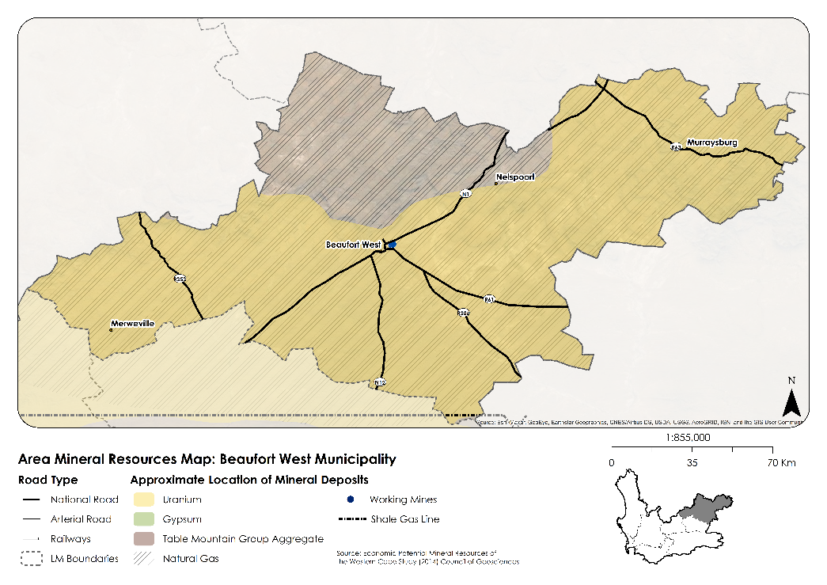
Figure 34: Mineral Resources in Beaufort West Municipality
[TO BE REPLACED WITH HIGH RESOLUTION MAP]

REGIONAL AND LOCAL SOCIO-ECONOMIC CONTEXT LINK

Population and Household Trends
The Beaufort West population is estimated to be 51 158 people for 2021 (Department of Social Development, 2020) – essentially unchanged from the 2020 projection of 51 298, when the population is estimated to have peaked. The population has increased from the 2002 estimate of 48 790 by a total of 4.5%, which translates into an average annual growth rate of 0.14% (Table 1). While there are expected to be some fluctuations in the population over the coming years as shown in Figure 35, the medium-growth population projection for 2035 of 51 146 represents a change of 0.00% from 2021. From 2021 to 2035, the total number of households is projected to increase by 9.6%, from 13 087 to 14 343. This – along with a flat population – means that household sizes are expected to decrease from 4.1 in 2021 to 3.7 in 2035, which is a trend that is consistently seen throughout South Africa: that household formation growth is greater than population growth.
Population projections are inherently uncertain, and it is important to contextualise that these estimates have been generated at the time of highest uncertainty: at the end of a census cycle and prior to the subsequent census. It will be necessary to check these projections and recalibrate infrastructure and housing plans accordingly against the 2021 census once its data is available. As discussed in Section 3.2.6, shale gas development will also have a significant impact on population numbers in the municipality should it proceed. Projections will also need be to be revised based on the findings of shale gas exploration in the area. In the SEA’s Medium and Big Gas scenarios, Beaufort West’s population will increase significantly as a result of jobs created by shale gas development.
The spatial implications of this are complex. Should only limited shale gas development take place, the focus in ensuing years needs to be on consolidating and maintenance of existing infrastructure networks and meeting current demand and planning for possible decline in the case of Beaufort West’s smaller settlements. However, should significant shale gas development occur, the focus needs to be on planning for the predicted population growth, accommodating increased housing demand and pressure on services and infrastructure that may occur, also considering that this growth may be temporary.
 | 2002-2021 | 2021-2035
Average Growth Rate Per Year | 0.14% | 0.01%
Total Growth | 4.85% | -0.01%
Table 1: Population Growth Rates for Beaufort West Municipality

Figure 35: Past Population Growth and Future Projections for Beaufort West Municipality

Economy and Employment Trends and Forecasts
The town of Beaufort West houses the Central Karoo District Municipal Offices, as well as Provincial and National facilities and services for the region, which partially accounts for Beaufort West being the economic hub of the Central Karoo District. Beaufort West contributed 70.1% to the district’s Regional Gross Domestic Product (GDPR) in 2018, as shown in Table 2.
While Beaufort West may be the largest contributor to GDPR in the Central Karoo District, its contribution to GDPR is also growing at the slowest rate of the three local municipalities in the district. Where GDPR in Prince Albert and Laingsburg grew at rates of 1.6% and 1.3% from 2014 to 2018, Beaufort West grew at only 0.6% over the same time period. While the neighbouring municipalities are starting from a smaller base and so can be expected to experience higher growth, it is important to note that Beaufort West’s economic growth rate over this period was lower than that of both the Central Karoo District (0.9%) and the Western Cape (1.4%).
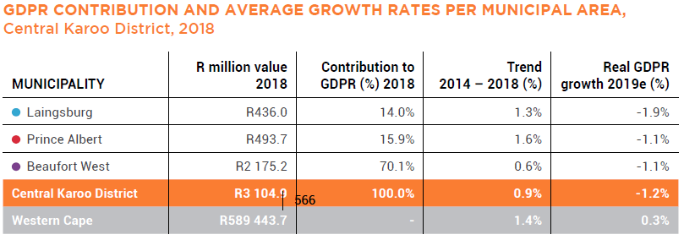
Table 2: GDPR Contribution for CKDM Municipalities (Western Cape Government, 2020)
In 2018, the economy of the municipal area was valued at R2.2 billion (current prices) with 12 515 employment opportunities. Despite remaining the same in terms of current prices, it is estimated that in 2019 the economy contracted by 1.1 per cent in real terms, while 16 jobs were lost. COVID-19 will have exacerbated this contraction, with GDPR expected to decrease by 5.1% in 2020, followed by a recovery of 1.0% in 2021 – not enough to offset the decreases of either 2019 or 2020 (Western Cape Government, 2020).
Table 3 shows the economic performance and employment contribution per sector in Beaufort West. The tertiary sector is the largest contributor to both GDPR and employment. The sectors that contributed the most to economic growth between 2014 and 2018 in the municipal area include the finance, insurance, real estate, and business services sector, as well as the general government sector. The long-running drought caused agriculture to contract by 8.7% in 2019, with knock-on effects on the transport, storage and communication sector which also contracted by 1.7%.
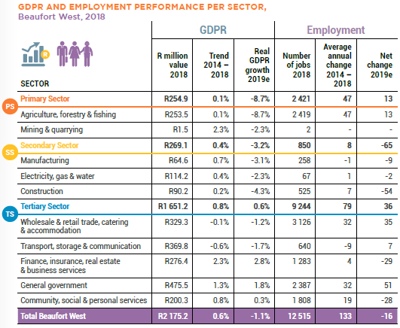
Table 3: GDPR and Employment per Sector for Beaufort West Municipality (Western Cape Government, 2020)
Analyses performed for the Karoo RSDF identified educational services and health care and social assistance as the two most resilient sectors to economic shocks in the region. In contrast, the least resilient sectors were utilities, construction, wholesale trade, retail trade, and transportation and warehousing (Karoo Regional Spatial Development Framework, 2020).
The spatial implications of this suggest that there is scope to invest further in health care and educational facilities. While the general improvement in health indicators in recent years (discussed further in Section 3.3.3) suggests that there is improvement in access to health care and social assistance, the dearth of educational facilities – and a dearth of tertiary institutions – suggests that investment in this area should be prioritised moving forward. The analysis in the Karoo RSDF suggests that beyond the obvious social benefit of such investment (in the form of improved education outcomes), there is also significant direct economic benefit from investment in educational services. The decline in agricultural activity is concerning and needs to be monitored. From a spatial perspective, intervention that targets improved water retention and re-use should be prioritised, and resources that drive tourist activity (such as the Karoo National Park) must be protected and preserved. Drought-resilient farming techniques should be proactively pursued, supported, and promoted to make the agricultural sector more resilient to an even more water-constrained future. Drought-resilient farming techniques should be proactively pursued, supported, and promoted to make the agricultural sector more resilient to an even more water-constrained future.
The Municipality’s Economic Recovery Plan, following the impact of Covid-19 should seek alignment with its Economic Development Strategy, and those of neighbouring municipalities in the Central Karoo and the KRSDF.
Potential economic growth and development areas (drawn in part from the PACA study 2013) include the following:
- Stock farming (drought permitting)
- Tourism and stayovers in Beaufort West town
- Mineral and gas reserves
- Passing traffic retail and refreshments
- CBD (Donkin Street) urban design improvements
- Renewable energy
- Aviation potential and aviation school
- Creating tertiary education opportunities
Collaboration between local economic stakeholders is a key aspect in maximising the economic potential in the municipal area. The role of the Beaufort West Municipality is to ensure the optimisation of local resources and available capacity through facilitating the participation of stakeholders and establishing partnerships with key public and private sector institutions.

Socio-Economic Conditions
Income and employment
Real GDPR per capita for Beaufort West was R26 000 per annum in 2018 – lower than the district average of R27 000 and almost half of the provincial average of R59 124 (Western Cape Government, 2020). Income inequality, as measured by the Gini Coefficient (where a number closer to 0 reflects lower levels of income inequality), compares favourably to both South Africa and the Western Cape. In 2019, Beaufort West’s Gini coefficient was 0.588, while the Western Cape’s was 0.618 (Western Cape Government, 2020). The most recent figure for South Africa as provided by Stats SA has the national Gini coefficient at 0.67 as of 2015 (Statistics South Africa, 2019). However, Beaufort West’s Gini coefficient in all likelihood is a result of the generally lower income levels discussed above – when the majority of residents earn very little, income levels will be clustered together and income inequality will be lower. The local municipality employs 741 staff per 100 000 residents – higher than Laingsburg or Prince Albert Municipality. This reflects the importance of the general government sector to the municipal economy. However, Beaufort West has severe capacity constraints in the capacity of its municipal staff; the municipality employs 0 qualified planners, accountants, or environmental officers, as shown in Table 4. These shortages reflect capacity issues within the municipality.
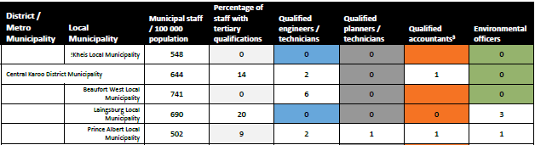
Table 4: Municipal Staff, Central Karoo District Municipality (Karoo Regional Spatial Development Framework, 2020)
Basic Services
While access to basic services has improved in recent years in Beaufort West (Figure 35), the rest of the province has improved substantially more on most measures, with the result that Beaufort West is now the lowest-ranked municipality in the province according to the Western Cape Government’s Growth Potential Study. This decline is more reflective of its relative performance compared to other municipalities than it is of a decrease in Beaufort West’s levels of infrastructure provision, which have actually improved:
A decrease from 31 to 0 in the infrastructure theme Score100 is observed for Beaufort West, from GPS13 to GPS18. The infrastructure theme Z-Score decreased from (-)0.95 to (-)1.51 standard deviations below the mean. Beaufort West is now the lowest ranked in this theme, a change from 19th of 24 Municipalities in GPS13 (Western Cape Government, 2020).
Social Facilities in Beaufort West settlements are mapped from 39 to 42. The spatial distribution of social facilities in the Central Karoo District Municipality is shown in Figure 37 and Figure 38. An important issue that needs to be addressed in the municipality is the lack of gender-based violence support facilities. There are no such facilities in the municipal area. Given the fact that most of the population sits in the town of Beaufort West, it would make sense to locate at least one facility there.
There are 14 public libraries in the municipal area. Many of the sports fields in the towns are walled off from the streets surrounding them. Sports fields have significant potential to add to the recreational and public space experience of residents. As such, attention should be given to sports fields that have solid walls surrounding them, as these detract from the quality of public space and remove an asset from the public domain.
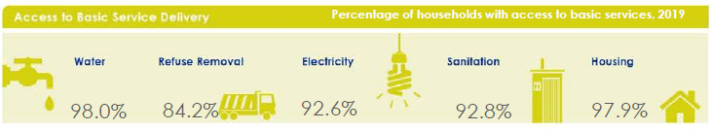
Figure 35: Access to Basic Services in Beaufort West Municipality (Western Cape Government, 2020)
Education
Learner enrolment increased by 1.8% per annum from 2017 to 2019. There are 18 schools, down from 20 in 2017 as schools have been rationalised, consolidated, and closed. The learner-teacher ratio has increased as the number of schools has decreased, sitting at 33.2 in 2019 – higher than the national average of 29.3. There are very limited opportunities for tertiary education through FET colleges in the municipality. There are no major capital investments in education infrastructure planned in the municipality.
Health
Beaufort West had 6 Primary Healthcare Clinics (CHCs) in 2019, consisting of 5 fixed and 1 Community Day Centre (CDC). There is 1 ambulance per 10 000 residents. Currently, and for the foreseeable future, there is no need for additional Health Care Services in the Beaufort West Area. The levels of EMS coverage are shown in Figure 45.
Any future Health services needs will be guided by the growth of the dependent population and the burden of disease. Infrastructure owned by the Department of Health is shown in Figure 36, while active and proposed projects are shown in Figure 37.
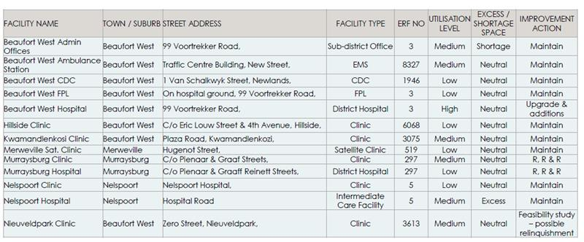
Figure 36: Accommodation owned by the Department of Health in the Beaufort West municipal area (Western Cape Government Department of Health, 2021)
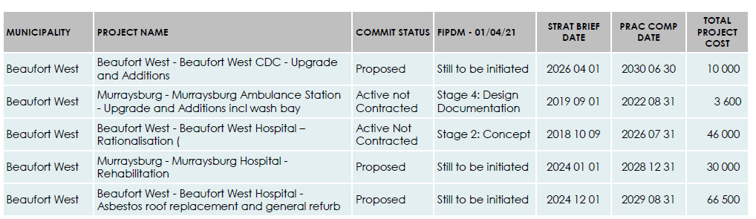
Figure 37: Active and proposed projects in the Beaufort West municipal area (Western Cape Government Department of Health, 2021)
Several key metrics relating to access to healthcare have been improving in Beaufort West Municipality. For example, child health outcomes have improved over the last several years, with immunisation rates reaching 76.7 percent in 2019/20. The number of malnourished children under five years (per 100 000) has also improved from 3.9 in 2018/19 to 3.7 in 2019/20. In turn, the neonatal mortality rate (NMR) (per 1 000 live births) improved from 13.4 in 2018/19 to 8.4 in 2019 – compared to 17 infants per 1000 live births for the province in 2017 (Western Cape Government, 2020) The low-birth-weight indicator was recorded at 19.3 in 2019/20, an improvement on the 22.4 in 2018/19.
Similarly, there were no in-facility maternal deaths in the Beaufort West municipal area in 2019/20 and the delivery rate to women between the ages of 10 and 19 improved from 18,6 percent in 2018/19 to 15.7 in 2019/20. The termination of pregnancy rate in the Beaufort West municipal area and the broader CKD was zero. A low termination rate is strongly associated with a decrease in unwanted pregnancies which in turn attests to improved family planning and access to health care services.
However, rates of certain natural causes of death, including chronic lower respiratory disease, hypertension, and tuberculosis, were elevated relative to the province. Prevalence of these conditions is associated with the Social Determinants of Health – the conditions in which people live and work (WHO Commission on the Social Determinants of Health, 2008). The issues listed in particular are associated with inadequate ventilation, poor nutrition and lack of physical activity – all of which can be partially addressed through spatial interventions. There are no land requirements for health infrastructure in Beaufort West Municipality, although doctor’s residences are required in Murraysburg.
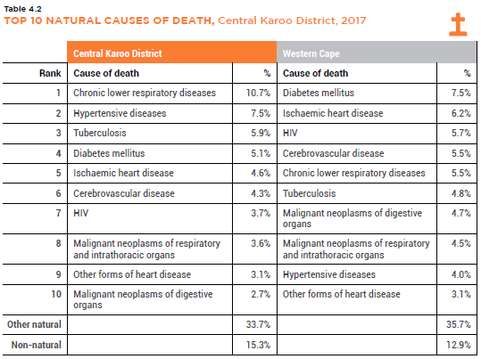
Table 5: Leading Natural Causes of Death, Central Karoo District (Western Cape Government, 2020)
Crime
Figure 36 shows the rates and total number of contact crimes for each category in 2018/19. Beaufort West was not in the top 10 for any crime category in this period (Western Cape Government, 2021).
Table 6 shows the projected number and cost of new facilities based on Department of Social Development population projections for 2035. The spatial implications of the above facility-related analysis are that access to basic services needs to be prioritised in order to improve rates of access for Beaufort West residents relative to other municipalities in the province. Interventions aimed at addressing the Social Determinants of Health should be prioritised while maintaining the current trend of improved outcomes in indicators for maternal and child health. School closures are a concern and the lack of an FET college in the municipality is a gap that should be addressed.
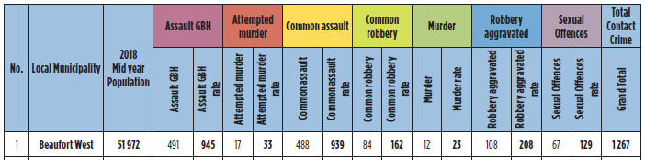
Figure 36: Contact Crime Rates for Beaufort West Municipality (Western Cape Government, 2021)

Table 6: Projected Cost of new facilities by 2035 in Beaufort West Municipality

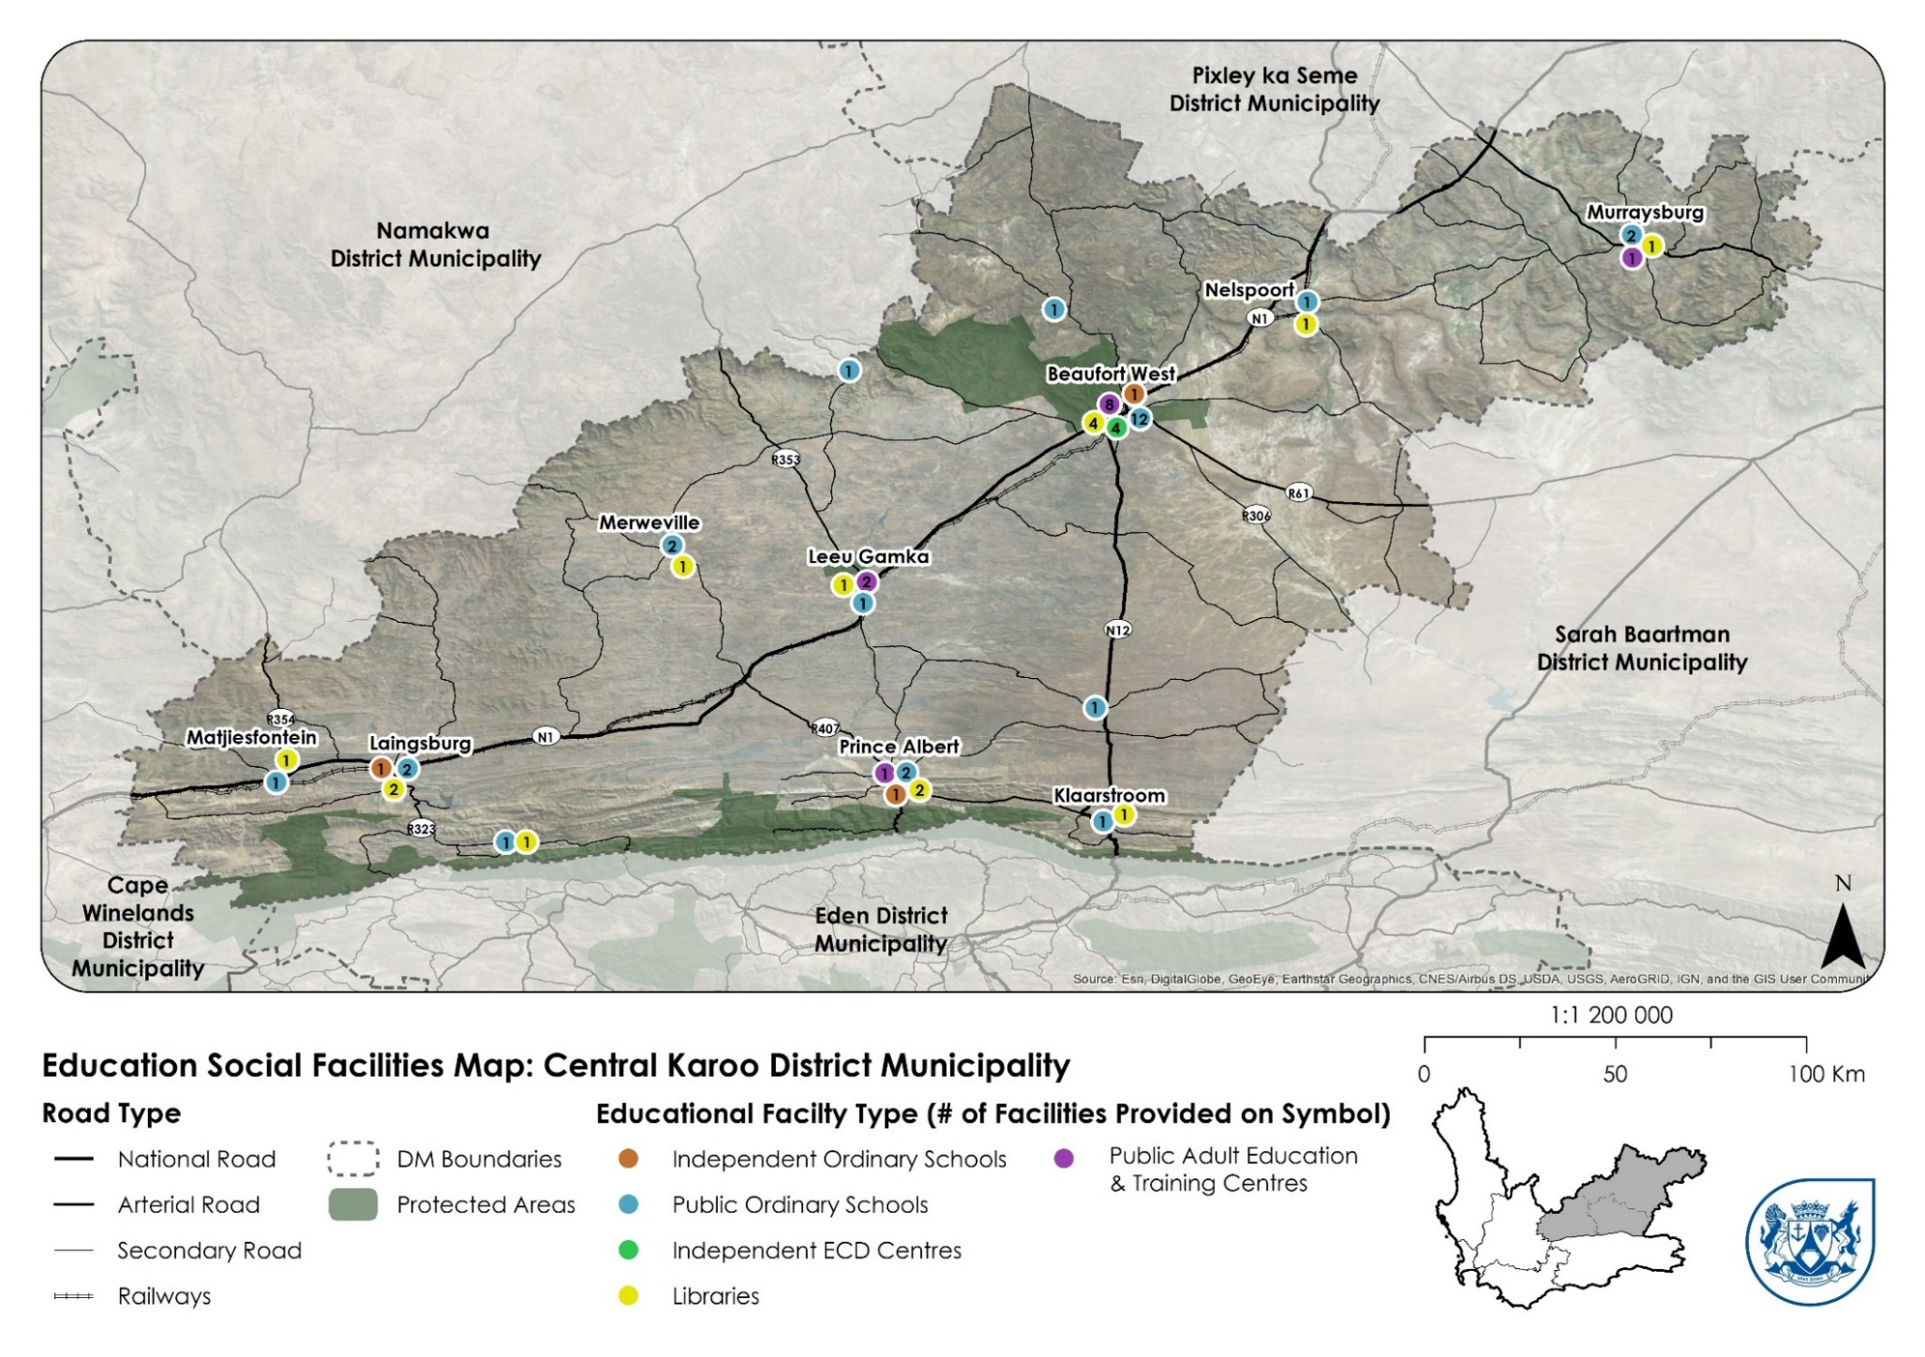
Figure 37: Education facilities in the Central Karoo District Municipality

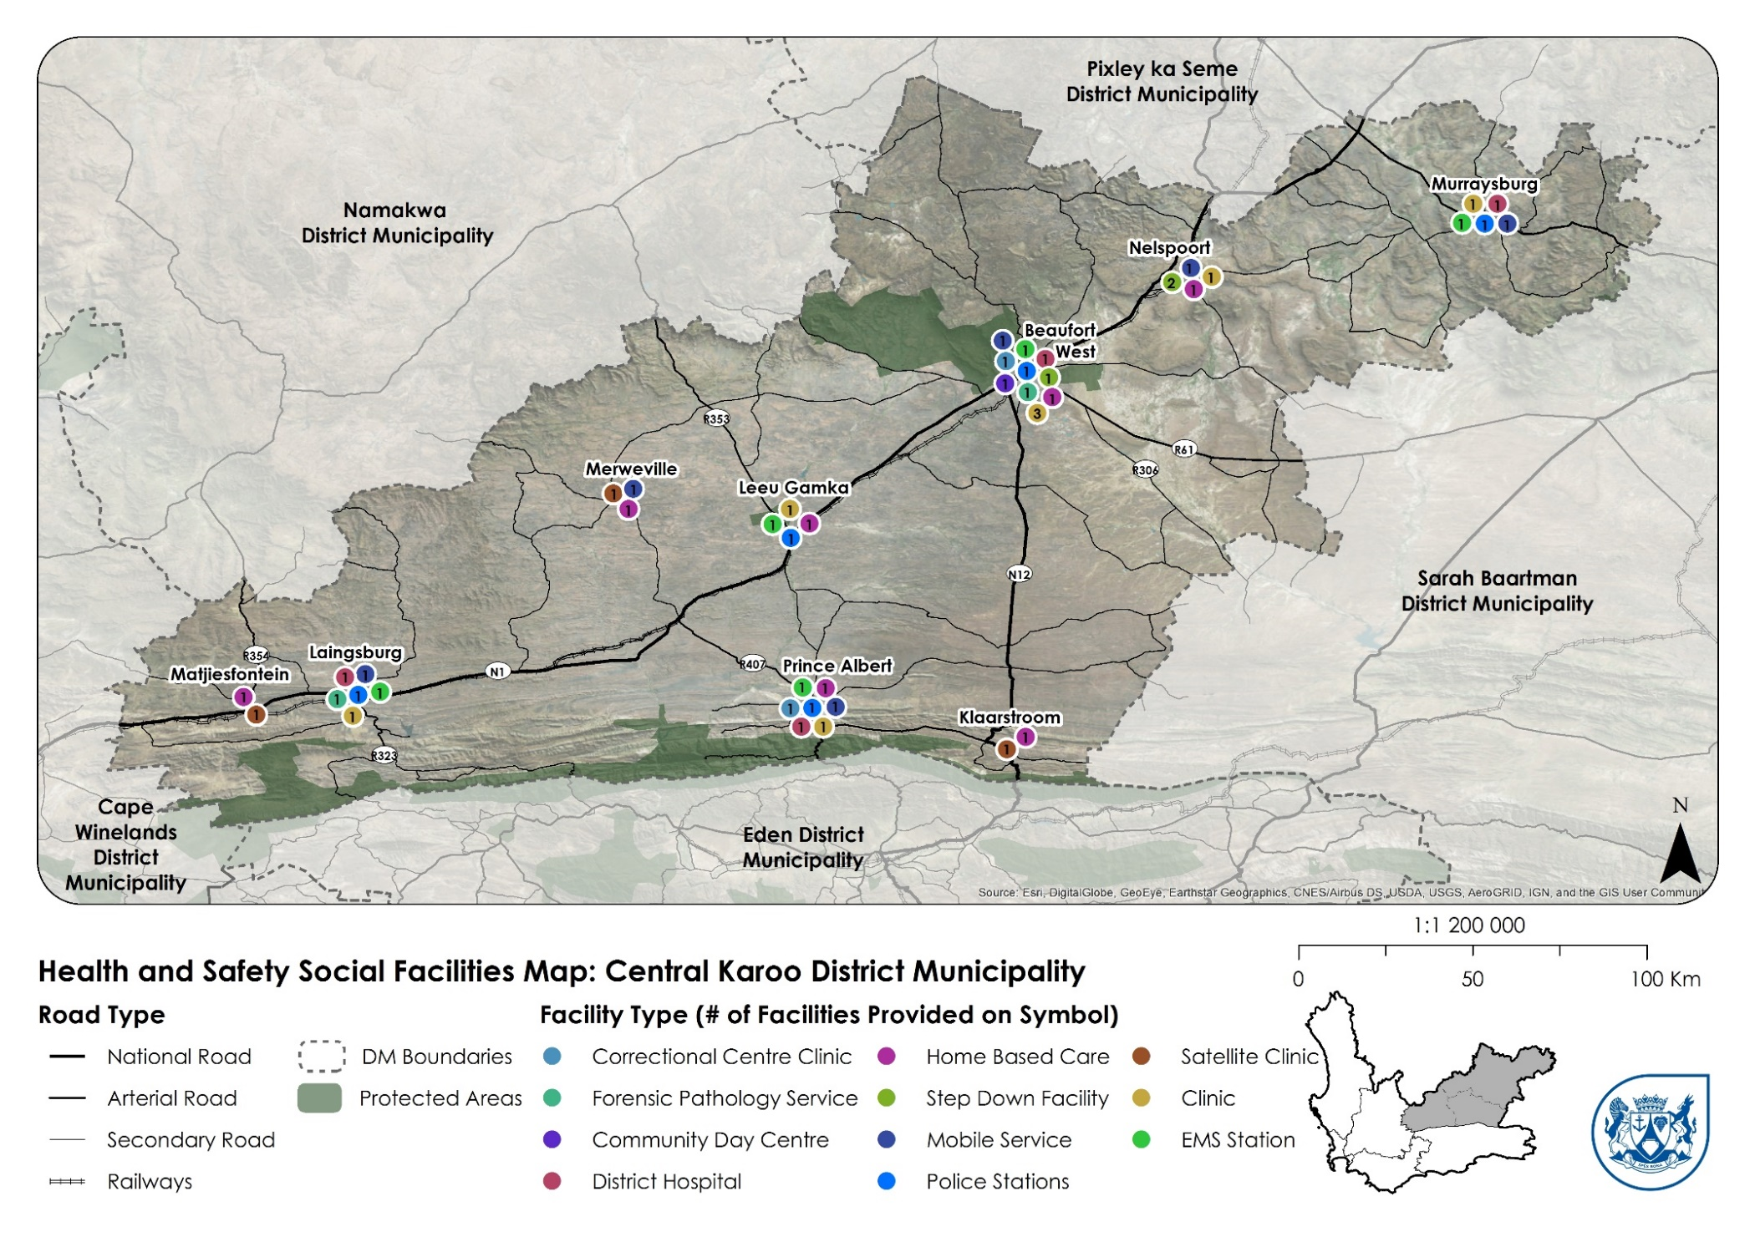
Figure 38: Health and safety facilities in the Central Karoo District Municipality
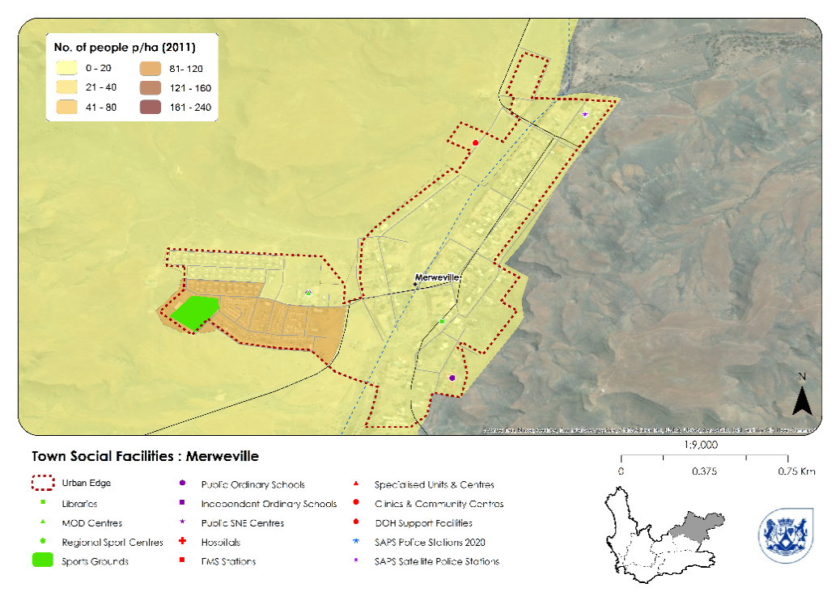
Figure 39: Social Facilities for Merweville
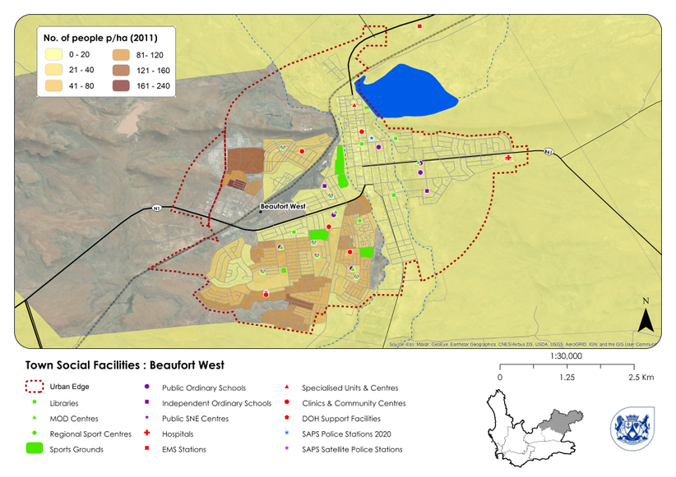
Figure 40: Social Facilities for Beaufort West Town
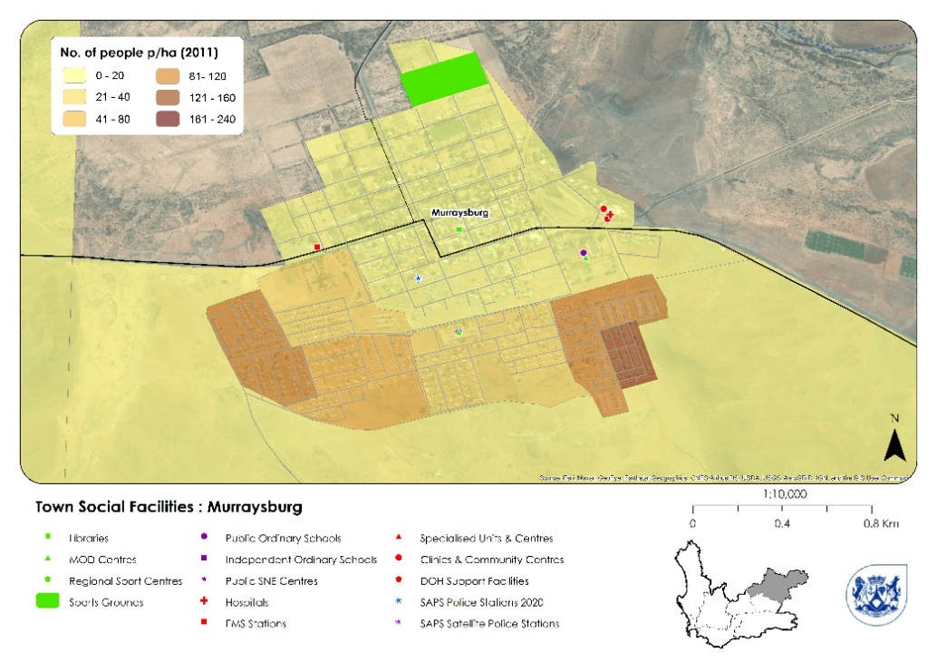
Figure 41: Social Facilities for Murraysburg
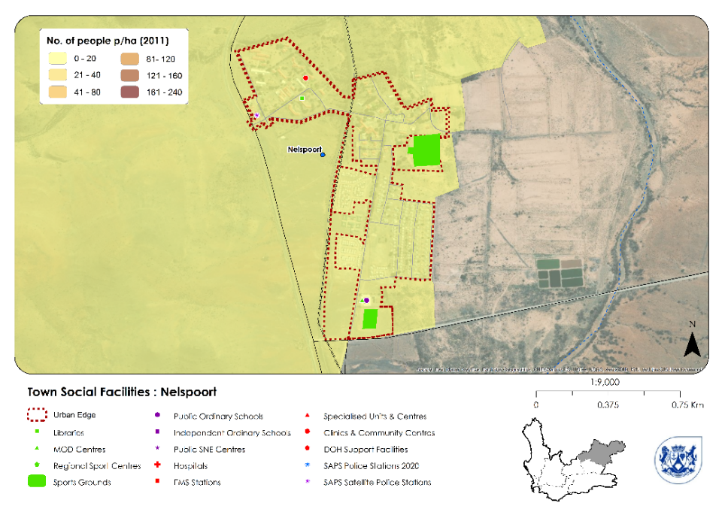
Figure 42: Social Facilities for Nelspoort

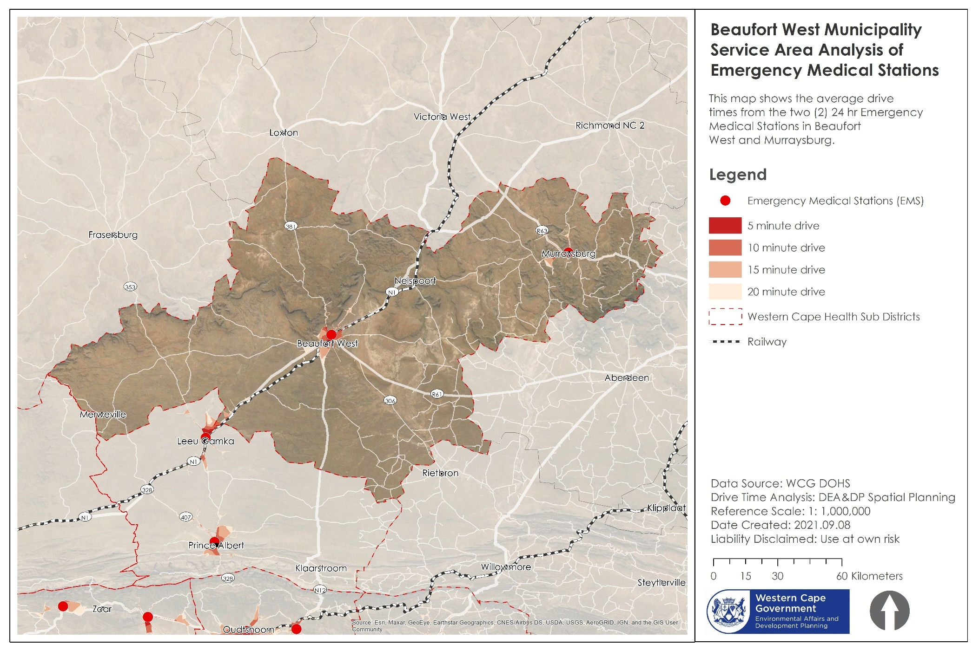
Figure 44: Service Area analysis of EMS stations

[TO BE REPLACED WITH A HIGH-RESOLUTION MAP]

Property Market
Figure 45 and Figure 46 show the number of sales and average sale price for farms and residential properties in Beaufort West town and Beaufort West rural areas, according to Property24. It appears that COVID-19 had an impact on the number of properties listed on the market, which declined markedly from 2019 to 2020. This appears to be rebounding in 2021, according to Figure 46. The average asking price increased during 2021, although the average sale price remained flat.
The spatial implications of this still need to play out. The high number of properties currently on the market coupled with declines in average asking and sale prices is reflective of a struggling local and national economy and should be monitored. However, COVID-19 has completely disrupted the property market and it may take several years for it to stabilise. Spatially differentiated data on property market activity is currently difficult and costly to obtain. Having access to such information would allow for more sophisticated analysis and facilitate a deeper understanding of how and where people want to locate in the municipality, as well as providing more insight into the local economy and demand for land. Anecdotally, however, the town of Beaufort West by far remains the most dynamic in terms of property transaction volume and range of property types and price ranges available, followed by Merweville which appears to be experiencing a tourism-related uptick in property transactions, also potentially as a result of the tarring of the road connecting Merweville to the N1 highway in the last decade. Murraysburg transaction volumes are low, reflective of a very distressed and stagnant property market and associated lack of appetite. There are also currently no properties listed for sale for Nelspoort on Property24.
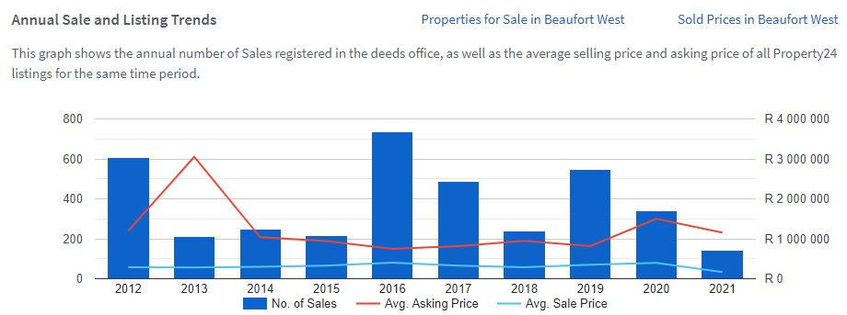
Figure 45: Annual Sale and Listing Trends for Beaufort West (Property 24, 2021)
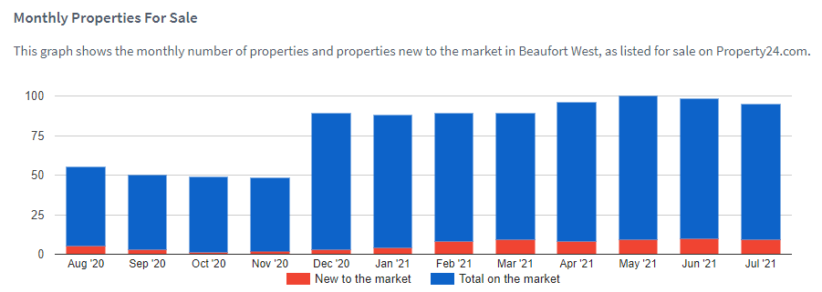
Figure 46: Monthly Properties for Sale in Beaufort West (Property 24, 2021)

Municipal Finances
Beaufort West Municipality is in dire straits financially. At the end of the 2018-19 financial year, its cash balance was −R12 421 274. This is a very pressing issue. According to National Treasury’s Municipal Money, a municipality's cash balance refers to the money it has in the bank that it can access easily. If a municipality's bank account is in overdraft it has a negative cash balance. Negative cash balances are a sign of serious financial management problems. A municipality should have enough cash on hand from month to month so that it can pay salaries, suppliers and so on. With the importance of the general government sector to the municipal economy and employment, this is an extremely serious concern (Municipal Money, 2021).
Compounding matters further, for the most recent financial year to be audited – 2019/20 – the municipality received a Disclaimer of Audit Opinion from the Auditor General. This means that the municipality was not able to account for how it spent public money – that it provided insufficient evidence in the form of documentation on which to base an audit opinion. The lack of sufficient evidence is not confined to specific amounts or represents a substantial portion of the information contained in the financial statements (Municipalities of South Africa, 2021). Further to this, the Western Cape Provincial Treasury found that the budget Beaufort West tabled for the 2021/22 financial year was not credible and was unfunded. As a result, the municipality will not receive equitable share grants until it is able to demonstrate that it has adopted a credible budget funding plan.
For the previous audit year (2018/19, when Beaufort West received a qualified audit), the municipality underspent 22% of its operating budget, and 14.9% of its capital budget. This is extremely concerning given that 23.2% of the operating budget that was spent was classified as fruitless and wasteful expenditure. The municipality generated 64.5% of its revenue locally. The balance (35.5%) was sourced through grants and transfers from national government (Municipal Money, 2021).
The spatial implications of this are self-evident. If the municipality is not able to account for how and where it spends its money, the provision of services, related maintenance, and capital investments is at best opaquely reported and at worst not undertaken timeously, and ultimately the residents of the municipality will suffer. It is imperative that the municipality’s finances are properly managed so that investment in new infrastructure and maintenance of existing assets can take place to serve the people of Beaufort West and put the municipality on a better footing to realise economic growth and private sector investment.

Tourism
The Karoo Regional Spatial Development Framework places a significant focus on tourism within the Karoo region, arguing for the development of a single Karoo brand to market the region to visitors. While it is important to develop tourism at the regional scale, the unique assets of individual places and streetscapes within towns are key to doing this. Tourist attractions in Beaufort West include the Karoo National Park and the Chris Barnard Museum, along with attractions like Karoo architecture, charm, cuisine, and culture.
Most tourists visiting the Central Karoo District (92.5%) are domestic tourists. The Western Cape accounts for the highest share of visitors to the district (with 41% of visitors originating in the province), followed by Gauteng with 23% as illustrated in Figure 47. The majority (77%) of visitors coming to the district do so for the purposes of leisure, with culture and heritage being the dominant (68%) activity undertaken (see Figure 48 and Figure 49).
The spatial implications of this suggest that preserving and enhancing Beaufort West’s existing heritage, streetscapes, karoo charm and architecture and natural resources is an important driver of economic activity and job creation going forward. Specifically, Donkin Street of Beaufort West (in many ways, the “face” of Beaufort West) can be significantly enhanced with necessary municipal investment, landscaping, and urban design improvements, as well as the heritage areas of Merweville, Nelspoort and Murraysburg, which can attract private sector initiative, entrepreneurship and investment, and hence attract tourism opportunities.
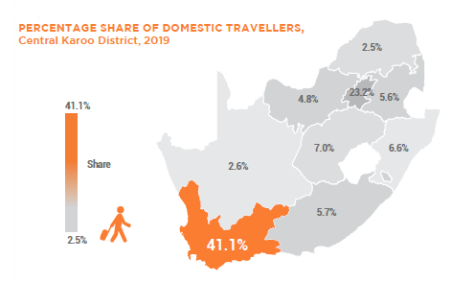
Figure 47: Percentage share of domestic travellers to the CKDM, 2019 (Western Cape Government, 2020)
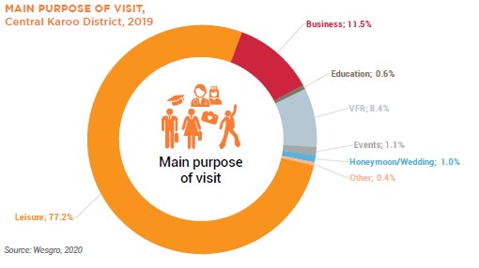
Figure 48: Main purpose of visit to the CKDM, 2019 (Western Cape Government, 2020)
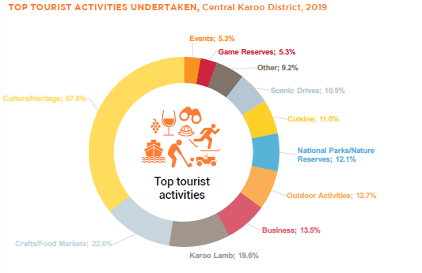
Figure 49: Top tourist activities undertaken in the CKDM, 2019 (Western Cape Government, 2020)

Trade
While the Central Karoo District as a whole has a positive trade balance as illustrated in Figure 50, Beaufort West has minimal import or export activity and contributes very little to this as shown in Figure 51. Indeed, while the district exported goods to the value of R67.4 million in 2019, Beaufort West contributed only R35 703 to this figure. This is in spite of Beaufort West having the largest economy in the area. The district’s positive trade balance is driven by Prince Albert, with dairy and wine products being the major exports. The manufacturing sector has also been a significant contributor to trade in the district, with food and beverages, metals, metal products and equipment, and electrical machinery and apparatus being the key products that are manufactured in the district. These products are linked to agricultural production, and as such there is a clear relationship between the agriculture and manufacturing sectors within the district.
The spatial implications of this depend on the municipality’s trajectory in terms of agriculture and shale gas development. As discussed in Section 3.2.5, agricultural activity has been declining in Beaufort West, which may explain its negligible contribution to trade in the district. Given that drought conditions are only expected to worsen, and the relationship between agriculture and manufacturing, the only sector that can be expected to make a sustained contribution to trade activity in the municipality in the future is the mining and quarrying sector. This is due to the potential for shale gas development and uranium mining discussed in Section 3.2.6. However, any increase in activity in these areas must take place with careful consideration for harmful environmental effects. There may, however, be unrealised manufacturing activities that Beaufort West could benefit from due to its location between Cape Town and Gauteng on the N1. Potential manufacturing activities should be identified by the municipality, and actively encouraged to locate within the municipality. Private sector investment generally, however, only follows where a municipality is seen to be well run, and hence the municipality must proactively improve its governance, urban management, infrastructure maintenance and renewal, and attractiveness of the municipality to encourage such investment.
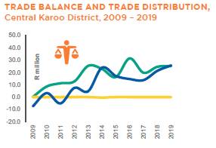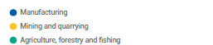
Figure 50: Trade balance for the CKDM (Western Cape Government, 2020)
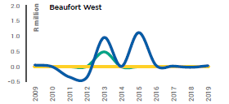
Figure 51: Trade Balance for Beaufort West Municipality (Western Cape Government, 2020)

Agriculture, Land Reform and Rural Development
The NDP targets, amongst other things, the development of a more inclusive and integrated rural economy. Its rural strategy is based on land reform, agrarian transformation, livelihood and employment creation, and strong environmental safeguards. Land reform and rural development, the responsibilities of National Government, are also on the PSDF’s spatial agenda as they have an important contribution to make to rural transformation. Overall, the evidence suggests that the pace of land reform in the province has been slow, and that there has been limited employment of underutilised state, provincial and municipal land as well as commonage to date. Strategies to develop small scale farmers are yet to produce results at scale.
The Central Karoo District Rural Development Plan/DALRRD Sector Plan (refer to Figure 52 and Figure 53 below) have been prepared to ease integration of the Agri-park Initiative and accompanying DALRRD Projects in the various Local Municipal and District Integrated Development Plans and Spatial Development Frameworks. It is also intended to assist the Local Municipalities and District Municipalities and other Sector Departments to invest in a coordinated manner to best enable the development and functioning of the Agri-Park.
An Agri-Park is defined as being a networked innovation system (not only physical buildings located in single locations) of agri-production, processing, logistics, marketing, training and extension services, located in District Municipalities. As a network, it enables the growth of market-driven commodity value chains and contributes to the achievement of the DALRRDs rural economic transformation model.
An Agri-Park comprises of three basic units:
      - A district-scale Agri-Hub Unit:

A production, equipment hire, processing, packaging, logistics and training (demonstration) unit, typically located in a larger agricultural service centre.

      - A local-scale Farmer Production Support Unit (FPSU):

A rural outreach unit connected with an Agri-Hub that does primary produce collection, some storage, some processing for the local market, and provides extension services including mechanisation. The identified catchment areas consist of all land parcels that are made up of a 60 km travel distance on the existing road network surrounding the FPSU and then buffered by 2 km to ensure ease of access to an existing road. These catchments then form the focus of spatial targeting for land reform, infrastructure, and production investment.

      - The Rural Urban Market Centre Unit (RUMC):
Typically located in a higher order urban centre with three main purposes; linking and binding together role players in rural, urban, and international markets through contracts; acts as a holding-facility, releasing produce to urban markets based on seasonal trends; and provides market intelligence and information feedback to the network of FPSUs and the Agri-Hub.
Figure 52 sets out the Composite Map for the Central Karoo District Rural Development Plan/DALRRD Sector Plan with Agri-Park components and FPSU catchment areas (60km) applicable in the Central Karoo and reference to the Rural Nodes (CRDP Wards) and additional Youth Profile (Pocket2) – aged between 18 – 35 years. Table 7 indicates the proposed interventions and economic opportunities (including the youth).

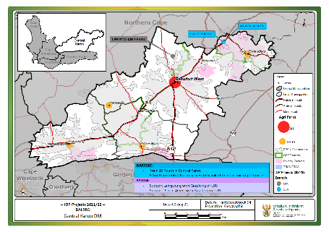
Figure 52: Central Karoo District Rural Development Plan/DALRRD Sector Plan 2021/22 (Draft)

Figure 53: DALLRD FPSU Catchment Areas 2020/21 – Beaufort West Local Municipality
Draft Implementation Plan for DALRRD Projects in the Central Karoo for 2021/22 financial year:
DISTRICT | AREAS OF INTERVENTION | PROJECT DESCRIPTION | BUDGET ALLOCATION | LOCATION GPS COORDINATES | LOCATION GPS COORDINATES | PROJECT LEADER | Branch*
CENTRAL KAROO | STRATEGIC LAND ACQUISITION | ACQUIRE MORDANT | R7,686,000.00 | -31.797534 | 23.367991 | STRATEGIC LAND ACQUISITION | SLA
CENTRAL KAROO | STRATEGIC LAND ALLOCATION | ALLOCATE MORDANT | R0.00 | -31.797534 | 23.367991 | STRATEGIC LAND ACQUISITION | SLA
CENTRAL KAROO | LAND RIGHTS AWARENESS CAMPAIGN | CAMPAIGN ABOUT LAND RIGHTS | R0.00 |  |  | TENURE REFORM IMPLEMENTATION | TRI
CENTRAL KAROO | JOB OPPORTUNITIES & SKILLS DEVELOPMENT | LINK 5 YOUTH TO ECONOMIC ACTIVITIES | R300,000.00 | 0 | 0 | NARYSEC | NARYSEC
CENTRAL KAROO | FARMER SUPPORT | SUPPORT DUNDEE FARMERS | R4,889,275.00 | -31.991259 | 22.540803 | LAND DEVELOPMENT SUPPORT | LDS
CENTRAL KAROO | JOB OPPORTUNITIES & SKILLS DEVELOPMENT | TRAINING OPPORTUNITIES FOR 16 YOUTH | R0.00 | 0 | 0 | NARYSEC | NARYSEC
Central Karoo |  |  | R12,875,275.00 |  |  |  | All Branches

*Branch Name Purpose
SLA Strategic Land Acquisition To coordinate the provision of land acquisition services.
LDS Land Development Support To coordinate land development support.
TRI Tenure Reform Implementation To coordinate implementation of land tenure and land rights programmes.
CED (EDTM Cooperatives and Enterprise Development To deliver and coordinate provincial cooperatives and enterprise development programmes.
RD Rural Development To deliver and coordinate provincial rural development programmes.

Table 7: Central Karoo District: Interventions & economic opportunities

FUNCTIONAL REGION DESCRIPTION | PRIORITISED VILLAGES BASED ON CONCENTRATION OF YOUTH
Functional Region 1 stretches from Laingsburg to the southwest until Murraysburg to the northeast.  Primary commodities: (WCCCRF&IP, 2016)  - small stock, cattle, vegetable seed, deciduous fruit  Secondary commodities: (Master Plan, p. 9)  - Lucerne, stone fruits, olives, vegetables | Priority areas (within 15km from projects):  - Beaufort West (9198) - inside FPSU  - Prince Albert (1780) – inside FPSU  - Laingsburg (1225) – inside FPSU  - Murraysburg (1124) – inside FPSU  Priority areas (within 30km from projects):  - None
REQUIRED INTERVENTIONS | REQUIRED SKILLS/TRAINING/ECONOMIC OPPORTUNITIES
Short term intervention  - Identification of beneficiaries and youth (CD (EDTM), LRD, LTA & NARYSEC) District wide social mobilization and establishment of cooperatives.  - Business Case/Precinct Plan for Beaufort West FPSU to enable small stock value chain interventions (Refer to Animal Improvement Business Plan and FPSU Process Plan in Annexure A).  - South of Beaufort West Small Stock Corridor synergies & interventions: Jonkersleegte Mingenoeg, Jonkersleegte Zucor, Tulpleegte, Toornitzkuil and Hoekskuil.  - West of Nelspoort: Small Stock Corridor synergies & interventions: Dassiesfontein, Rondawel, Matjieskloof and Melrose Need.  - Use of the existing Youth Hub for youth training/economic opportunities.  - Establishment of legal entity and appointment of Board of Directors (CD (EDTM), 2018)  - Drought interventions (climate change).  Medium term intervention  - Implement Prince Albert Business Case & FPSU process plan.  - Fracking related opportunities.  - Linkages with Northern Cape and Free State through Regional SDF & Rural Town Revitalization Programme (SALGA). | - Skills training in sheep shearing, meat processing and veld management.  - Horticultural skills.  - Game and veld management.  - Olive’s processing.  - Fruit processing.  - Training/skills: security services, gym instructor & swimming lessons.  - Fracking related skills/training/opportunities.

Land Reform:
Land Reform in South Africa has evolved over the years. The Land Redistribution for Agricultural Development (LRAD) grant was developed to help establish and promote Black emergent farmers. The Proactive Land Acquisition Strategy (PLAS) was introduced in order to accelerate the pace of land reform. The LRAD and SLAG grants were eventually discontinued in order to shift the focus towards acquisition of strategically located agricultural land though PLAS, with land being made available through lease agreements. A majority of the former DRDLR land reform projects are located in the Beaufort West municipal area. According to the District Land Reform Registry, there are currently 13 PLAS projects, 22 LRAD projects and 4 SLAG projects. This makes up roughly 100 700 hectares of land being transferred to previously disadvantaged South Africans.
Restitution & Post settlement support:
The purpose of the restitution programme is to provide equitable redress to victims of racially motivated land dispossession, in line with the provisions of the Restitution of Land Rights Act, 1994 (Act No. 22 of 1994). A Commission of excellence that ensures that effective, efficient, and speedy redress is provided to all those who were dispossessed of their land rights through racially motivated laws or practices after 19 June 1913.
The objective the restitution programme is to resolve restitution claims within the target period, through negotiated settlements that restore land rights, or award alternative forms of equitable redress to claimants. The intended impact is to facilitate access to land by victims of racially motivated land dispossessions that took place under the previous government. Poverty alleviation through sustainable development on restored land, as well as improved livelihoods. Foster the rights of vulnerable groups, in terms of ownership and participation in economic activities and foster national reconciliation and stability (2020, https://www.drdlr.gov.za/sites/Internet/AboutUs/commission-restitution/Pages/default.aspx).
Land tenure reform:
The Transformation of Certain Rural Areas Act, Act 94 of 1998 (TRANCRAA), that came into effect on 02 November 1999, is the first comprehensive legislation to reform communal land tenure in South Africa. It prescribes the processes to be followed for the creation of entities to hold the land in the commonages in trust for the inhabitants of the Rural Areas [Rural Areas Act (Act 9 of 1987)]. This process is managed by the Department of Agriculture, Land Reform and Rural Development (DALRRD) in consultation with the Municipality responsible for the relevant Rural Area.
TRANCRAA aims at providing the restoration of land that has been held in trust for the community in certain rural areas, to its rightful owner. Due to development or administrative processes on the land, the land is categorized according to TRANCRAA into:
- Land in a township, section 2 land (being every piece of land within the border of approved General Plans – mostly existing as Residential area). Township is also defined as any township situated in a board area established, approved, proclaimed or otherwise recognised as such under any law.
- And land in the remainder, section 3 land (being the remainder of the parent farm – the original trust land after Township Establishment has taken place - also known as commonage land or meentgrond). Remainder Trust Land is also defined under TRANCRAA as land situated in a board area other than township land, including land which has been planned, classified and subdivided as an agricultural area or outer commonage in terms of section 20 (2) of the Rural Areas Act, 1987.
Figure 52 sets out the DRDLR Agri-Park components including the enlarged FPSU catchment areas (60km) applicable in the Central Karoo and reference to the Rural Nodes (CRDP Wards), the location of the proposed Agri Hub in Beaufort West, and Farmer Production Support Units in Laingsburg, Merweville, Prince Albert and Murraysburg. Figure 52 also displays the Land Reform Projects per type in the Central Karoo District Municipality.
Notwithstanding the above land reform imperatives, serious reflection is required to determine viability of the Karoo for land reform with the intent to realise agricultural activity and economic benefit. Already the well-resourced and established agricultural sector is in severe distress in the municipal area, and promoting agricultural land reform, with the intent to enable previously disadvantaged persons and emerging farmers from benefiting from agricultural opportunity, may be setting them up for failure, if the farm is located in a low agricultural potential, water scarce region. Hence, proper due diligence and feasibility analyses should be undertaken before acquiring more land with the intent of implementing land reform for agricultural production in the Karoo.

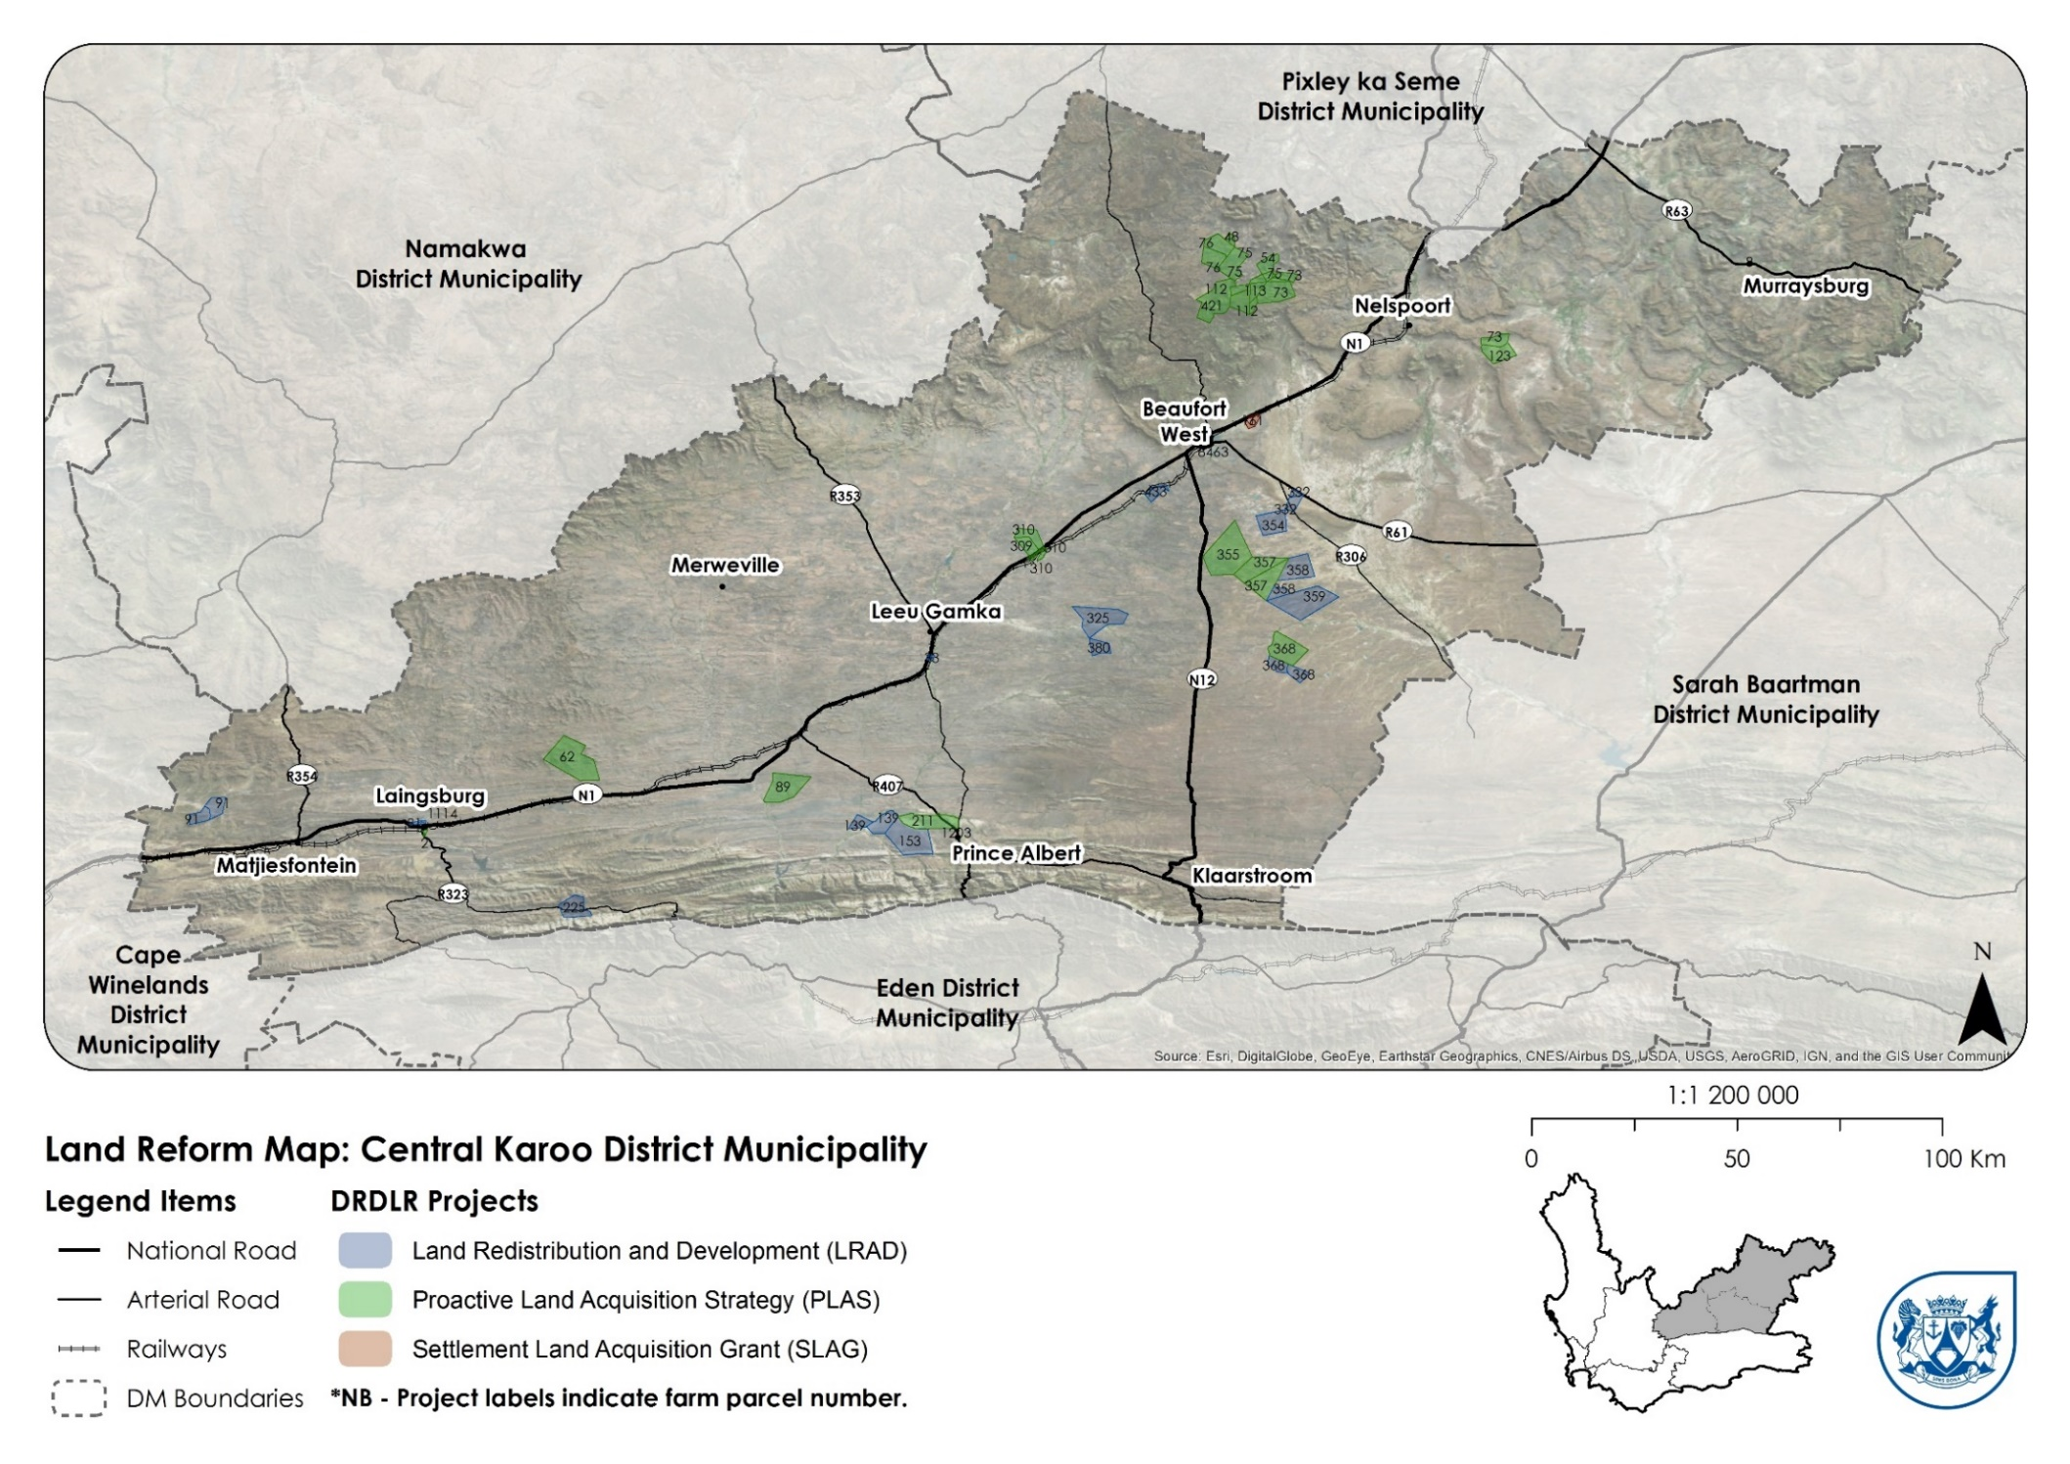
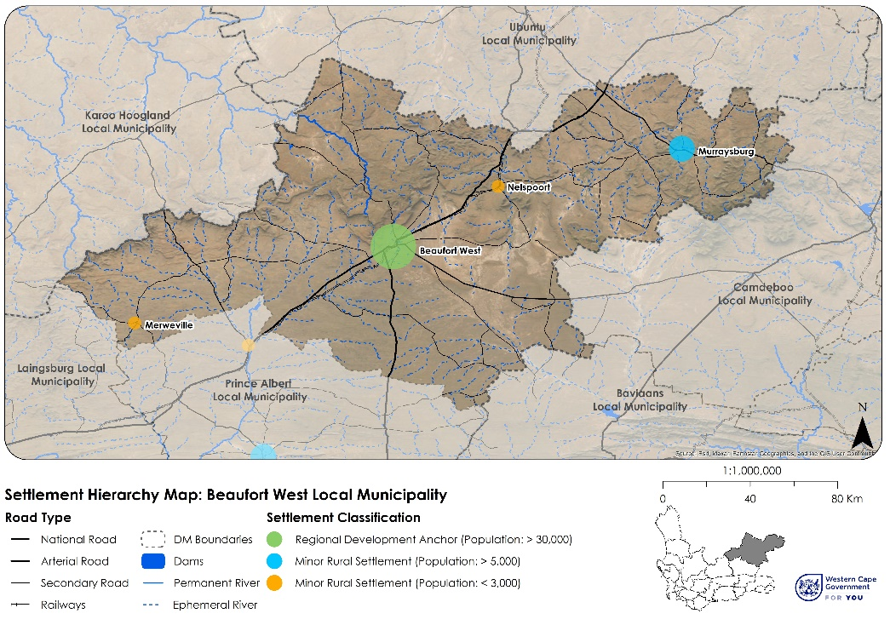
Figure 54: Rural Development and Land Reform Project Map for the CKDM

BUILT ENVIRONMENT ASSESSMENT
This section outlines an assessment of the built environment in Beaufort West Municipality.

Urban Settlements and Settlement Hierarchy
There are four settlements in Beaufort West Municipality:
- Beaufort West Town
- Nelspoort
- Murraysburg
- Merweville
According to the CSIR, “a settlement refers to a distinct human community in its physical, socioeconomic, and environmental whole which requires the provisioning of services such as engineering and social services. Settlements can be ordered by size and other factors to define a settlement hierarchy, ranging from city regions to hamlets or dispersed rural settlements”. Often, population is a crucial factor in determining the hierarchy of settlements in a region and deciding where to target essential basic services.
Beaufort West is a predominantly rural municipality, with Beaufort West Town functioning as a regional service centre for the Central Karoo District and the broader region. It is home to most of the medical, educational, commercial, and regional administration activities in the local and district municipalities. The NSDF defines Beaufort West Town as a Regional Development Anchor – although it should be noted that the town’s economic potential is in decline and this hierarchy may change. Murraysburg is a major rural settlement which offers some services mentioned above to the surrounding farming communities. Minor rural settlements like Merweville and Nelspoort offer limited services that are structured around farming, railway, and transport activities. The settlement hierarchy for Beaufort West Municipality is shown in Figure 55. Landcover change from 2014 to 2020 is shown in Figure 56.

Figure 55: Settlement Hierarchy for Beaufort West Municipality

Area | Number of informal settlements | Structure count
Plakkerkamp Beaufort West | 1 | 23
Merweville | 1 | 6
Murraysburg | 1 | 9
Total | 3 | 38
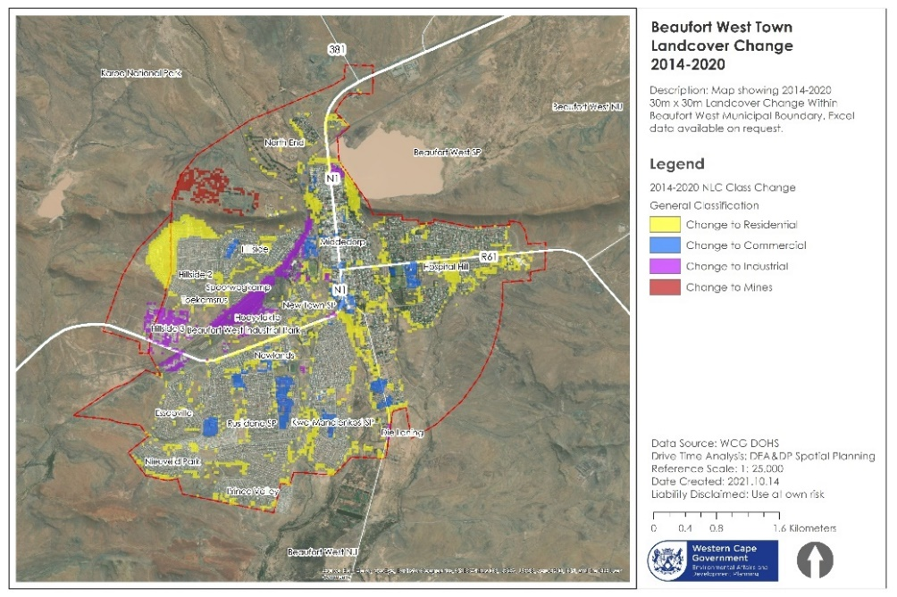
Figure 56: Landcover change, 2014-2020 in Beaufort West Town

Housing
Table 9 shows the current housing demand for Beaufort West Municipality. The total recorded housing demand in Beaufort West municipality is 6 242 people or 75% of the total demand in the Central Karoo. 389 people fall within the gap market and may be eligible for the FLISP housing program. The largest percentage (89.5% or 4 880 persons) of these people reside in Beaufort West Town. Murraysburg has the second largest housing demand at 848 or 13.6% of the municipal demand. Importantly, the 2014 Beaufort West MSDF includes a proposal to introduce a freight bypass to the N1 highway (this is discussed further in the proposals chapter of this MSDF). The proposed bypass had two possible routes, of which one is now no longer possible due to the completion of the large housing development in the North-west of Beaufort West Town.
The Human Settlements Pipeline programme types and locations for Beaufort West’s settlements are shown in Figure 57 to Figure 62.
Though small, the Municipality has 3 informal settlements that are spread between Beaufort West (± 30 households), Merweville (± 10 households) and Murraysburg (± 6 households). These are shown in Table 8.

Table 8: Informal Settlements
The spatial implications are as follows:
- Most of the sites are peripheral to the settlement, making them poorly located in addition to creating challenges to accessing opportunities.
- The housing typology is not conducive to enabling economic opportunities and lacks variety of land use and lacks visual attraction.
- Insufficient attention is paid to the public spaces between housing projects, and to the interface between housing and the public domain.
- Quality public open space is limited, if not completely unavailable
- Higher density typologies must be provided on better-located sites in future.
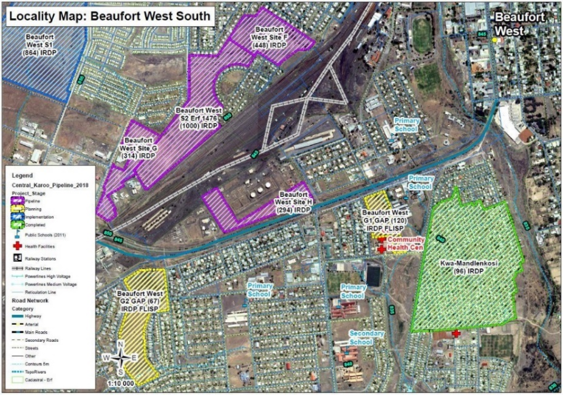
Figure 57: Human Settlements Pipeline for Beaufort West South
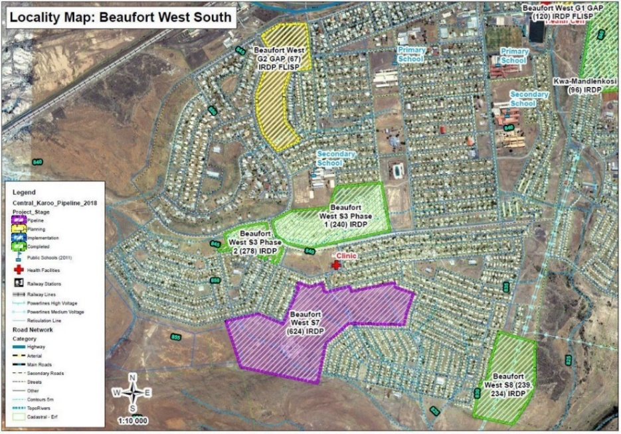
Figure 58: Human Settlements Pipeline for Beaufort West South (cont)

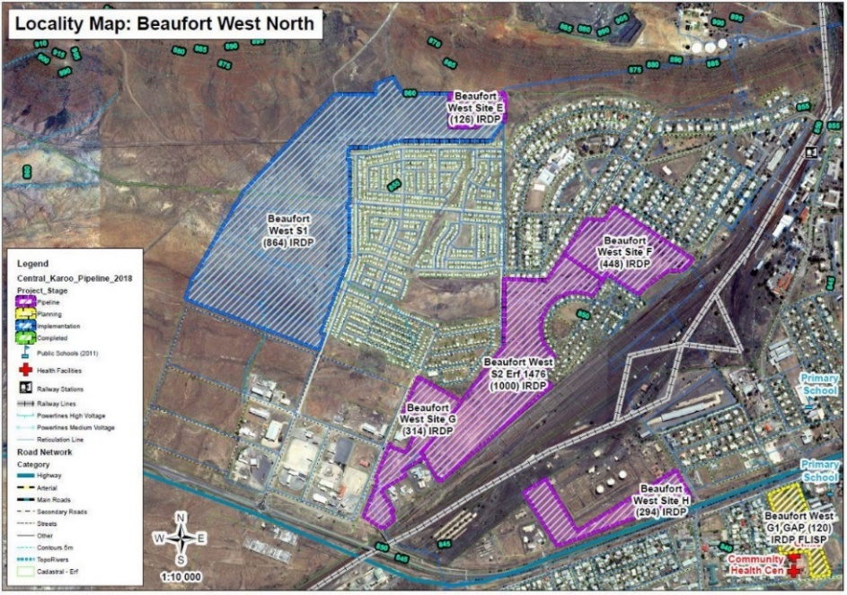
Figure 59: Human Settlements Pipeline for Beaufort West North
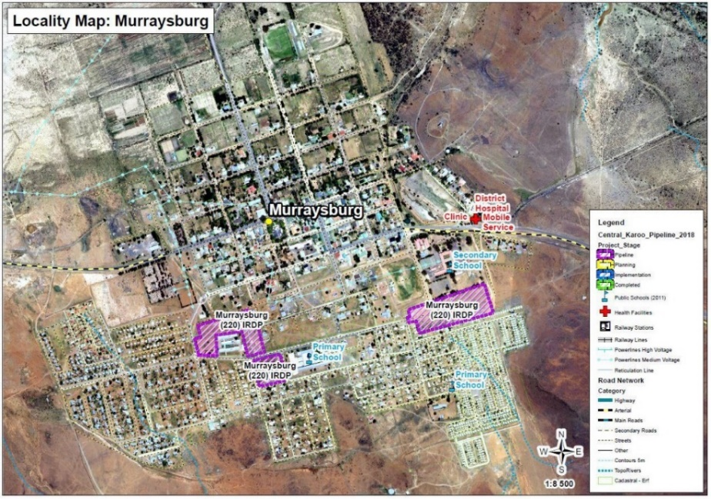
Figure 60: Human Settlements Pipeline for Murraysburg
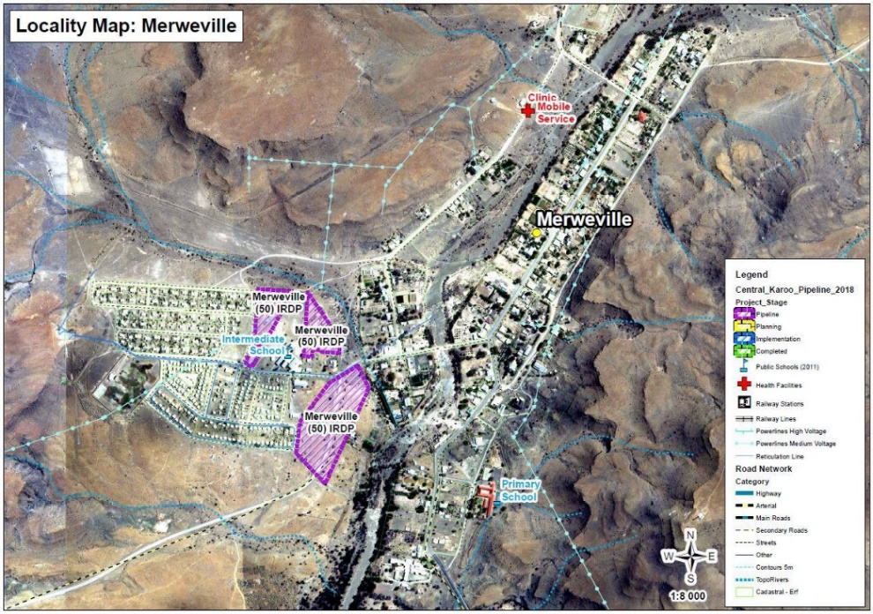
Figure 61: Human Settlements Pipeline for Merweville
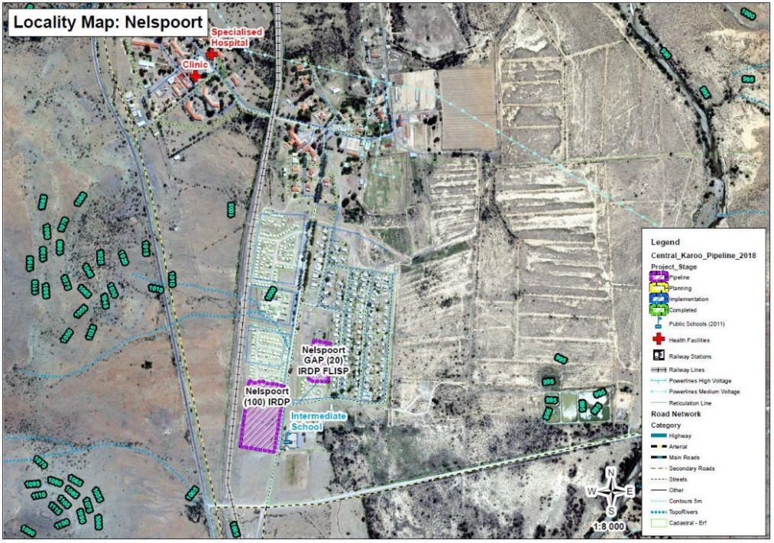
Figure 62: Human Settlements Pipeline for Nelspoort

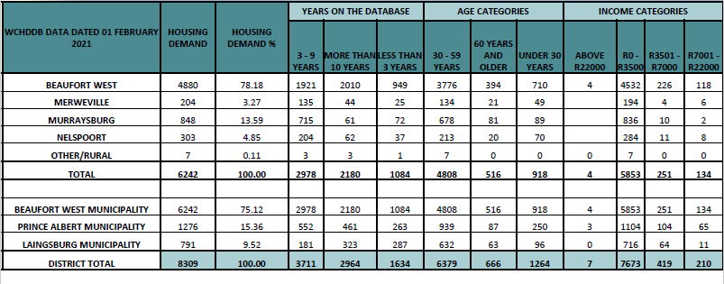
Table 9: Housing Demand figures for Beaufort West Municipality (Western Cape Government Department of Human Settlements, 2021)
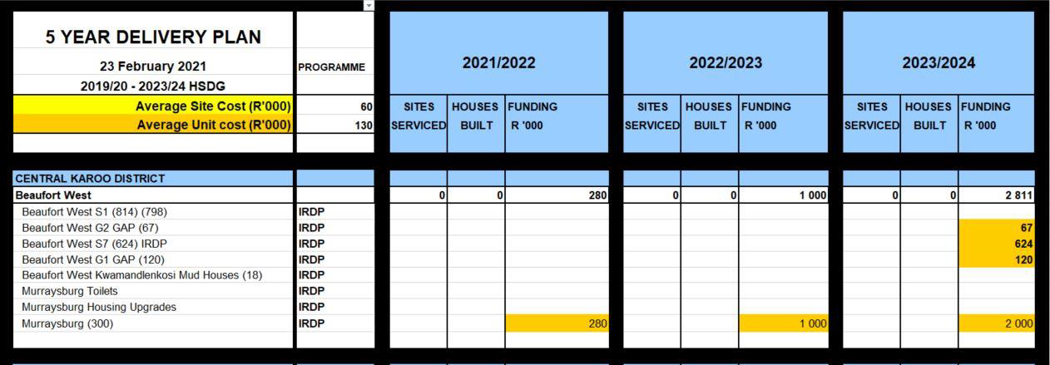
Table 10: Human Settlement Development Grant Allocation for Beaufort West Municipality

Road, Rail and Public Transport
The Beaufort West Municipality Local Integrated Transport Plan (Western Cape Government, 2021)(LITP) identifies the following key issues for transport systems in Beaufort West town and the municipality more broadly:
- Non-Motorised Transport (NMT) is a very important mode in the town and should be a focus of infrastructure provision;
- No formal NMT infrastructure, or public transport services, are available to assist patients discharged from the hospital. This service should be provided;
- Scholar transport is a major problem. A lack of formal scholar transport in the vicinity leads to scholars hitchhiking to and from schools during the week. This exposes schoolchildren to major safety risks;
- The train stops in Beaufort West only two to three times per week, and can thus not be used as reliable regional public transport; and
- Public transport in the area is provided by private taxi services. One private non-subsidised bus is operational, but it is not considered as reliable.
These issues are discussed in more detail below.

Road Network
The road hierarchy or is shown is shown in Figure 63. The N1 is a key national connector linking Cape Town to Johannesburg, while the N12 connects Beaufort West to Oudtshoorn, and onwards to George. Beaufort West’s location on the junction of these two roads is an important locational advantage for the municipality. An important proposal in the current MSDF is the introduction of a freight bypass taking the N1 around the outskirts of Beaufort West Town. The R61 is also an important regional connector route between the Western and Eastern Cape (linking the town of Beaufort West to Aberdeen and beyond to Graaf Reinet). It experiences very high vehicle volumes over holiday periods when people travel between the Eastern and Western Cape.
The road network and condition of roads is shown in Figure 64. The inventory of roads and managing authorities is shown in Table 11.
The national and arterial movement routes through the municipality (roads of key economic importance) are:
- N1 national road – running diagonally through the municipality and the town of Beaufort West. This route is the main movement route between Cape Town and Johannesburg.
- N12 arterial – running in a southerly direction from Beaufort West to Oudtshoorn.
A number of main roads link with the N1 national road and facilitate movement to rural areas in the Beaufort West Municipality and nearby towns in adjacent municipalities. These main roads are as follows:
- R353 – cuts across the western corner of the municipality and the link between Leeu-Gamka and Fraserburg.
- R381 – between Beaufort West and Loxton in the north.
- R61 – between Beaufort West and Aberdeen in the east.
- R306 – between Beaufort West and Rietbron in the southeast.
- R63 – link between the N1 and Murraysburg which further extends to Graaff-Reinet in the east.

The Provincial Freight Strategy and Implementation Programme should also be consulted as a tool to give guidance to the movement of freight in the Beaufort West Local Municipality. The majority of road investment projects relate to the provision of retention dams, maintaining gravel road networks, rehabilitating paved road networks, and associated stormwater systems. These are shown in Figure 65.
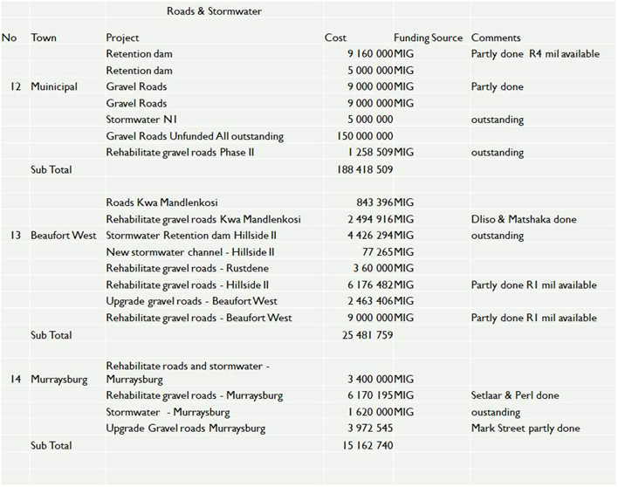
Figure 65: Road investment projects for Beaufort West Municipality
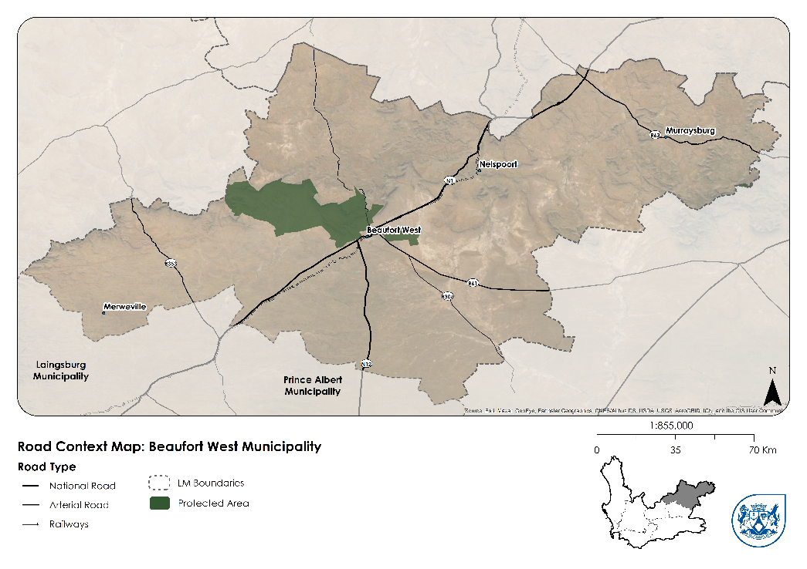
Figure 63: Road Hierarchy for Beaufort West Municipality

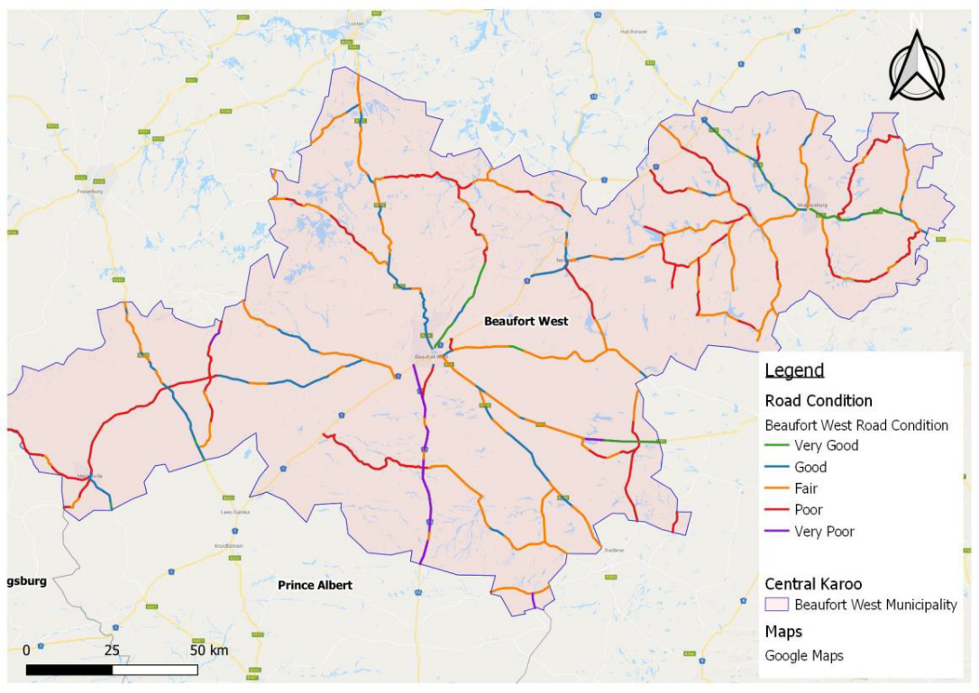
Figure 64: Road Inventory and Condition in Beaufort West Municipality
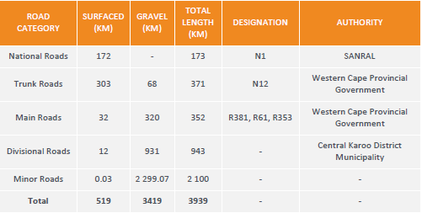
Table 11: Road Inventory for Beaufort West Municipality

Rail Network
There are two rail services that pass-through Beaufort West. These are the Tourist Blue Train and the passenger rail service, Shosholoza Meyl. The Shosholoza service is between Cape Town and Johannesburg and from Cape Town to Queenstown through Beaufort West. The route through Beaufort West passes through Laingsburg for both the blue train and Shosholoza Meyl rail services. The Tourist class Shosholoza passes though the Prince Albert Road station 45km from the town of Prince Albert on a Tuesday, Wednesday, Friday, and Sunday on the route between Cape Town and Johannesburg.
Both passenger and freight rail services are in distress nationally, suffering from diminished levels of service, decreased reliability, neglect and degradation of state-owned infrastructure networks and assets and hence decreased importance, despite national policy seeking to revive and reframe rail in the country. The revival of the regional economy of the karoo largely depends on the ability of government to revive both passenger and freight rail systems. There is a need for national government to reconsider the entire model of delivering the rail function, to allow for improved levels of service to be realised and for the ultimate goal of seeing the shift from road to rail. Not only does this have positive climate change mitigation effects, but it results in fewer road accidents and deaths, and potentially improves logistic service volumes that can be transported at any one time.

Road based Public Transport
The 2013 Central Karoo Mobility Strategy and 2021 Beaufort West Local Integrated Transport Plan identify the following transport routes as part of a proposed Integrated Public Transport Network (IPTN). These are also shown in Figure 65:
- From Beaufort West to Laingsburg (along the N1), possibly as far as Worcester
- Beaufort West to Oudtshoorn along the N12, possibly as far as George
- Merweville to Prince Albert
- Klaarstroom to Prince Albert
- Merweville to Beaufort-West
- Prince Albert to Beaufort-West
- Leeu-Gamka to Beaufort West
- Leeu-Gamka to Prince Albert
- Nelspoort to Beaufort West
- Murraysburg to Beaufort West
- Hutchinson to Murraysburg
- Vleiland to Laingsburg
- Public transport from Beaufort West, Laingsburg, and Hutchinson rail stations to surrounding areas.
- From the rural settlements located along the R61 to Beaufort West, including learners in the settlement of Rietbron.
Additionally, the LITP notes that, in Beaufort West Town, there is one formal taxi rank in Beaufort West at Voortrekker & Donkin Street and there is one on street bus embayment along Donkin Rd. This facility is used predominantly by the mini-bus taxis and the one observed private bus.
In Beaufort West, there are two dominant modes for local public transport. These are sedan vehicles and mini-bus taxis. The LITP noted the following around public transport in the town:
- The Shoprite Park rank is utilized by the sedan vehicles only.
- Mini-bus taxis offer private scholar routes (private contracts with the scholar’s parents).
- The mini-bus taxis operate from outside the Shoprite rank and have 8 formal routes assigned to the association.
- The mini-bus taxis operate multiple chartered services and scholar services.
- In the morning peak, vehicles do not operate from the taxi rank, but from the residential areas and transports directly to the places of work.
- In the afternoon peak, sedan vehicles operate from the rank.
- There is one bus operating from the on-street bus embayment.
Figure 65: Routes and depots identified in the 2013 CKDM Strategy

Learner Transportation
Private learner transport in Beaufort West is undertaken by mini-bus taxis on a private contract between the parents and the taxi association. The scholars are collected at home and transported to their schools.
Public learner transportation is performed by the Western Cape Education Department. There are three routes running in the municipality. Two routes come from outside Beaufort West town bringing learners from two opposite sides to the schools in town.
One route starts in town and transports learners to schools on the opposite side of the town due to learners having to cross the busy N1 as there is no bridge or sub-way for them to cross. While these routes are operational, the LITP indicates that they are insufficient, as many learners still walk to school.
The school learner routes are shown in Figure 66 to Figure 68.
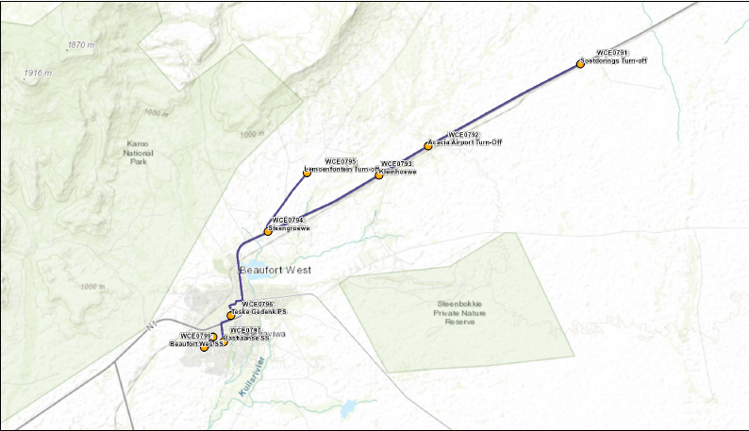
Figure 66: School Learner Route 1
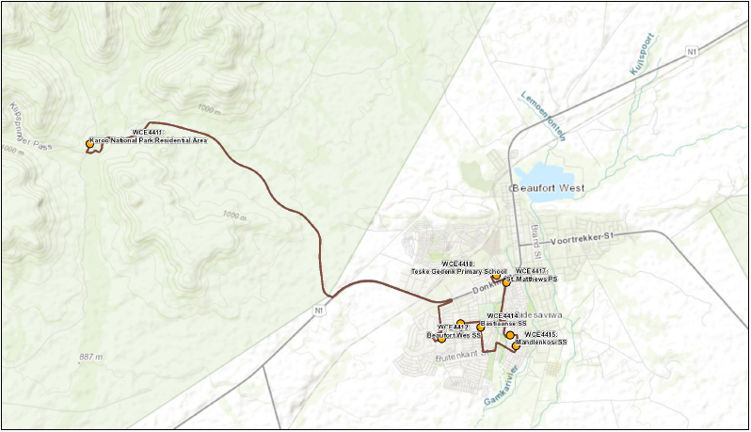
Figure 67: School Learner Route 2
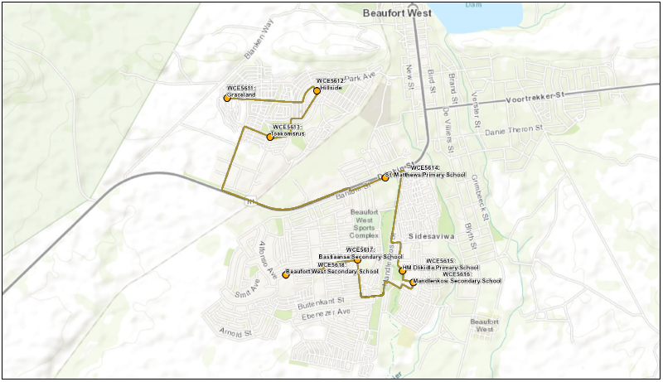
Figure 68: School Learner Route 3

Air transport
There is one privately-owned airport in Beaufort West Municipality, located on the N1 North approximately 10km from the town of Beaufort West. The airport is currently used for chartered flights only. Additionally, the Beaufort West Airport is also used by the AVIC International Flight Training Academy. The potential exists for this airport to be equipped to accommodate scheduled flights in the future should there be demand for these. This will obviously be subject to economic activity and potential industry driving the demand for such flights.

Non-Motorised Transport
The LITP included a study of NMT use in the municipality. The study showed that, in Beaufort West Town, pedestrians were observed walking between Shoprite and the residential areas in excess of 2km, even with the options of sedan, mini-bus taxi and a bus service, which is probably a factor of affordability. In addition, during consultation with schools, it was noted that there are learners walking in excess of 3km to schools. Clearly, NMT is an important mode of transport for Beaufort West residents, and streets and pavements should be optimized for use by pedestrians and cyclists – with particular attention needing to be paid to school learners.
The status quo study found that the existing pedestrian walkways provide reasonable connectivity across the settlements in the Municipality of Beaufort West. However, the continued priority would be improvements in the network, pavement condition, walkway widths, and lighting, particularly in Murraysburg and to an extent in Beaufort West.
Beaufort West Town NMT routes:
The non-motorized transport routes provided in Beaufort West are in a good condition. The two primary non-motorized transport routes are from town along both sides of Mandlenkosi Street in Kwa-Mandlenkosi towards Prince Valley (1.517km); and from De Vries Street in Rustdene to the bridge and intersection at Danie Theron Street (1.215km). The lack of formal NMT infrastructure around the hospital is a concern. The extent to which the 2013 Beaufort West MSDF proposed NMT routes for the town, as illustrated in Figure 69 have been implemented is not clear.
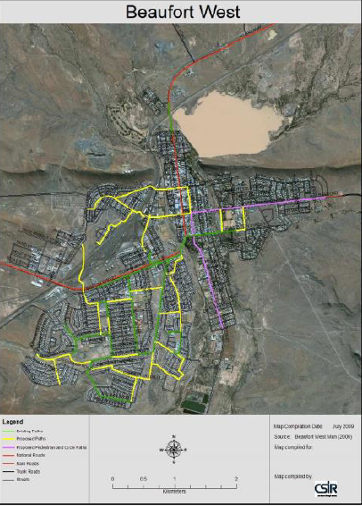
Figure 69: Proposed NMT Routes in the 2013 Beaufort West MSDF
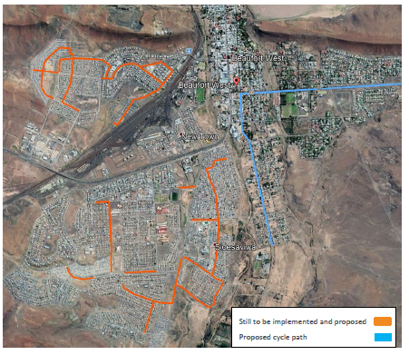
The Beaufort West Municipality Local Integrated Transport Plan (2019 – 2024) sets out the revised NMT requirements for the Beaufort West Town terms of the proposed NMT routes as well as the proposed cycle path which still need to be implemented during 2020 – 2025 as illustrated in Figure 70.
Figure 70: Revised NMT routes for Beaufort West Town (2020 – 2025)

Merweville NMT routes:
The existing walkways in Merweville are recently constructed. The coverage is good, and the walkways are majority all-weather walkways. The proposed NMT route for Merweville for 2020 – 2025 is illustrated in Figure 71 below.
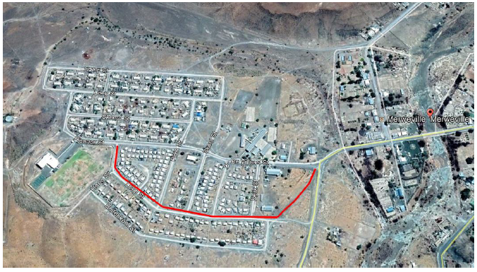
Figure 71: Proposed NMT route for Merweville (2020 – 2025)

Nelspoort NMT routes:
The walkways at Nelspoort provide adequate coverage for the community.
Murraysburg NMT routes:
The walkways in Murraysburg mostly consist of old and damaged infrastructure that requires maintenance. The NMT coverage is low in the township areas of Murraysburg. The walkways start and stop along Angelier St in front of the schools, but do not connect to anything. Currently the stormwater channel is being used as a walkway. It is effective in dry conditions, but cannot be used in wet weather, forcing pedestrians into the road in poor visibility conditions.
The proposed walkways for Murraysburg for 2020 – 2025 are illustrated in Figure 72 below.

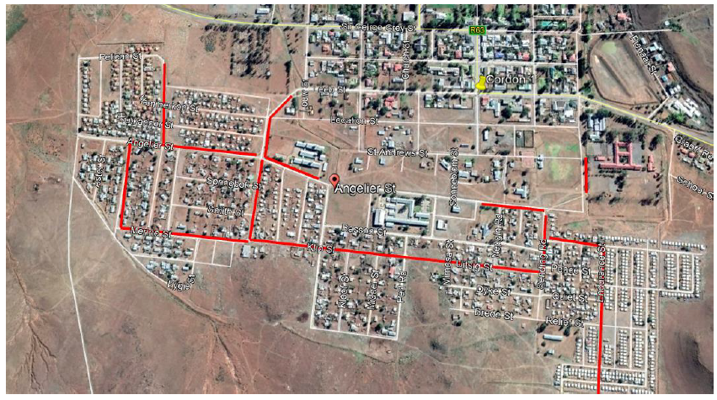
Figure 72: Proposed Walkways for Murraysburg (2020 – 2025)
Specific NMT interventions are proposed in the LITP to address the needs discussed above. These are discussed in the proposals chapter of this MSDF.

Water Infrastructure
Beaufort West Municipality is the designated Water Services Authority (WSA) within the municipal area. It is also the Water Services Provider (WSP).
Water is supplied via separate water distribution systems to Beaufort West, Merweville, Nelspoort and Murraysburg. Beaufort West and Nelspoort are reliant on surface and groundwater sources, while Merweville and Murraysburg only utilize groundwater sources. Beaufort West Municipality also operates its own Water Treatment Works and Wastewater Treatment Works, where wastewater recycling is done to maximize water use. The water utilities map for the Beaufort West Town is illustrated in Figure 73.
The most significant challenges, from a Water Services perspective are the following:
- Stormwater master plans are outdated, and there are no funds to update them.
- Infrastructure is ageing, resulting in frequent service cuts to water services.
- Augmentation of the existing groundwater resources for Beaufort West
- Upgrading of the Nelspoort and Murraysburg oxidation ponds
- The refurbishment and upgrading of the existing water and sewer networks and pump stations and to ensure the provision of basic services to rural communities located on private farms.
Beaufort West Municipality will continue to develop strategies and action plans, in collaboration with farm owners, for the Municipality to fulfil its legal obligations and responsibilities as WSA for the provision of basic services. Key investments and actions the municipality is undertaking in the water infrastructure space are as follows:
- Beaufort West
- Upgrading of the wastewater treatment works in Beaufort West
- New 3 000 kilolitre reservoir in Beaufort West
- Leak detection and repair in Hillside and Rustdene
- Refurbishing of the existing water treatment works in Beaufort West
- Upgrading of the existing wastewater treatment works in Beaufort West

- Murraysburg
- Construction of Two New Reservoirs in Murraysburg
- Borehole siting, exploration, and development in Murraysburg
- Provide 0.5 Ml additional water storage.

- Nelspoort
- Rehabilitation of the oxidation ponds in Nelspoort
- New bulk water supply in Nelspoort
- Replace existing 0.911 Ml reservoir with a new 1 Ml reservoir.
- Additional 0.5Ml reservoir
- New 0.5 Ml/day water treatment works.
- Upgrading of wastewater main pump station to 15lps
- Rehabilitate oxidation pond phase 2.

- Merweville
- New water supply pipelines and upgrade boreholes and pump station along the Klein Hans River
- Augmentation and upgrading of the water supply network in Merweville.
- Refurbish or replace disinfection facility in Merweville.
- New 0.5 Ml reservoir in Merweville
- Upgrading internal sewer drainage network
- For all towns, extensive upgrading of the deteriorating water network
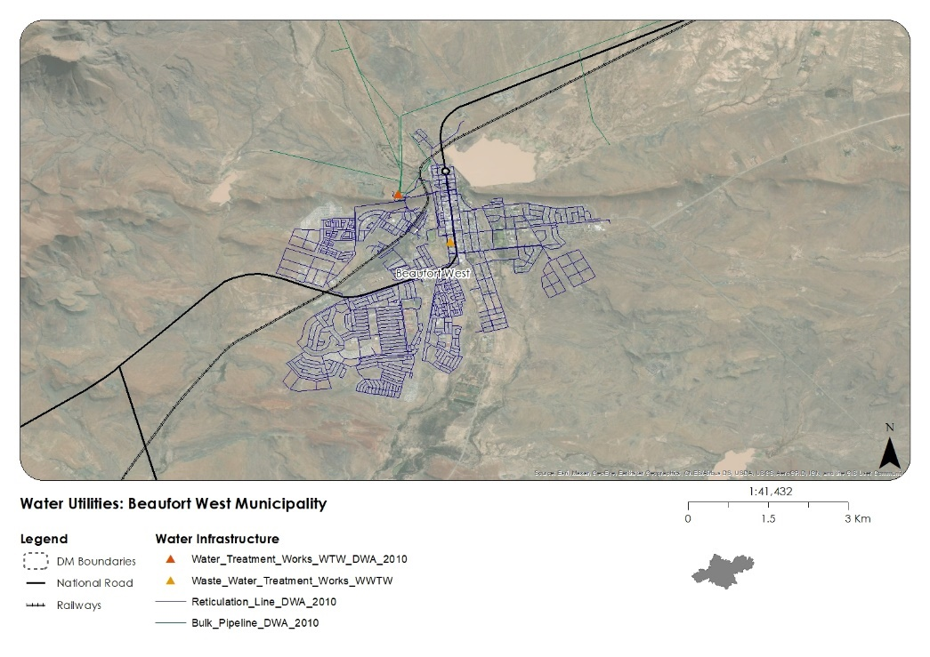
Figure 73: Water Utilities in Beaufort West Town

Energy and Electricity
Much of Beaufort West Municipality falls into a Renewable Energy Development Zone (REDZ) (see Figure 74) under phase 2 of national government’s project to identify areas of strategic importance for large-scale wind and solar photovoltaic development.. The REDZ was gazetted on 26 February 2021 when Minister Barbara Creecy published Government Notice No. 142, 144 and 145 in Government Gazette No. 44191. The gazetting of REDZs as areas of strategic importance for large scale wind and Solar PV development gives effect to provisions in terms of section 24(5)(a) and (b) of the National Environmental Management Act, 1998. This process outlines procedures to be followed when developments occur in geographical areas of strategic importance. Also of note is Regulation 15 of the Environmental Impact Assessment Regulations, 2014, which states that any applications falling within these gazetted areas will have the benefit of reduced time frames i.e., conducting a Basic Assessment instead of a full Scoping and Environmental Impact Assessment. The reduction in these timeframes is due to the reduction of the decision-making timeframes to 57 days. Through these provisions the authorities and other decisionmakers will be able to ensure that wind and solar PV development in REDZs is given priority in planning, approval and implementation.
There are two guidelines to consider for the spatial planning within the REDZ Zone: The EIA guideline for renewable energy projects; and Phase two of the Strategic Environmental Assessment 2019 for wind and solar photovoltaic energy in South Africa. The latter document makes special spatial prioritisation for renewable energy development based on important areas for agriculture, bats and birds.
[HIGH RESOLUTION MAP TO BE INSERTED IN THE FINAL DOCUMENT]
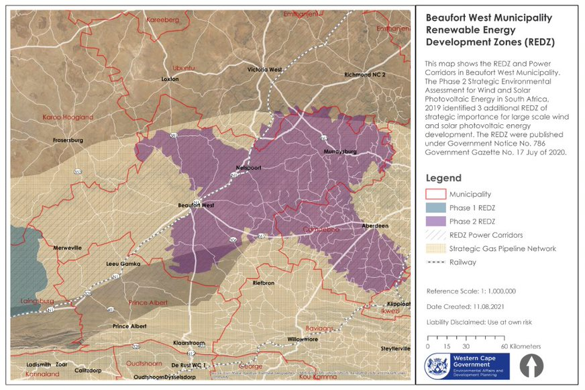
Figure 74: Renewable Energy Development Zone
Existing electrical infrastructure in Beaufort West Municipality consists of a single 132kV (kilo Volts) point of supply at Beaufort West Substation with a notified maximum demand (NMD) of 20MVA (mega Volt Amps). In 2020 the maximum utilised demand was 10.6MVA on the 30 August. There are two 132kV lines supplying this substation. One from Droerivier Main Transmission Substation (MTS) in the south and one from Hydra Main Transmission Substation (MTS) in the north. These 132kV lines both have thermal capacities of 80MVA. This is shown in Figure 75.
This infrastructure is considered to be adequate for now and in the future, although a new 500MVA 400/132kV Transformer and 132kV busbar is planned at Droerivier MTS to enable the connection of Independent Power Producers (IPPs). The Municipality has also requested a second 132kV point of supply at their current point of supply so that they can install a second transformer in their substation. This will ensure that if one of their transformers were to trip out then the second transformer could still supply the load, drastically reducing the risk of electrical failure in the municipality.
All the IPPs that have applied to Eskom to be connected to the Eskom grid have been quoted. If they are awarded preferred bidder status then the networks they were quoted for will be constructed to connect them to the grid. Applications range from 20MVA to 140MVA. Current IPP applications are shown in Figure 75.
For service delivery, the following figures are notable:
- Electricity Complaints : ± 500 PER MONTH
- Electricity Distribution Network: LV AND MV
- Service Connections : ± 14 000
- High Mast Lighting: 130
- Streetlights: 1 200
Budget has been allocated for upgrading and maintenance of substations, high mast lighting in Beaufort West and Nelspoort, and various upgrading projects have been identified as per Table 12 and Table 13. However, funding has not been secured for the majority of these projects.
There are two policies needed in the municipality: small-scale electricity generation, and fibre optic and network telecom. The existing policies are outdated and must be reviewed.
Table12: Electro Technical Services projects in Beaufort West Municipality
Table 13: Electro Technical Services projects in Beaufort West Municipality (cont)
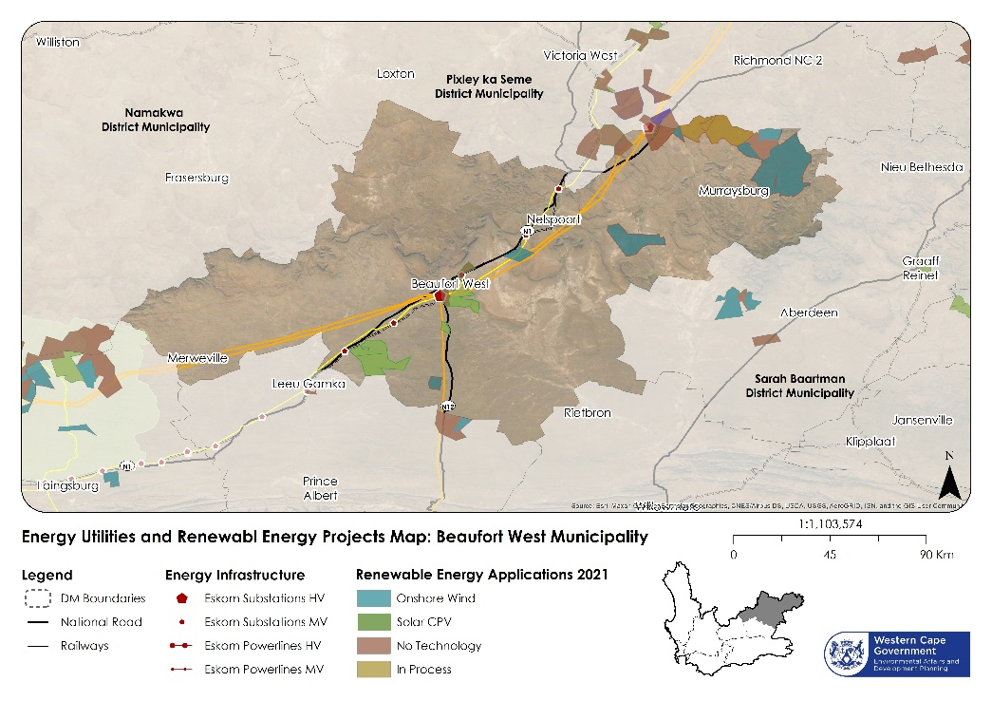
Figure 75: Energy Utilities and Renewable Energy Projects in Beaufort West Municipality

Waste Infrastructure
The Review of the Integrated Waste Management Plan (IWMP) was drafted in 2021. The IWMP notes that Beaufort West Municipality provides a weekly door-to-door waste removal service to the households and a bi-weekly service to businesses. Medical waste generated by hospitals, general practitioners and clinics is collected by a private company in George. A private contractor is responsible for the spillage removal along the N1 National Road traversing the Beaufort West municipal area.
The Municipality removes garden refuse together with domestic waste on normal removal days if it is placed in refuse bags. Building rubble is removed by residents themselves and the municipality removes only building rubble when it is dumped illegally.
There are four waste management facilities within Beaufort West municipal area and the waste management licensing unit was in the process of licensing the facilities. They are Merweville, Nelspoort and Murraysburg and Vaalkoppies (Beaufort West Town) waste disposal facilities (WDF). Nelspoort (Landfill Site) Waste Disposal Facility has an operational NEMA section 24G environmental authorisation. Merweville (Landfill Site) Waste Disposal Facility has an operational Waste Management Licence. Vaalkoppies (Landfill Site) Waste Disposal Facility has an operational Permit. The operations at all landfill sites is poor, with no regular compaction and covering of waste. The infrastructure has deteriorated due to vandalism, with fencing having been stolen and informal reclamation activities taking place regularly. Funding has been applied for and approved for upgrading the Vaalkoppies landfill site and to establish a waste transfer station at Murraysburg. The budget for this project is R 17 000 000. This needs to be implemented urgently. The state of waste management in Beaufort West town in particular is a serious environmental health risk to the residents living there. It is also a significant detractor from economic and tourism potential in the town and the municipality. The landfill and waste management sites in Beaufort West Town, Merweville, Murraysburg and Nelspoort are illustrated in Figure 76 below.
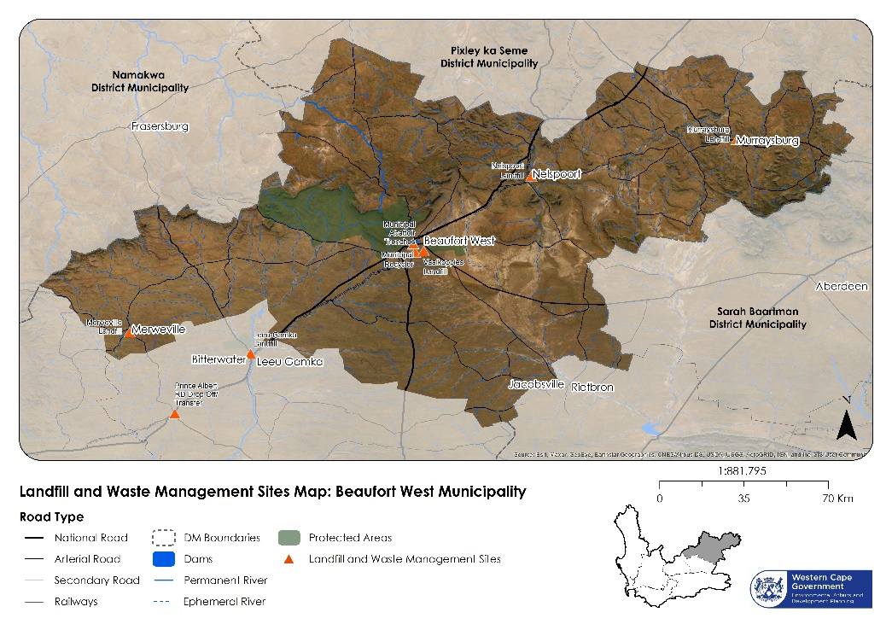
Figure 76: Landfill and Waste Management Sites in Beaufort West Municipality

Built Heritage
A desktop heritage survey was undertaken for the preparation of the 2014 Beaufort West MSDF. The survey found that Beaufort West town had a high density of Victorian domestic buildings and much of its civic and religious architecture is of high architectural and historic significance. Important sites (and their proposed heritage grading) are outlined below:
- Beaufort West Town
- Grade I
  - Anglo Boer War Graves
- Grade II
  - Matoppo House
  - Clyde House
  - Christ Church
  - Old Town Hall
  - DR Mission Church
  - Girls’ Public School
  - DR Church
  - Old Public Library
  - Cyprus and Pear trees
- Grade III
  - Beaufort West Club
  - Christ Church Lodge
  - Vine Lodge
  - Gaol
  - Methodist Church
  - Railway Station
  - Anglo Boer War block house
  - Coronation villa
  - Karoo lodge
  - Pritchard House
  - Coronation Hall
- Merweville
- Dutch Reformed Church (c1905) – Proclaimed National
- Monument/Provincial Heritage Site (PHS)
- Lieutenant Walter Oliphant Arnot War Grave – Grade I

- Nelspoort
- Nelspoort Sanatorium and Homestead – Grade III (A)
- Nelspoort Rock Art Sites – Archaeological Site, possibly Grade II/PHS

- Murraysburg
- Powder Magazine (c1878) – Proclaimed National Monument/PHS
- 33 Darling Street – Proclaimed National Monument/PHS
- Dutch Reformed Church (c1907) – Grade III (A/B)
- Magistrate’s Office (c1905) – Grade III (A/B)
- 15 Voortrekker Street (c1860) – Grade III (A/B)
- 21 Voortrekker Street (c1890) – Grade III(C)
- 23 Voortrekker Street (c1870) – Grade III (C)
- Pastorie Street (c1890) – Grade III (C)
- Former church building, corner of Leeb and Church Street (c1880) – Grade III (C)
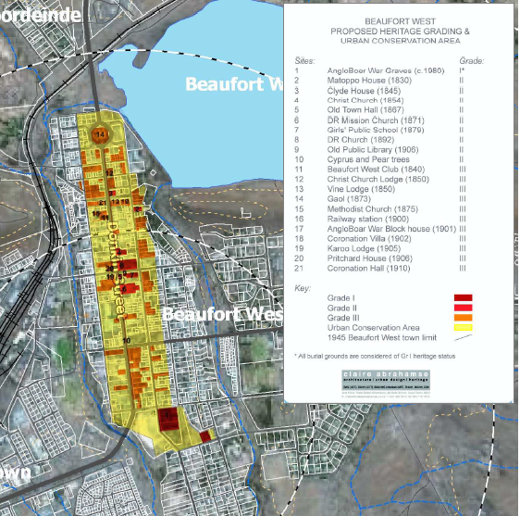
Figure 77: Heritage Resources in Beaufort West Town

SYNTHESIS
The purpose of this section is to undertake a synthesis and performance assessment of the key spatial issues and opportunities are within the Beaufort West municipal area. This will both identify any cross-sectoral issues or opportunities that require attention, as well as inform the proposals and plans that the MSDF will put forward.

Municipal Scale Synthesis
The following sections describe the spatial opportunities for the natural environment, built environment, and socioeconomic systems at the municipal scale, as well as at the local scale in the town of Beaufort West.

Natural Environment Synthesis

The key issues affecting Beaufort West municipality’s natural systems at the municipal scale are shown in Figure 78.
- The topography in the South of the municipal area mainly consists of gently undulating plains. In contrast, the northern extent is characterised by the Nuweveld Mountain range, with peaks ranging between 825 to 1,911 m. Toorberg to the south of Murraysburg forms part of the Sneeuberg range which is the divide between the Central Karoo District and the Eastern Cape.
- There are very few perennial river systems in the municipal area. There is a serious need for veld rehabilitation in the highly degraded Sout River basin which could become a dustbowl.
- Drought is a serious and persistent issue in the municipality, with climate change predicted to compound this issue. The north-eastern area around Murraysburg has historically seen higher rainfall than the rest of the municipality and has been the agricultural hub of the municipality as a result. However, the recent drought appears to have put an end to much of this activity.
- The Karoo National Park is the major Protected Area in the municipality. It is a key strategic asset at the regional scale and contributes to tourism in Beaufort West as well as being ecologically important to the natural environment.
- Critical Biodiversity Areas and Environmental Support areas have been mapped for the entire municipality and must be protected from inappropriate development such as urban development, intensive agricultural activity, or shale gas / mining activity.
- Shale gas extraction presents both environmental risks and economic opportunities.
- Aquifers are significant ground water resources for the municipality and need to be better studied to understand their capacity and extent.
- Scenic routes worthy of protection are the Karoo National Park and CBA areas in the municipality. Development within the buffer zones must be prevented or mitigated to prevent activity-related disturbances to the park.
- Environmental pressure points in the municipality are the threat of degradation to sensitive natural areas, and the potential effects of shale gas extraction.
- Environmental Opportunities in the municipality are mountain catchments, rivers, wetlands, and rangelands. These areas should be prioritised for protection or rehabilitation.
- Environmental or Disaster risk areas in the municipality are the seriously degraded Vaalkoppies landfill site, and the ongoing drought.

Built Environment Synthesis

The key issues affecting Beaufort West municipality’s-built environment at the municipal scale are shown in Figure 79.
- The N1, the N12, and the rail network are significant national and regional assets. Beaufort West is situated between South Africa’s two largest economic centres. Freight transport over road and rail brings a high volume of traffic and economic activity into the town and the municipality. The rail system is currently functioning sub-optimally. This needs to be urgently addressed.
- The lack of rainfall mentioned in Section 3.5.1.1 appears to have had a particularly detrimental effect on Murraysburg, with the local economy struggling as a result and the urban environment of the town declining, and in distress – needing maintenance and improvement.
- The towns in Beaufort West Municipality are separated by large distances. Maintenance of their connecting infrastructure is highly important to their functioning. The road connecting Merweville to the N1 was recently tarred, which appears to have had a positive effect on Merweville’s development, with the town experiencing a degree of economic regeneration as a result of the improved connecting infrastructure.
- The area surrounding Beaufort West Town, along with the land around the major roads in the municipality, is classified as having a high vulnerability to landcover change by 2050. This vulnerability will be exacerbated if measures are not taken to curb the effects of pollution as a result of the degradation of the landfill site outside Beaufort West Town.
- Water infrastructure systems are ageing, resulting in frequent service cuts to water services. Augmentation of the existing groundwater resources for Beaufort West is a priority, as is upgrading of the Nelspoort and Murraysburg oxidation ponds. The refurbishment and upgrading of the existing water and sewer networks and pump stations must be prioritized. The provision of basic services to rural communities located on private farms must also be prioritized.
- Waste infrastructure systems are in serious decline. Urgent intervention is required at the Vaalkoppies landfill site in particular. The development of additional housing in the municipality must be managed carefully as the municipality cannot address its current waste management crisis.
- Electricity infrastructure systems are relatively stable. Budget has been given for upgrading and maintenance of substations, high mast lighting in Beaufort West and Nelspoort. However, funding has not been secured for the majority of these projects.
- There are two electrical services policies needed in the municipality: small-scale electricity generation, and fibre optic and network telecom. The existing policies are outdated and must be reviewed.

Socioeconomic Synthesis

The key issues affecting Beaufort West municipality’s socioeconomic systems at the municipal scale are shown in Figure 80.
- Higher-order social services and facilities are clustered in Beaufort West Town. This is where the major population pressure exists and where new facilities are most likely to be needed. The smaller towns are adequately serviced for their populations. Focus needs to be on maintaining existing social facilities and upkeep of the existing facilities, particularly in Murraysburg. Sites for new facilities need to be identified in Beaufort West Town, as there are areas with high residential densities and very limited access to services, in spite of the high number of facilities overall. This is discussed in more detail in the town-level synthesis.
- The REDZ and Strategic Gas Pipeline hold economic opportunity for the Municipality, as evidenced by the number of renewable energy applications. Much of the economic future in the municipality will depend on the outcome of shale gas exploration.
- The results of the facility calculator outputs show that, should Beaufort West grow by 1 256 households by 2035, the cost of additional facilities will be R216 973 972. The most urgent requirement will be for additional primary schools and secondary schools.
- The biggest economic opportunity lies in the potential for shale gas extraction, which could bring an influx of workers and visitors to the municipality. While the economic benefits of shale gas extraction would be significant, this has to be balanced against the environmental and social pressures. Shale gas extraction and its associated activities will place notable burdens on existing transport infrastructure and basic services, as well as posing a significant threat to the already severely constrained groundwater supply.

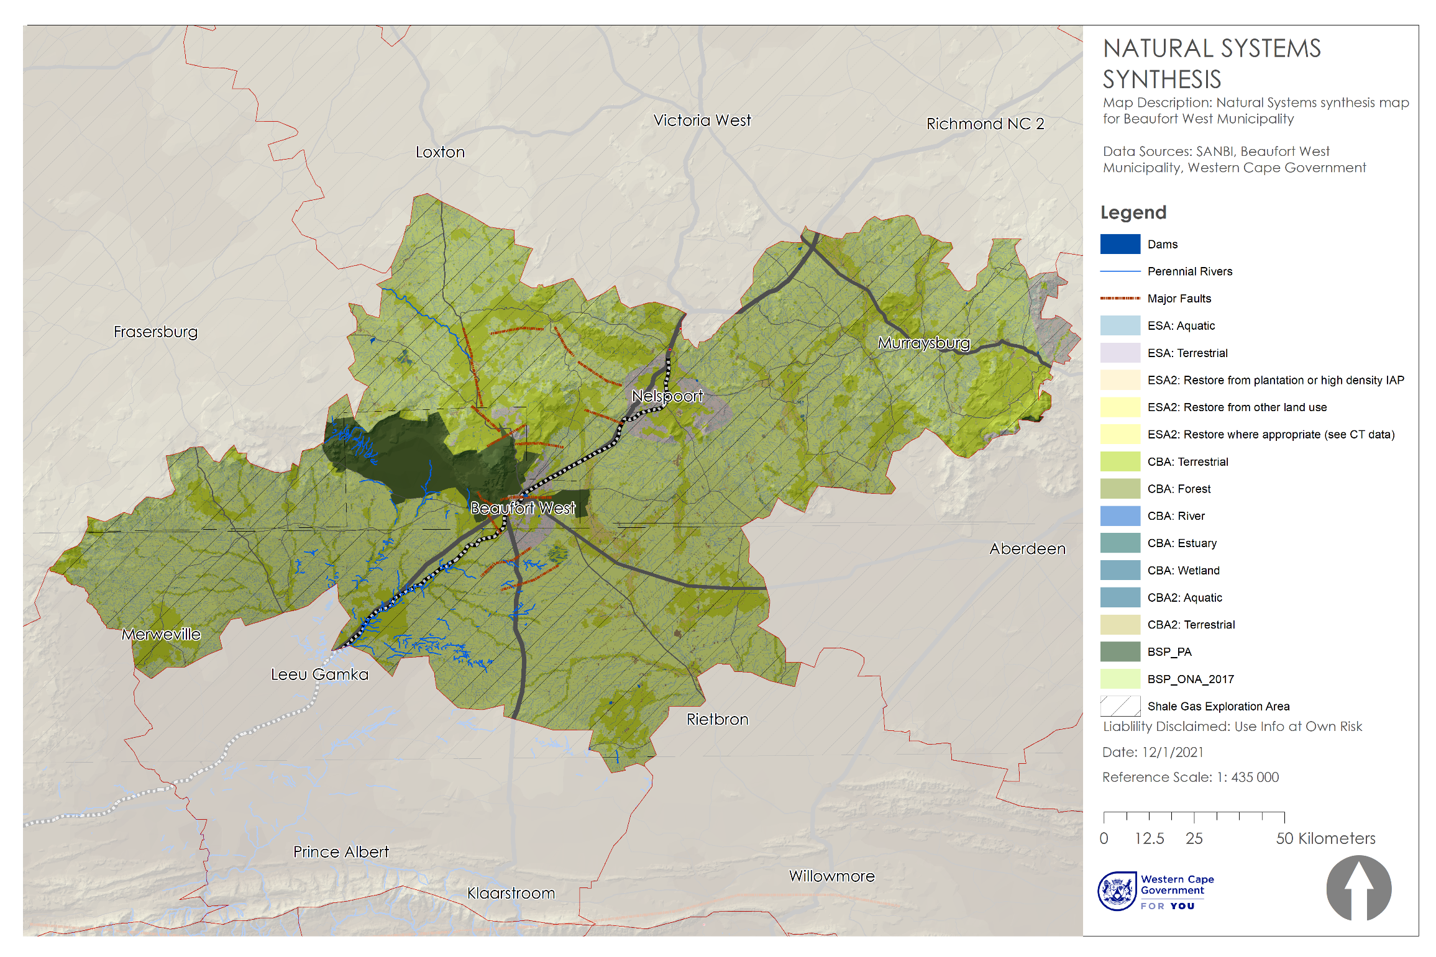
Figure 78: Natural Environment Synthesis Map for Beaufort West Municipality
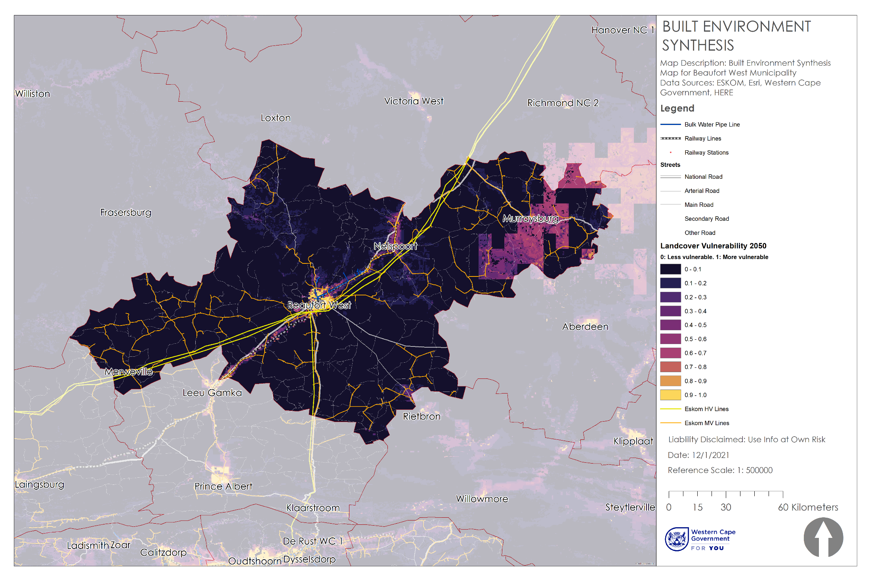
Figure 89: Built Environment Synthesis Map for Beaufort West Municipality
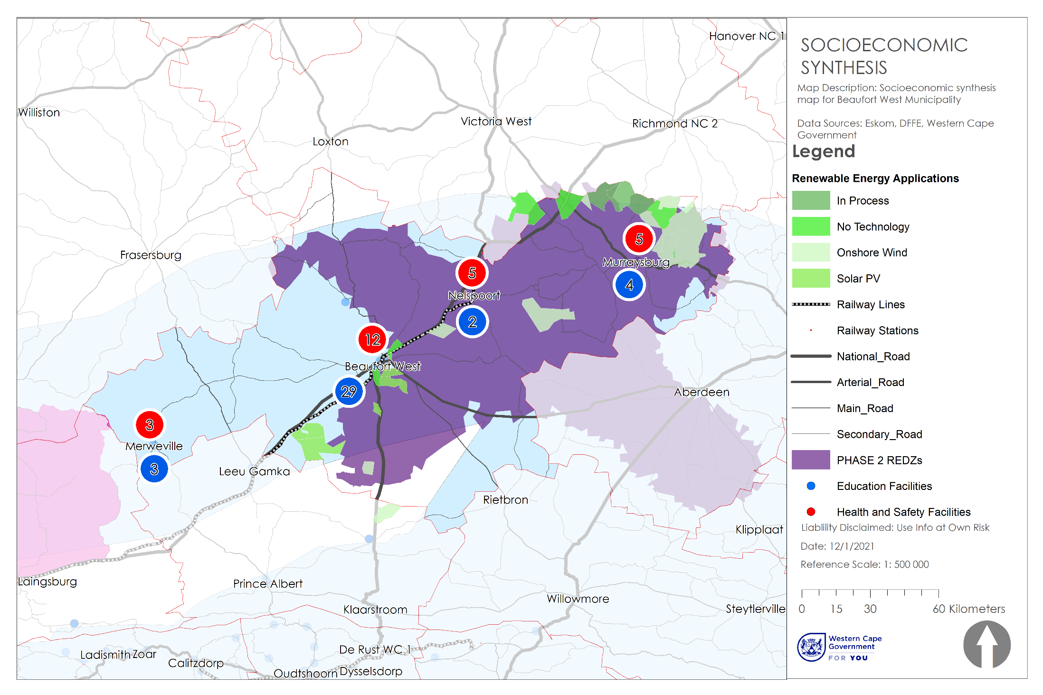
Figure 80: Socioeconomic Synthesis Map for Beaufort West Municipality

Town Scale Synthesis
This section outlines the issues and opportunities emanating from the synthesis analysis of Beaufort West town. Town level synthesis maps are shown from Figure 81 to 83.

Beaufort West Town: Biophysical Synthesis
- The Karoo National Park is a significant asset and tourism attraction located in close proximity to Beaufort West Town.
- There is an inconsistency between the buffer zone for the Karoo National Park and the built environment of the town. The buffer zone extends into the urban edge of the town and over areas that have already been developed for housing.
- As discussed in Section 3.5.2.2, the state of the Vaalkoppies landfill site is a severe environmental risk. The overflow of waste poses a significant threat to all of the natural systems in the town.
- The majority of the land around the town constitute Critical Biodiversity Areas or Ecological Support areas. This is cause for additional concern around the state of the landfill site.
- The riverbeds running through the centre of the town represent a flood risk when the area receives rain and are often filled with dumped rubbish particularly the poorer areas of the town.
- The hilly topography to the North of the town is a constraint on development.
- There is a fault line running through the town in the North that should be noted.

Beaufort West Town: Built Environment Synthesis
- The Vaalkoppies waste site, located to the South-East of the town, is overflowing and in need of urgent intervention. The degradation of the waste site is leading to litter getting blown into the town and the surrounding areas. This is an environmental health hazard to residents and a threat to the Critical Biodiversity Areas surrounding the town. The state of the surrounding areas is shown in Figure 81.
- The rail network and the N1 highway are a spatial buffer between the suburb of Hillside and most of the town’s commercial land uses. These transport systems are important assets at this area – and where open space does exist, it is usually in the form of a walled off sports field that is separated from the public realm.
- Future housing pipeline projects fall between Hillside and the railway area. These housing projects are separated from the commercial centre of the town by the railway.
- The primary commercial land uses in the town occur along the N1 at the entrance to the West, and along Donkin Street in the town’s CBD.
- The main industrial uses in the town are located close to the railway line and highway at the Western entrance to the town. The rail network is currently underutilised. Its upgrading and maintenance should be prioritised as it offers a significant strategic advantage for Beaufort West Town and the municipality.
- There is a proposed heritage overlay zone around the CBD to protect the character of the historical buildings in this area.
- The low-density residential areas to the East and South of the CBD are well located and enjoy easy access to the commercial opportunity along Donkin Street.
- There is limited state-owned land available for infill housing. However, the water reticulation network extends South of the well-located areas to the East of the CBD. Given the existence of this infrastructure, and the problems with accessibility in the areas North of the railway line, this area should be considered for infill housing.
- the municipal scale, but function as a barrier to integration at the town scale. Interventions that improve accessibility across the rail system in particular should be prioritised.
- The densest areas of the town are located in the suburb of Hillside, in the Northwest of Beaufort West. There is very little public open space in 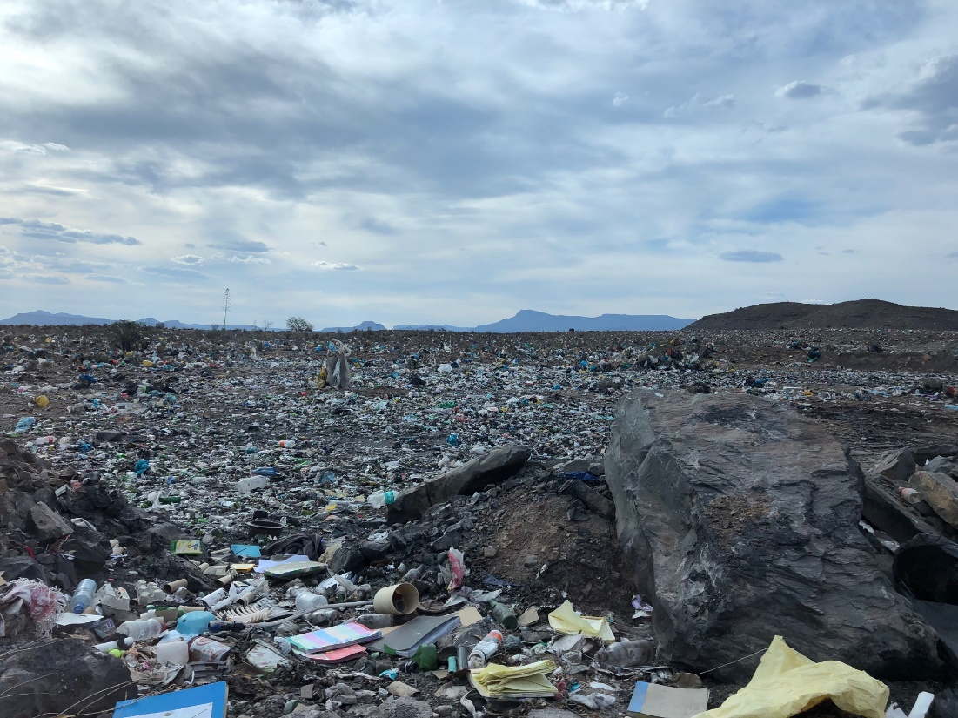
Figure 81: Waste on the edge of Beaufort West Town

Beaufort West Town: Socioeconomic Synthesis
- Hillside is drastically under-serviced. A single school and a single clinic service the entire area to the North of the railway line. Many of the newer houses in the area are a minimum of fifteen minutes’ walk from a school or healthcare facility, and parts of the newer housing developments are outside the fifteen-minute walking distance band. This is a significant problem, considering that non-motorised transport is the primary mode of transport for most residents in Beaufort West Town.
- Rustdene and Kwamandlenkosi are relatively well serviced in terms of social facilities and community centres. This uneven distribution of facilities has created a situation where children are either bussed to school from Hillside or are forced to cross the N1 and rail system on foot.
- Property values are lowest in Hillside and the Southern areas of Rustdene and Kwamandlenkosi. There is some economic activity in the North of Rustdene, close to the N1. This is reflected in relatively higher property values in this area.
- The highest residential property values in Beaufort West Town are in the area to the East of the CBD. This area around De Villiers Street is close to the economic centre of the town and is well serviced by social facilities and public open space.
- Economic activity primarily occurs in the CBD, along Donkin Street. This is reflected in the clustering of businesses, community service centres, financial institutions, restaurants, and shops in this area.
- As mentioned above, there is some economic activity towards the North of Rustdene and at the entrance to the town from the East (these are primarily businesses serving trucks passing through Beaufort West along the N1). There is no discernible formal economic activity occurring in Hillside.

3.5.2.4 Murraysburg Synthesis
- The town of Murraysburg was established on the Farm Eenzaamheid in 1855 as a “church town”. The town was named after Rev. Andrew Murray, minister of the Dutch Reformed Church in Graaff-Reinet.
- The main source of income in the town is in the agricultural sector.
- The town has limited economic activity and there is only a limited range of facilities. These include schools, a clinic, a sports field, and a few shops.
- The historical town has some beautifully restored old houses and a church dating back to 1856,
- Tourism activities offered in and around the town include: hunting, bird watching, stargazing, fly-fishing, hiking, fossil viewing, photography tours and donkey cart rides.
- The lower income, higher density neighbourhoods of the town are situated to the south of the main town. Large pieces of vacant land separate the two areas.
- Murraysburg has been identified as a settlement with exceptionally low development potential (struggling settlement) and very high social needs.

3.5.2.5 Merweville Synthesis
- The small town of Merweville was established in 1904 on the farm Vanderbylskraal and was named after Reverend van Der Merwe, the then minister of the Dutch Reformed Church in Beaufort West.
- The town served as service centre for the surrounding agricultural areas. This role has significantly dwindled and the town is left with very limited economic opportunities.
- Facilities offered in the town include Primary schools, a clinic and a general dealer.
- The original town is characterised by some beautifully restored buildings, some of which have been turned into guest accommodation.
- The town is segregated by the Vanderbylskraalleegte River. The low-income area lies to the west of the river and the main town to the east.
- The town has a low development potential (coping settlement) with very high social needs.

3.5.2.6 Nelspoort Synthesis
- The town of Nelspoort was established when number of farmers established their homes here.
- The town also became a haven for those with chest ailments and in 1924 the first “chest hospital” was established here mainly for the treatment of TB sufferers. In 1969 the first psychiatric patients were admitted to the hospital, mainly due to the decline of TB patients due to sufferers being able conduct home based treatment. Today the hospital is still in operation but with very low occupancy.
- The town offers extremely limited economic opportunities with no business or commercial areas.
- The town has a few facilities including: a police station, primary school and a hospital.
- The centre of the town is characterised by deserted buildings, some of which have become dilapidated.
- The railway line separates the hospital from the rest of the town. Access across the railway line is provided by means of a underpass.
- Between the town and the Sout River to the east there are some agricultural activities.
- Bushman and Khoi rock paintings and engravings are found throughout the “koppies” around Nelspoort.
- Although the area appears somewhat clean, many residents burn their waste, and the landfill is poorly managed.

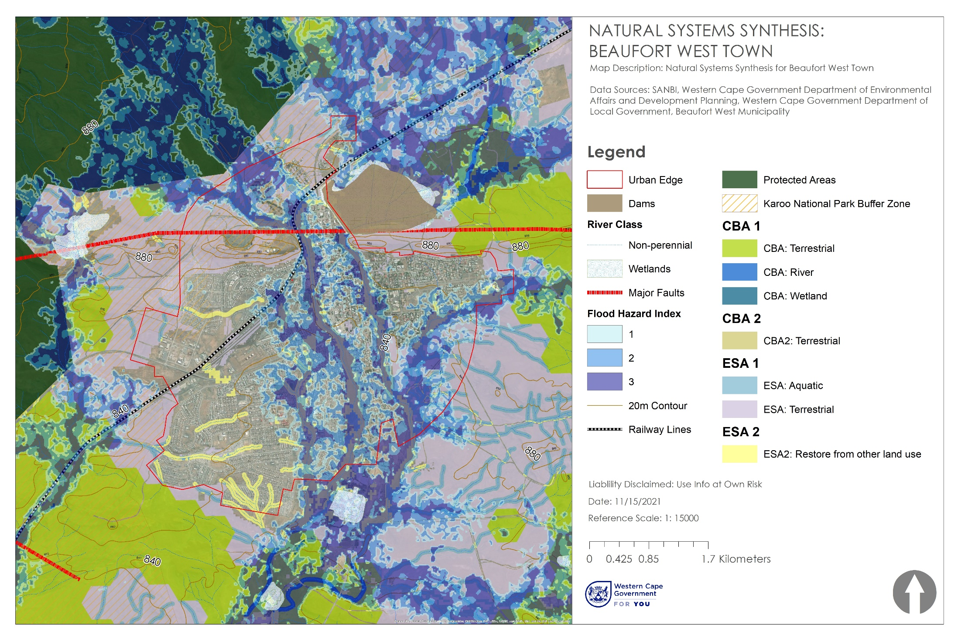
Figure 82: Natural Environment Synthesis Map for Beaufort West Town
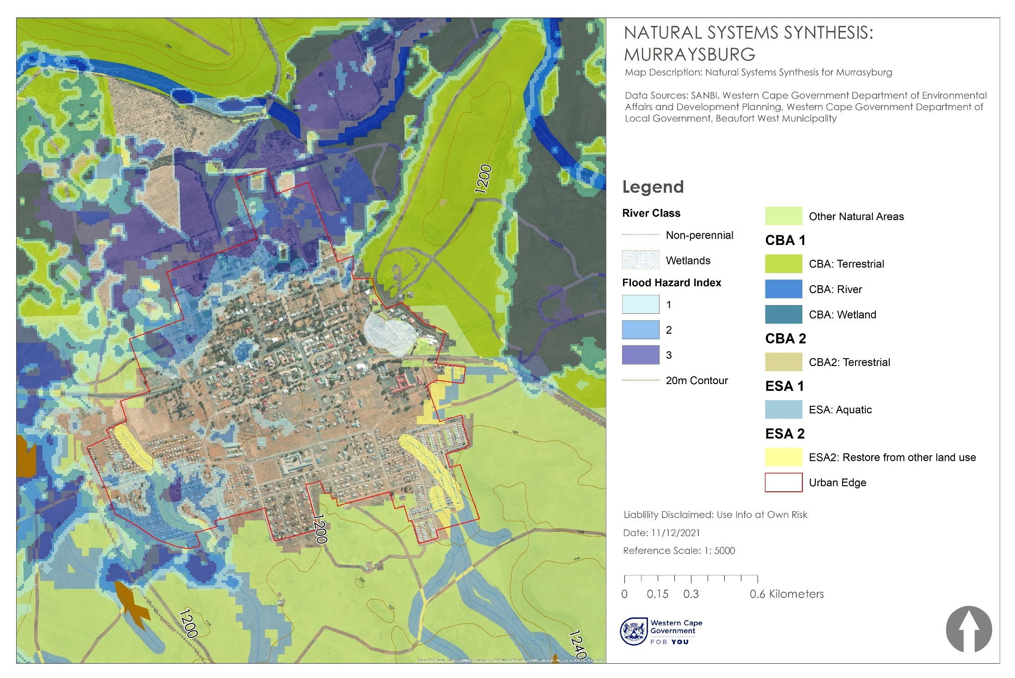
Figure 83: Natural Environment Synthesis Map for Murraysburg
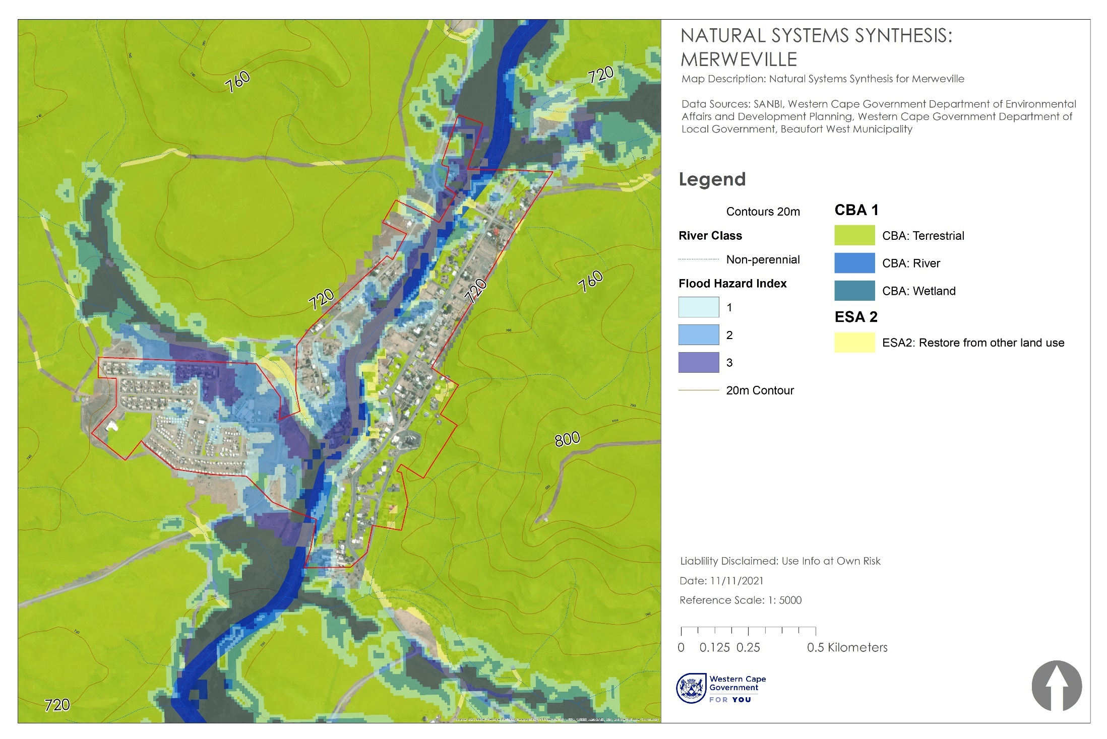
Figure 84: Natural Environment Synthesis Map for Merweville
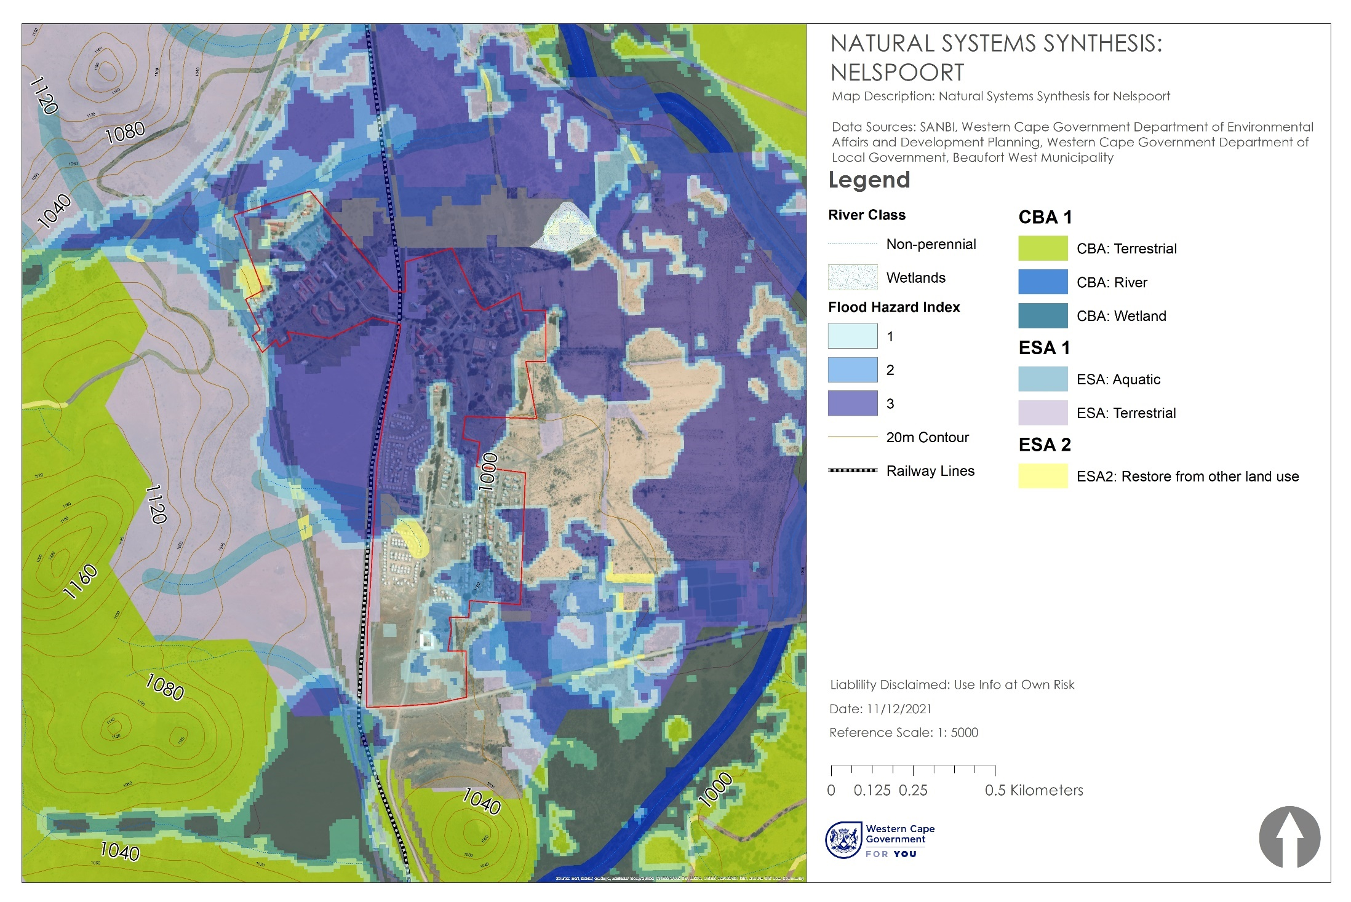
Figure 85: Natural Environment Synthesis Map for Nelspoort
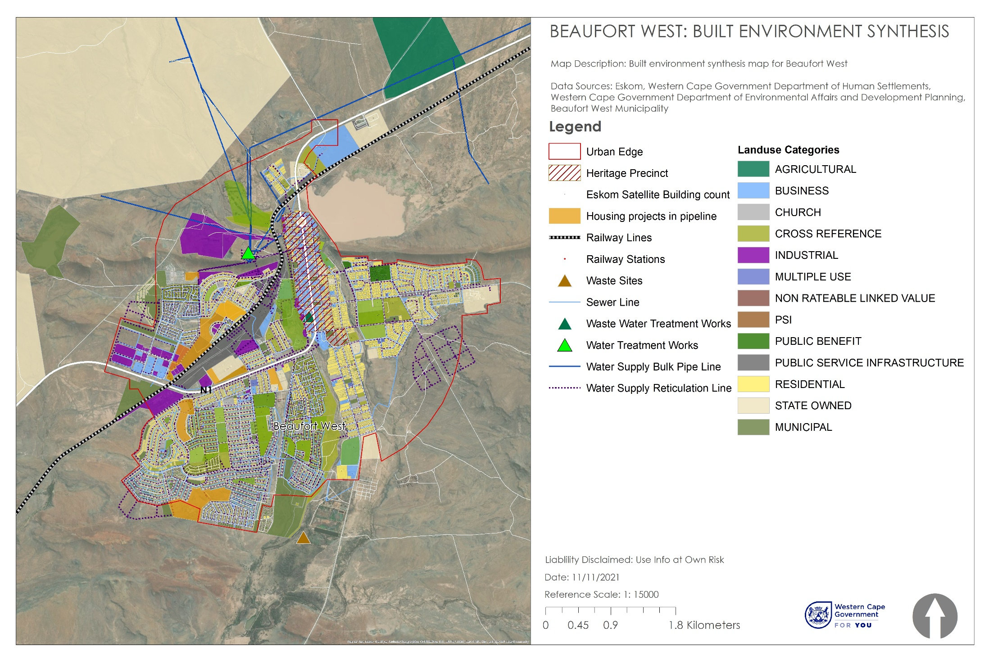
Figure 86: Built Environment Synthesis Map for Beaufort West Town
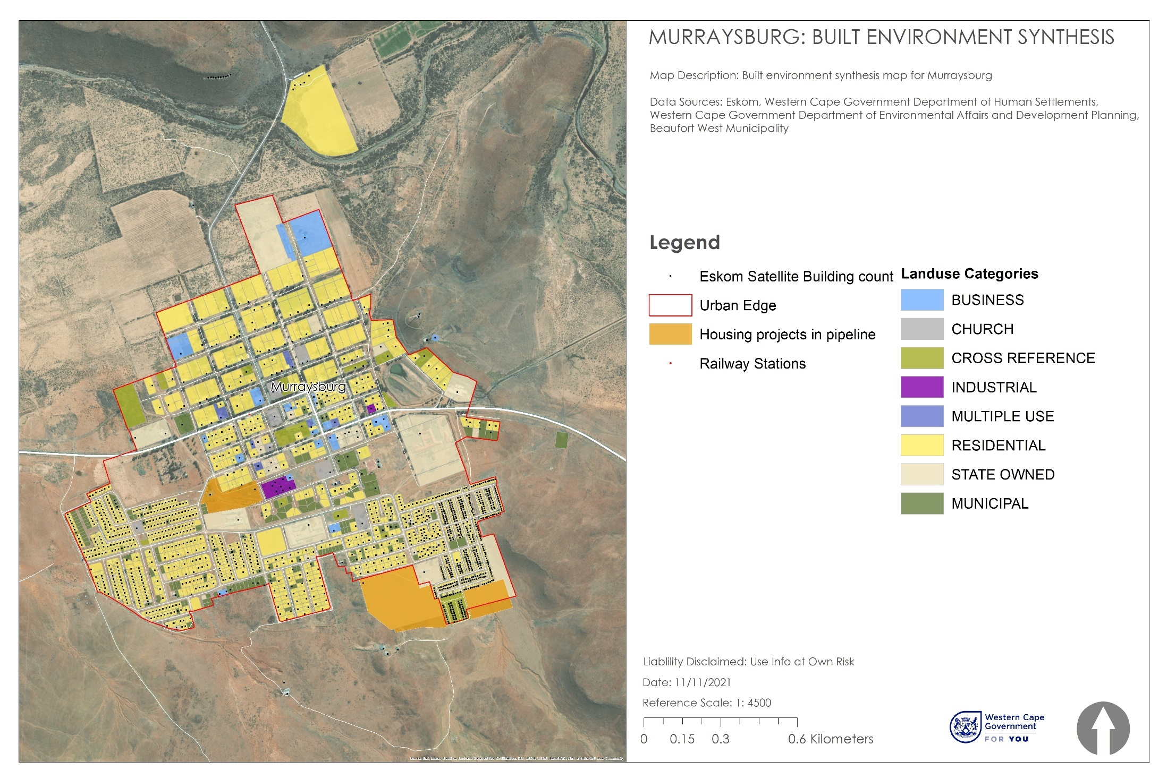
Figure 87: Built Environment Synthesis Map for Murraysburg
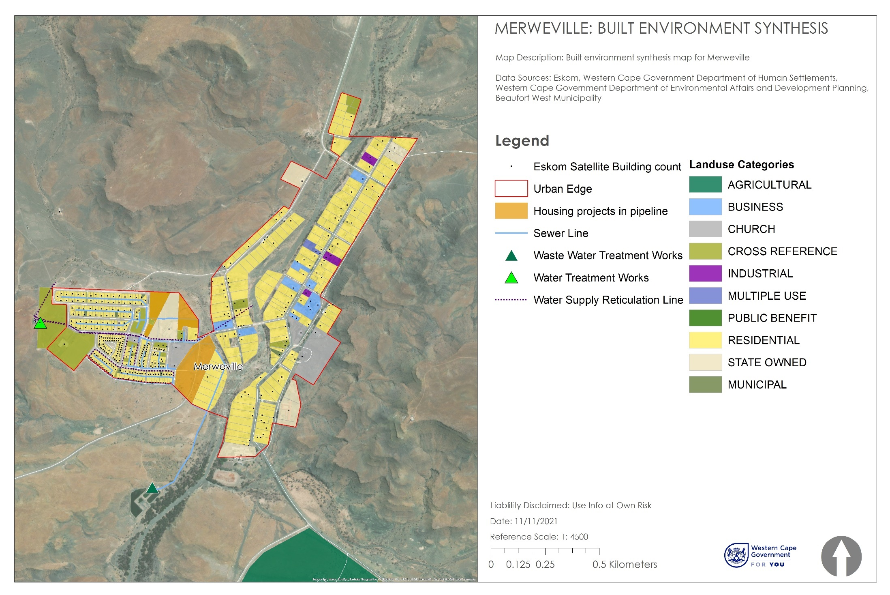
Figure 88: Built Environment Synthesis Map for Merweville
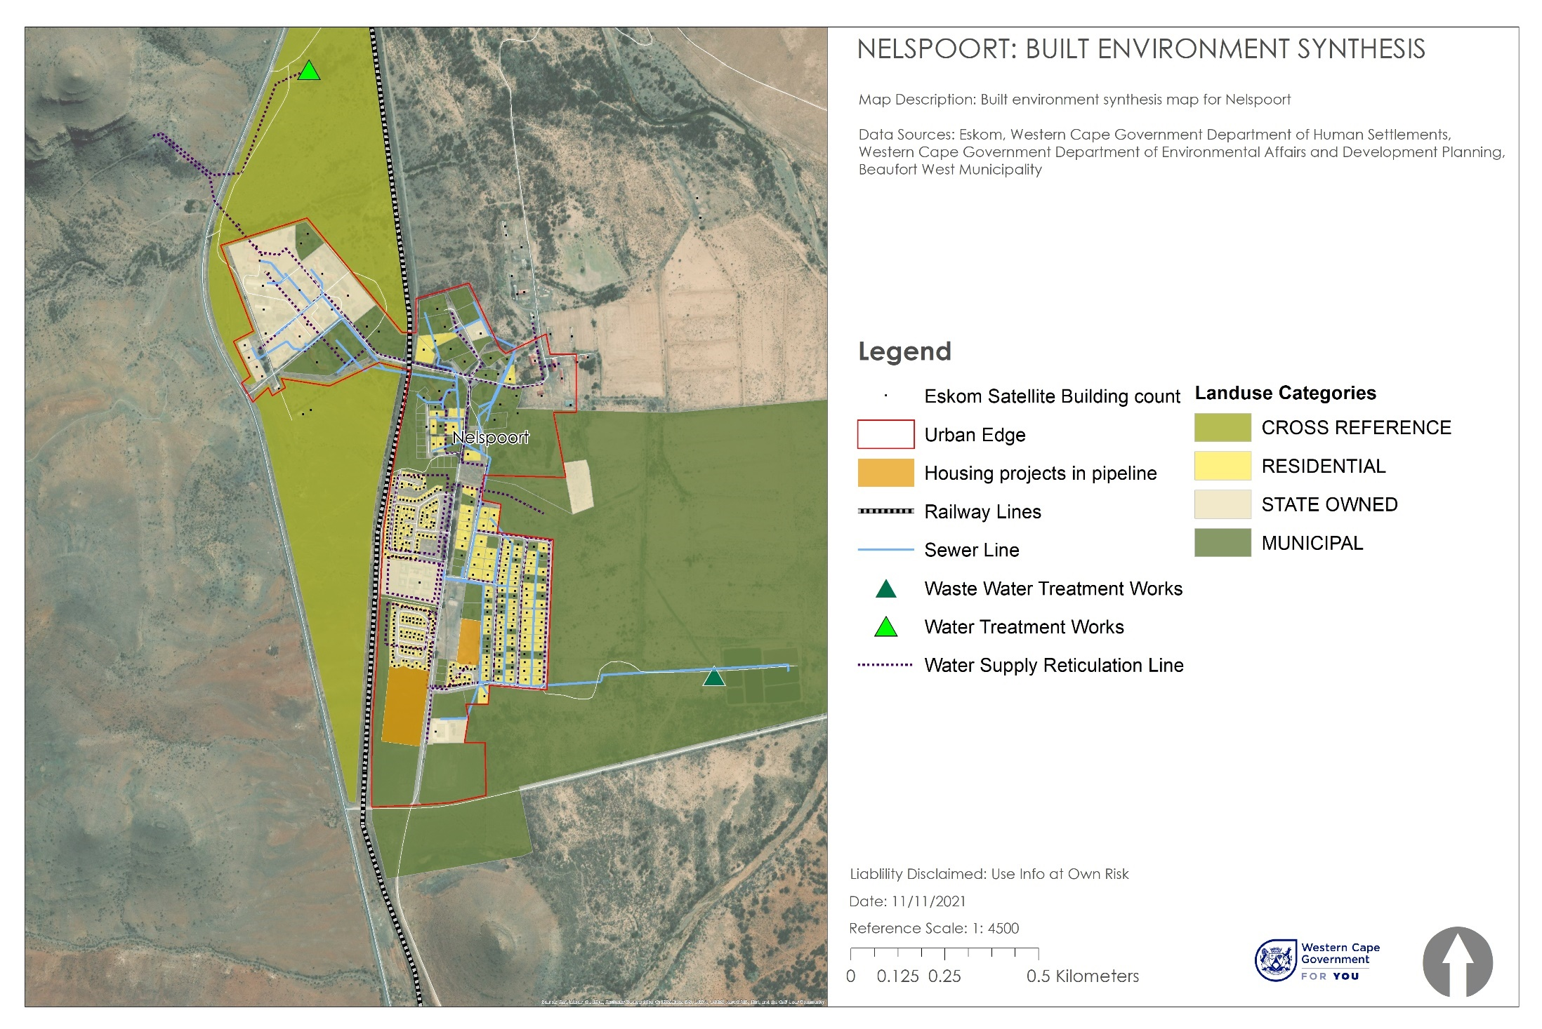
Figure 89: Built Environment Synthesis Map for Nelspoort
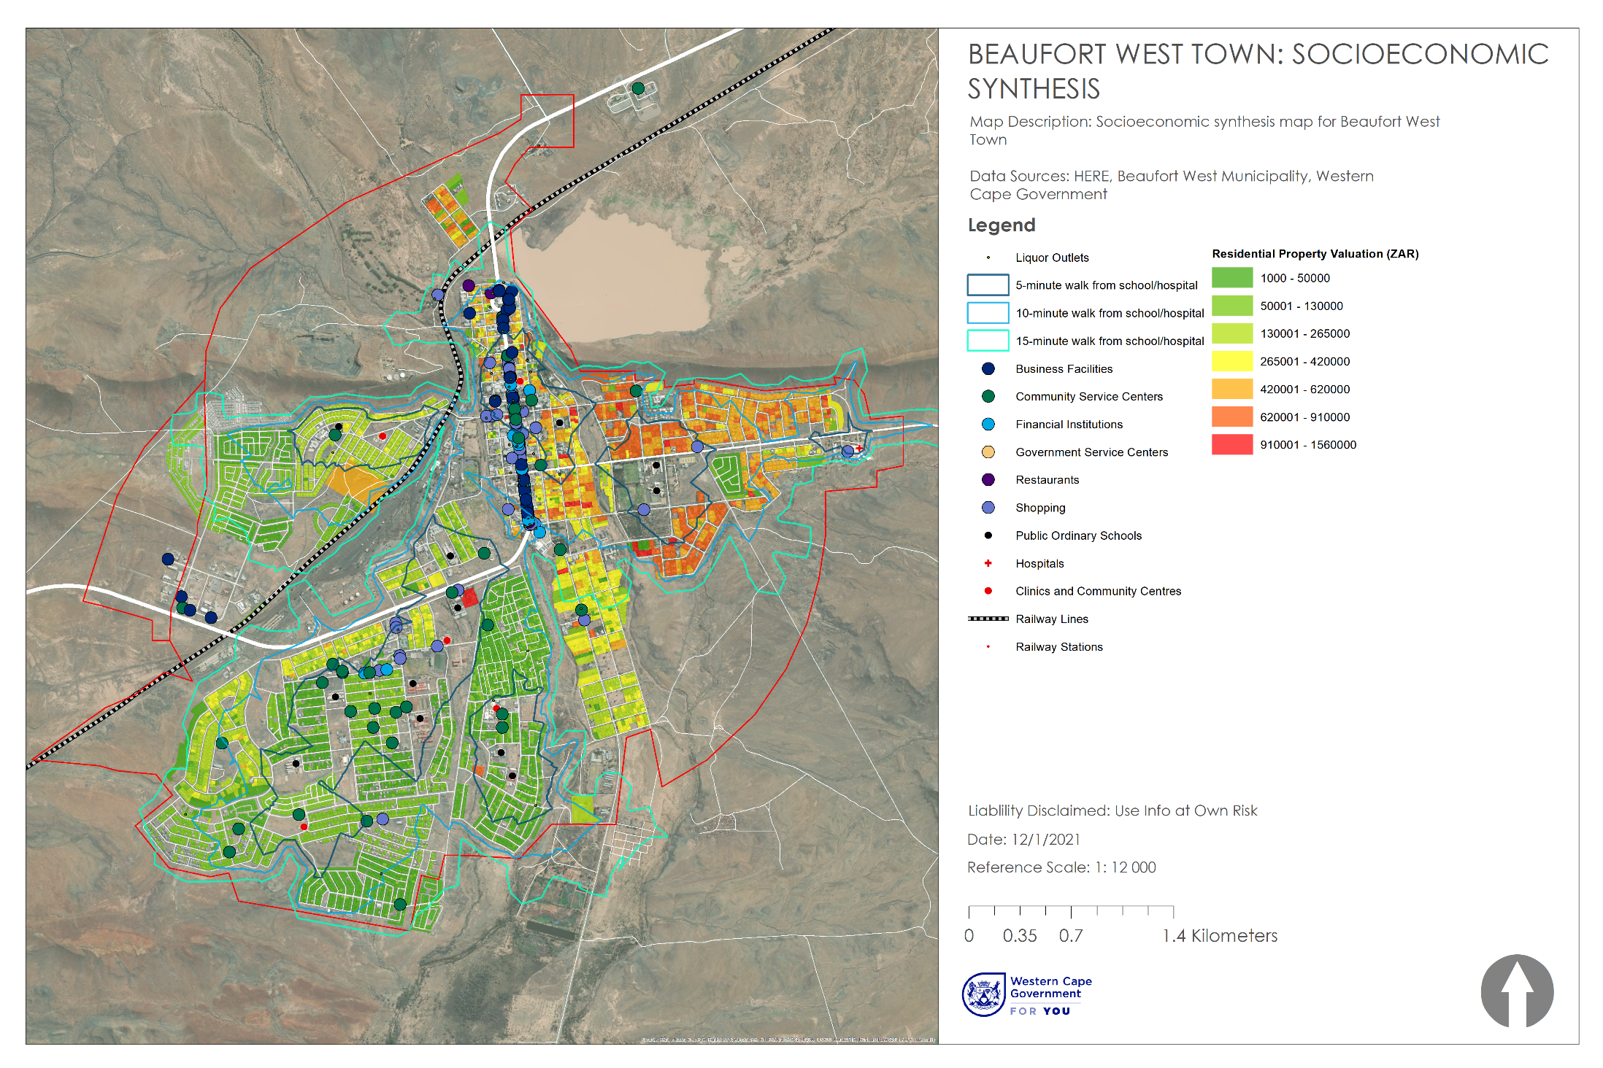
Figure 90: Socioeconomic Synthesis Map for Beaufort West Town
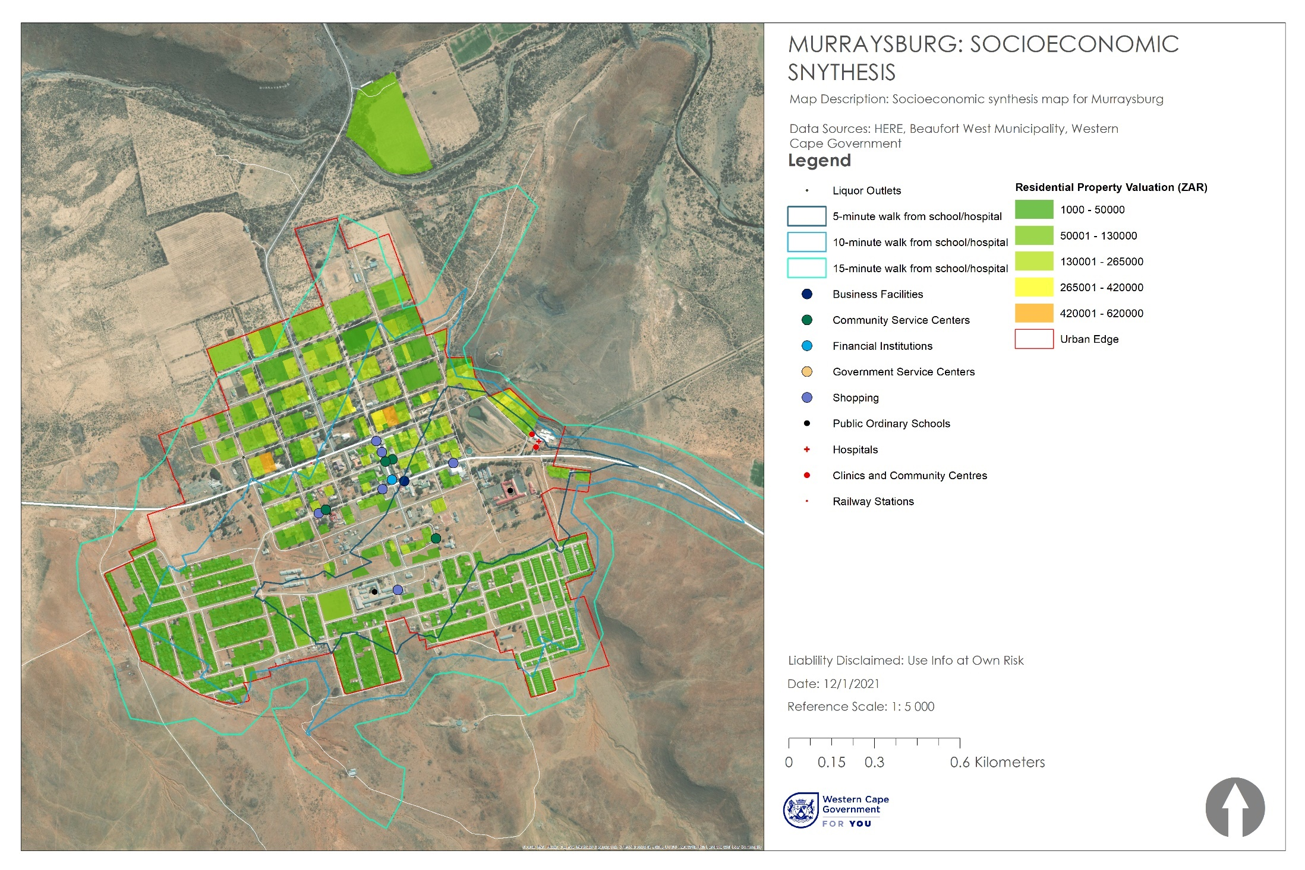
Figure 91: Socioeconomic Synthesis Map for Murraysburg
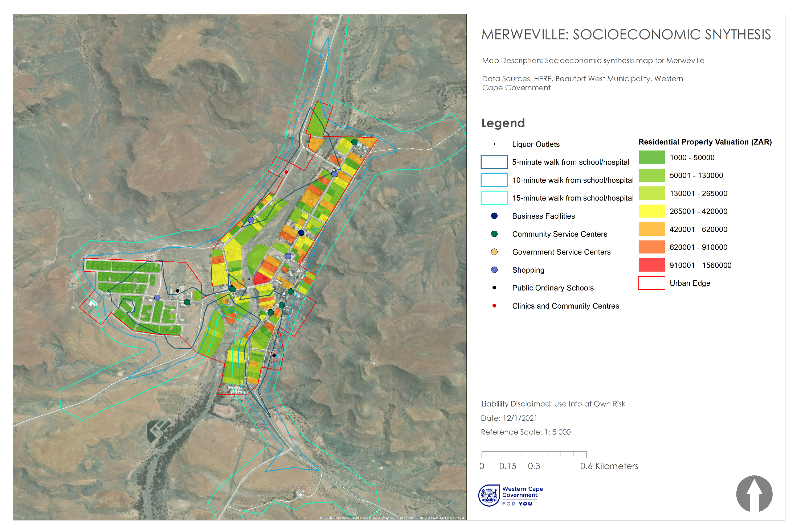
Figure 92: Socioeconomic Synthesis Map for Merweville
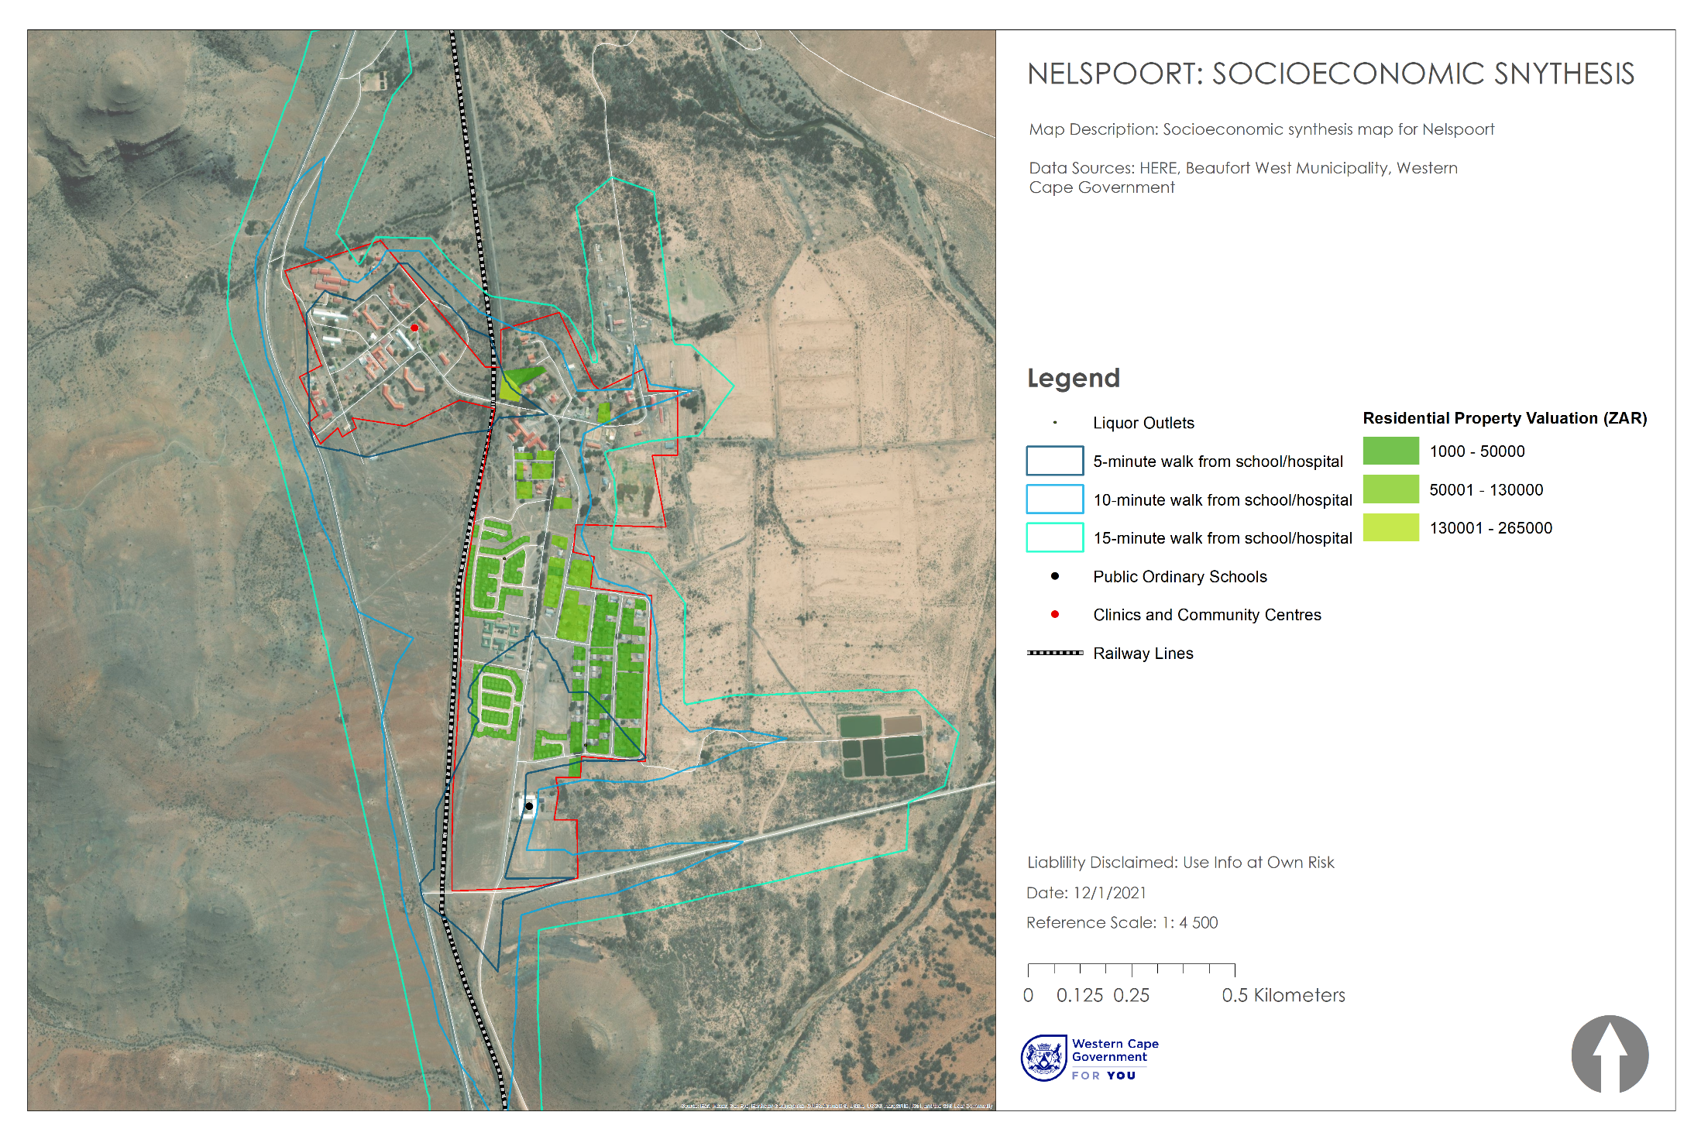
Figure 93: Socioeconomic Synthesis Map for Nelspoort

PERFORMANCE ASSESSMENT: OPPORTUNITIES AND KEY ISSUES OR CHALLENGES
The inputs to this performance assessment are the outcome of a qualitative exercise undertaken by the MSDF drafting team following a site visit to the Beaufort West towns.

Beaufort West Town
This is the largest town in the arid Great Karoo region of South Africa and is known as the "Capital of the Karoo". It is the hub of a farming district based primarily on sheep farming and is located along a major road junction of the N1, N12 and R61. The Karoo National Park is adjacent to the town of Beaufort West, where important fossils have been found, initially by David Baird, son of the local magistrate, in 1827. Both the old Town Hall and the Dutch Reformed Church are designated national monuments.
- First impression of the town.
Arriving at the town from the south entrance via the N1 highway, one passes the truck stops on the left-hand side, and it becomes apparent that the rail / industrial and low-income residential portion of the town on the left of the N1-highway seem derelict, uncared for, and harsh where litter and a lack of basic urban management and lack of cleaning is apparent. This is evident throughout most of the low-income portions of the town. The national road infrastructure is well maintained, but the local roads seem beyond their design life, needing maintenance and upgrade.
Beaufort West is by no means a small or sleepy village. It is a sizable town and is the largest in the Karoo. It appears to have seen better days, where the economy was probably more vibrant as a result of a more vibrant agricultural and rail sector, which has declined over recent decades. Driving through the main town (Donkin Street), there are elements of attractive architecture, landscaping, and attractive urban design, interspersed with modernist architecture and blank facades. Long queues outside the Post Office, which distributes social grants, reflect the full extent of poverty and economic desperation.
There are pockets of the town that are very attractive and should be enhanced, such as the full length of Donkin Street, as well as Bird Street.

- Ky Opportunities for the town
- The Beaufort West Town is strategically located at the confluence of the N1, N12 and R61 routes which connects Beaufort West to Gauteng, Cape Town, Oudtshoorn, George and the eastern Cape.
- The town is perfectly placed to be a refreshment and rest stop for travelers between Gauteng and Cape Town and has high quality tourism accommodation & experiences.
- Similarly, it is well placed to serve truckers and future rail opportunities / logistics.
- The town has mechanic & motor related services to service passing traffic.
- The town could enhance and capitalize on its karoo charm, architecture and streetscape to attract more coffee shops and tourism related stops.
- Bird Street is a significant tourism asset, which has high quality tourism accommodation and interface with the adjacent stream running from the Gamka Dam.
- Portions of Donkin Street offer a quality urban Karoo Charm experience, but this is fragmented and requires more attention. Along this road, there are museums, a public square, and historic architecture.
- The middle-income housing stock on the north-eastern portion of the town (to the south of the ridgeline running between the Gamka Dam and the town) is an attractive area to live, where people take pride in their frontages through planting, and landscaping, providing a quiet, small town and peaceful atmosphere. The interface between this suburb and the wilderness of the Karoo is peaceful and attractive.
- This town acts as an oasis in a very dry area – offering refuge, services, shops, and facilities to this part of the Karoo area.
- The town still has the potential to attract tourists with BnB’s along the main street and the enhancement town’s sense of place and public streetscapes through paving, tree planting along the main roads is could significantly improve its attractiveness.
- The implementation of basic urban management practices and waste management programmes could significantly improve the Town’s attractiveness to visitors or tourists.
- The town-center mall seems vibrant and well-integrated into urban fabric.
- Key Weaknesses
- Recent drought conditions undermined the carrying capacity of the town, since water scarcity limits business and industrial opportunity.
- The existing lack of urban management and cleaning in the town undermines its attractiveness to private sector investors (and even for regional public sector investments).
- The high level of unemployment and poverty is evident – which shows generally low levels of economic opportunity.
- The waste site is poorly managed, resulting in extensive wind-blown litter in the natural veld.
- Parks need to be upgraded. Libraries are not prominent elements of the public environment, which could be used to uplift / enhance areas.
- Low-income areas (such as hillside) seem devoid of quality public spaces.
- Low-income areas lack economic opportunities and structure in the urban environment for economic opportunity to accrete along.
- Parks and recreation facilities are old, not maintained, and swings broken.
- Much of the infrastructure seems old and worn, with municipal roads nearing or at the end of their design life. There is a clear need to implement (or upscale) an infrastructure maintenance programme.
- From a socio-economic perspective, the town and its people are visibly struggling.
- Levels of service are under pressure, affordability of service provision is under pressure, and the finances of the municipality are under pressure.

- Non-motorized Transport routes in Beaufort West Town
- Donkin street is generally pedestrian friendly and traversable. The buildings front onto it the street and provide a human scale and generally historic sense of place on portions of the street (interspersed with modernist architecture).
- Donkin Street could use more trees and shade to escape from the intense summer heat.
- The low-income areas of the towns lack economic opportunity and pedestrians generally share the road with cars, but this is not necessarily a significant issue as traffic is not heavy.
- Dried river corridors are often littered with the rubbish that people dump.

Murraysburg
- First impression of the town
Entering Murraysburg Town on the R63 east, there is a picturesque view of the Sneeuberg Mountains. Driving down the main street, the Dutch Reformed Church pokes out above a tall line of mature trees. The town appears to have had its economic heyday and the main street seems to be in decline. This is certainly affirmed when comparing 2010 Google Earth Street View to the actual visit. The ongoing drought and COVID 19 lockdown regulations have had a clear impact on the economy. The previous SDF 2014 mentioned that Murraysburg is a refuge for ex farmworkers and this trend may have been exacerbated under current circumstances.
- Key Opportunities for the town

- The town enjoys good tar road access on the R 63 between Victoria West (90kms) and Graaff Reinet (92kms). It is the wettest and most fertile part of the municipality. The town abuts the Buffelsrivier to the north, which replenishes ground water for farmers to extract for sheep, goats, and cattle. Murraysburg is also well known for its quince hedges which are reported to be some of the largest in the world. Quince is a small and rounded pome fruit grown on trees.
- The main street still has potential, especially if the local economy fared better.
- All gateways into town should be enhanced to improve its sense of arrival.
- The town still has the potential to attract tourists with BnBs along the main street.
- It’s closely located to a river.
- There is decent access to main roads although not a national route.
- Key Weaknesses of the town
- The agricultural economy is reliant on groundwater in an environment that is only going to get hotter and drier.
- The economy is highly vulnerable to shock – drought and lockdown.
- Murraysburg is somewhat isolated in relation to the towns in the rest of the municipality. It is confusing when leaving Beaufort West to get to Murraysburg, that you exit the Western Cape only to come back into the Western Cape again to get to Murraysburg.
- Many children appear not to be in school.
- The main street has gone into decline.
- Those with money don’t seem to be there anymore.
- Many of the low-density middle to higher income lots behind the Main Street are vacant. These are considered farm to market lots in the 2014 SDF and losing these can possibly threaten local food security.
- There are large amounts of vacant land between low-income area and the main street.
- The storm water systems in the easter part of the town are filled with litter.
- Non-Motorised Transport for Murraysburg
The main street is pedestrian friendly and traversable but still in decline. The sand runoff into the drains has not been cleared, many buildings haven’t been maintained by private owners in years and a feeling of despair is prevalent. The main street is illustrated in Figure 94.
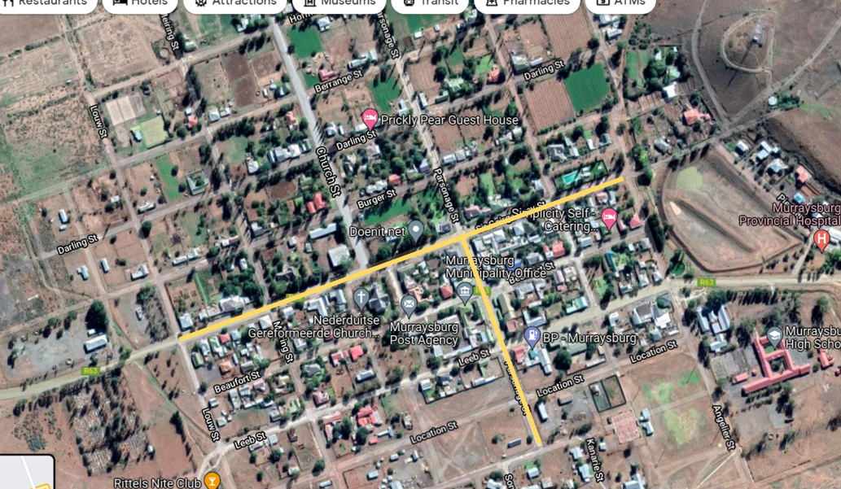
Figure 94: Murraysburg St George Street and Parsonage Street
Clean, green and maintain the main street (St George Street as well as the secondary main street Parsonage Street – (see Figure 94) and upgrade the main entrances.

Give more design (urban acupuncture) attention to this township node (See Figure 95), specifically in terms of social facility clustering and providing a safe a min urban oasis. It seems to be where much of the energy of the people is. A focus on paving, lighting, landscaping, and incentivized infill should be followed. Including the school, clinic, local business owners and women and children in the design process will be important especially since the space could include a parklet, retail, ECD and residential.
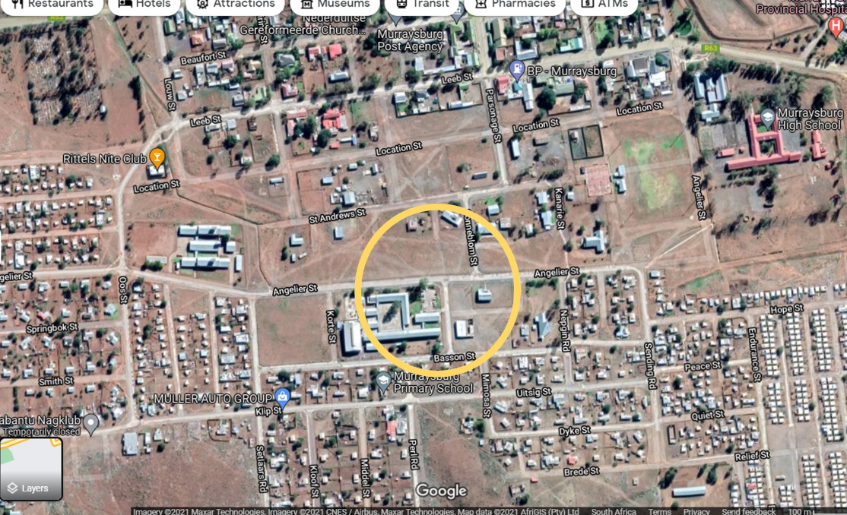
Figure 95: Illustrates the identified township node where mixed-used development is encouraged.
The street ‘is’ the primary public space for people living in what is considered the lesser managed part of the town. Many people are walking in the day, in the residential parts, when one would expect them to be in class or at their places of work. Sadly, the streets are littered, it’s very hot and there aren’t many trees to provide shade. The proposed Walkways for Murraysburg are illustrated in Figure 96.

Figure 96: Proposed Walkways for Murraysburg (2020 – 2025)

Merweville
- First impression of the town
The 40km route from the N1 at Prince Albert Road to Merweville was tarred in 2015. The route enjoys spectacular views of undulating hills of golden veld grasses interspersed by dark grey-brown sands and what looks to be a bucket list favorite for the avid motorcyclist. Entering the town, white rocks spell out ‘Merweville’ atop the first landmark hill. The landscape gives off the impression of an isolated community that maintains an old-world charm, like that of Nevada or Arizona. Upon entry the food garden lots, windmills and main street draw the visitor’s curiosity to a place back in time.
- Key opportunities for the town
- The new 40km stretch from the N1 gives the town good access.
- The well-maintained Karoo Architecture buildings along the main street and Dutch Reformed Church (see figure 97) and Windmills provides tourism opportunities - Heritage buildings are well kept.
- The main street is pedestrian friendly and traversable. The houses front onto it the street and provide a human scale and historic sense of place.

- The towns’ tourism economy (hiking, stargazing, game driving, BnB’s, quad and motorbiking) can leverage the access provided by the newly tarred access road from the N1.

- Tourism based advertising is required and efforts should be made to explore opportunities of placing tourism related signage about Merweville at the Prince Albert Road stop.
- Although there aren’t any streetlights, the Dutch Reformed Churches illuminates the town and main street at night, further adding to the historic sense of place.
- The slow paced, laid back and peaceful lifestyle.
- The relative location to Prince Albert Road, Sutherland, Fraserburg, Laingsburg and Beaufort West.
- There is land for grazing and food gardening along the river corridor,
- The isolation, wilderness environments and historic very small-village atmosphere.
- The main street is tarred, clean, walkable, well-kept and litter free.
- Homeowners take pride in their places by planting trees and maintaining frontages.
- All parts of the town are well serviced in terms of basic infrastructure and social facilities.
- The distances between the lower income part of the town and the main street are less than a kilometer and the gravel roads are clean and easily traversable.
- Additional streetlights in the main street, street maintenance and a continued green network of shade through continued tree planting along pedestrian walkways.
- The main street is recently tarred.
- Social facilities are used and appear to be in a good condition.
- From a socio-economic perspective it appears to be better performing than Murraysburg, with very low levels of informality.
- Plant trees along Pienaar and DS de Villers Streets to create an integrating main street network between all parts of the town, including paving the eastern extremity of these networks.
- Proclaim river corridors, where possible at least 32 m from banks in which no intensive agriculture nor urban development is permitted.
- Support and encourage continued use of current market gardening plots.
- Investigate use of open land or undeveloped areas closest to river corridors for market gardening and livestock farming, (e.g., pigs); and,
- The eastern side of the settlement should be declared a heritage precinct with guidelines to which renovations to existing and extensions and new buildings should comply to strengthen and not erode this important asset; and,
- All gateways into town should be enhanced.
- Symbolically integrate the settlement by ensuring a uniform tree planting and road pavement treatment on the main route network linking all the urban areas comprising Pienaar, DS de Villiers west and DS de Villiers east streets; and,
- Land for any new urban development, for instance, BNG housing should be located on the land parcels identified that will consolidate rather than disperse the settlement.
- Advertise the area as film shoot location.
- Attract motorcyclists.
- Advertise the town at the Prince Albert Road stop.
- Maintain a green network along pedestrian desire lines.
- Incentivize signage and art murals.
- Maintain heritage.
- Encourage market gardening along river corridors which must have 32m development buffer but still allow grazing.

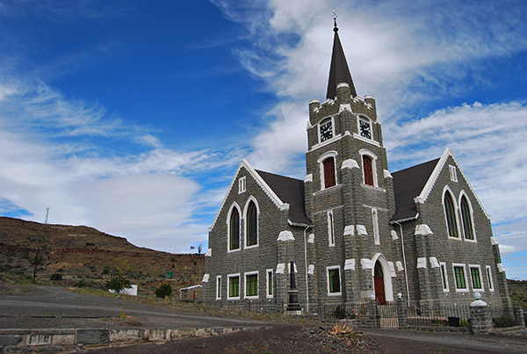
Figure 97: The Dutch Reformed Church along the main street of Merweville (Source: https://www.karoo-southafrica.com/koup/merweville/)
- Key weaknesses of the town
- Declining natural resource base. The town is completely reliant on groundwater in an environment that is only going to get hotter and drier.
- It’s an isolated settlement. Prince Albert Road is the only convenience route, 46km’s from the town. However, it’s still another 116kms to the next largest town, Beaufort West
- The economy is highly vulnerable to shock – drought and lockdown.
- There is a dried river corridor between the lower income end of the town and the main street, which may be problematic in times of flooding and access.
- Having a wall around the sports field in the lower income part of the town is a poor design choice because it creates a negative atmosphere around the edges.

- Non-Motorised Transport Infrastructure
The infrastructure is very basic but well kept. There are only two roads while the access roads are all gravel but still well maintained and have sidewalks. Each of the main lots has a windmill and round concrete storage tank. It is clear the town relies only on groundwater. The public spaces are there but keeping them green in such a climate is a luxury unafforded. The proposed Walkway for the town for the 2020 – 2025 period is illustrated in Figure 98.
Figure 98: Proposed Walkway for Merweville (2020 – 2025)

Nelspoort
- First impression of the town?
The first impression of Nelspoort is pleasant. The entrance is well signposted, and the sidewalks are decorated and well-maintained. The road entering the town runs past the Nelspoort clinic, which appears to be in good condition and functioning well. The streets were clean, and infrastructure appeared to be well-maintained. There was no informality that was obviously visible, and the settlement appeared to cater to the needs of its people.
- Key Opportunities for the Town

- The clinic dominates the town. It seems to be the main source of employment and activity. The location is beautiful and there is a certain charm to the area. It is also located on the railway system, which is a potential competitive advantage. However, there does not appear to be a significant reason to visit Nelspoort beyond any specialist healthcare services the clinic may offer.

- The town is attractive and well-maintained. There is not a lot of litter and the people living there seem to be catered for in terms of schooling and access to healthcare.

- The town is located on the railway system and in relatively close proximity to the N1.

- The streets are wide and pedestrian friendly, which is important for its population.

- Nelspoort functions well for pedestrians as there is very little traffic and the streets are wide and in good condition. The main street is tree-lined, which offers shade for pedestrians and there could be more active public space (e.g., outdoor gyms, gardens, picnic areas etc.).

- Transforming the abandoned school into a site with a constructive use. This could be state-led or in partnership with the private sector, but the space should be active instead of decaying, particularly as it is the first thing a visitor sees once they have passed the clinic.

- Key Weaknesses of the Town
- The old school opposite the clinic is crumbling and abandoned. There is also very limited existing economic opportunity or tourism infrastructure. In contrast to Merweville, where many of the buildings have historical charm, most of the buildings are modern and functional. This limits the appeal of the town to tourists and visitors.

- The clinic, which is the economic center of the town, is separated from the main residential area of the town. The town is so small that it is still in fairly close proximity, but this does pose a safety risk to people walking back late at night, particularly as they have to walk past the abandoned school building.

- Apart from the clinic, there are no centers of economic opportunity or employment. This suggests that the majority of the population of Nelspoort are either employed by the state at the clinic or grant dependent.

This figure comes from the Western Cape’s Socio-Economic Profile. The Regional Profile created for the Karoo RSDF uses Regional Gross Value Added (GVA-R) and puts Beaufort West’s figure at R33 809 per capita (for 2019 adjusted for 2020 value). This is lower than GVA-R per capita for both the Central Karoo Region (R39 591), for the Western Cape (R58 572), and for the country (R48 582).

